Download te latest version of my resume at:
https://github.com/GijsGroote/Resume/tree/main/pdfs/resumes

Or scan the following QR-code:
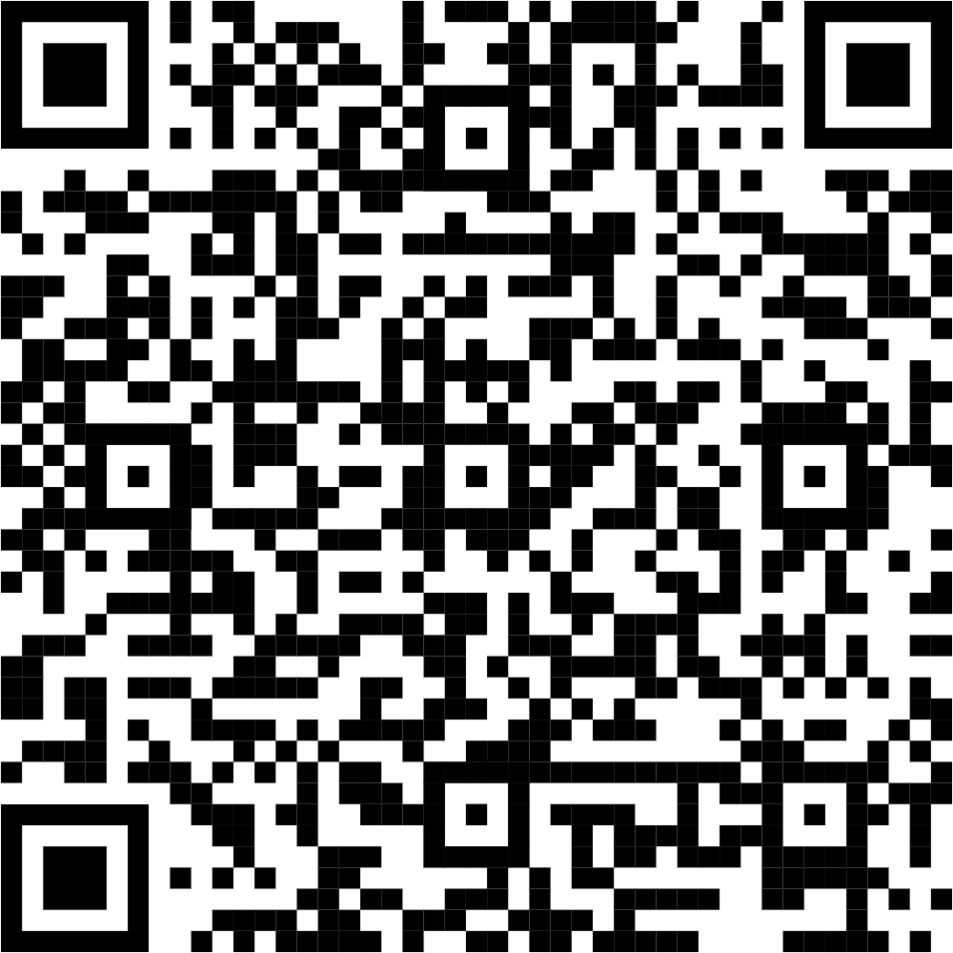
ps. version control is important.

