**Селекторы**

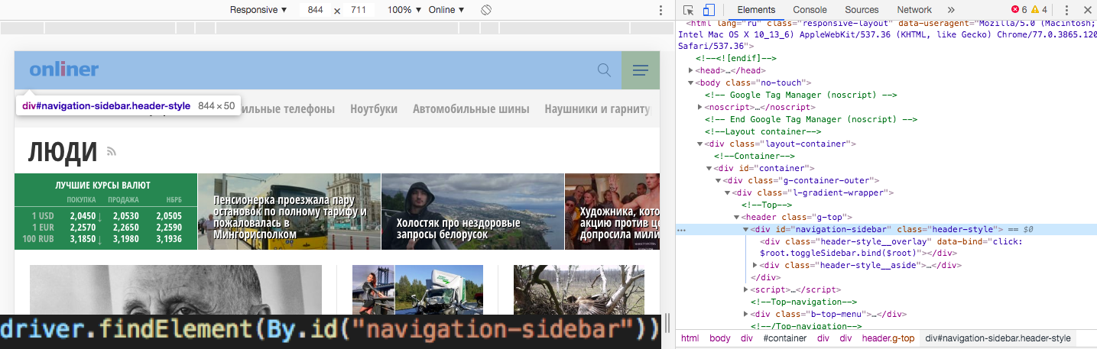

2.

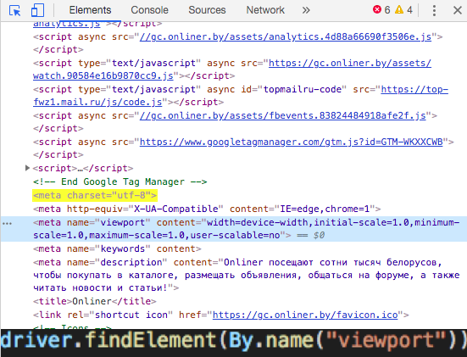

3.

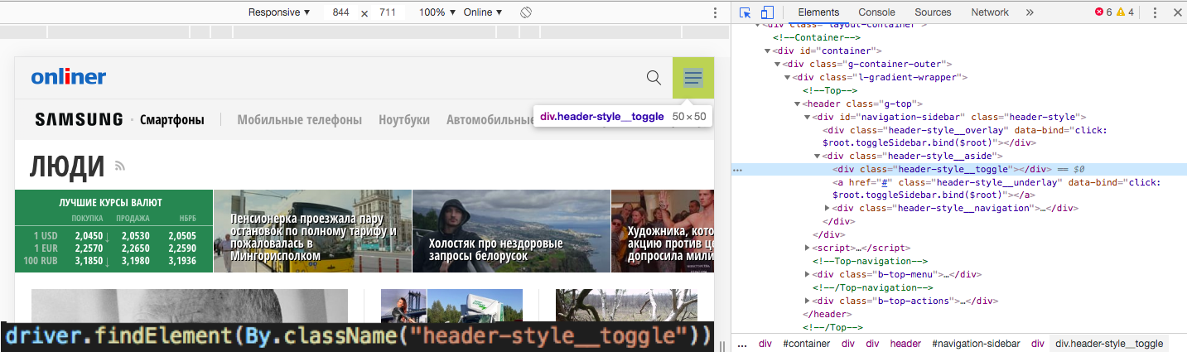

4.

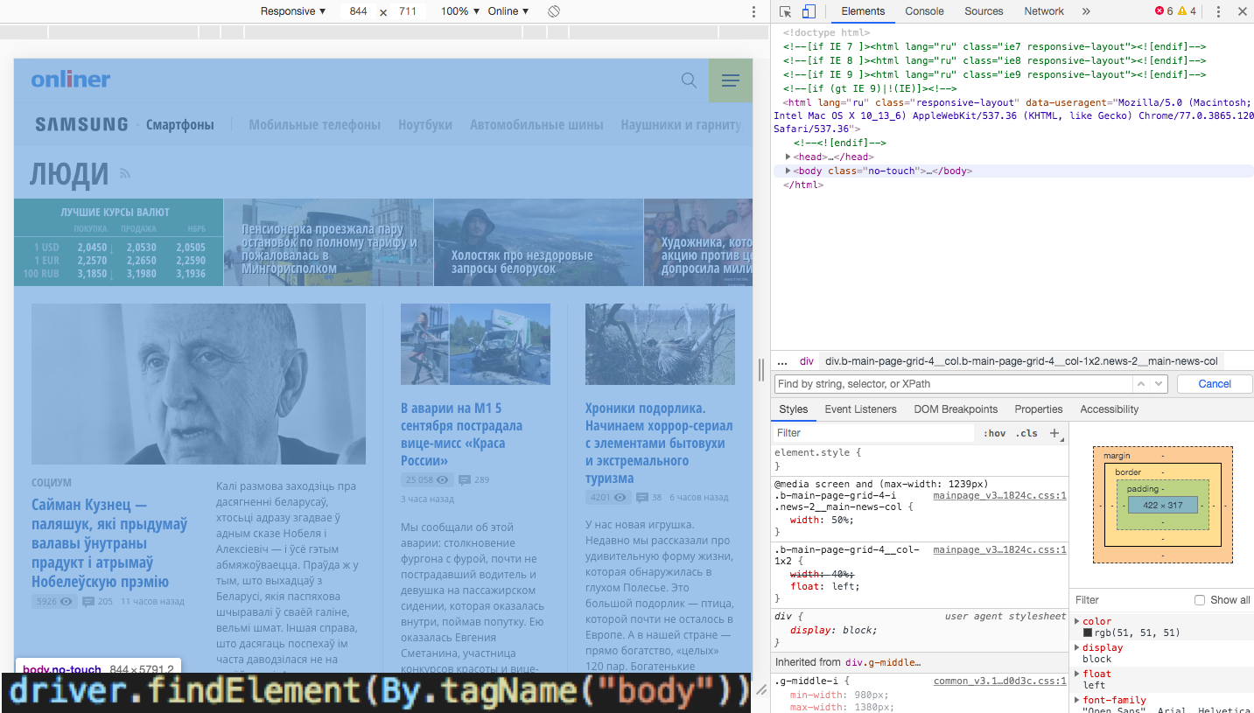

5.

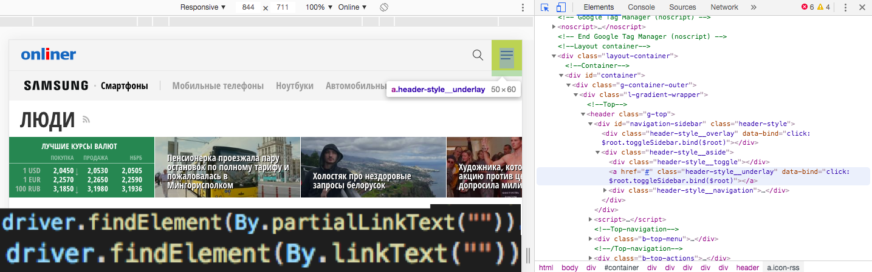

6.

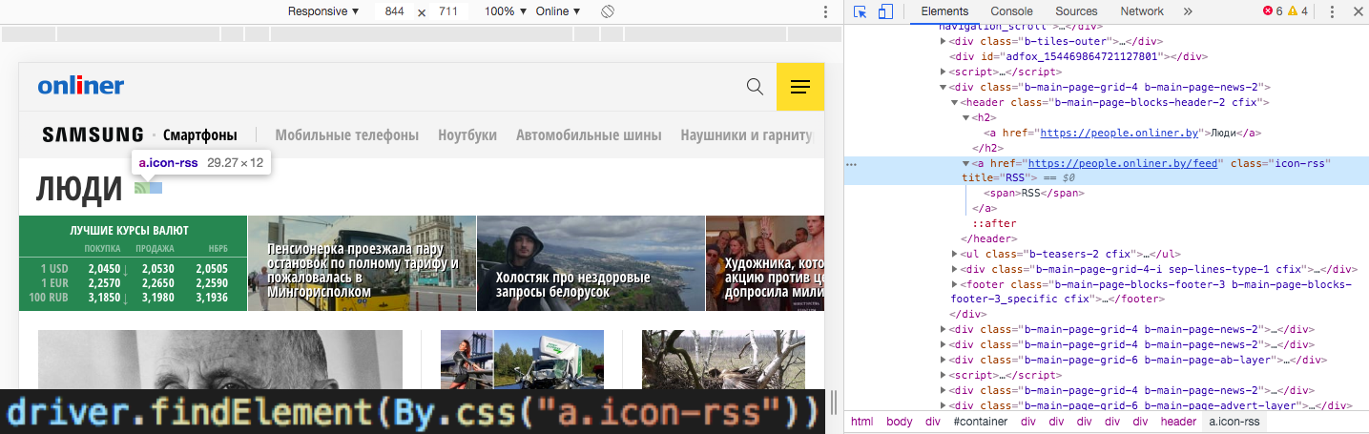

**Xpath**

//tbody/tr/td[count(//th[.="Id"]/preceding-sibling::*)+1][..//.="SimpleDataset"]

