Paper – LLM MCTS

L-policy: LLM is the policy, query it for next actions given history

L-model: LLM builds up word knowledge and apply a planning algorithm to the model

Preconditions: accuracy of world model + efficiency of planning algorithm

LLM-MCTS is a combination of both ideas

VirtualHome for simulation.

Their results:

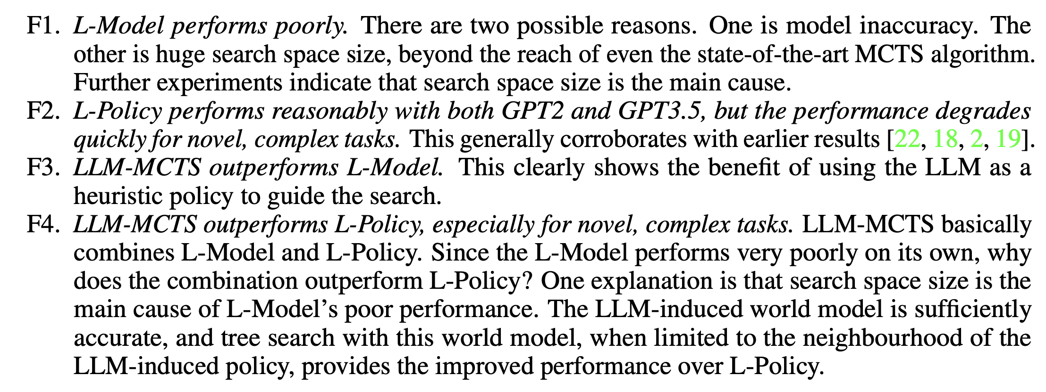

Problem definition:

Partially Observable Markov Decision Process (POMDP): (S,A,Ω,T,O,R,γ)

Actions in VirtualHome:

(1) pick(object), where the robot collects an observed, proximate object;

(2)place(object,placement), allowing the robot to set a picked object nearby or inside an open container;

(3) open(container) and (4) close(container), for interacting with an observed, nearby containers; and

(5) move(room/object/container)