**Flow BP**

Software Engineering Project

Application Design Document

Eilon Benami

Eyal Almog

Hadas Atiya

Gilad Abudi

**Contents**

Chapter 1: Use Cases……………………………………………………………………………………………………………..2

Chapter 2: System Architecture…………………………………………………………………..………………….…….12

# **Chapter 1- Use Cases**

|  |  |
| --- | --- |
| Use-case name | Block addition |
| Description | The user drags a block from the left-handed side toolkit onto the working sheet, or clicks on a block for the editor to locate it arbitrary on the working sheet |
| Pre-conditions | None |
| Post-conditions | The block will be visible on the working sheet |

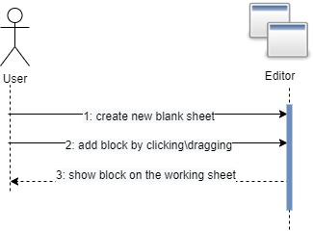

|  |  |
| --- | --- |
| Use-case name | Edit code section on a General/Console block |
| Description | After creating a general/console block, the user can edit the code on the block by clicking the block, then clicking the "Open Code Editor" button on the right-handed side toolkit. After clicking the button, a new window with a text area will be opened, and in order to save the code the user should press the apply button. |
| Pre-conditions | A general/console block was created on the working sheet |
| Post-conditions | The editor saves the code of the specific block |
| Alternatives | If the user writes code with syntax errors, the editor will notify the user that an error has occurred, and allow the user to fix the code. |

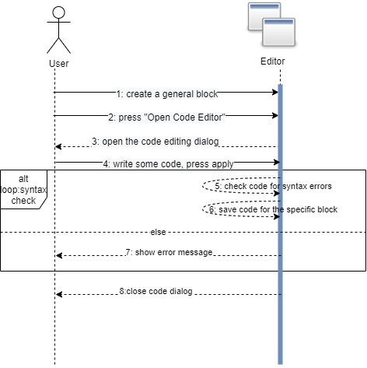

|  |  |
| --- | --- |
| Use-case name | Edit Number of outputs on a general block |
| Description | After creating a general block, the user can edit the number of outputs the block has by clicking the block, then editing the "Number of outputs" field. Then pressing apply will change the number of outputs. |
| Pre-conditions | A General block was created on the working sheet |
| Post-conditions | The number of outputs on the specific block is changed accordingly |

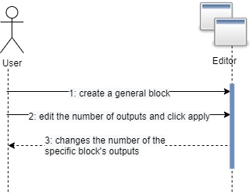

|  |  |
| --- | --- |
| Use-case name | Edit outputs labels \ block title on general block |
| Description | After creating a general block, the user can edit the output's labels and the block title by pressing the block and changing the field on the right-hand side toolkit |
| Pre-conditions | A general block was created on the working sheet |
| Post-conditions | The labels\title are showed visually on the block |

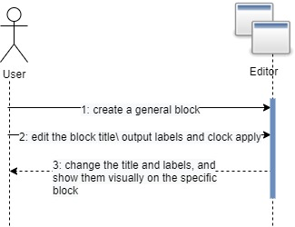

|  |  |
| --- | --- |
| Use-case name | Edit request, wait and blocked fields on a Bsync block |
| Description | After creating a Bsync block, the user can edit the request, wait and block event fields on the block by simply clicking the block, and using the right-hand side toolkit. In order to save the fields, the user should press the apply button. |
| Pre-conditions | A Bsync block was created on the working sheet |
| Post-conditions | The editor saves the sync fields of the specific block |

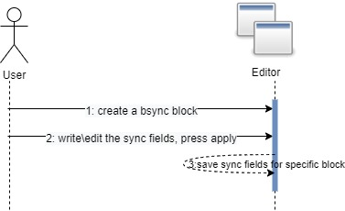

|  |  |
| --- | --- |
| Use-case name | Edit Payloads on a start block |
| Description | After creating a start block, the user can edit the number of payloads the block contains, and the payloads contents. The user clicks the block, and edits the fields on the right-hand side toolkit |
| Pre-conditions | A start block was created on the working sheet |
| Post-conditions | The fields on the specific block are changed accordingly |

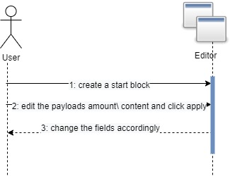

|  |  |
| --- | --- |
| Use-case name | Loading a program |
| Description | The user is pressing the load-program button, picks an XML file and opens it |
| Pre-conditions | None |
| Post-conditions | The working-sheet filled with the graph represented by the structure inside the XML file |

**8.**

|  |  |
| --- | --- |
| Use-case name | Saving a program |
| Description | The user is pressing the save-program button, picks location and file name and saves it. |
| Pre-conditions | None |
| Post-conditions | An XML created on the wanted location, filled with mxgraph structure, which contains all the graph details. |

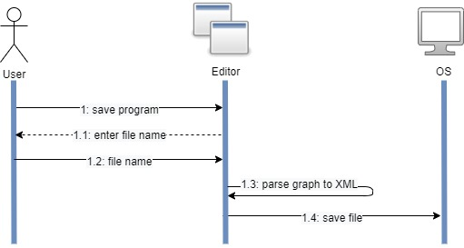

|  |  |
| --- | --- |
| Use-case name | Executing a program |
| Description | Pressing the run button after a graphical BP Flow program is located on the working sheet. The XML of the graph is being parsed and converted to a graph-like object. The interpreter traverses through the graph-like object, parses the information from the nodes and edges, and executes the program according to BP Flow semantics. |
| Pre-conditions | Loaded/Created graph bases on the working-sheet |
| Post-conditions | The output console filled with events occurred according to the program restrictions. |
| Alternatives: | 1. The graphical program that located on the working sheet has graphical issues (an edge without a target node or start node that is not connected to any other node). An error message will be shown to the user, and the bad graphical objects will be red colored. |
|  | 2. One of the general blocks' code section has code that breaks in run-time. The execution will stop, and an appropriate message will be shown to the user. |

|  |  |
| --- | --- |
| Use-case name | Debugging a BP-Flow program |
| Description | After a graphical program is located on the working sheet, pressing the debugging button will transform the UI into debug mode. The system will execute the BP-Flow program created on the working sheet, and will allow the user to debug a recording of the execution. |
| Pre-conditions | Loaded/Created graph bases on the working-sheet |
| Post-conditions | Step Forward, step back and stop buttons are available, all other editor options are blocked, until exiting debug mode. |

|  |  |
| --- | --- |
| Use-case name | Step forward/back in debug mode |
| Description | While in debug mode, the user can click on the step – forward/back button, to see the next/previous step of the program recording that lies on the working sheet |
| Pre-conditions | Debug button was clicked, and the editor is in debug mode. |
| Post-conditions | The next/previous step of the program execution will be visible to the user. |
| Alternative | The recording has reached the end of the execution/The program is at the start of execution, and therefore the step-forward/step-back button is disabled.  (there are no more steps to continue/go back to in the execution) |

**Chapter 2**

# **System Architecture**

The system is based on one of the MxGraph javascript graphical editor examples. MxGraph is an open – sourced repository for defining graphical objects, with a model called ${MxGraph Model}^{1}$.

For more information about mxGraph:

* Main repository: <https://github.com/jgraph/mxgraph>
* Graph editor example (being used in this project): <https://github.com/jgraph/mxgraph/tree/master/javascript/examples/grapheditor>

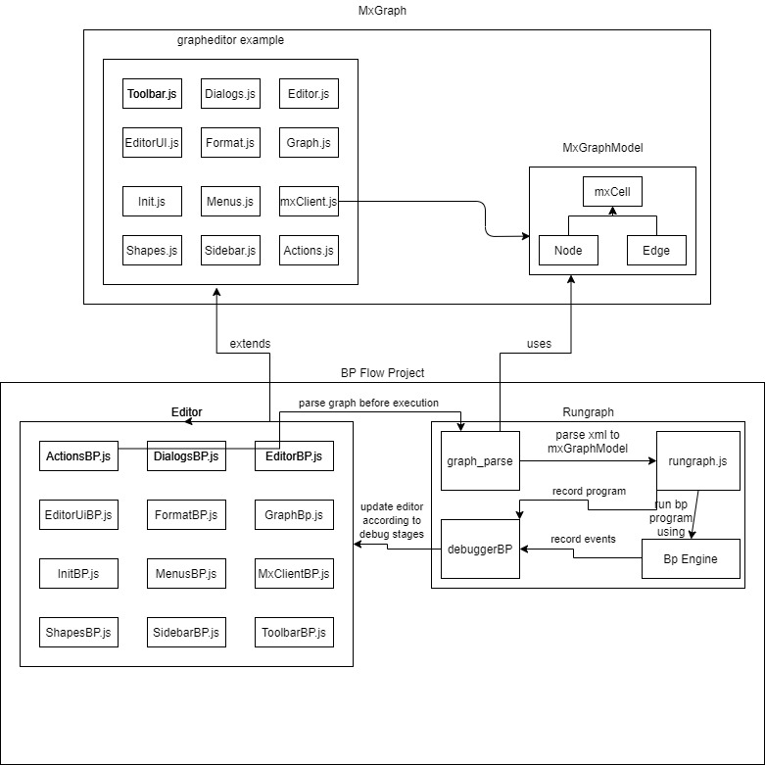

1: MxGraphModel - A graph-like model in the MxGraph repository. Takes every shape and arrow from the graph and converts it into nodes and edges, using the MxCell object as a node\edge accordingly

The editor part of the project is responsible for the graphical additions and changes to MxGraph's "grapheditor" example.

Editor Files:

* **ActionsBP**.js – extends Actions.js of MxGraph. Responsible for defining different actions (Execution, debugging, etc.).
* **DialogsBP**.js – extends Dialogs.js of MxGraph. Responsible for defining dialogs and pop up windows opened (Code editor, Output console, etc.).
* **EditorBP**.js - extends Editor.js of MxGraph.
* **EditorUiBP**.js – extends EditorUi.js of MxGraph.
* **FormatBP**.js – extends Format.js of MxGraph. Responsible for the right-hand menu opened while clicking on a certain graphical object.
* **GraphBP**.js – extends Graph.js of MxGraph.
* **InitBP**.js – A new file(not an extension) some like similar to Init.js of MxGraph, but with the certain definitions and file paths needed for the current project to run correctly.
* **MenusBP**.js – extends Menus.js of MxGraph. Responsible for the upper menu ( File,Edit,View etc.).
* **MxClientBP**.js – extends MxClient.js of MxGraph. The main file which defines the entire MxGraph Model used for parsing diagrams and graphical objects.
* **ShapesBP**.js – extendsShapes.js of MxGraph. Responsible for the graphical objects' behavior.
* **SidebarBP**.js – extends Sidebar.js of MxGraph. Responsible for the left-hand menu where the shapes and graphical objects lie. In order to create a shape, you need to click it \ or drag it from that sidebar.
* **ToolbarBP**.js – extends Toolbar.js of MxGraph. Responsible for the lowest upper toolbar, with the icons. In this toolbar there are default MxGraph actions like undo and zoom in\out, and added actions like execute \ debug.

The RunGraph part of the project is responsible for Executing and Debugging BP Flow programs, which are created according to the syntax of the graphical objects created in the working sheet by the user.

Rungraph Files:

* **Graph_parse.**js – responsible for converting the XML that describes the diagram into a MxGraph Model. When the user clicks the 'Execute' button, the action written in ActionsBP.js which is connected to that button, sends the xml to this file. Then the XML is being transformed into a MxGraph Model, and sent to rungraph.js for execution.
* **Rungraph**.js – Responsible for executing and debugging BP Flow programs. The file holds an interpreter inside, which traverses over the entire graph given by graph_parse (MxGraph Model) and executes actions according to the BP semantics. Each scenario is handled separately. Events selected and String given from Console nodes are written into the console Window ( defined in DialogsBP.js)
* **BPEngine**.js – responsible for registering B threads, selecting events in every bsync point, and continuing bthreads execution according to the BP program flow
* **debuggerBP**.js – responsible for the BP flow debugger definition and functionality. When clicking on the debug button, this file runs the specified BP flow programs and records every step. On every step the debugger saves the state of each scenario's nodes which are relevant to the time of the step, and additionaly writes to the console the events selected in the specific step the debugger is currently on.