BOUNTEOUS MOTORS AI
Vehicle Price Prediction — Model Training Progress Report
Prepared: 2 August 2026

1. Summary
Four regression models — Decision Tree, Random Forest, Gradient Boosting, and XGBoost — were trained and hyperparameter-tuned on the cleaned used-car dataset (6,019 vehicles after cleaning) to predict resale price. A Linear Regression baseline is included for reference. All four target models substantially outperform the linear baseline, with
XGBoost currently the best performer: R² = 0.891 and MAE ≈ KES 192,000 on held-out test data.

2. Data Pipeline
All four models share the same cleaning, feature-engineering, and preprocessing pipeline, so comparisons between them are apples-to-apples:
Stage | What it does
Data loading | Reads used_cars_data.csv (7,253 rows, 14 columns) into a DataFrame with basic sanity checks.
Cleaning | Removes duplicates and unused columns; drops rows with no target price; parses Mileage/Engine/Power out of free-text units; converts USD → KES; imputes missing values (median/mode); standardizes text casing; validates the result.
Feature engineering | Extracts Brand and Model from the car name; computes Car_Age, Kilometers_Per_Year, Power_Per_CC, and a Luxury_Brand flag.
Preprocessing | ColumnTransformer: median imputation + standard scaling for numeric features, most-frequent imputation + one-hot encoding for categorical features.
Model training & tuning | Each candidate model is wrapped in the same preprocessing pipeline and tuned with RandomizedSearchCV (5-fold cross-validation, scored on R²).
Evaluation & selection | Each tuned model is scored on a held-out 20% test split (MAE, RMSE, R²); the pipeline with the best test R² is saved as the deployable artifact.

3. Model Comparison
Each model (except the linear baseline) was tuned with RandomizedSearchCV over a model-specific hyperparameter grid, using 5-fold cross-validation on the training set. Test metrics below are computed on a held-out 20% split the models never saw during tuning.
Model | CV R² | Test R² | Train R² | MAE (KES) | RMSE (KES)
Linear Regression (baseline) | – | 0.4103 | 0.9705 | 451,886 | 1,107,398
Decision Tree | 0.8035 | 0.8193 | 0.9444 | 263,019 | 613,056
Random Forest | 0.8780 | 0.8798 | 0.9731 | 203,690 | 499,946
Gradient Boosting | 0.8850 | 0.8829 | 0.9532 | 233,860 | 493,555
XGBoost — BEST | 0.8945 | 0.8909 | 0.9874 | 192,130 | 476,258
Reading the table:
- CV R² is the average cross-validated score during hyperparameter search (training data only).
- Test R² / MAE / RMSE are computed on the untouched 20% test split — the fairest comparison across models.
- Train R² vs Test R² gives a rough overfitting check; Decision Tree shows the widest gap, as expected for a single unconstrained tree.

4. Best Model: XGBoost
XGBoost was selected automatically by train.py as the model with the highest test R², and its pipeline (preprocessing + tuned model) has been serialized for use by the prediction service.
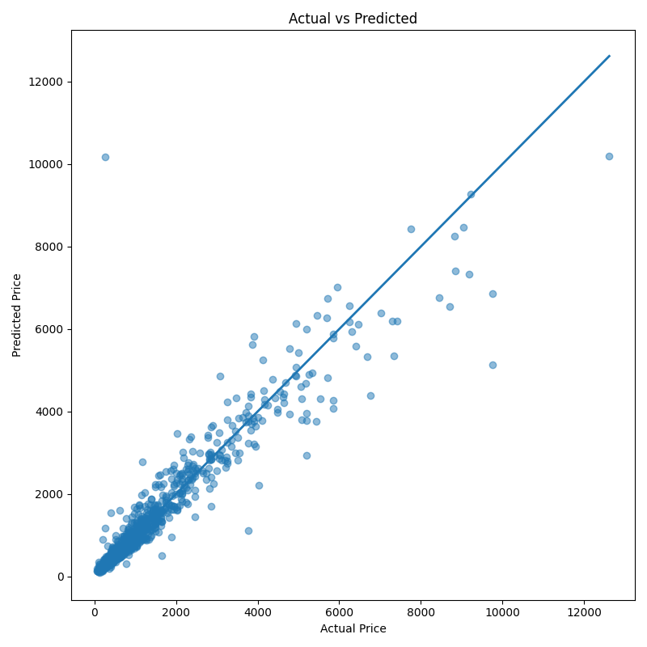
Figure 1. Actual vs. predicted price — best model (XGBoost), test set.
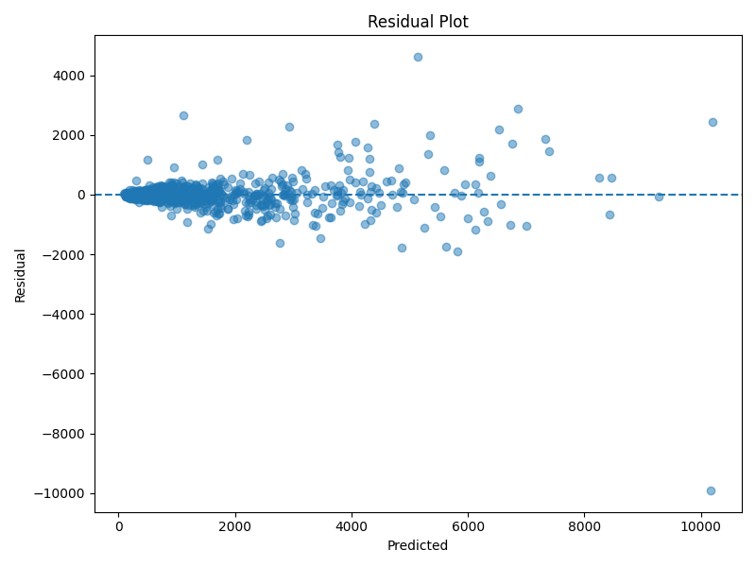
Figure 2. Residuals vs. predicted price — best model (XGBoost), test set.
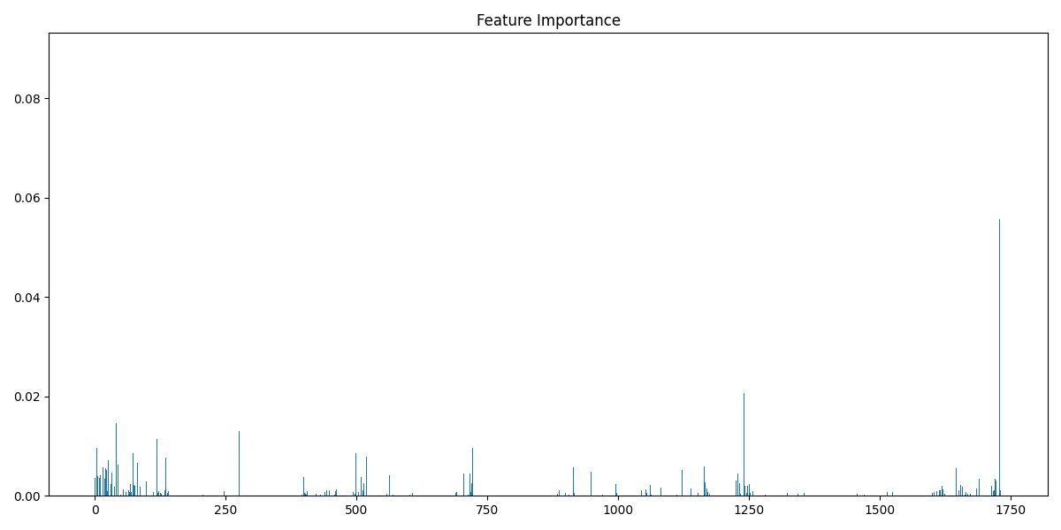
Figure 3. Feature importance — best model (XGBoost).

5. Engineering Notes
While preparing this run, a few issues in the existing codebase were identified and corrected so the pipeline runs end-to-end:
- config.py was missing the METRICS_FILE path that evaluation.py depends on — added.
- model_loader.py and predict.py referenced a module path (ML.src.…) that didn't match the project layout — corrected to relative imports.
- Decision Tree had no hyperparameter grid in tuning.py, so it was training with default settings only — a tuning grid was added.
- One row in the raw dataset has Seats = 0, a data-entry error that bypassed missing-value imputation and failed validation — the cleaning step now treats 0 as missing and imputes it.

6. Next Steps
- Run the full-scale hyperparameter search (5-fold CV × 15 candidates per model, already configured in tuning.py) on a multi-core machine for the production model — this progress check used a lighter search budget to fit the review timeline.
- Wire the saved pipeline into predict.py / the mobile app's inference endpoint for live price predictions.
- Begin integrating the computer-vision component (vehicle condition/damage detection from images) alongside the tabular price model.
- Consider adding SHAP-based explanations (shap is already in requirements.txt) so predictions can show which features drove a given price estimate.

