GILB-003 | ANALYSIS & VERIFICATION
GHANA’S SLEEPING WALLETS • RESEARCH STAGE V1.0 • 11 NOVEMBER 2026
Purpose: establish a reproducible evidence base for the approved third-story subject. This is an initial single-publication analysis, not a final, independently peer-reviewed publication sign-off.

Executive findings
Measure | August 2025 | August 2026
Registered mobile money accounts | 77.7 million | 85.8 million
Active accounts (90-day definition) | 25.1 million | 26.4 million
Not active under the definition | 52.6 million | 59.4 million
Active share of registered accounts | 32.30% | 30.77%
Monthly transactions | 831 million | 1,046 million
Monthly value of transactions | GH¢354.1 billion | GH¢518.8 billion
Principal result: the Bank of Ghana reported 85.8 million registered accounts in August 2026, of which 26.4 million had transacted at least once during the preceding 90 days. Subtraction yields approximately 59.4 million accounts outside that active definition (69.2% of registered accounts).
The numbers describe accounts, NOT unique people, permanent account abandonment, balances held, or reasons for inactivity.

Primary source and reporting period
Bank of Ghana (BoG), Summary of Economic and Financial Data — September 2026, released 23 September 2026. Printed page 13, Table 11, “Payment Systems Data”, subsection “Mobile Money (MM) Data”. Periods: August 2025 through August 2026, in 13 monthly columns.
https://www.bog.gov.gh/wp-content/uploads/2026/09/Summary-of-Economic-and-Financial-Data-September-2026.pdf
Source note 15 defines active mobile money accounts as accounts that transacted at least once in the 90 days prior to reporting. The report warns that data are subject to revision. The Bank’s catalogue listed September 2026 as the latest Summary edition when checked on 11 November 2026.

What was actually checked
1. Located the BoG’s official report and inspected its printed Table 11 directly (including the definitions below the table).
2. Transcribed 13 observations each for registered accounts, active accounts, transaction counts and transaction value, preserving BoG units. The supplied CSV is a transcription, not a direct download of the Bank’s underlying dataset.
3. Checked each period appears once in chronological order, all required numbers are present, and active account counts do not exceed registered accounts.
4. Independently recalculated active proportion, not-active accounts, year-on-year changes and growth using the supplied Python script; tested key arithmetic assertions.
5. Evaluated editorial wording against the 90-day definition and distinguished observed aggregates from user-level behaviour and causal explanations.

Reproducibility
Run from the repository root:
py -3 stories/GILB-003/analysis/reproduce_gilb003.py
Inputs: stories/GILB-003/data/raw/GILB-003_BoG_Table11_2025-08_to_2026-08.csv. Output: stories/GILB-003/analysis/GILB-003_computed_metrics.json. Calculation methods appear in the next section; the Python file contains assertions for headline results.

Detailed calculations
Calculation | Formula using reported rounded values | Result
Active share, Aug 2026 | 26.4 ÷ 85.8 × 100 | 30.77%
Not-active share, Aug 2026 | (85.8 − 26.4) ÷ 85.8 × 100 | 69.23%
Not-active accounts, Aug 2026 | 85.8 − 26.4 | 59.4 million
Not-active accounts, Aug 2025 | 77.7 − 25.1 | 52.6 million
Change in registered accounts | 85.8 − 77.7 | +8.1 million
Change in active accounts | 26.4 − 25.1 | +1.3 million
Change in not-active accounts | 59.4 − 52.6 | +6.8 million
Change in active share | 30.7692 − 32.3037 | −1.53 percentage points
Registered account growth | (85.8 ÷ 77.7 − 1) × 100 | +10.42%
Active account growth | (26.4 ÷ 25.1 − 1) × 100 | +5.18%
All values above use rounded figures printed by the BoG. Do not present these as precise individual-account counts.

The 13-month comparison
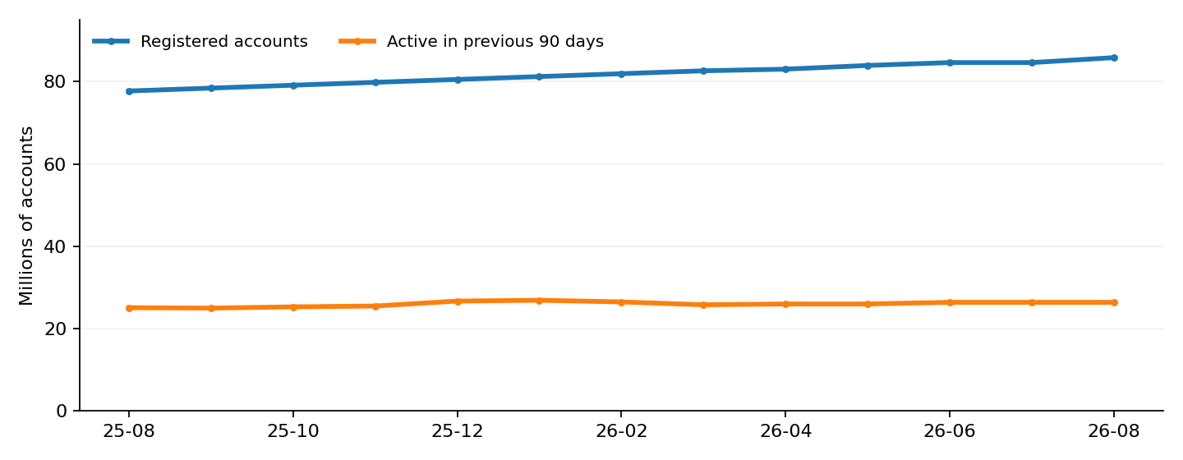
Chart reconstructed from BoG September 2026, Table 11. Registered and active totals refer to different measures; this is not an individual conversion funnel.

Claims audit
Proposed editorial statement | Decision
“About seven in ten registered wallets were not active in the preceding 90 days.” | Supported by the source and arithmetic; explain the 90-day definition.
“Ghana added eight million mobile money users.” | Reject: changes are in registered accounts, not people.
“Six new registrations yielded one new active wallet.” | Reject: aggregate changes are not a cohort conversion rate.
“59 million wallets contain money that is sitting idle.” | Reject: the source does not report balances by inactive-account status.
“Most accounts are permanently abandoned.” | Reject: no inactivity duration beyond the 90-day window is established.
“The gap between registered and 90-day-active accounts increased.” | Supported for the Aug 2025–Aug 2026 comparison; the gap increased about 6.8 million.

Editorial interpretation and limits
The strongest story is not that mobile money is failing; transaction counts and values are large, while registered accounts and the number qualifying as active measure different things. The defensible surprise is how different “registered” and “recently active” look when placed side by side.
The original concept brief’s population-led opening, 86-wallet grid and “six new registrations for every new active account” conversion-like language were reviewed but have not been approved for production. The old draft is retained as a pre-review historical reference, not the current script.
For a short mobile-first animation, consider ten large account symbols with three highlighted to illustrate the rounded 30.8% active share, accompanied by clearly printed exact account totals. Avoid implying each symbol is a person, a real wallet balance, or a tracked customer’s history. Build a look distinct from both previous videos.

Limitations and unresolved checks
• Single-document check: these figures were checked against one official September 2026 publication; historical release-to-release revisions have not yet been audited.
• The active metric uses a rolling 90-day window, not activity occurring strictly within August alone.
• The data are reported to one decimal place in millions/billions, which limits precise implied counts and calculated percentages.
• Registered accounts can include multiple accounts held by one individual; neither 85.8 million nor 26.4 million is a headcount.
• No account-level transitions, balances by activity status, exact account-age distribution or causes of inactivity are provided.
• A later BoG publication may revise historical values. Re-check the source catalogue before final release.
• No ownership or final video publication sign-off is granted by this report.

Reproducible files and next actions
This package contains the primary-source transcription CSV, a standalone calculation script, generated metrics JSON, this editable verification report, a research decision note, and a cautious local registry updater. It does not contain the BoG PDF itself; its permanent URL appears in the source records.
Next: review the evidence and decide the final story hook and visual treatment. Only after editorial approval should we write a recording script and storyboard. The registry entry should remain in Analysis/Research and must not grant evidence or publication approval.

Document provenance
Prepared 11 November 2026 from the BoG September 2026 Table 11 and the earlier Sleeping Wallets concept brief. The analytical methods and derived measures were produced for GilB; external review is encouraged. This is not an independent multi-reviewer audit.

