DATA & EVIDENCE / REPORT 02

GILB-002
Analysis & Verification Report
  - Ghana mobile internet subscriptions • January 2024 – July 2026
Version 2.0 | 8 November 2026 | 31 months | MTN, Telecel, AT

Executive decision
The historical market-share paradox is supported by official National Communications Authority (NCA) subscription tables. All 93 operator-month values in the dataset match the independently re-read NCA source tables. However, explanations for unusual monthly shifts and final human publication approval remain open.
TOTAL MNO SUBSCRIPTIONS | MTN NET ADDITIONS | MTN SHARE CHANGE
30,800,194 in Jul 2026 | +5,673,061 | -1.60 percentage points

Key conclusion
Ghana had 23,247,115 mobile-network data subscriptions in January 2024 and 30,800,194 in July 2026 (+32.49%). MTN grew from 18,973,091 to 24,646,152, yet its share moved from 81.61% to 80.02%. Telecel grew 61.88% in count and increased its share by +2.92 percentage points.
Critical nuance: MTN share bottomed out in June 2025 and then recovered. The January 2024–July 2026 endpoint comparison is valid, but the share did not decline continuously.

Evidence decision
- NCA table-to-data check: 93 / 93 matched, zero discrepancies.
- NCA monthly operator totals: 31 / 31 reconciled.
- No verified causal explanation established for sharp monthly changes.
- Claims are NOT yet approved for publication; full original PDF archive remains pending.

1 Research scope and source register
Research question: How did mobile internet subscriptions and relative operator market shares in Ghana evolve across the available January 2024–July 2026 series?
In scope: monthly active mobile-network data subscriptions as reported for MTN, Telecel and AT by the NCA. Excluded: fixed-line subscriptions, BWA, voice SIMs, unique people, data traffic, revenue, customers switching networks, and explanations not supported by evidence.
ID | NCA source | Coverage / use
S1 | NCA 2024 monthly MNO subscriptions | 2024-01 to 2024-12; 12 months
S2 | NCA 2025 monthly MNO subscriptions | 2025-01 to 2025-12; 12 months
S3 | NCA 2026 monthly MNO subscriptions | 2026-01 to 2026-07; 7 months
S4 | NCA quarterly industry statistical dashboard | Secondary aggregated trend cross-check; Q2 2026
S5 | NCA policy update on revised data bundles, 2 July 2025 | Timeline/context only; not causal proof

2 Acquisition and preservation
- Located the NCA mobile-data publication page and opened the 2024, 2025 and 2026 official PDF tables [S1–S3].
- Selected the Mobile Network Data Operators (MNO) subscription-count row, not “TOTAL DATA SUBSCRIPTION” which includes fixed-line/BWA.
- Recorded month, operator, integer subscription count and source URL. A 2023 link appeared inconsistent and its data were excluded.
- Retained the transcribed CSV as a raw-table snapshot and a normalised 93-row long-form CSV as the analysis dataset.
- Original NCA source PDF files are linked but not stored in this package; downloading and hashing them is an open archive task.

3 Data cleaning and definitions
- Standardise the three operator identities: Scancom PLC = MTN; Ghana Telecommunications Company/Vodafone = Telecel; Airtel Ghana/AirtelTigo = AT.
- Standardise month keys to YYYY-MM-01; one record for each operator-month. Use integer counts; no fractional subscriptions.
- Recompute market shares from counts using the monthly sum of the three MNOs; never copy shares from another denominator.
- Preserve original source URLs and do not modify historical counts to smooth abrupt monthly changes.

4 Source-check and quality controls
A second source transcription was entered from the NCA 2024, 2025 and 2026 primary PDF tables inspected on 8 November 2026. Each of its 93 operator-month values was compared to the cleaned CSV, with differences recorded row by row.
Test | Expected | Result
Dates × operators | 31 × 3 = 93 | PASS — 93 records
Missing or duplicate keys | No missing or duplicates | PASS
Primary source row comparison | 93 source values equal CSV | PASS — 93/93
Monthly totals | 31 operator sums equal NCA TOTAL MOBILE | PASS — 31/31
Publication approvals | No automatic approval | PASS — withheld

A machine-replayable comparison ledger accompanies this report: GILB002_Source_to_Clean_Comparison_93_Rows_v2.csv. Note that the comparison is AI-assisted; an external human review is encouraged before publication.

5 Calculation specification
Measure | Reproducible formula
Total MNO subscriptions | MTN + Telecel + AT in each month
Operator market share | Operator count / same-month MNO total × 100
Net count change | Ending count − beginning count
Count growth (%) | (Ending / beginning − 1) × 100
Share change (pp) | Ending share (%) − beginning share (%)
Share of net industry change | Operator net count change / total net change × 100

Worked MTN example
Net subscriptions: 24,646,152 − 18,973,091 = 5,673,061. Starting share = 18,973,091 / 23,247,115 = 81.61%; ending share = 24,646,152 / 30,800,194 = 80.02%; difference = -1.60 percentage points. Underlying full-precision ratios are used before rounding.

6 Results — market shares over time
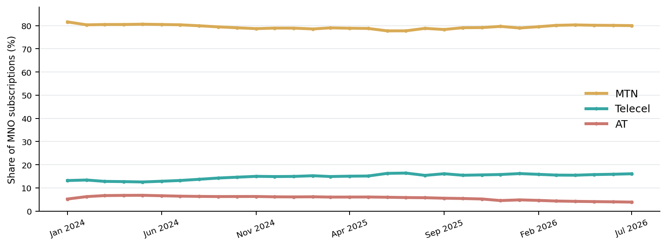
Figure 1. Percent of MNO mobile internet subscriptions. MTN’s June 2025 trough and later recovery are important to interpreting the endpoint comparison.
Operator | Jan 2024 share | Jul 2026 share | Change (pp)
MTN | 81.61% | 80.02% | -1.60
Telecel | 13.18% | 16.10% | +2.92
AT | 5.21% | 3.88% | -1.33

Finding: MTN remains dominant at about four in five subscriptions. Its share is slightly lower than in January 2024, while Telecel’s share increased. This does NOT establish any direct movement of subscribers between providers.

7 Results — absolute counts
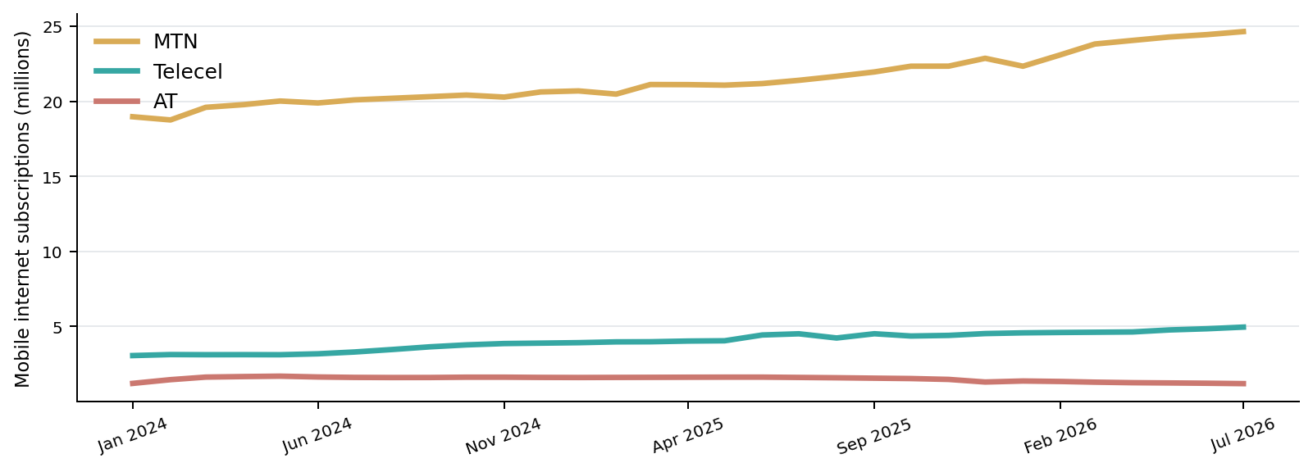
Figure 2. Monthly subscription counts (millions), not distinct individuals.

8 Operator growth and comparisons
Operator | Jan 2024 | Jul 2026 | Change | Growth (%)
MTN | 18,973,091 | 24,646,152 | +5,673,061 | +29.90%
Telecel | 3,063,868 | 4,959,805 | +1,895,937 | +61.88%
AT | 1,210,156 | 1,194,237 | -15,919 | -1.32%

Telecel grew much faster proportionally (61.88%) than MTN (29.90%), while MTN added far more subscriptions in absolute terms. “Largest net count gain” and “fastest percentage growth” are different measures.

9 Date-window sensitivity
Window | MTN start share | MTN end share | Change (pp)
2024-01 → 2026-07 | 81.61% | 80.02% | -1.60
2025-06 → 2026-07 | 77.75% | 80.02% | +2.27
2025-12 → 2026-07 | 79.68% | 80.02% | +0.34

The long-window net decline and recovery from June 2025 are both true. The video must show the complete share trend, not depict an uninterrupted slide. Avoid framing the endpoint difference as proof that MTN “lost millions of customers.”

10 Unusual month-on-month changes
Operator / month | Change | What we can conclude
Telecel • Jun 2025 | +385,538 / +9.52% | Published count movement; cause unverified
Telecel • Aug–Sep 2025 | −279,842 then +283,016 | Published reversal; cause unverified
AT • Dec 2025 | −173,037 / −11.73% | Published count movement; cause unverified
MTN • Jan 2026 | −527,881 / −2.31% | Published count movement; cause unverified

The NCA confirmed revised data bundle allocations taking effect around July 2025 [S5]. This is relevant historical context but cannot be presented as the cause of any monthly change without additional evidence.

11 Claims ledger and publication limits
ID | Claim | Status
F01 | Total subscriptions +7,553,079 (+32.49%) | Source-checked; human sign-off pending
F02 | MTN +5,673,061; share −1.60 pp | Source-checked; human sign-off pending
F03 | Telecel +61.88% in count | Source-checked; human sign-off pending
F04 | MTN share trough June 2025 ~77.75% | Source-checked; human sign-off pending
H01 | Why Telecel, AT or MTN moved sharply | Unexplained; no causal claim allowed

12 External verifier’s reproducibility checklist
- Download original NCA reports [S1–S3]; retain files, access dates and file hashes.
- Inspect the MNO rows and confirm all 93 monthly operator counts using the attached CSV comparison ledger.
- Recompute all 31 published TOTAL MOBILE figures from the three operator rows.
- Recompute shares, growth and net changes using the documented formulas, not rounded input shares.
- Confirm displayed axis scales, time window, units and wording on the final video storyboard.
- Sign off each on-screen claim and citation separately before approving publication.

13 Editorial recommendation and release gates
Working angle: “MTN added 5.7 million mobile internet subscriptions — so why did its share edge down?” Explain the mathematics through Telecel’s faster percentage growth, then show MTN’s mid-2025 dip and later recovery. This remains a proposed angle, not final narration.
- Original NCA PDF binaries archived: OPEN.
- External human reviewer approves exact figures and wording: OPEN.
- Causes of unusual monthly movements: OPEN; do not use causal claims.
- Editorial angle and narration: NOT YET APPROVED.

Sources and data dictionary
[S1] NCA 2024 monthly MNO subscriptions | 2024-01 to 2024-12; 12 months
https://nca.org.gh/wp-content/uploads/2025/06/Market-Data-2024.pdf
[S2] NCA 2025 monthly MNO subscriptions | 2025-01 to 2025-12; 12 months
https://nca.org.gh/wp-content/uploads/2026/02/Data-Subscription-December-2025.pdf
[S3] NCA 2026 monthly MNO subscriptions | 2026-01 to 2026-07; 7 months
https://nca.org.gh/wp-content/uploads/2026/10/Monthly-Industry-Data_July_2026-.pdf
[S4] NCA quarterly industry statistical dashboard | Secondary aggregated trend cross-check; Q2 2026
https://statisticaldashboard.nca.org.gh/
[S5] NCA policy update on revised data bundles, 2 July 2025 | Timeline/context only; not causal proof
https://nca.org.gh/2025/07/02/update-2-mnos-begin-implementation-of-directives-on-improved-data-bundle-allocations/

Data dictionary
Column | Meaning / allowed values
story_id | Permanent GILB-002 registry ID
month | YYYY-MM-01, monthly snapshot
operator | MTN | Telecel | AT (normalised names)
subscriptions | Integer active MNO mobile internet subscriptions
market_share | Operator subscriptions ÷ month’s MNO total (fraction 0–1)
market_segment | Mobile-network data subscriptions only
source_url | Direct NCA original report URL
data_status | Provenance and reconciliation notes

File lineage and version history
Research dataset v1 → independent NCA cross-check v2 → row-by-row verification CSV → this v2 Word and Markdown report → human review and publication approval (pending). Prior reports and data remain preserved for comparison.
Audit scope: source-table accuracy and calculation reproduction, not customer-level validation or an independently audited NCA data-collection process.

