DB2日志模板 参照说明



北京睿至大数据有限公司2017年10月18日

目录

1 说明 3

1.1 日志样例 3

1.2 字段映射列表 3

1.3 日志源格式配置 4

1.4 日志解析方式 4

2 其它 4

2.1 其它 4

2.2 略 4

# 说明

DB2日志包含以下日志：

1. DB2 Diag
2. DB2 ……

## DB2 Diag日志样例

2017-09-16-00.24.28.736094+480 I1E1668 LEVEL: Event

PID : 110054 TID : 140116206548768 PROC : db2flacc

INSTANCE: db2inst1 NODE : 000

HOSTNAME: svr17.bj.raysdata

FUNCTION: DB2 UDB, RAS/PD component, pdLogInternal, probe:120

START : New Diagnostic Log file

DATA #1 : Build Level, 232 bytes

Instance "db2inst1" uses "64" bits and DB2 code release "SQL10053"

with level identifier "0604010E".

Informational tokens are "DB2 v10.5.0.3", "s140203", "IP23551", Fix Pack "3".

DATA #2 : System Info, 664 bytes

System: Linux svr17.bj.raysdata 6 2 x86_64

CPU: total:4 online:4 Cores per socket:2 Threading degree per core:1 SIMD:Y

CPU binding: not in use

Physical Memory(MB): total:15938 free:162

Virtual Memory(MB): total:23954 free:8178

Swap Memory(MB): total:8016 free:8016

Kernel Params: msgMaxMessageSize:65536 msgMsgMap:65536 msgMaxQueueIDs:31868

            msgNumberOfHeaders:65536 msgMaxQueueSize:65536

            msgMaxSegmentSize:16 shmMax:68719476736 shmMin:1 shmIDs:4096

            shmSegments:4096 semMap:32000 semIDs:128 semNum:32000

            semUndo:32000 semNumPerID:250 semOps:32 semUndoSize:20

            semMaxVal:32767 semAdjustOnExit:32767

Cur cpu time limit (seconds) = 0xFFFFFFFFFFFFFFFF

Cur file size limit (bytes) = 0xFFFFFFFFFFFFFFFF

Cur data size (bytes) = 0xFFFFFFFFFFFFFFFF

Cur stack size (bytes) = 0x0000000100000000

Cur core size (bytes) = 0xFFFFFFFFFFFFFFFF

Cur memory size (bytes) = 0xFFFFFFFFFFFFFFFF

nofiles (descriptors) = 0x0000000000100000

## 字段映射列表

|  |  |  |
| --- | --- | --- |
| **字段名** | **类型** | **内容** |
| @timestamp | Date | 2017-09-16-00.24.28.736 |
| hostname | Text | svr17 |
| instance | Text | db2inst1 |
| record_id | Text | I1E1668 |
| pid | Text | 110054 |
| tid | Text | 140116206548768 |
| proc | Text | db2flacc |
| node | Text | 000 |
| msg | Text | START : New Diagnostic Log fileDATA #1 : Build Level, 232 bytesInstance "db2inst1" uses "64" bits and DB2 code release "SQL10053"with level identifier "0604010E".Informational tokens are "DB2 v10.5.0.3", "s140203", "IP23551", Fix Pack "3".DATA #2 : System Info, 664 bytesSystem: Linux svr17.bj.raysdata 6 2 x86_64CPU: total:4 online:4 Cores per socket:2 Threading degree per core:1 SIMD:YCPU binding: not in usePhysical Memory(MB): total:15938 free:162Virtual Memory(MB): total:23954 free:8178Swap Memory(MB): total:8016 free:8016Kernel Params: msgMaxMessageSize:65536 msgMsgMap:65536 msgMaxQueueIDs:31868 msgNumberOfHeaders:65536 msgMaxQueueSize:65536 msgMaxSegmentSize:16 shmMax:68719476736 shmMin:1 shmIDs:4096 shmSegments:4096 semMap:32000 semIDs:128 semNum:32000 semUndo:32000 semNumPerID:250 semOps:32 semUndoSize:20 semMaxVal:32767 semAdjustOnExit:32767Cur cpu time limit (seconds) = 0xFFFFFFFFFFFFFFFFCur file size limit (bytes) = 0xFFFFFFFFFFFFFFFFCur data size (bytes) = 0xFFFFFFFFFFFFFFFFCur stack size (bytes) = 0x0000000100000000Cur core size (bytes) = 0xFFFFFFFFFFFFFFFFCur memory size (bytes) = 0xFFFFFFFFFFFFFFFFnofiles (descriptors) = 0x0000000000100000 |
| function | Text | DB2 UDB, RAS/PD component, pdLogInternal, probe:120 |
| level | Text | Event |

## 日志源格式配置

|  |  |
| --- | --- |
| **db2_diag_default_log_format** | **zeta_log_fields** |
| %t %ri %l %pid %tid %p %i %n %h %fun %m |  |
| %t | @timestamp |
| %h | hostname |
| %i | instance |
| %ri | record_id |
| %pid | pid |
| %tid | tid |
| %p | proc |
| %n | node |
| %m | msg |
| %fun | function |
| %l | level |

## 日志解析方式

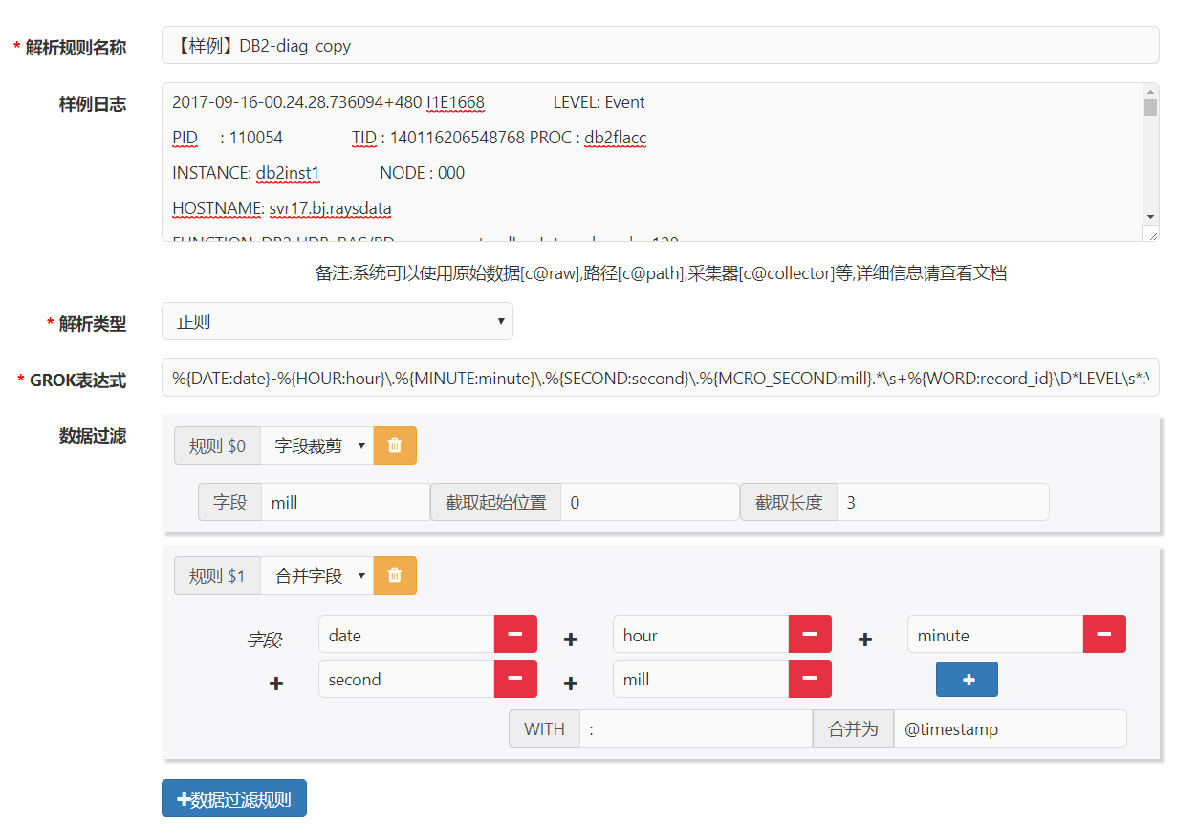

**GROK表达式：**

%{DATE:date}-%{HOUR:hour}\.%{MINUTE:minute}\.%{SECOND:second}\.%{MCRO_SECOND:mill}.*\s+%{WORD:record_id}\D*LEVEL\s*:\s*%{WORD:level}\D*PID\s*:\s*%{WORD:pid}\D*TID\s*:\s*%{WORD:tid}\D*PROC\s*:\s*%{WORD:proc}\D*INSTANCE\s*:\s*%{WORD:instance}\D*NODE\s*:\s*%{WORD:node}\D*HOSTNAME\s*:\s*%{WORD:hostname}\D*FUNCTION\s*:\s*%{DATA:function}\n%{ALL:msg}

# DB2 ……

## 其它

## 略