Oralce日志模板参照说明



北京睿至大数据有限公司2017年10月31日

目录

说明 3

1.1 Oracle Listener日志样例 3

1.2 Oracle Listener日志字段映射列表 3

1.3 Oracle Listener日志源格式配置 4

1.4 日志解析方式 4

2 Oracle …… 4

2.1 其它 4

2.2 略 4

# 说明

Oracle 相关日志包含以下几种：

1. Oracle Listener
2. Oracle ……

## Oracle Listener日志样例

12-OCT-2016 19:57:39 * service_update * WAREHOUS * 0

12-OCT-2016 19:58:28 * (CONNECT_DATA=(SID=WAREHOUS)(CID=(PROGRAM=perl@DRTEST)(HOST=DRTEST)(USER=oracle))) * (ADDRESS=(PROTOCOL=tcp)(HOST=10.10.161.14)(PORT=42242)) * establish * WAREHOUS * 0

12-OCT-2016 19:59:12 * (CONNECT_DATA=(CID=(PROGRAM=)(HOST=DRTEST)(USER=oracle))(COMMAND=services) (ARGUMENTS=64)(SERVICE=(DESCRIPTION=(ADDRESS=(PROTOCOL=TCP)(HOST=DRTEST)(PORT=1521)))) (VERSION=186646784)) * services * 0

## Oracle Listener日志字段映射列表

|  |  |  |
| --- | --- | --- |
| **字段名** | **类型** | **内容** |
| @timestamp | Date | Wed Oct 12 19:57:39 CST 2016 |
| return_code | Text | 0 |
| instance | Text | WAREHOUS |
| event | Text | service_update |
| connect | Text | (CONNECT_DATA=(SID=WAREHOUS)(CID=(PROGRAM=perl@DRTEST)(HOST=DRTEST)(USER=oracle))), (CONNECT_DATA=(CID=(PROGRAM=)(HOST=DRTEST)(USER=oracle))(COMMAND=services)(ARGUMENTS=64) (SERVICE=(DESCRIPTION=(ADDRESS=(PROTOCOL=TCP)(HOST=DRTEST)(PORT=1521))))(VERSION=186646784)) |
| address | Text | (ADDRESS=(PROTOCOL=tcp)(HOST=10.10.161.14)(PORT=42242)) |

## Oracle Listener日志源格式配置

|  |  |
| --- | --- |
| **oracle_listener_default_log_format** | **zeta_log_fields** |
| %t * %rc * %i * %e * %co * %a |  |
| %t | @timestamp |
| %rc | return_code |
| %i | instance |
| %e | event |
| %co | connect |
| %a | address |

## 日志解析方式

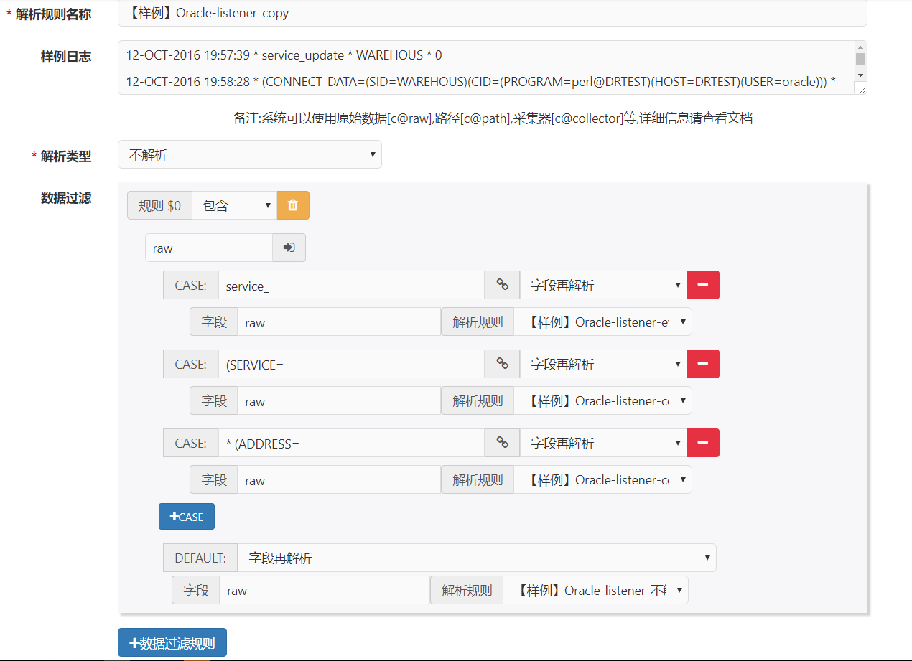

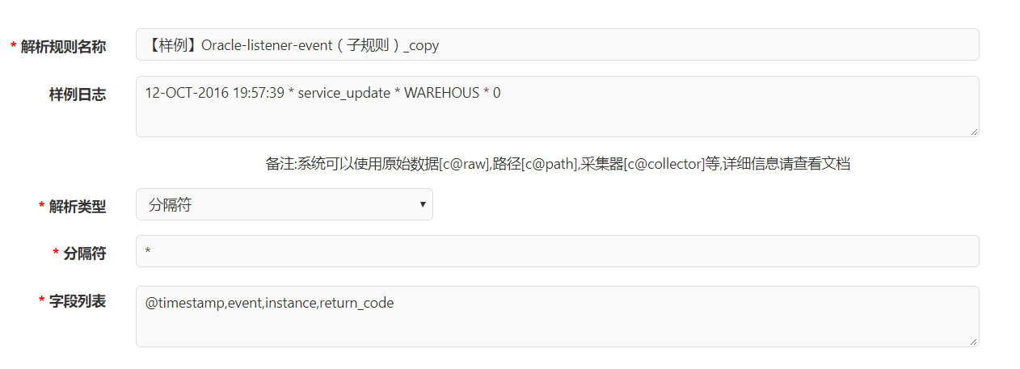

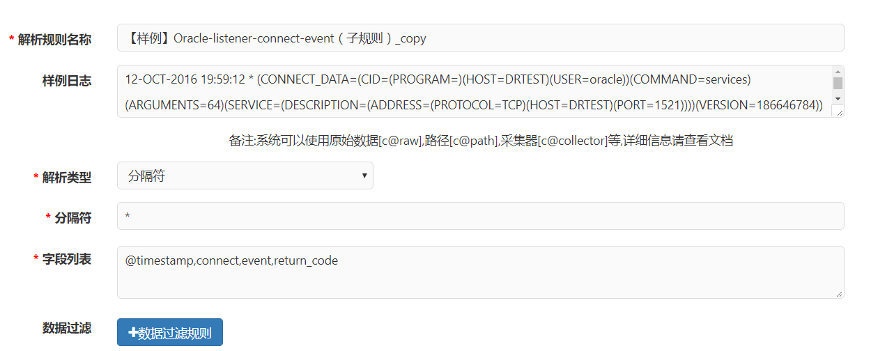

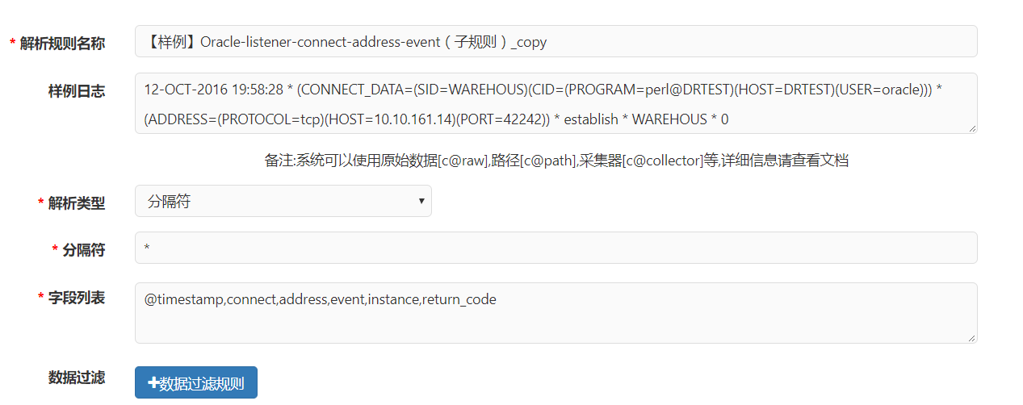

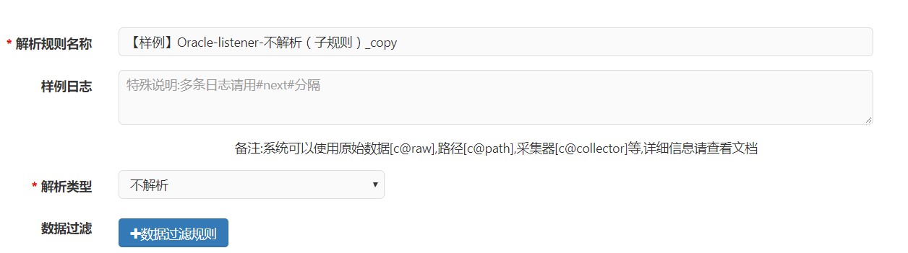

# Oracle ……

## 其它

## 略