WAS日志模板参照说明



北京睿至大数据有限公司2017年10月31日

目录

说明 3

1.1 WAS SystemOut日志样例 3

1.2 WAS SystemOut日志字段映射列表 3

1.3 WAS SystemOut日志源格式配置 4

1.4 WAS SystemOut日志解析方式 4

2 WAS …… 4

2.1 其它 4

2.2 略 4

# 说明

WAS日志包含以下几种：

1. WAS SystemOut
2. WAS ……

## WAS SystemOut日志样例

[10/10/17 15:36:15:526 CST] 00000045 webapp I com.ibm.ws.webcontainer.webapp.WebApp log SRVE0292I: Servlet Message - [IBM Cognos#p2pd.war]:.cfgss: Adding class library file:/opt/ossinsight/JazzSM/profile/installedApps/JazzSMNode01Cell/IBM Cognos.ear/p2pd.war/WEB-INF/lib/ags.jar

## WAS SystemOut日志字段映射列表

|  |  |  |
| --- | --- | --- |
| **字段名** | **类型** | **内容** |
| @timestamp | Date | 10/10/17 15:36:15:526 CST |
| event_type | Text | I |
| msg | Text | com.ibm.ws.webcontainer.webapp.WebApp log SRVE0292I: Servlet Message - [IBM Cognos#p2pd.war]:.cfgss: Adding class library file:/opt/ossinsight/JazzSM/profile/installedApps/JazzSMNode01Cell/IBM Cognos.ear/p2pd.war/WEB- INF/lib/ags.jar |
| thread_id | Text | 00000045 |
| thread_name | Text | webapp |

## WAS SystemOut日志源格式配置

|  |  |
| --- | --- |
| **was_SystemOut_default_log_format** | **zeta_log_fields** |
| [%t] %thi %thn %et %m |  |
| %t | @timestamp |
| %thi | thread_id |
| %thn | thread_name |
| %et | event_type |
| %m | msg |

## WAS SystemOut日志解析方式

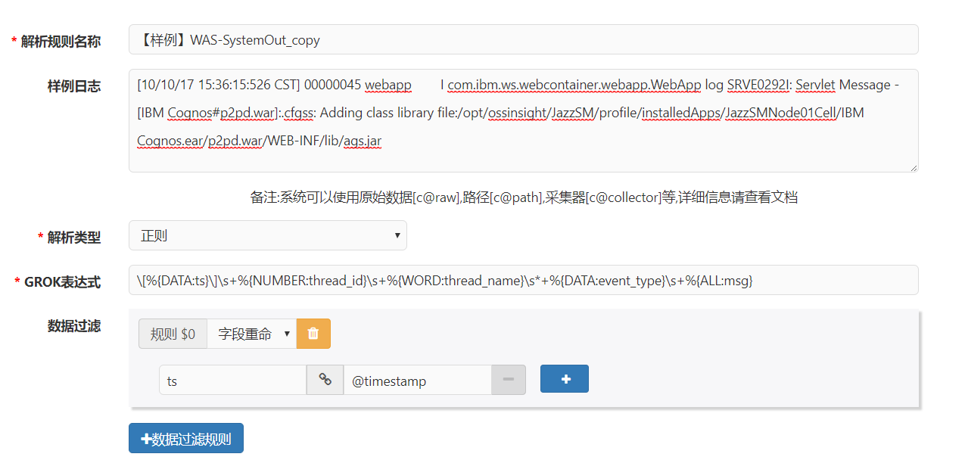

**GROK表达式：**

\[%{DATA:ts}\]\s+%{NUMBER:thread_id}\s+%{WORD:thread_name}\s*+%{DATA:event_type}\s+%{ALL:msg}

# WAS ……

## 其它

## 略