EcoWatt Solutions
Business Plan
Smart Energy Monitoring System
Prepared by: EcoWatt Solutions
Date: October 31, 2025
Location: Lagos, Nigeria

Table of Contents
1. Executive Summary
2. Company Overview
3. Market Analysis
4. Product / Service Description
5. Marketing Plan
6. Operations & Management
7. Financial Plan
8. Risk Analysis & Mitigation
9. Growth Strategy
10. Conclusion
Appendix

1. Executive Summary
EcoWatt Solutions develops and markets an IoT-based Smart Energy Monitoring System designed for households, small businesses, and institutions across Nigeria and later, the African market. Our system provides real-time energy consumption monitoring, AI-powered insights, and practical recommendations to reduce energy waste and lower electricity costs. EcoWatt aims to bridge the information gap many users have about their energy consumption and to deliver measurable savings through actionable data.
Business Highlights:
- Product: Smart energy monitoring device + mobile/web application.
- Market: Urban households, SMEs, and institutions.
- Revenue Model: Device sales, subscription services, installation and maintenance fees.
- Funding Need: ₦5,000,000 initial investment for product development, pilot testing, and market entry.
Key Objectives:
- Launch a working pilot within 6 months.
- Acquire 1,000 paying customers in Year 1 and scale to 6,000 by Year 3.
- Achieve break-even within the first 18 months and deliver net margins around 25% by Year 3.

2. Company Overview
Company Name: EcoWatt Solutions
Legal Structure: Private Limited Liability Company to be registered in Nigeria.
Location: Headquartered in Lagos with plans for regional distribution hubs.
Ownership: Founders (technical co-founder and business co-founder), with equity reserved for early investors and key hires.
Mission: To empower individuals and organizations to make data-driven decisions that save energy and protect the environment.
Vision: To be Africa’s leading provider of smart energy management technologies by 2030.

3. Market Analysis
Industry Overview:
The global smart energy management market is expanding due to rising energy costs, increased adoption of renewable energy, and a heightened focus on sustainability. In Nigeria, unreliable power supply and rising tariffs increase the demand for technologies that help users optimize usage and manage backup systems like inverters and solar installations.
Target Market Segments:
- Urban Households: Middle-income families in cities who want to lower their monthly energy bills and monitor inverter/solar usage.
- Small and Medium Enterprises (SMEs): Shops, offices, and hospitality businesses that need to manage operating costs.
- Institutions: Schools, clinics, and small hospitals seeking cost control and system reliability.
Market Size & Opportunity:
While exact figures vary, there are millions of urban households and tens of thousands of SMEs across major Nigerian cities. Increasing smartphone penetration and interest in energy savings create a strong market opportunity for a localized, affordable solution.
Competitor Analysis:
Competitor | Product | Strengths | Weaknesses
Generic Smart Plug Brands | Smart plugs & basic energy monitors | Low cost, widely available | Limited accuracy, no localized analytics
Imported Smart Meter Solutions | Advanced meters, utility-grade | High accuracy, established tech | Expensive, hard to integrate with local inverters
Local Electrical Installers | Manual meter readings & advice | On-ground presence | No automated analytics or scalable software

SWOT Analysis:
Strengths | Localized product design, affordable pricing, AI analytics, mobile-first UX.
Weaknesses | Initial manufacturing scale, brand recognition early-stage, reliance on internet connectivity for cloud features.
Opportunities | Growing demand for energy management, potential partnerships with solar companies, expansion across West Africa.
Threats | Imported cheap devices, regulatory changes, currency fluctuation affecting component costs.

4. Product / Service Description
Product Components:
- Hardware: A compact IoT sensor module that clamps onto the main incoming cable or is installed at the consumer unit. It measures voltage, current, power factor and communicates via Wi-Fi/GSM to the cloud.
- Software: Mobile app (iOS/Android) and web dashboard with real-time monitoring, historical reports, appliance-level estimates, and AI-driven suggestions.
- Services: Installation, optional maintenance subscription, and analytics reporting for energy audits.
Technical Details:
The device uses a low-power microcontroller with ADC for accurate current sensing, an energy measurement IC for power calculations, and secure TLS communication to the cloud. Edge processing allows local alerting even when internet connectivity is intermittent.
Key Features:
- Real-time kWh and cost tracking
- Usage breakdown by time-of-day
- Alerts for abnormal consumption or potential faults
- Integration with solar inverter telemetry and battery status
- Energy-saving suggestions and scheduling
Product Roadmap:
- Month 1–3: Hardware prototyping and MVP app.
- Month 4–6: Pilot testing with 50 users, collect data and refine algorithms.
- Month 7–12: Manufacturing setup, marketing launch, and scaling distribution.
- Year 2: Add B2B features, deeper analytics, and expand to regional markets.

5. Marketing Plan
Market Positioning:
EcoWatt positions itself as an affordable, reliable, and locally-adapted energy monitoring solution.
Marketing Mix (4Ps):
Product: Smart energy monitor with mobile app, installation and subscription options.
Price: Device priced at ₦30,000 with an optional premium analytics subscription at ₦2,000/month.
Place: Direct sales via website, partnerships with electronics retailers and solar installers.
Promotion: Digital campaigns, influencer partnerships, referral programs, and community workshops.
Customer Acquisition Strategy:
- Digital advertising targeting homeowners and small business owners.
- Partnerships with inverter and solar vendors to sell the device as a bundled offering.
- Pilot program incentives and testimonials to build trust.
- Local installers trained and certified to provide installation and after-sales support.
Retention Strategy:
- Offer a free basic app with premium features behind a subscription.
- Regular energy reports and personalized tips to keep users engaged.
- Loyalty discounts for referrals and multi-site business customers.

6. Operations & Management
Operational Plan:
Manufacturing will start with small-batch local assembly using outsourced PCB fabrication and component sourcing. Quality checks will be performed at assembly and prior to shipment. Installation teams will be contracted initially and transitioned to in-house teams as the business scales.
Management Team:
- CEO/Business Lead: Oversees strategy, partnerships, and finance.
- CTO/Product Lead: Hardware and software development.
- Head of Operations: Manufacturing, logistics, and installation.
- Marketing Lead: Customer acquisition and branding.
Additional hires include customer support, sales agents, and field technicians.
Key Partnerships:
- PCB manufacturers and electronic distributors.
- Solar and inverter dealers for joint marketing.
- Local installation contractors and certified electricians.
- Cloud service provider for data storage and analytics.

7. Financial Plan
Startup Costs (one-time):
Item | Cost (₦)
Hardware prototype & testing | 2,000,000
App & cloud development | 1,500,000
Marketing & branding | 500,000
Office & operations (initial) | 1,000,000
Total Initial Investment: ₦5,000,000
Revenue Model and Assumptions:
- Device price: ₦30,000
- Variable (production + installation) cost per unit: ₦12,000
- Premium monthly subscription: ₦2,000
- Year 1 units (conservative): 1,000
- Growth assumptions: Year 2 = 3,000 units, Year 3 = 6,000 units.
Projected Financials (3 Years):
Year | Units Sold | Revenue (₦) | COGS (₦) | Gross Profit (₦) | OPEX (₦) | Net Profit (₦)
1 | 1,000 | 30,000,000 | 12,000,000 | 18,000,000 | 8,000,000 | 10,000,000
2 | 3,000 | 90,000,000 | 36,000,000 | 54,000,000 | 12,000,000 | 42,000,000
3 | 6,000 | 180,000,000 | 72,000,000 | 108,000,000 | 18,000,000 | 90,000,000

Break-even Analysis:
- Fixed/Startup costs: ₦5,000,000
- Contribution per unit (Price - Variable cost): ₦18,000
- Break-even units = Fixed costs / Contribution per unit = 5,000,000 / 18,000 ≈ 277.78
- Rounded break-even units = 278 units.
Cash Flow Considerations:
Maintain a 3-6 month cash buffer to handle component lead times, customer refunds, and warranty obligations. Early revenues should be reinvested to fund manufacturing scale-up.

Projected Revenue vs Net Profit:
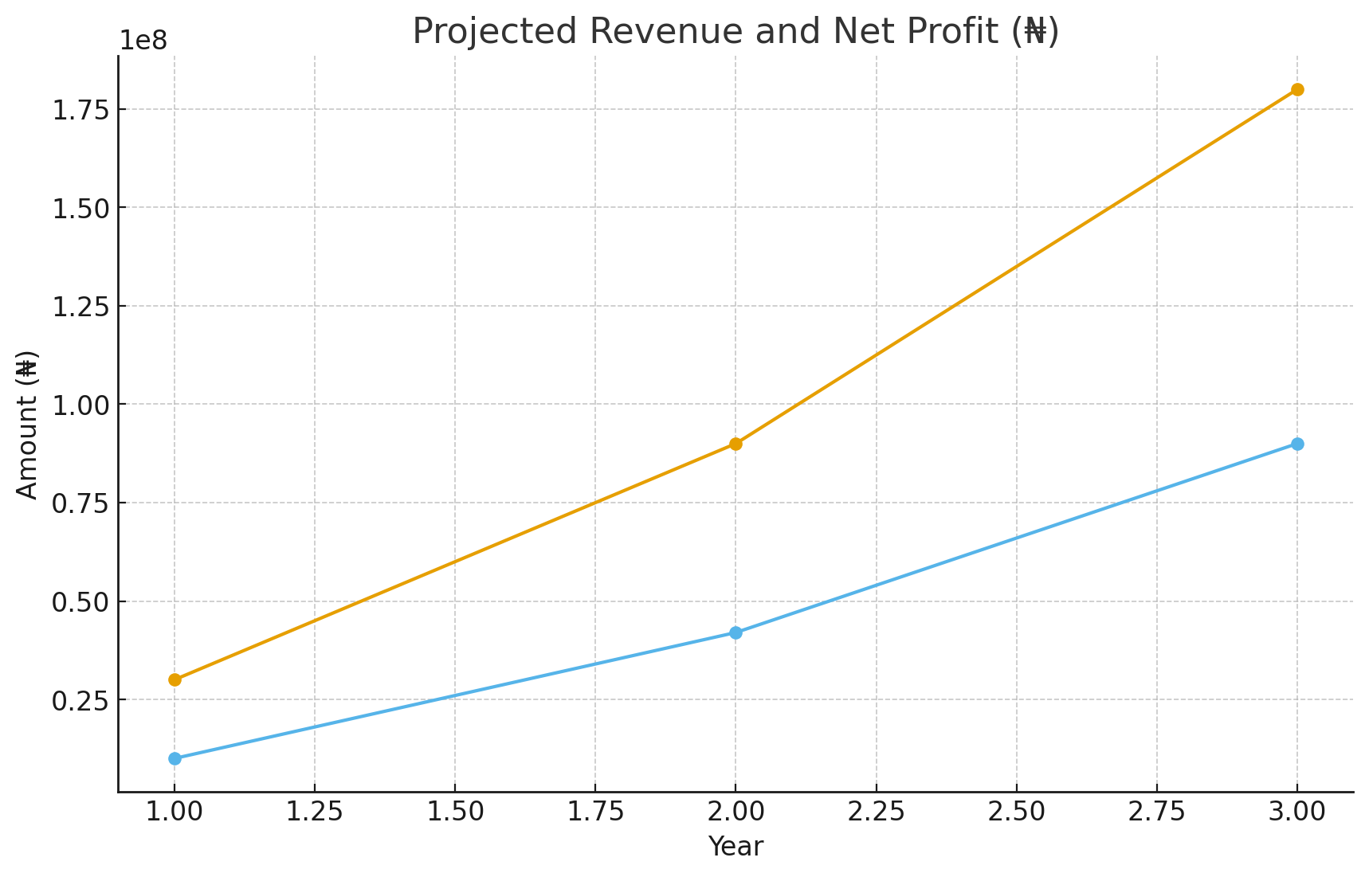

8. Risk Analysis & Mitigation
- Supply Chain Disruption: Maintain multiple suppliers, order critical components early, and keep safety stock.
- Regulatory Changes: Engage with local regulators early and ensure device compliance with local electrical standards.
- Currency Fluctuation: Negotiate local currency contracts where possible, and price products with margins that absorb short-term swings.
- Technical Failures: Invest in rigorous testing, a clear warranty policy, and quick-response field service teams.
- Market Acceptance: Pilot with testimonials, offer strong customer support, and price competitively for local markets.

9. Growth Strategy
Short-term (Year 1): Focus on product-market fit through pilot programs and initial customer acquisition in Lagos and Abuja.
Medium-term (Year 2): Expand distribution to other major cities, establish partnerships with solar and inverter companies, and introduce B2B analytics products.
Long-term (Year 3+): Enter neighboring West African countries, diversify product line (commercial-grade monitors), and explore partnerships with utilities and government programs.

10. Conclusion
EcoWatt Solutions offers a timely and practical solution to a widespread problem: energy inefficiency and opaque consumption patterns. With a solid product, a focused go-to-market plan, and prudent financial management, EcoWatt is well-positioned to capture market share and deliver value to customers while driving sustainable energy use across the region.

Appendix
Additional details, technical specifications, and pilot test plans are available on request. Contact: info@ecowattsolutions.ng

