Software Requirements Specification

for

COSC2299 Major Project 2023

Version 1.0 approved

Prepared by

James Czeredys – s3900781

Ned Pearson - s3844470

Rita Lam Cordeiros- 3947881

Raphael Bullen - s3897844

Yash Dhukate - s3898134

Yiqi (Gilbert) Du - s3665887

RMIT

August 2023

Table of Contents

______________________________________________

1. Introduction

1.1 Purpose

1.2 Intended Audience and Reading Suggestions

1.3 Product Scope

1.4 References

2. Overall Description

2.1 Product Perspective

2.2 Product Functions

2.3 User Classes and Characteristics

2.4 Design and Implementation Constraints

2.5 Assumptions and Dependencies

3. External Interface Requirements

3.1 User Interfaces

4. System Features

5. Other Nonfunctional Requirements

5.1 Performance Requirements

5.2 Security Requirements

5.3 Software Quality Attributes

6. Scrum Artifacts

Appendix A: Analysis Models

# Introduction

## Purpose

By giving customers a solid platform to quickly find the best offers for the things they want to buy, our solution, SuperPrice, is intended to create a website that combines product prices from numerous retail outlets, making it simple for consumers to compare prices and find the best deals. We also provide a delivery service, allowing our customers to have their chosen products delivered to them.

## Intended Audience and Reading Suggestions

This document is intended for developers as well as our product owner. This SRS document contains all our wireframes, user stories and planning. It is organized based around the table of contents above. It is recommend reading this document in order or going through the relevant sections based on the table of contents above.

## Product Scope

SuperPrice provides a single platform which allows users to have a cohesive online shopping experience which combines searching, comparing and purchasing into one service.

## References

Template of SRS:

Copyright © 1999 by Karl E. Wiegers. Permission is granted to use, modify, and distribute this document.

# Overall Description

## Product Perspective

This product is an entirely new, self-contained system. It does not follow-on member of a product family, or a replacement for certain existing systems.

## Product Functions

* Specific product search, display price options for searched items
* View products in chosen category/categories
* Order delivery of products
* Notification/alert system

## User Classes and Characteristics

This software can be widely used by any group of people who have internet access, especially for the following group of people:

* Young people who do not have much time to do the physical shopping.
* Elderly who are not capable of physical shopping.
* People with physical impairments that may hinder their shopping ability.
* People who are trying to maximise the use of their money by shopping for the cheapest products.

## Design and Implementation Constraints

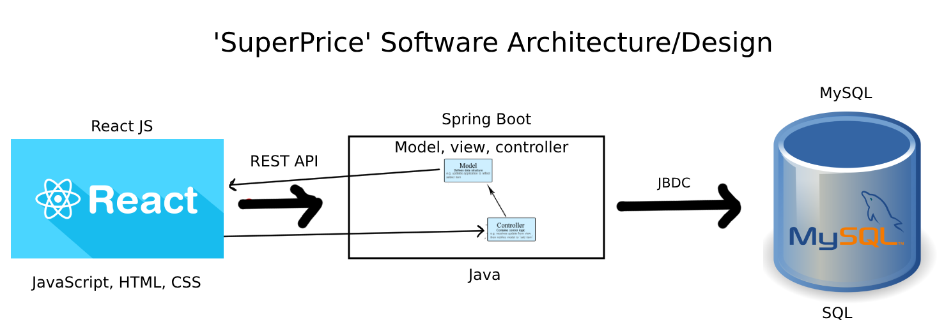

## Assumptions and Dependencies

The App is developed based on JDK version 17 with the dependency's versions listed below:

**REACT (FRONT-END) DEPENDINCES**

testing-library/jest-dom : “^5.17.0"

testing-library/react: "13.4.0"

testing-library/user-event: “^13.5.0"

react: “^18.2.0"

react-dom: “^18.2.0"

react-router-dom: “^6.15.0”

react-scripts: “5.0.1"

web-vitals: "^2.1.4"

**SPRING BOOT (BACK-END) DEPENDENCES**

spring-boot-starter-parent

spring-boot-starter-web

spring-boot-starter-test

h2

spring-boot-starter-jdbc

spring-boot-maven-plugin

# External Interface Requirements

## User Interfaces

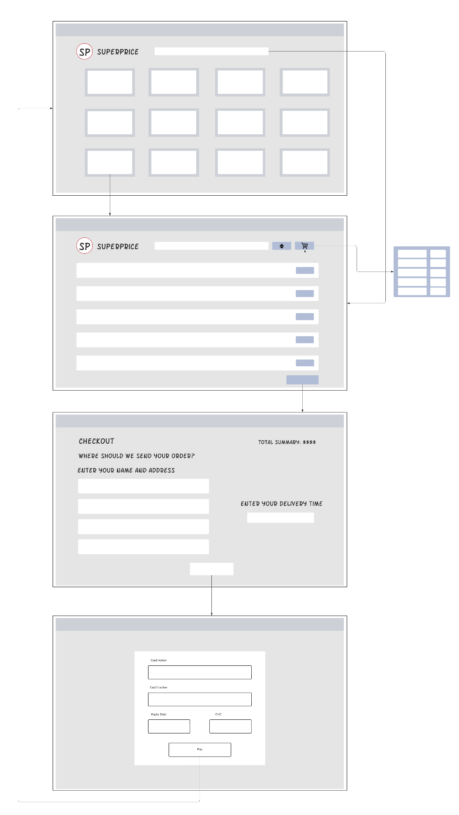

# System Features

|  |  |  |  |
| --- | --- | --- | --- |
| **Story 1:** | Search feature | **Priority** | 1 |
| **Effort** | 9 |
| As a | Online Shopper | | |
| I want | to be able to use a search feature | | |
| So that I can | view specific products | | |
| Acceptance criteria | **Criterion i:**  **Given that I am on the home page of the SuperPrice**  **When I enter a search query in the search bar and press enter**  **Then I should see a list of products matching the search on the results page in a clear and organized manner such that information such as the product name, image, prices and description is visible.**  **Criterion ii:**  **Given that I have entered a search that does not return any results**  **When I preform the search**  **Then the system should display a message indicating that no matching products were found**  **Criterion iii:**  **Given that I am entering a search query in the search bar**  **When I start typing, auto-suggestions should appear**  **Then I can click on one of the autosuggestions so that I can quickly search for a product**  **Criterion iv:**  **Given that I am on the results page**  **When I click on a product**  **Then the system should present all items in a format that prominently displays the product name, location, and price, ensuring clear visibility and easy comprehension** | | |

|  |  |  |  |
| --- | --- | --- | --- |
| **Story 2:** | Category feature | **Priority** | 1 |
| **Effort** | 9 |
| As a | Online Shopper | | |
| I want | to be able to search by category | | |
| So that I can | efficiently browse and discover products that align with my interests and needs | | |
| Acceptance criteria | **Criterion i:**  **Given that I am on the home page of the SuperPrice**  **When I click on one of the available categories**  **Then the system should display all the items associated as well as the prices**  **Criterion ii:**  **Given that products of the category are displayed**  **When I click on one of the available products**  **Then the system should present all items in a format that prominently displays the product name, location, and price, ensuring clear visibility and easy comprehension** | | |

|  |  |  |  |
| --- | --- | --- | --- |
| **Story 3:** | Price Sort feature | **Priority** | 3 |
| **Effort** | 6 |
| As a | Online Shopper | | |
| I want | sort the results based on price | | |
| So that I can | efficiently browse and discover products that fit my price budget | | |
| Acceptance criteria | **Criterion i:**  **Given that I have obtained some result from my search**  **When I view the result page**  **Then the system sound present all items in a format that prominently displays the product name, location, and price, ensuring clear visibility and easy comprehension**  **Criterion ii:**  **Given that I have obtained some result from my search**  **When I click on a sort by button**  **Then the system should display all the items sorted the way I want it either from high to low, or low to high allowing me to compare prices and find the cheapest store** | | |

|  |  |  |  |
| --- | --- | --- | --- |
| **Story 4:** | Shopping Cart Feature | **Priority** | 2 |
| **Effort** | 7 |
| As a | Online Shopper | | |
| I want | A shopping cart feature | | |
| So that I can | Add all the products I am searching for, making it convenient to manage and finalise my purchases | | |
| Acceptance criteria | **Criterion i:**  **Given that I am browsing products on the system**  **When I find a product, I want to purchase**  **Then there should be a clear and easily accessible "Add to Cart" button or icon displayed with the product.**  **Criterion ii:**  **Given that I have added products to my shopping cart,**  **When I click on the shopping cart icon or navigate to the cart page,**  **Then I should see a detailed list of all the products I have added, including their names, quantities, and prices.**  **Criterion iii:**  **Given that I am viewing the contents of my shopping cart,**  **When I want to adjust the quantity of a product or remove it,**  **Then the system should provide options to increase, decrease, or delete items, updating the cart total accordingly.**  **Criterion iv:**  **Given that I am viewing the contents of my shopping cart,**  **When I am satisfied with my selections,**  **Then I should have the ability to proceed to checkout, initiating order placement process.** | | |

|  |  |  |  |
| --- | --- | --- | --- |
| **Story 5:** | Delivery service feature | **Priority** | 2 |
| **Effort** | 7 |
| As a | Online Shopper | | |
| I want | SuperPrice to offer a delivery service | | |
| So that I can | Have my groceries delivered to my doorstep | | |
| Acceptance criteria | **Criterion i:**  **Given that I have finished adding all my products**  **When I am ready to place the delivery**  **Then I should see a delivery option that allows me to select having the groceries delivered to my doorstep.**  **Criterion ii:**  **Given that I have selected the delivery option for doorstep delivery**  **When I proceed with the checkout process and confirm my order**  **Then I should receive confirmation that my groceries will be delivered to my specified address.**  **Criterion iii:**  **Given that I have finished adding all my products to the cart**  **When I finished with entering my details**  **Then the system should also ask me if when I want the delivery to be made** | | |

|  |  |  |  |
| --- | --- | --- | --- |
| **Story 6:** | Notification feature | **Priority** | 3 |
| **Effort** | 6 |
| As a | Online Shopper | | |
| I want | SuperPrice to deliver notifications and alerts | | |
| So that I can | Be informed about price drops and special offers | | |
| Acceptance criteria | **Criterion i:**  **Given that I have selected a product**  **When there is a cheaper alternative available**  **Then the system should send a notification or alert on the platform's interface**  **Criterion ii:**  **Given that I the system has sent a notification**  **When I have viewed it**  **Then I should have the option of closing it** | | |

# Other Nonfunctional Requirements

## Performance Requirements

Pages should be loaded quickly. When a user clicks a button, the corresponding action should be executed with little delay to minimise the time waiting for the user.

Searches should be executed quickly, and results should be displayed in a timely manner. Efficient methods to access/sort the data, such as using specific SQL queries instead of creating algorithms in the backend/frontend, should be used to reduce strain on the server and to provide search results in a shorter time to the software user.

## Security Requirements

The software should be protected against SQL injection attacks. These pose a threat from users potentially using their own SQL queries or commands by using certain characters in a field that would be used to query the database (potential for deletion or illegal data access), such as the search bar. To prevent this, either a blacklist (block certain characters) or a whitelist (allow certain characters) should be used to ensure no unintended SQL queries can be executed.

## Software Quality Attributes

The software should provide a seamless experience for the end user. The software should be easy to navigate and understand. Colour choices should be made to ensure all elements are visible and clear for users.

Interface elements should be easy to identify and interact with. They should also be in intuitive locations to make the flow of the software easy to follow.

The software will be set up using maven, which can be used for automated testing when building the project. This will ensure any changes made do not break the existing codebase.

## 6. Scrum Artifacts

Product Backlog, Sprint 1 Backlog, and Sprint 2 Backlog viewable on GitHub board: <https://github.com/orgs/cosc2299-sept-2023/projects/62>

**Sprint 0 Retro**

|  |  |  |
| --- | --- | --- |
| What Went Well? | What didn’t Go Well? | What Can be Improved? |
| Team collaboration – first time most members have worked with each other | Database clarification received was not timely | Assign tasks more specifically ahead of time |
| Frequent team meeting and attendance | Client interaction – did not provide as much guidance as expected | Unify team members vision of product |
| Work finished timely and with high quality |  |  |

Appendix A: Analysis Models

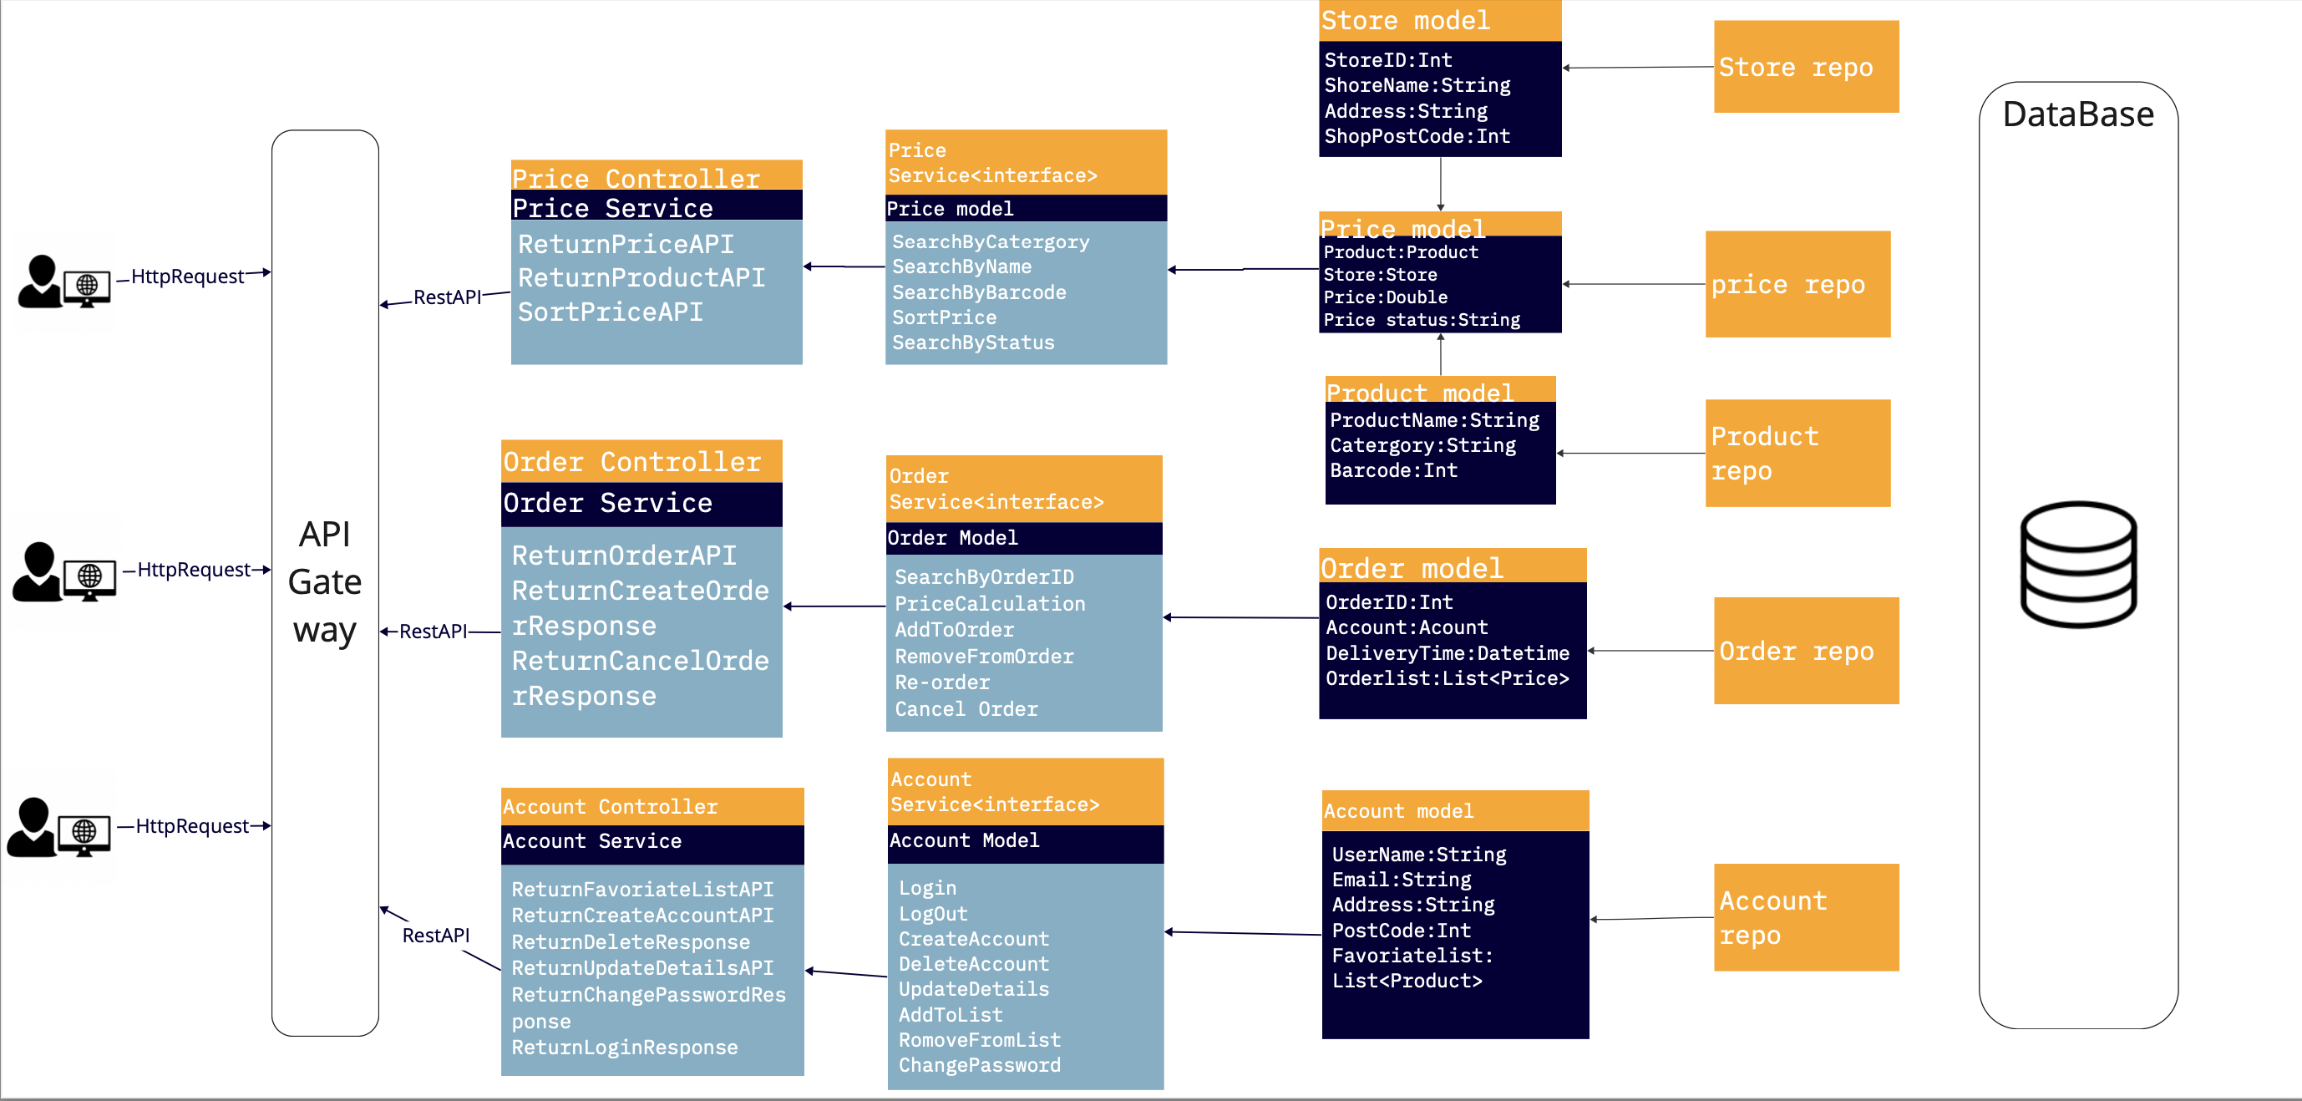

Class Diagram

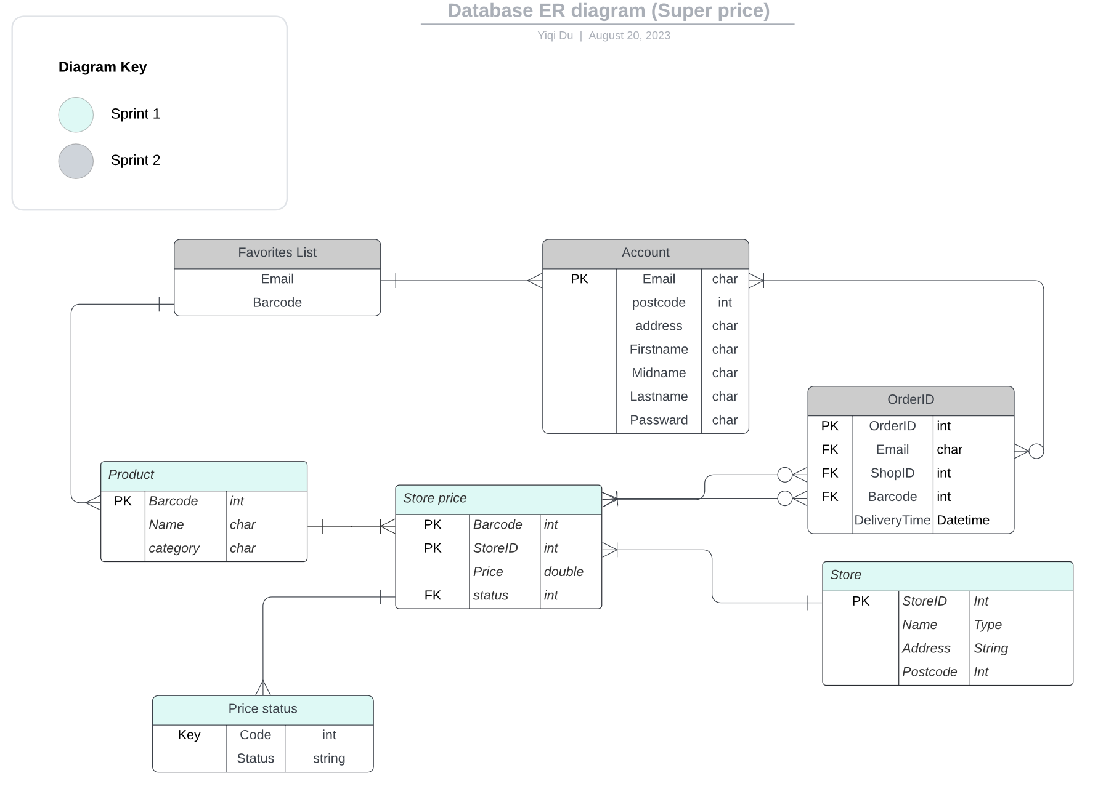

Entity-relationship diagram