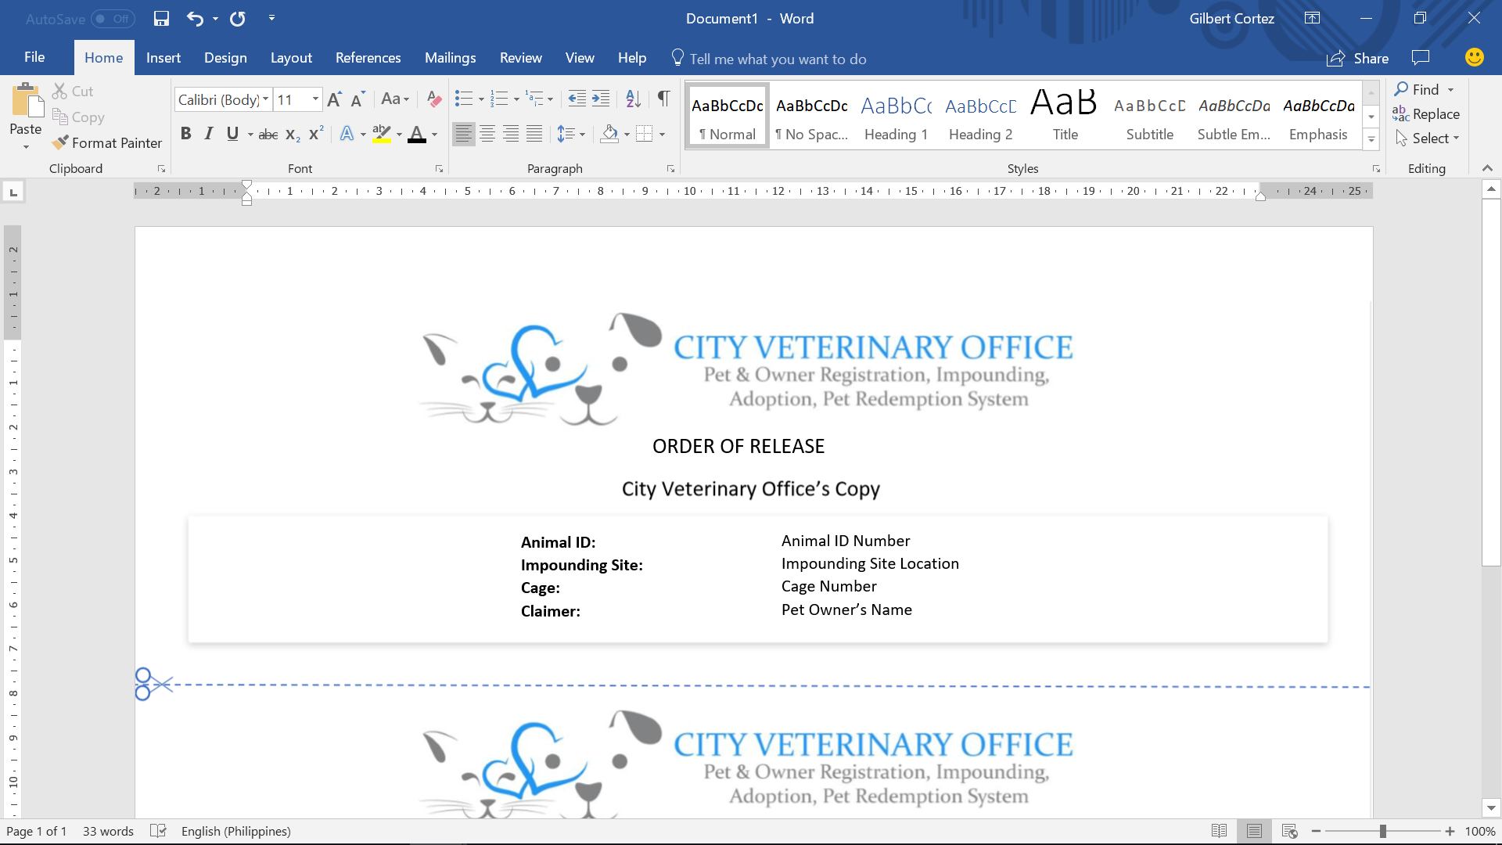

**Apprehension ID:**

**Apprehension Date:**

**Barangay Involved:**

#1

01/23/2018

Concepcion & Sto. Nino

Chief’s Operations Copy

ORDER OF APPREHENSION