**Spectral Separability Analysis and NDBI for Guwahati city**

Source: Landsat 9 – OLI – TIR – Collection 2 Tier 1

Date of Capture: 2022/12/09

Raster Info:

Columns and Rows: 688, 656

Bands: Band 3 Visible (0.53 - 0.59 µm) 30-m

Band 4 Red (0.64 - 0.67 µm) 30-m

Band 5 Near-Infrared (0.85 - 0.88 µm) 30-m

Cell Size: 30,30 (Spatial Resolution)

Pixel Characteristics: Unsigned 16-bit integer (Radiometric)

No Data Value: 0,0,0

Spatial Reference:

XY coordinate system: WGS_1984_UTM_Zone_46N

Datum: D_WGS_1984

ROI: Extent

Top: 2904399.56946

Left: 366190.422611

Right: 386830.422611

Bottom: 2884719.56946

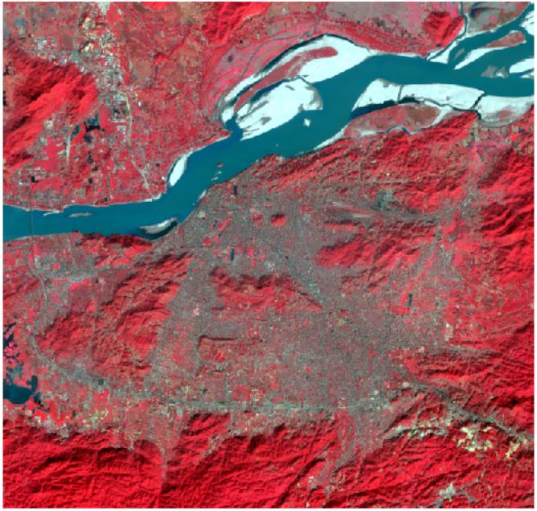ROI in FCC:

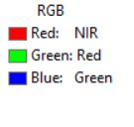

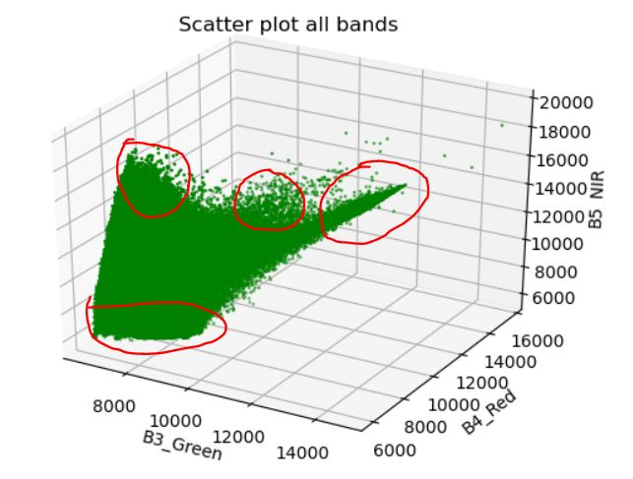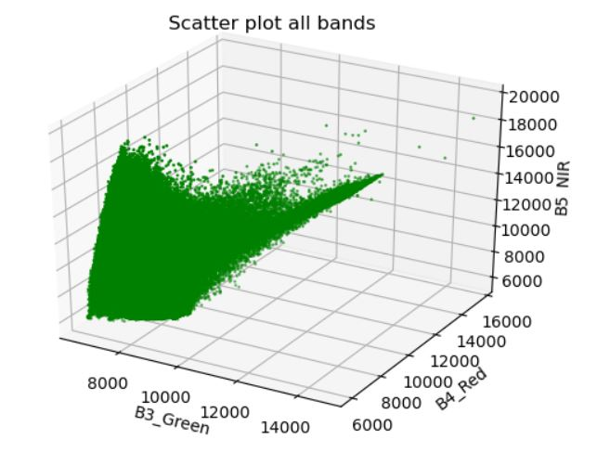**Scatter Plot of the bands of ROI:**

The 3D plot of the pixel values of the imagery with Band 3, Band 4, Band 5 of landsat 9 OLI sensor is made with GDAL module and by converting bands to numpy array and then using matplotlib to display it. From the above plot It is observed that there are four visible cluster of pixel group in the region. Hence the minimum class that can be extracted from the imagery is four classes. The plotting ipynb and the corresponding files are attached at the end of the report in the annexure.

Plotting out band vs band of pixel values would give more detailed insight on the imagery.

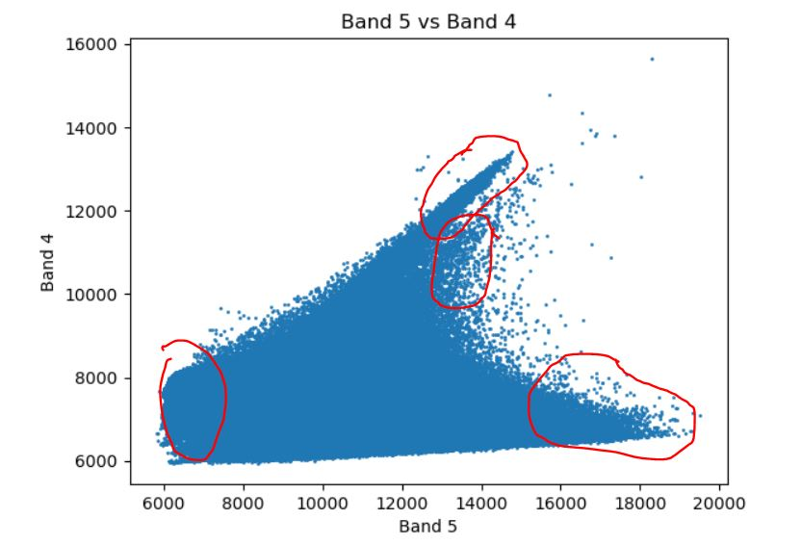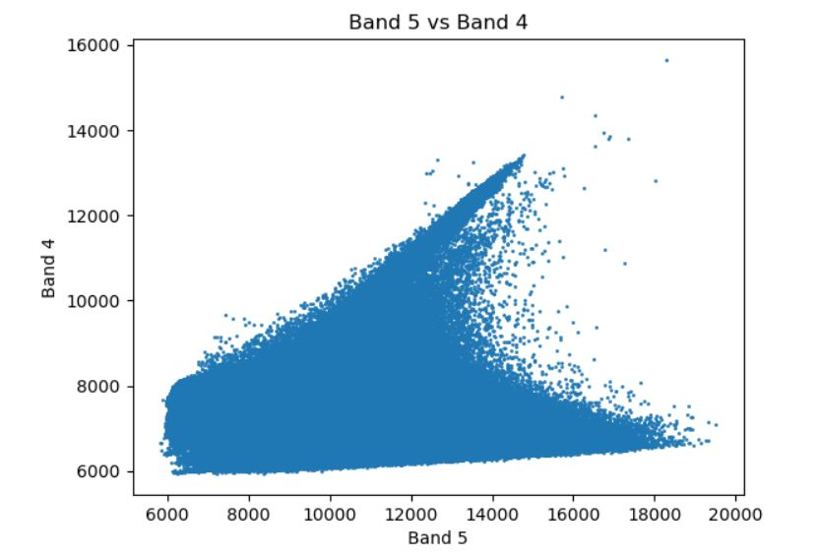**Band 5 vs Band 4**

From plotting Band 4 vs Band 5 it is observed that, there are definitely four distinct class that could be identified and classified.

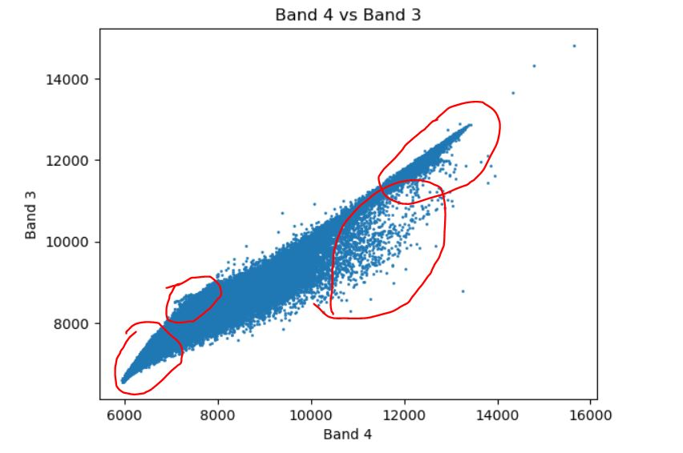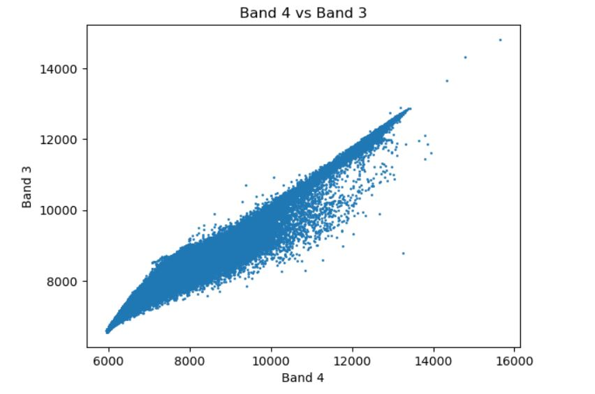**Band 4 vs Band 3**

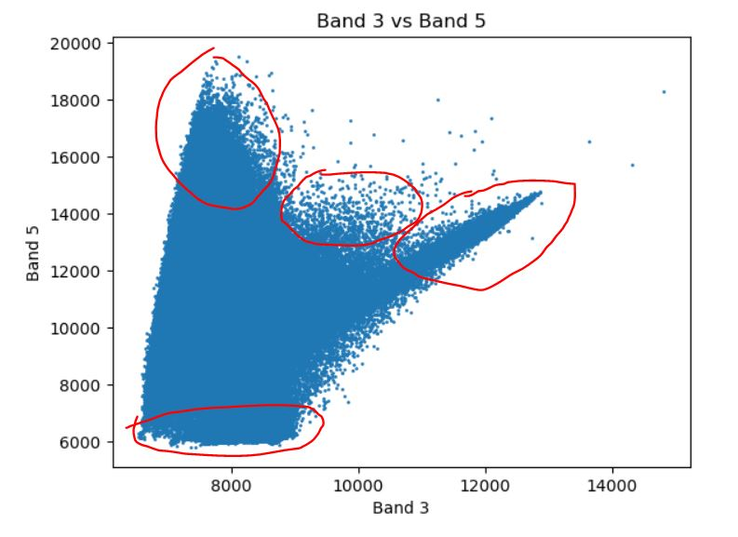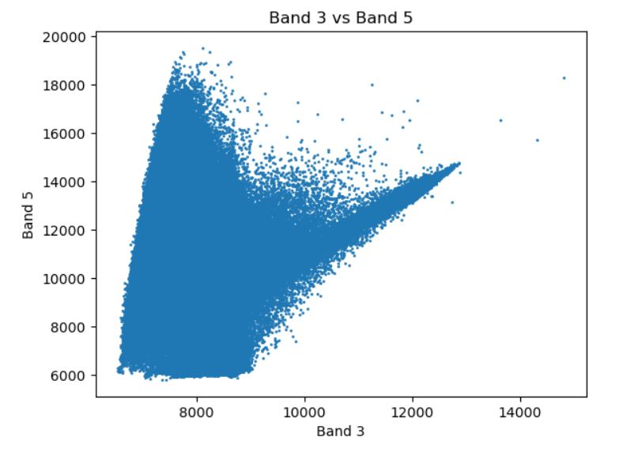**Band 3 vs Band 5**

From the above plotting it is inferred that, there appears four distinct clusters of pixel which could be classified as distinct features. Hence creating a training set of four visually interpretted features could reveal much more about the classification.

**Training set:**

Creating a training set using classification toolbar in ARCMAP 10.8. Four to five samples are drawn for each class and then combined together for diversification.

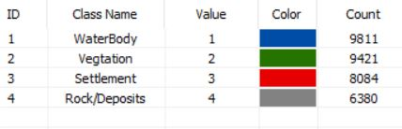

Now visualising the pixels of the training sample could help in verifying the cluster identification for classification.

*Band 5 vs Band 4*

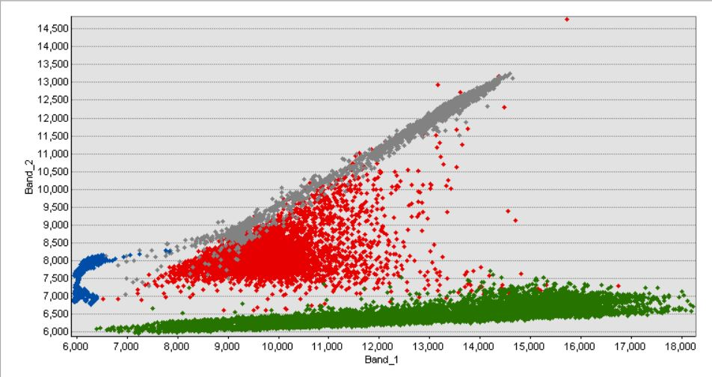

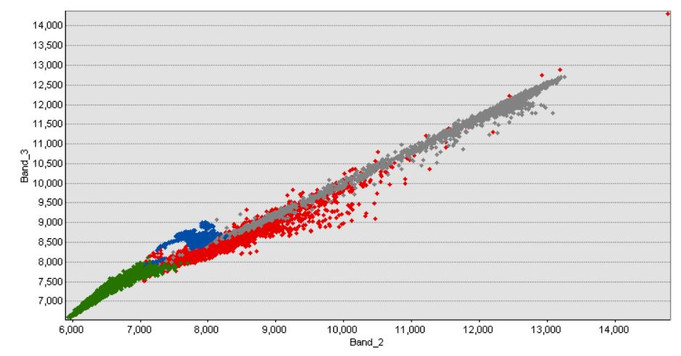*****Band 4 vs Band 3*

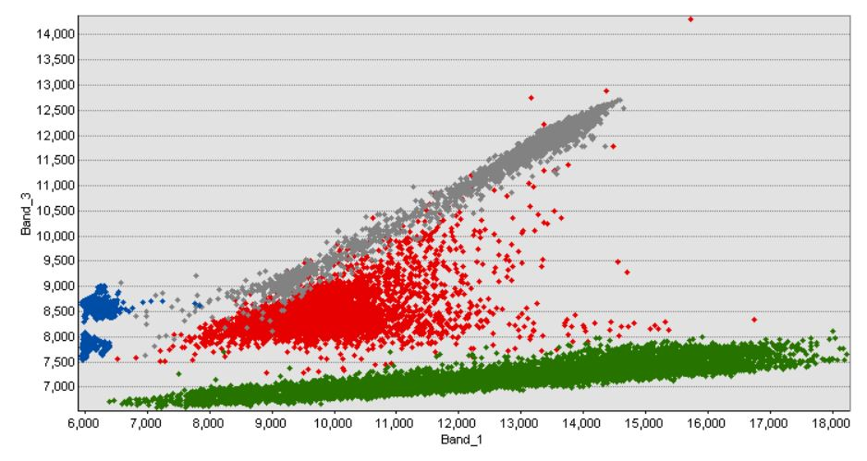*Band 3 vs Band 5*

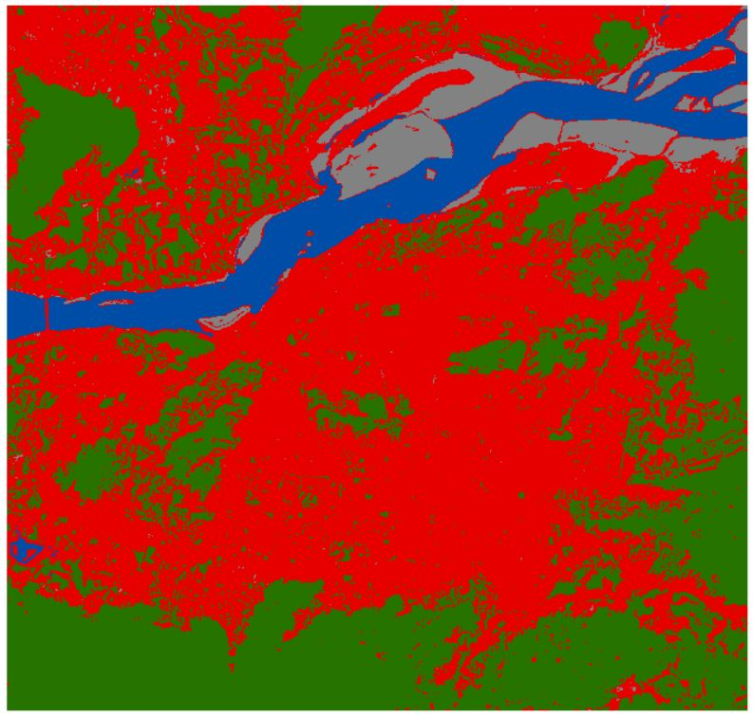Above plotting shows that the identified clusters distinctly defines the fetaures. Hence a supervised classification with these training set is performed in ARCMAP and the classified image is shown below.

From the above classified image the settlement class clearly borders out the Guwahati City and its surrounding settlements in red color.

**Normalised Difference Building Index (NDBI):**

NDBI is given by the normalised difference between short wave infrared and near infrared bands pixel value. Hence

NDBI = (SWIR – NIR)/(SWIR + NIR)

NDBI for the region of interest is calculated in google earth engine and view it here <https://code.earthengine.google.com/993e864cccdf4b22523360fc37657c92>

Get a peek into the earth engine app : [guwahatindbi (earthengine.app)](https://johnson220898.users.earthengine.app/view/guwahatindbi)

Annexure:

assignment1.ipynb

*#!/usr/bin/env python*

*# coding: utf-8*

*# In[1]:*

*from osgeo import gdal as gd*

*import matplotlib.pyplot as plt*

*import numpy as np*

*# In[2]:*

*data_set = gd.Open(r'imageries/guwahati/guw.tif')*

*#print(data_set.RasterCount)*

*band_1 = data_set.GetRasterBand(1)*

*band_2 = data_set.GetRasterBand(2)*

*band_3 = data_set.GetRasterBand(3)*

*b1 = band_1.ReadAsArray()*

*b2 = band_2.ReadAsArray()*

*b3 = band_3.ReadAsArray()*

*#print(b1)*

*# In[21]:*

*fig = plt.figure()*

*ax = fig.add_subplot( projection='3d')*

*ax.scatter(b3, b2, b1, c=['g'],s=1)*

*ax.set_zlabel('B5_NIR')*

*ax.set_ylabel('B4_Red')*

*ax.set_xlabel('B3_Green')*

*ax.set_title('Scatter plot all bands')*

*plt.show()*

*# In[18]:*

*def scatplot(b1,b2,st):*

*plt.scatter(b1,b2,s=1)*

*plt.xlabel(st[1])*

*plt.ylabel(st[2])*

*plt.title(st[0])*

*scatplot(b1,b2,['Band 5 vs Band 4','Band 5','Band 4'])*

*# In[19]:*

*scatplot(b2,b3,['Band 4 vs Band 3','Band 4','Band 3'])*

*# In[20]:*

*scatplot(b3,b1,['Band 3 vs Band 5','Band 3','Band 5'])*