Practicum Case | 
COMP6048 | COMP6048001 | COMP6048016 | COMP6048049
Data Structures
Computer Science | O221-COMP6048-AM01-04
Valid on Even Semester Year 2021/2022 | Revision 00

Learning Outcomes
- LO1 – Explain the concept of data structures and its usage in computer science
- LO2 – Illustrate any learned data structures and its usage in application
- LO3 – Apply data structures using C

Topic
- Session 4 – Hash Table

Sub Topics
- Push
- Pop
- Search

Soal
Case
Bluejack Library
Bluejack Library is one of the popular libraries in the town. This library has more than 50.000 books. Sadly the senior librarian wants to resign and he doesn’t have time to teach the new librarian. Bluejack Library needs a simple program to help the new librarian so he can easily manage and search books. Bluejack Library hires you as a programmer to help them create a program that can help a new librarian find and manage books in this library easily using a C programming language and hashtable data structure. The criteria of the program are:
- The program consists of 4 menus, there are:
- View Book
- Insert Book
- Remove Book
- Exit

Figure 1. Main Menu
- If the user chooses View Book (Menu 1), then:
- If there is no book, then show “There is no book(s) !” message.
Figure 2. There is No Book Message(View)
- Otherwise, the program will show all the book data.
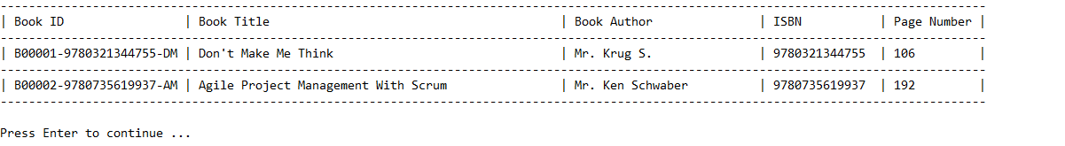
Figure 3. Show All Book Data

- If the user chooses Insert Book (Menu 2), then:
- The program will ask user to input the following data:
- Book Title
- Validate Book Title must be between 5 and 50 characters.
- Validate Book Title must be unique.
- Book Author
- Validate Book Author must start with “Mr. “ or “Mrs. “ and its length must be between 3 and 25 characters.
- ISBN
- Validate ISBN must be numeric and its length must be between 10 and 13 digits.
- Page Number
- Validate Page Number must be at least 16.
- After that, the program will generate a unique id for the inputted book data. The format will follow the following formula.
[BXXXXX]-[ISBN]-[A][T]
X is the last inserted Book Id number increased by 1
A is the first character of Book Author in uppercase format
T is the first character of Book Title in uppercase format
Example: B00001-0123423123-JH, B00002-0123412341-AZ
- Then, the program will store the inputted new book data to the next item of the last item of the chaining hash table with size 1007 using the following hash function.
KEY = SUM % SIZE
KEY : the hash table index that will store the data
SUM : the sum of the ascii from Book Id
SIZE : the size of the hash table
Example:
Book Id : B00001-0123423123-JH
SUM : 1044
SIZE : 1007
KEY : 1044 % 1007 = 37
Then, the book data will be stored at index 37 of hash table.

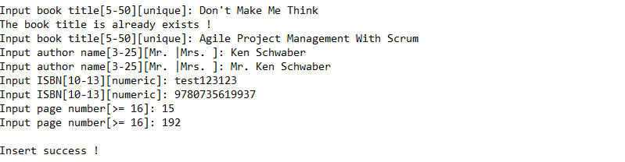
Figure 4. Insert Menu
- If user chooses Remove Book (Menu 3), then:
- The program will ask user to input a Book ID
- Validate if the inputted Book ID doesn’t exists then show “Book not found”.
Figure 5. The Inputted Book ID Doesn't Exists
- Otherwise, show the book data and ask the user for confirmation. Validate input must be either “y” or “n”.
- If user chooses “y”, then delete the data.
- Otherwise, if user chooses “n”, then return back to main menu.

Figure 6. Confirmation To Delete
- If user chooses Exit (Menu 4), then terminate the program.

Please run the EXE file to see the sample program

