Assignment Case | 
COMP6048 | COMP6048001 | COMP6048016 | COMP6048049
Data Structures
Computer Science | E233-COMP6048-JS19-01
Valid on Even Semester Year 2022/2023 | Revision 00

- Mahasiswa tidak diperkenankan untuk:
Students are prohibited from:
    - Berdiskusi dan/atau bekerja sama dengan mahasiswa lainnya,
Discussing and/or cooperating with other students,
    - Melihat sebagian atau seluruh jawaban mahasiswa lainnya,
Seeing a part or the whole answer from other students,
    - Membuka dan/atau menyalin jawaban dari buku, catatan, video, dan jenis referensi lainnya,
Open and/or copy answer from books, notes, videos, and other references,
    - Membuka dan/atau menyalin jawaban dari internet,
Open and/or copy answer from the internet,
    - Mengumpulkan jawaban yang tidak sesuai dengan tema soal,
Submitting an answer with a different theme from the given case,
    - Melakukan tindakan yang menyebabkan jawaban dicontek oleh orang lain atau kelompok lain, baik disengaja maupun tidak disengaja,
Doing action that could result the answer being copied by someone or other groups, intentionally or unintentionally,
    - Melakukan tindakan kecurangan lainnya.
Committing other dishonest actions.

- Jika mahasiswa dan/atau terbukti melakukan tindakan seperti yang dicantumkan pada butir ke-1, maka nilai mahasiswa dan/atau kelompok yang melakukan kecurangan, baik menyontek atau dicontek, akan dinolkan sesuai dengan peraturan yang berlaku.
If it has been proven that a student and/or group has committed dishonest actions outlined in point 1 above, the students and/or groups related to the incident, regardless of which one copies or has their answer copied, will be issued a score of zero according to the regulation.

- Jawaban yang dapat diterima dan dinilai adalah jawaban yang dikumpulkan sebelum batas waktu yang telah ditentukan.
The answer must be submitted before the designated deadline to be accepted and graded,
- Jawaban akan dinilai berdasarkan teknik yang diajarkan dalam praktikum dengan menggunakan software yang telah ditentukan.
The scoring will be based on the materials taught during the practicum classes using the designated software. Using different software than requested may result in your answer not being graded.

- Jika Anda tidak membaca peraturan ini, maka Anda dianggap sudah membaca dan menyetujuinya.
By taking this exam, you agree to these regulations, regardless of whether you have read it or not.

- Persentase penilaian untuk matakuliah ini adalah sebagai berikut:
The score will be distributed as follows:
Tugas Mandiri  Assignment | Proyek  Project | UAP  Final Exam
40% | - | 60%

- Perangkat lunak yang digunakan pada matakuliah ini adalah sebagai berikut:
This course uses the following software:
Software
Software
Dev-C++ 5.11

- Ekstensi file yang harus dikumpulkan untuk matakuliah ini adalah sebagai berikut:
Your answers must be in the following file extensions:
Tugas Mandiri  Assignment | Proyek  Project | UAP  Final Exam
CPP | - | CPP

Soal
Case

codeforJeS
codeforJeS is a competitive programming website. Contests are regularly hosted here. Competitive coding enthusiasts from all over the world participate in these contests. It also contains a rich set of problems from previous contests which are awesome to improve one’s algorithm skills. To increase efficiency in codeforJeS, the team of developer in codeforJeS decides to hire you, an avid programmer to create a program using C language and hash table with chaining method. The program will be created based on the following requirements:
- The program will consist of 4 menus.
- Add a Code Problem
- View All Code Problem
- Delete a Code Problem
- Exit
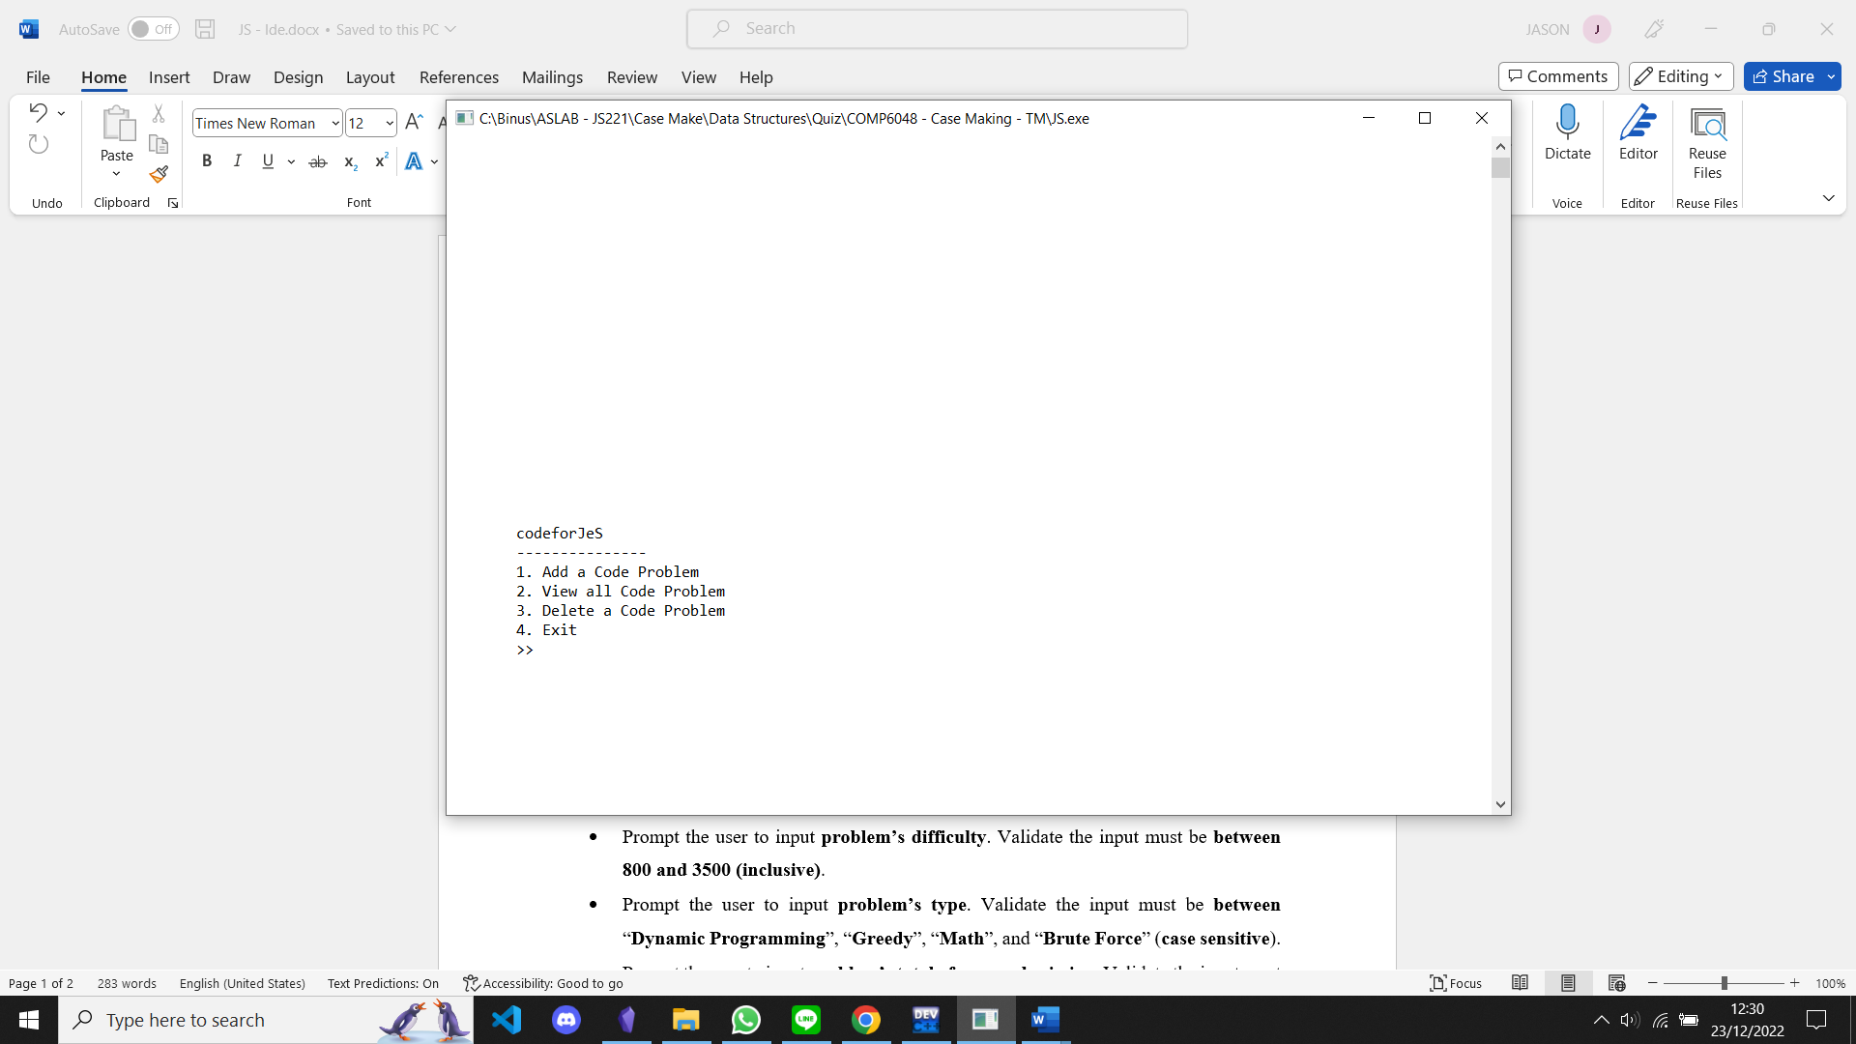
Figure 1. Main Menu
- If user choose menu 1 (Add a Code Problem), the program will:
- Prompt the user to input problem’s name. Validate the input must be between 3 and 30 characters (inclusive).
- Prompt the user to input problem’s difficulty. Validate the input must be between 800 and 3500 (inclusive).
- Prompt the user to input problem’s type. Validate the input must be between “Dynamic Programming”, “Greedy”, “Math”, and “Brute Force” (case sensitive).
- Prompt the user to input problem’s total of cases submission. Validate the input must be between 0 and 100 (inclusive).
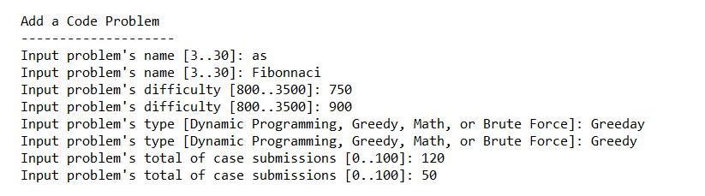
Figure 2. Add a Code Problem
- Calculate problem’s total of cases solved based on the following formula.
Cases Solved = Random number between 0 - (70% of total of cases submission)

- Determine the first two characters of problem’s id using the following conditions.
Code Problem Type | AA
Dynamic Programming | DP
Greedy | GR
Math | MA
Brute Force | BF
- Generate unique code problem ID based on the following formula.
AAXXX
AA : based on Code Problem’s Type (explained above)
X : random number between 0 - 9
- Display information regarding the code problem.
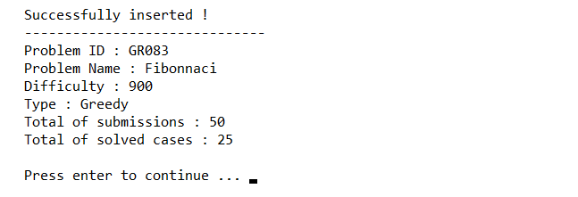
Figure 3. Code Problem Information

- Store new code problem data to the next item of the last item of chaining hash table with size of 25 based on following key which could be calculated as follows.
Key = X % Y
X : total ASCII value from each characters of problem’s id
Y : size of hash table

Problem ID : GR209
X : 71 (G) + 82 (R) + 50 (2) + 48 (0) + 57 (9)
Y : 25
Key : 308 % 25, therefore key will be 8
- If user choose menu 2 (View All Code Problem), the program will:
- Check data from hash table. If there are no code problem, display following message and redirect to main menu.
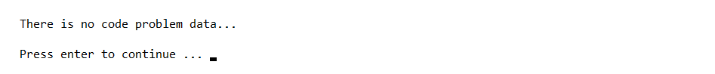
Figure 4. View All Code Problem (Empty Problem)
- Otherwise, display all code problems data and redirect to main menu.
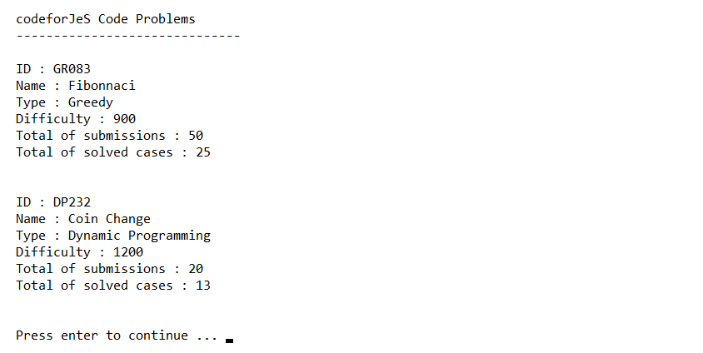
Figure 5. View All Code Problem
- If user choose menu 3 (Delete a Code Problem), the program will:
- Check data from hash table. If there are no code problem, display following message and redirect to main menu.

Figure 6. Delete a Code Problem (Empty Problem)
- Display all code problem data.
- Prompt user to input the problem id.
- Search problem data based on the problem id. If data does not exist, display following message, and redirect to main menu.
Figure 7. Delete a Code Problem (Code Problem Not Found)
- Otherwise, remove data from hash table, display following message, and redirect to main menu.
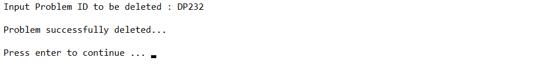
Figure 8. Code Problem Deleted
- If user choose menu 4 (Exit), the program will close.

