DATASET : Brain Tumor Image DataSet : Semantic Segmentation (kaggle.com)

Any preprocessing methods, including data splitting, etc. (10%)
For the preprocessing, because the data is already splitted between train, test, val. We don’t have to do any splitting. Butt he dataset is not suitable for modelling, so we must resize the image data into (224, 224) and create a binary mask based on the JSON file that’s given in the dataset. After createing the MASK, we then create a custom dataset and the loader for each dataset in PyTorch, which will be used for the modelling and evaluation.
The model that you used (10%)
All of the model that’s used is based on U-Net Architecture, with the 1st using efficientnet-b0 as the encoder and unfreezing all of the layer. The 2nd model also use the efficientnet-b0, but with freezing the encoder layer.
Training and validation results (10%)
1st Model : The training for the 1st model resulted in Train Loss: 0.2004, Train IoU: 0.6696
Validation Loss: 0.3147, Validation IoU: 0.5377 with graph of
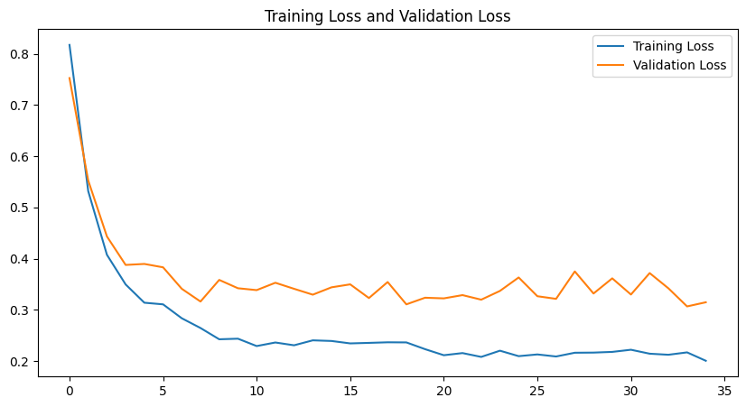
2nd Model : the training for the 2nd model resulted in Train Loss: 0.1903, Train IoU: 0.6828
Validation Loss: 0.3852, Validation IoU: 0.4663 with graph of
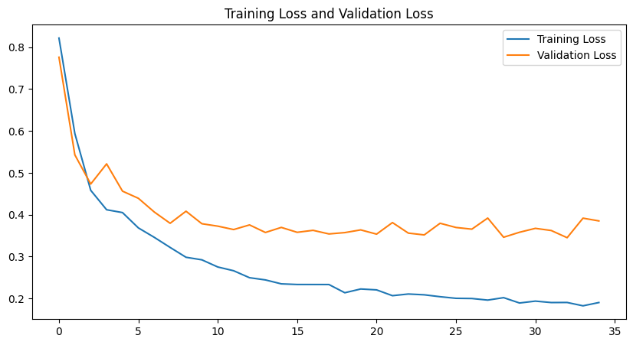
Evaluation results (10%)
1st Model :
The Dice loss of 0.2004 and Train IoU of 0.6696 on the train data indicated that more of the true image and predicted image on the train data is correctly classified, this shows us that the model is performing good on the train data. The model can be improved by increasing the number of epochs, increasing the learning rate, and increasing the batch size.
The Diceloss of the validation data is 0.3147, with it having more than half the diceloss of the train data this shows that the model is a little overfitting. The model can be improved by increasing the number of epochs, increasing the learning rate, and increasing the batch size.
The overfitting of the model can also be seen on the graph wtih the validation and training loss having such a large gap, with training lossbeing in the bottom
The form of the predicted mask is also rectangular, which could be more suited to image detection tasks. The prediction maybe improved by using a different model approach.
2nd Model :
The Dice loss of 0.1903 and Train IoU of 0.6828 on the train data indicated that more of the true image and predicted image on the train data is correctly classified, this shows us that the model is performing good on the train data. The model can be improved by increasing the number of epochs, increasing the learning rate, and increasing the batch size.

The Diceloss of the validation data is 0.3852, with it having half more than the diceloss of the train data this shows that the model is overfitting. The model can be improved by increasing the number of epochs, increasing the learning rate, and increasing the batch size.
The overfitting of the model can also be seen on the graph wtih the validation and training loss having such a large gap, with training loss being in the bottom
The form of the predicted mask is also rectangular, which could be more suited to image detection tasks. The prediction maybe improved by using a different model approach.
Existing challenges or future opportunities for your model (10%)
The model currently is not really a good fit for the data because the data uses bounding box like mask, this indicates that using object detection algotithm maybe more appropriate.

