Name : Wilbert Chandra
NIM : 2602113666

Problem 1 :
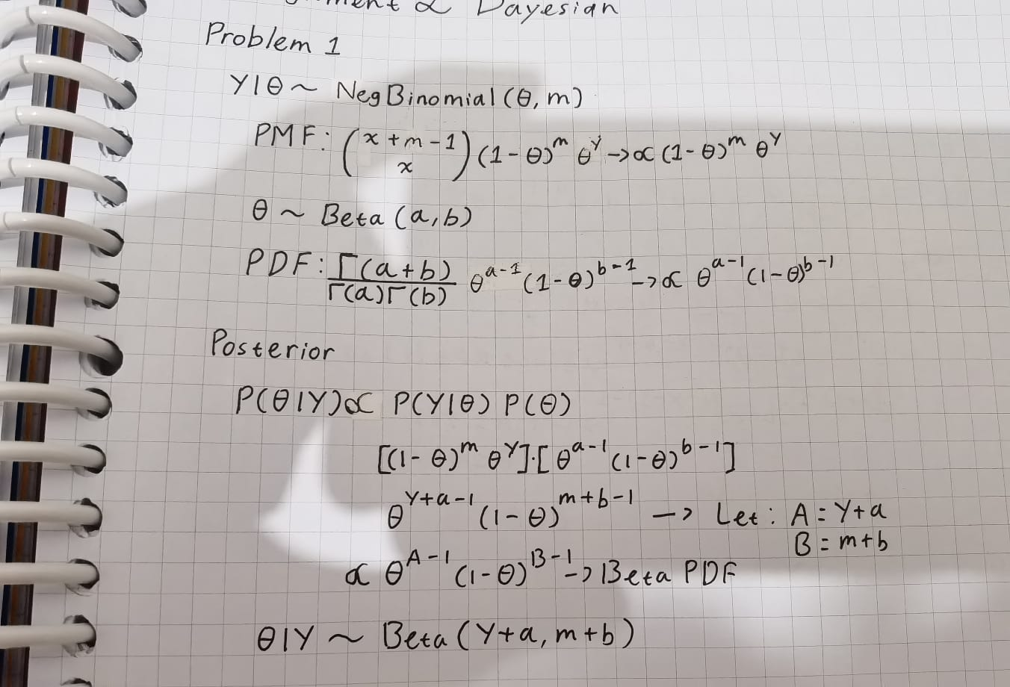
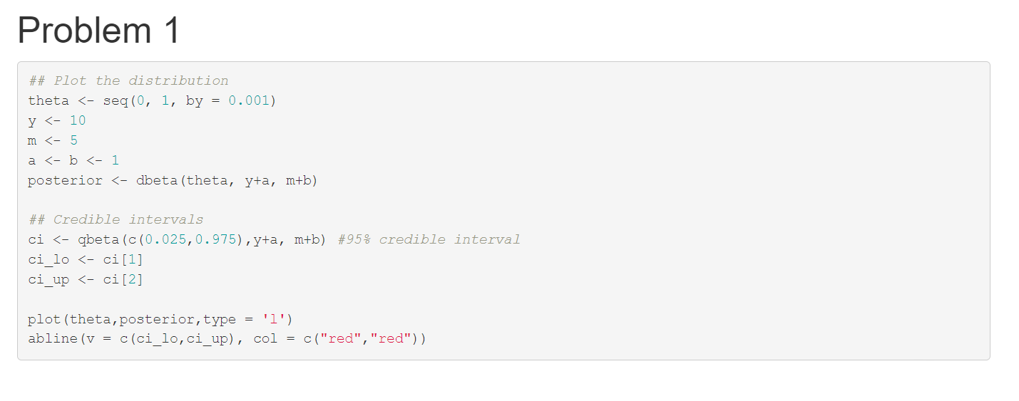
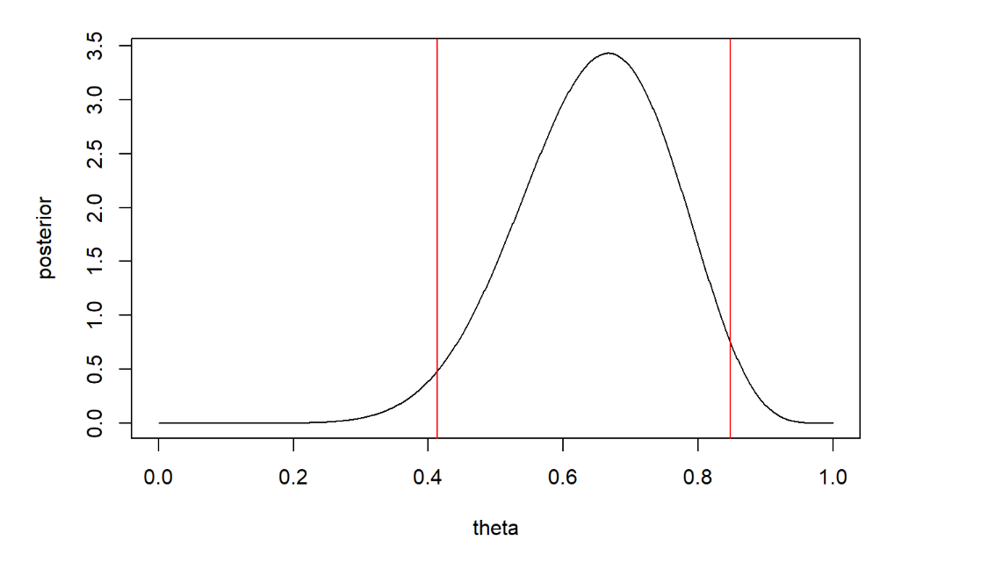

Problem 2 :
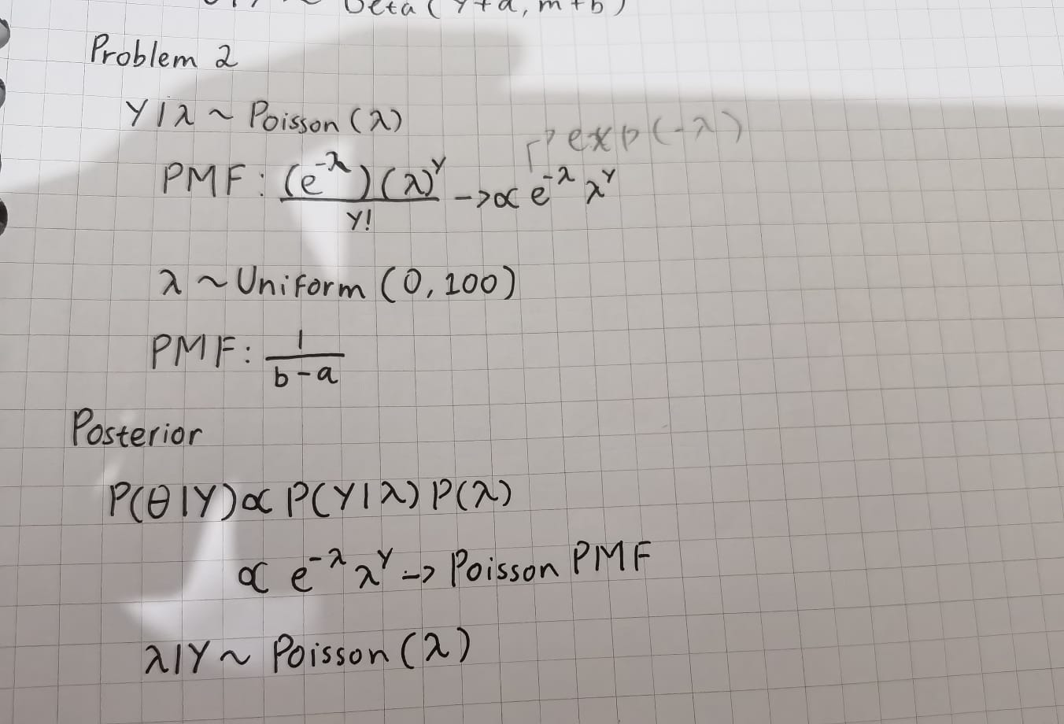
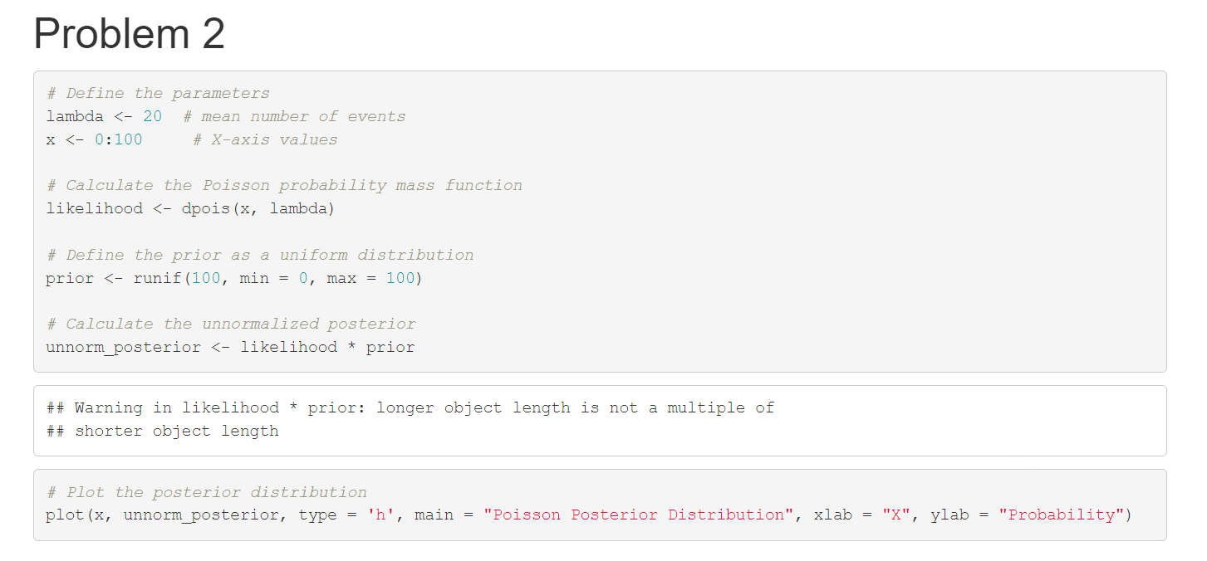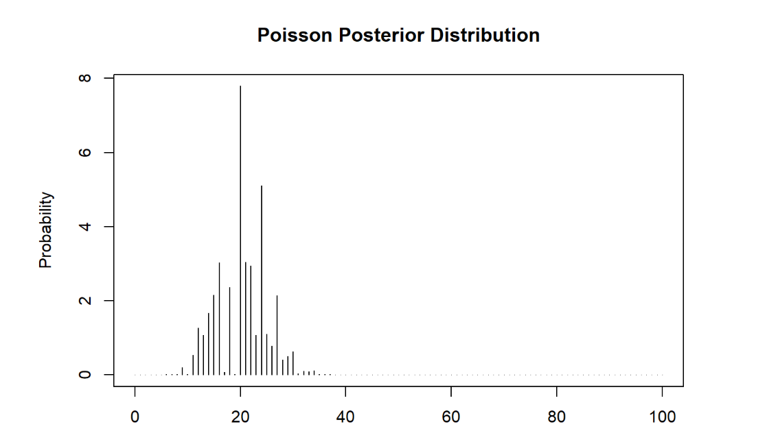

Problem 3 :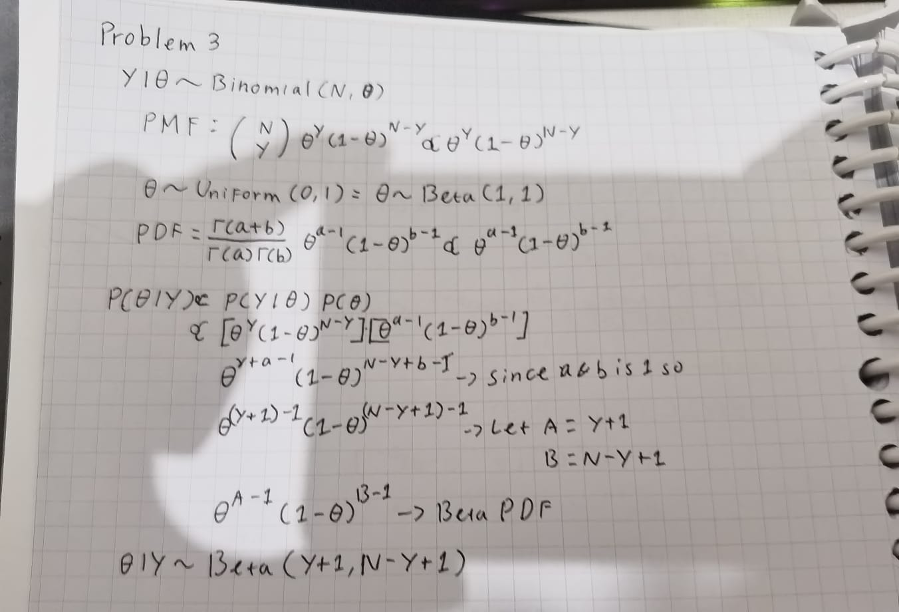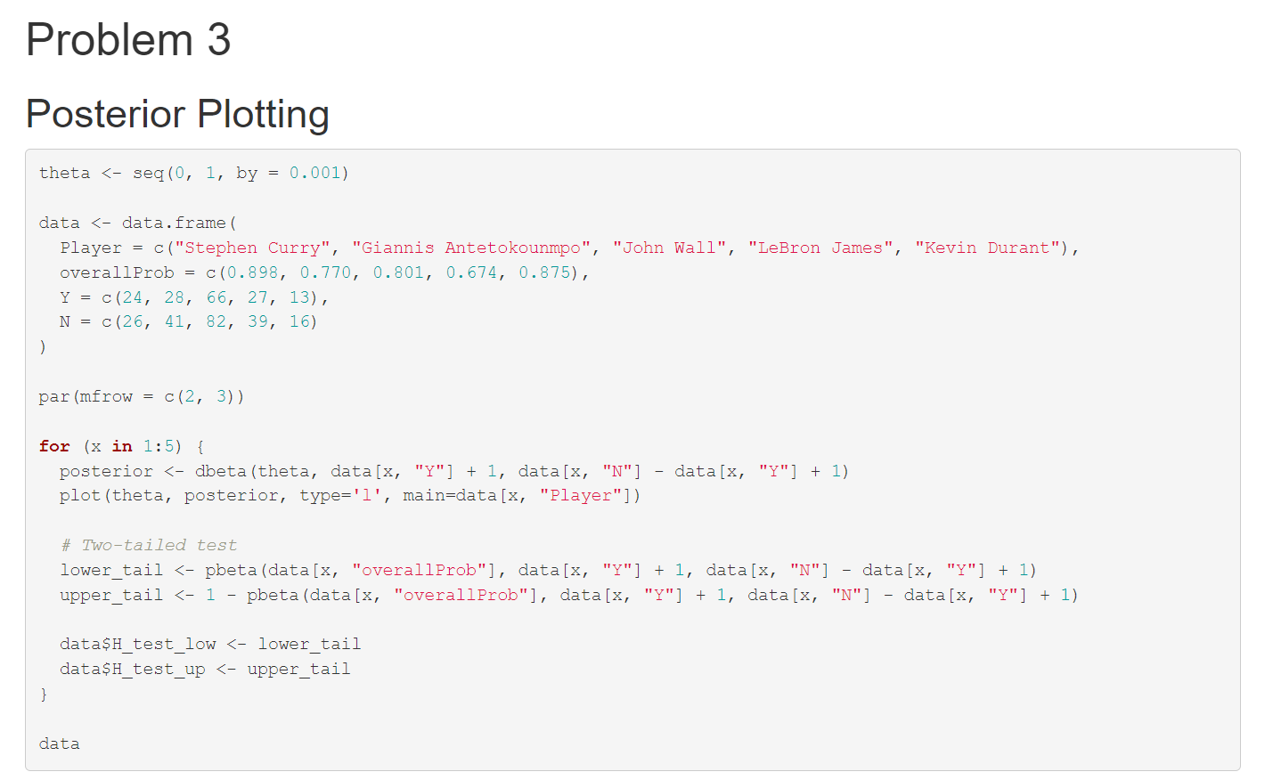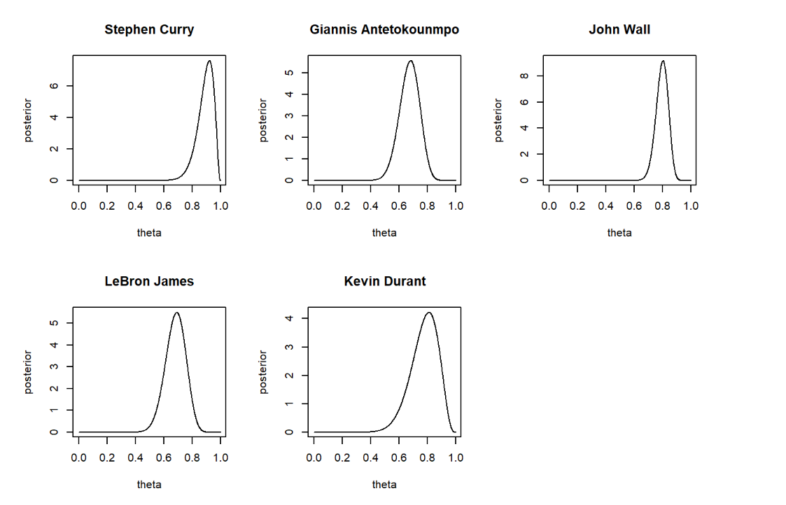
From the Hypothesis Testing above, given the prior and likelihood probability that the null hypothesis is true for θ < Overall Performance is 0.47 and for θ > Overall performance is 0.53.
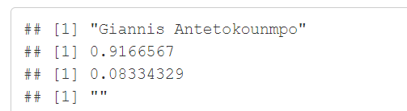
From the Hypothesis Testing above, given the prior and likelihood probability that the null hypothesis is true for θ < Overall Performance is 0.92 and for θ > Overall performance is 0.08.
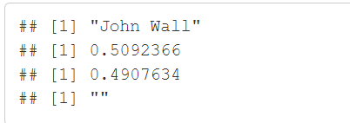
From the Hypothesis Testing above, given the prior and likelihood probability that the null hypothesis is true for θ < Overall Performance is 0.51 and for θ > Overall performance is 0.49.
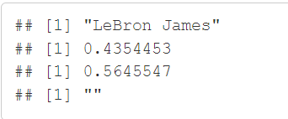
From the Hypothesis Testing above, given the prior and likelihood probability that the null hypothesis is true for θ < Overall Performance is 0.44 and for θ > Overall performance is 0.57.
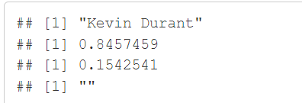
From the Hypothesis Testing above, given the prior and likelihood probability that the null hypothesis is true for θ < Overall Performance is 0.85 and for θ > Overall performance is 0.15.

