Untitled

# **R markdown**

## ***Challenge - Integrating code***

3 + 4

## [1] 7

(2*3)+1

## [1] 7

#### *Make sure you have a copy of the gapminder data available. Then write a code chunk to:*

#### *•Load the tidyverse package*

#### *•Read in the gapminder data*

#### *•Filter down to just the Australian data and print it to the screen*

#### *•Show a plot of the Australian population over time*

#### *Save and Knit your document when you have finished.*

knitr::opts_chunk$set(message = FALSE, warning = FALSE, fig.width = 3)

library(tidyverse)  
  
gapminder <- read_csv("data/gapminder.csv")  
  
num_countries <- gapminder %>%   
 group_by(country) %>%   
 summarise() %>%   
 nrow()

Filler text There are 1704 rows of sdata for us to work with. And there are 142 in the study.

australia

## # A tibble: 12 x 6  
## country continent year lifeExp pop gdpPercap  
## <chr> <chr> <dbl> <dbl> <dbl> <dbl>  
## 1 Australia Oceania 1952 69.1 8691212 10040.  
## 2 Australia Oceania 1957 70.3 9712569 10950.  
## 3 Australia Oceania 1962 70.9 10794968 12217.  
## 4 Australia Oceania 1967 71.1 11872264 14526.  
## 5 Australia Oceania 1972 71.9 13177000 16789.  
## 6 Australia Oceania 1977 73.5 14074100 18334.  
## 7 Australia Oceania 1982 74.7 15184200 19477.  
## 8 Australia Oceania 1987 76.3 16257249 21889.  
## 9 Australia Oceania 1992 77.6 17481977 23425.  
## 10 Australia Oceania 1997 78.8 18565243 26998.  
## 11 Australia Oceania 2002 80.4 19546792 30688.  
## 12 Australia Oceania 2007 81.2 20434176 34435.

ggplot(data = australia,  
 mapping = aes(x = year,  
 y = pop  
 ))+  
 geom_line()

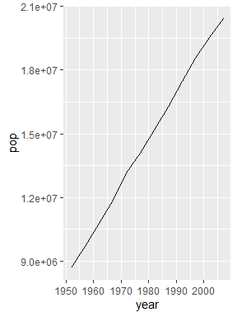

Make text **bold** or *italics* or code

* First thing to do
* Second thing
* Third
* First thing to do
* Second thing
* Third

Some text that needs footnoting [1].

1. First thing to do
2. Second thing
3. Third

[Link to our notes](https://csiro-data-school.github.io/rmarkdown)

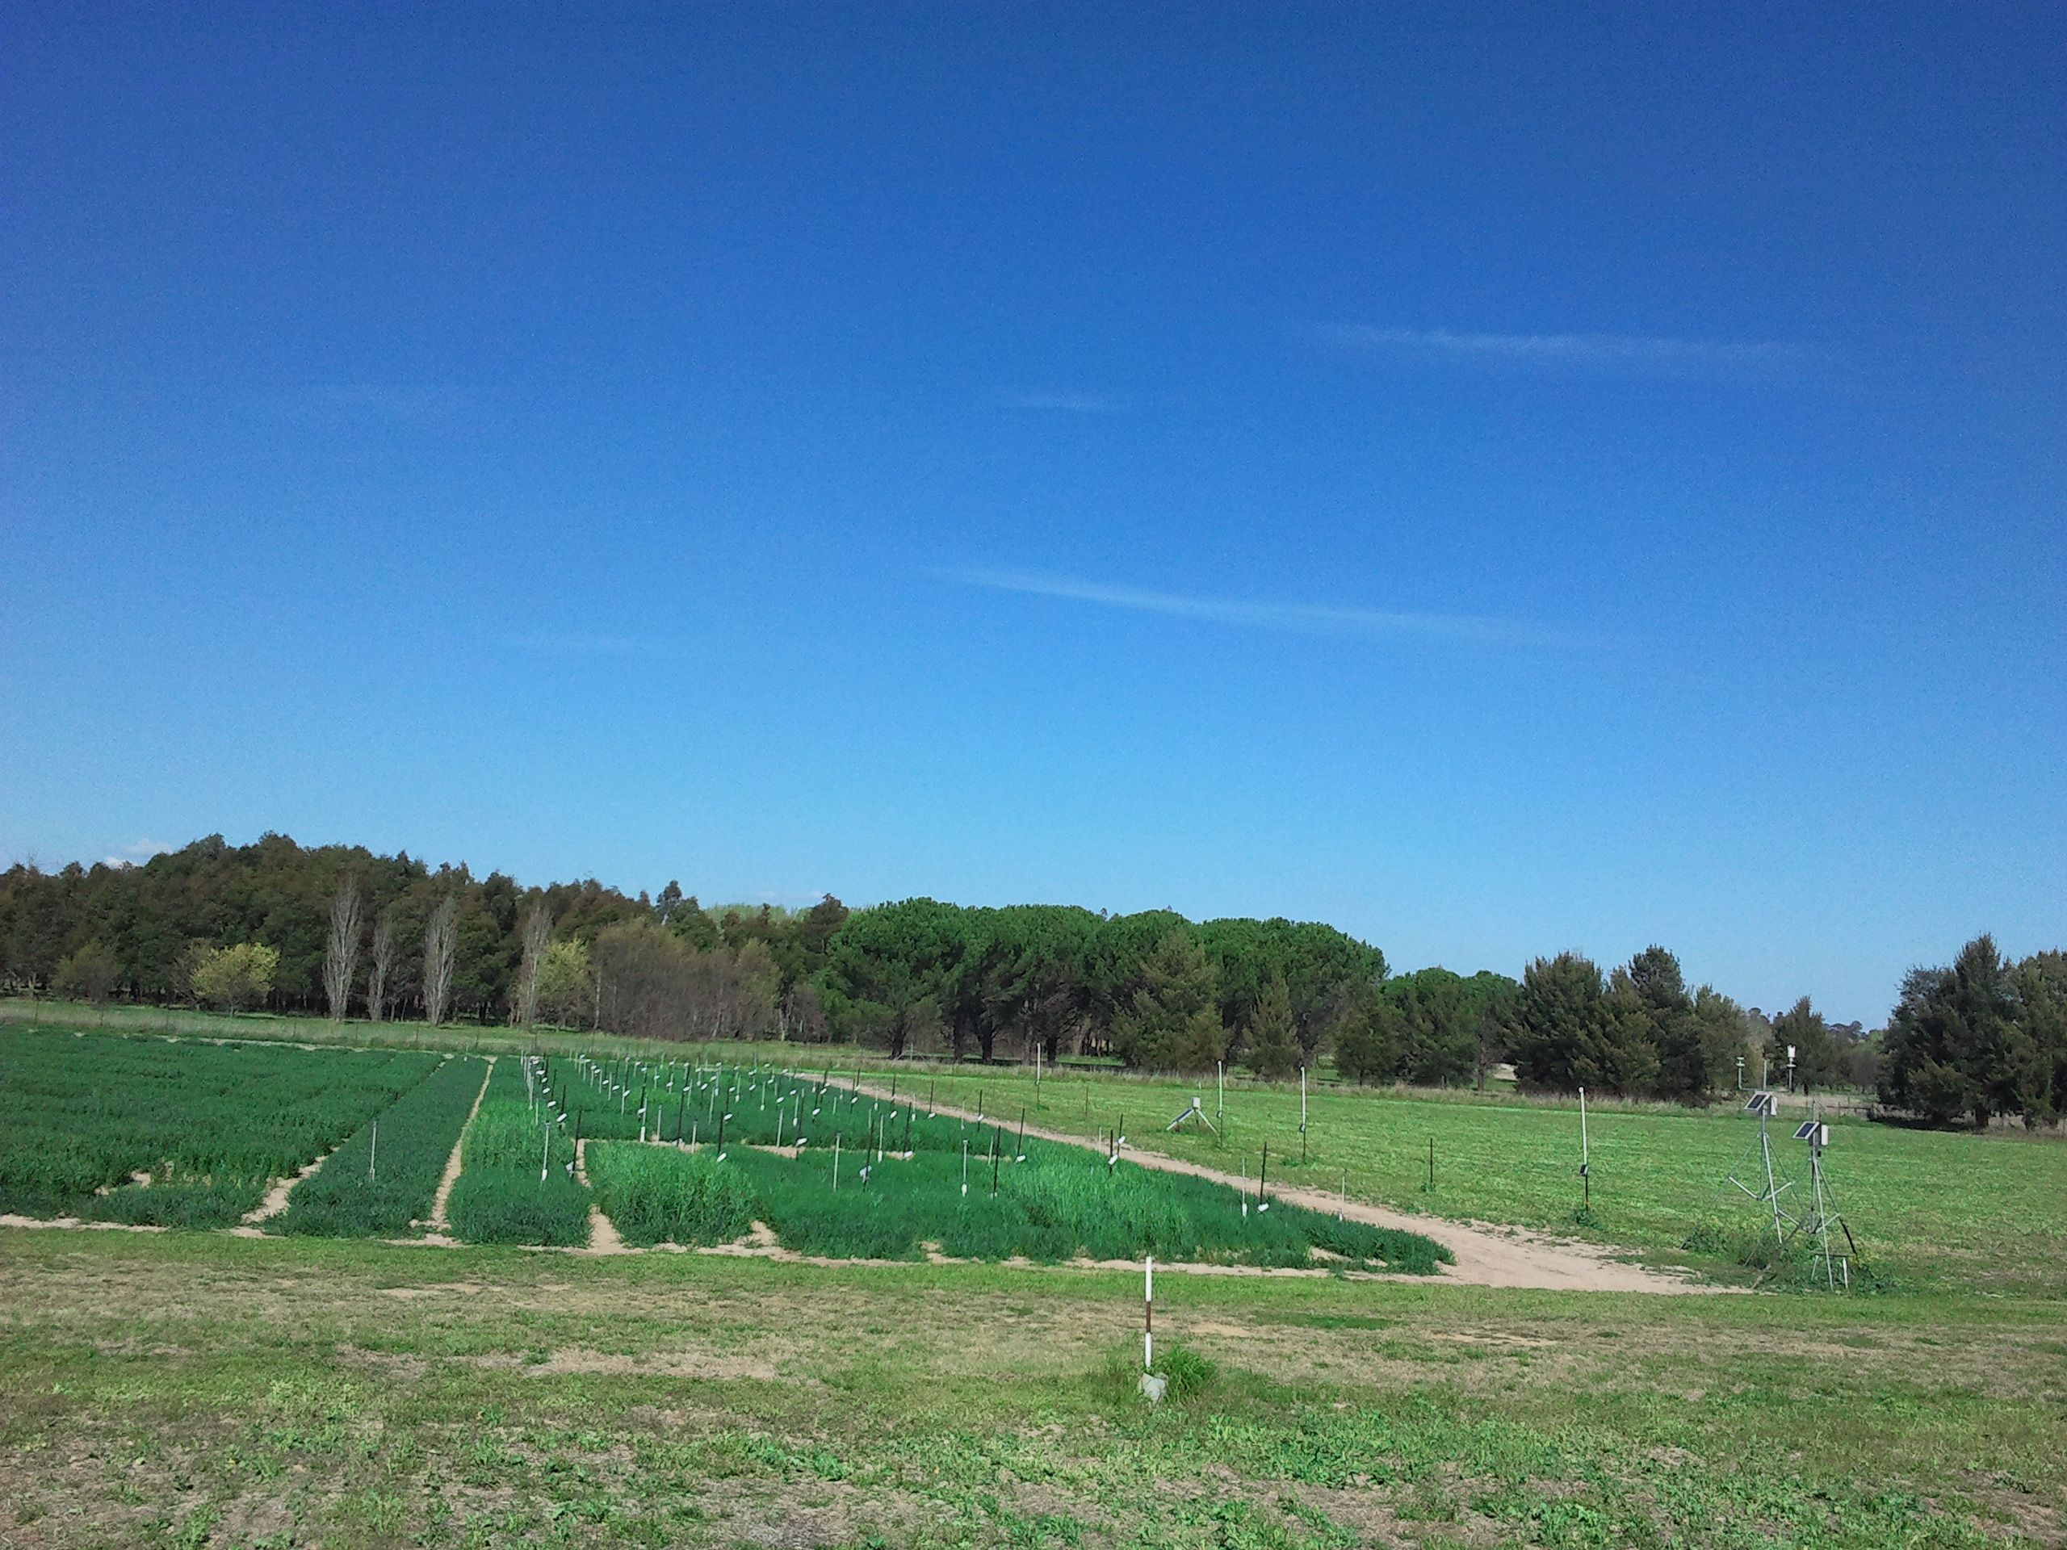

"Caption

We are using the R version 3.6.1 and the package tidyverse version 1.2.1

1. And here is my footnote text