* ＤＡＴＡ：
* 牛津網站 <https://ourworldindata.org/covid-school-workplace-closures>

之前NPIs只有14項，後來今年官網又增加為17項

Data between March 3, 2020, and June 14, 2021, used as the experiences for training the SCI_2LNN agent is collected whereas data between June 14, 2021, and 14-Nov-2021 is for the testing period.

* 以色列國家官網 <https://graphics.reuters.com/world-coronavirus-tracker-and-maps/countries-and-territories/israel/>

這裡有以色列感染人數資料

以色列國家官網有恢復（解隔離）人數資料

* 程式碼
* 之前處理的：

前處理的資料、Code(找到的參數)、md都在這個Repository:

<https://github.com/DpRams/SEIR_COVID>

* 泰國預測模型及程式碼Forecasting the COVID-19 trend using the SEIR model

<https://towardsdatascience.com/forecasting-the-covid-19-trend-using-the-seir-model-90979abb9e64>

* ＣＳＩ程式碼（用安寧ＤＡＴＡ跑的）<https://colab.research.google.com/drive/13VrXx5OhCJ_1X3r9WojRSDk0xCgfpClW>
* 另一個版本ＣＳＩ程式碼參考：<https://colab.research.google.com/drive/1xExAGZ6LFC_neefyiv9GCojxoW0wwbD9>
* ＸＡＩ＿ＧＨＳＯＭ程式碼參考：<https://colab.research.google.com/drive/17gPYTV5OxXnN0_0-X9WejU-DpgaC6Fzl>
* 理論
* 強化學習理論圖Reinforcement Learning for Control Systems Applications <https://www.mathworks.com/help/reinforcement-learning/ug/reinforcement-learning-for-control-systems-applications.html>

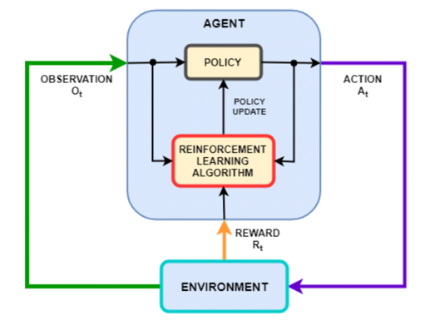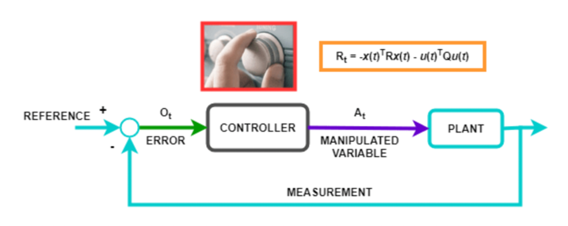

| **Paper Title** | **Publication Year** | **Authors** | **Models Used** | **Models Simple Descriptions** | **Strengths of the Model** | **Drawbacks of the Model** | **Future Research Expectations** |
| --- | --- | --- | --- | --- | --- | --- | --- |
| "Gupta, R. et al. Machine learning models for government to predict COVID-19 outbreak. Digital Government: Research and Practice" | 2020 | R. Gupta, G. Pandey, P. Chaudhary, S.K. Pal | Random Forest, SVM, Gradient Boosting, KNN | Supervised learning models that use demographic data, epidemiological data, and NPIs to predict outbreak trends | Able to provide insights for governments to plan for and implement NPIs | Limited by the accuracy of data and assumptions made | More refined data collection and analysis to improve model accuracy |
| "Pandey, G. et al. SEIR and Regression Model based COVID-19 outbreak predictions in India. arXiv preprint arXiv:2004.00958." | 2020 | G. Pandey, P. Chaudhary, R. Gupta, S.K. Pal | SEIR model, regression model | The SEIR model simulates disease spread based on four compartments: susceptible, exposed, infected, and recovered; the regression model uses the number of cases to predict future trends | SEIR model able to predict the disease spread over time, regression model able to provide short-term predictions | SEIR model limited by assumptions made about the population and disease dynamics; regression model limited by short-term predictions | Refining SEIR model assumptions and improving regression model accuracy |
| "López, L. & Rodo, X. A modified SEIR model to predict the COVID-19 outbreak in Spain and Italy: simulating control scenarios and multi-scale epidemics. Results in Physics" | 2021 | L. López, X. Rodo | Modified SEIR model | SEIR model with modified parameters to account for NPIs and population behavior | Able to simulate control scenarios and multi-scale epidemics | Limited by the complexity of the model and assumptions made about the population and disease dynamics | Further refinement of the model to improve accuracy and adaptability |
| "Feng, S. et al. Prediction of the COVID-19 epidemic trends based on SEIR and AI models. PLoS One" | 2021 | S. Feng, Z. Feng, C. Ling, C. Chang, Z. Feng | SEIR model, ANN, SVM, RF, KNN | Combination of SEIR model and multiple machine learning models for prediction of epidemic trends | Able to incorporate multiple sources of data and provide accurate predictions | Limited by the complexity of the model and assumptions made about the population and disease dynamics | Further research into integrating machine learning models with SEIR models for improved accuracy |
| "Cai, M. et al. Fractional SEIR model and data-driven predictions of COVID-19 dynamics of Omicron variant. Chaos: An Interdisciplinary Journal of Nonlinear Science" | 2022 | M. Cai, G. Em Karniadakis, C. Li | Fractional SEIR model | SEIR model modified to account for fractional derivatives and predict COVID-19 dynamics of Omicron variant | Able to account for new variants and predict epidemic trends | Limited by the complexity of the model and assumptions made about the population and disease dynamics | Further research into the use of fractional derivatives in epidemic modeling |
| "Zisad, S. N. et al. An integrated neural network and SEIR model to predict Covid-19. Algorithms" | 2021 | S.N. Zisad |  |  |  |  |  |



| **Paper Title** | **Publication Year** | **Authors** | **Models Used** | **Model Simple Descriptions** | **Strengths of the Model** | **Drawbacks of the Model** | **Future Research Expectations** |
| --- | --- | --- | --- | --- | --- | --- | --- |
| Gupta et al. | 2020 | Gupta, Pandey, Chaudhary, Pal | LSTM, SVR, RF, KNN | Machine learning models for predicting COVID-19 outbreaks in India | Flexible and adaptable to different data sets, good accuracy and prediction capabilities | Limited by data availability and quality, may not account for social and behavioral factors, requires extensive preprocessing and feature engineering | To refine the models with more data, use more advanced machine learning techniques, consider incorporating social and behavioral factors into the models |
| Pandey et al. | 2020 | Pandey, Chaudhary, Gupta, Pal | SEIR, Regression | SEIR and Regression Model based COVID-19 outbreak predictions in India | Provides accurate short-term predictions, accounts for changes in population behavior and government interventions | Limited to short-term predictions, may not account for long-term effects of government interventions, may not be applicable to other countries or regions | To refine the models with more data, validate the models with real-world data, compare the models with other prediction models, consider incorporating dynamic models to account for long-term effects of government interventions |
| López and Rodo | 2021 | López, Rodo | Modified SEIR | A modified SEIR model to predict the COVID-19 outbreak in Spain and Italy: simulating control scenarios and multi-scale epidemics | Accounts for changes in population behavior and government interventions, provides accurate short-term predictions, can simulate control scenarios and multi-scale epidemics | Limited to short-term predictions, may not account for long-term effects of government interventions, may require extensive parameter tuning | To refine the models with more data, validate the models with real-world data, compare the models with other prediction models, consider incorporating dynamic models to account for long-term effects of government interventions |
| Feng et al. | 2021 | Feng, Ling, Chang | SEIR, AI models | Prediction of the COVID-19 epidemic trends based on SEIR and AI models | Accounts for changes in population behavior and government interventions, can be used for short-term and long-term predictions, can predict epidemic trends in different regions and countries | Limited by data availability and quality, may require extensive preprocessing and feature engineering, may not account for social and behavioral factors | To refine the models with more data, validate the models with real-world data, compare the models with other prediction models, consider incorporating social and behavioral factors into the models |
| Cai et al. | 2022 | Cai, Em Karniadakis, Li | Fractional SEIR | Fractional SEIR model and data-driven predictions of COVID-19 dynamics of Omicron variant | Provides accurate short-term predictions, accounts for changes in population behavior and government interventions, can simulate control scenarios and multi-scale epidemics | Limited to short-term predictions, may not account for long-term effects of government interventions, may require extensive parameter tuning | To refine the models with more data, validate the models with real-world data, compare the models with other prediction models, consider incorporating dynamic models to account for long-term effects of government interventions |
| Zisad et al. | 2021 | Zisad, Hossain, Andersson | SEIR, neural network | An integrated neural network and SEIR model to predict Covid-19 | Accounts for changes in population behavior and government interventions, can be used for short-term and long-term predictions, can predict epidemic trends in different regions and countries | Limited by data availability and quality, may require extensive preprocessing and feature engineering, |  |