

**Project #2: Money Exchange App**

***Course Title*: Introduction to Object Programming**

***Course Number*: 420-P25-AS**

***Group Number*: 07056**

***Professor*: Hamideh Riazat**

***Due Date*: April 25, 2018**

This project is a **windows application project in C#** with the following requirements:

* **Project Description:** This program allows users to calculate the value of an amount from one currency to the ***American dollar*** (and vice versa). On the exchange windows (Form frmChange), A list is displayed to allow the user to select the name of a currency’s country. As soon as user select a currency, value of the selected currency based on US Dollar is displayed in relevant textboxes in the form. Then, the user can select the type of conversion which is “From currency to US Dollar” or vice versa. Finally, the user can enter an amount that he/she wants to convert and click on the convert button to see the result .( Check the screenshots below)
* **Technical Details:**
  + The project uses a ***text file,*** which contains information about all the countries and their currencies, to work with required data. (Currency: Name, Value, CountryName)

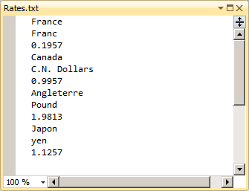

* + You are expected to use a personalized data Structure or Object and an array (no collection) to implement the project.
  + The application has threeforms:
    1. *frmMain*: A ***mdi*** form with a menu bar: (***Start, Admin, Change and Quit***).
    2. *frmChange*: The main form of the application in which user converts US Dollar to a selected country ‘s currency or vice versa.

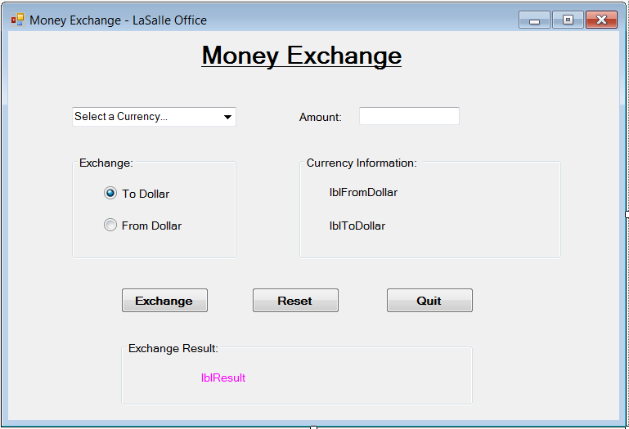

Example:

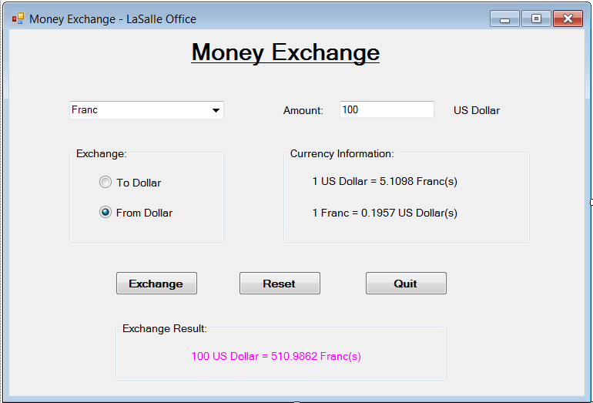

* + 1. *frmAdmin*: An administration form which allows admin to manage information about currencies such as ***Name, Value, and Country Name***. This form displays information of only one currency at a time with some controls such as Navigation buttons (***first, next, previous, last***) and admin buttons (***add, delete, edit, save, cancel***).

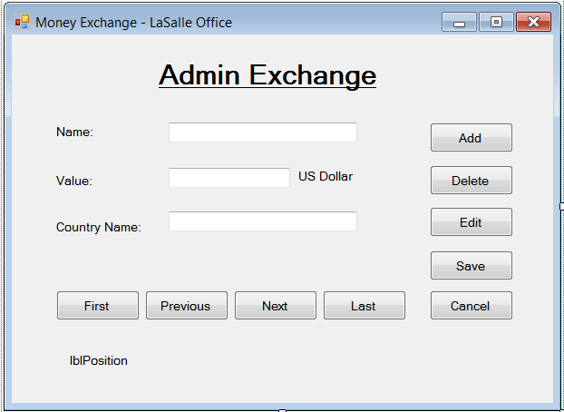

* **Submission:** Zip your project folder and rename it to project2_studentName_studentID. Then submit the project via Lea under project#2
* **Evaluation Grid:**

|  |  |  |
| --- | --- | --- |
|  | Functionalities | Mark value (total:100) |
| frmMain (MDI) | Contains all the other forms | 10 points |
| frmAdmin | Display currencies  Navigation buttons  Manage buttons | 10 points  10 points  10 points |
| frmChange | Fill combobox with currencies  Display infos about a currency  Manage conversion types  Convert the amount | 10 points  10 points  10 points  15 points |
| Text File,  Data structure | Read and write from/to a text file  Struct/Object and array | 5 points  10 points |

**Project Bonus (+15 points)**

You are allowed to build the second version of the same project, where there is no the US Dollar as the basic (by default) currency, you can convert from any currency to others currencies.

You can download information from a website as an XML file which is a replace to your text file. The program reads information from the xml file and work with it.

(Any website is accepted for example: <http://www.bankofcanada.ca/stats/assets/rates_rss/noon/en_all.xml> )

You have two options to implement the application:

1. Online:

The file should be downloaded automatically when the application is executed. In this case it is better to download only once per day to avoid wasting time. If connection to the website is currently impossible use the last file which is exists in the application memory.

1. Offline:

Download the file once and work with the file though is not up to date.