**Students Union Discount Application**

The following application allows a user to purchase Hoodies and T-shirts from the students Union. As the first semester is almost over, the students union have decided to apply discounts for bulk purchases of each of the items as follows:

|  |  |  |  |
| --- | --- | --- | --- |
| **Item** | **Price Per Item** | **Quantity** | **Discount** |
| Hoody | €20 | 10 or more | 20% |
| 5 - 10 | 10% |
| T-Shirt | €10 | 10 or more | 10% |
| 5 - 10 | 5% |

This application asks the user how many Hoodies, and Tshirts they would like to buy and calculates totals for each applying the appropriate discounts. Once the discounts have been applied, the total cost of the whole purchase is calculated and then output to the user.

The code has been developed for you (See Below for the code and a description of variables used).

Carry out each of the following tasks:

1. Download the code from Moodle and Import it to your snap application
2. Identify 10 suitable test cases to test that the application gives the correct output (Outline the Input and Expected Output)

|  |  |  |
| --- | --- | --- |
| Input | Expected Output | Actual Output |
| Buy 3 hoodies and no tshirt(check no discount for hoodies) | 60€ | True |
| Buy 6 Hoodies and no tshirt(check 10%discount) | 54€ | False |
| Buy 20 hoodies and no tshirt (check 20% discount) | 320€ | False |
| Buy 3 T-shirts and no hoodies(check no discount) | 30€ | True |
| Buy 6 T-shirts and no hoodies(check 5%disc) | 57€ | False |
| Buy 20 T-Shirts and no hoodies( check 10% disc) | 180€ | False |
| Buy 3 hoodies and 3 T-Shirts (check for no discount on both) | 90€ | True |
| Buy 3 hoodies and 5 t-shirt(check no disc for hoodies + 5% disc for t-shirts) | 107.50€ | False |
| Buy 5 hoodies and 3 t-shirts(check for disc in hoodies + no disc in t-shirts) | 120€ | False |
| Buy 20 hoodies and 20 t-shirt ( check 20% + 10%) | 500€ | False |

1. Run these test cases and document the Actual output
2. If the Actual Output and Expected Output don’t match, fix the code and run the test cases again. Insert a script pic of your corrected code here:





With this change now it displays the proper price

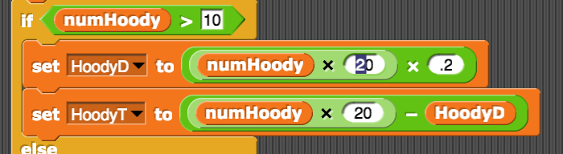





With this change now displays properly

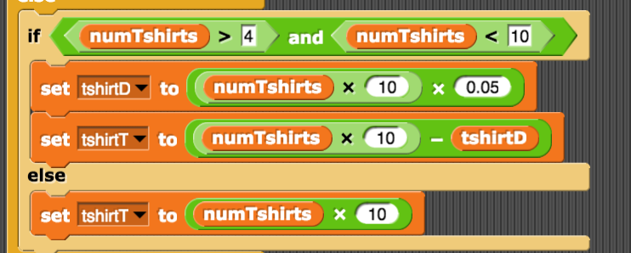

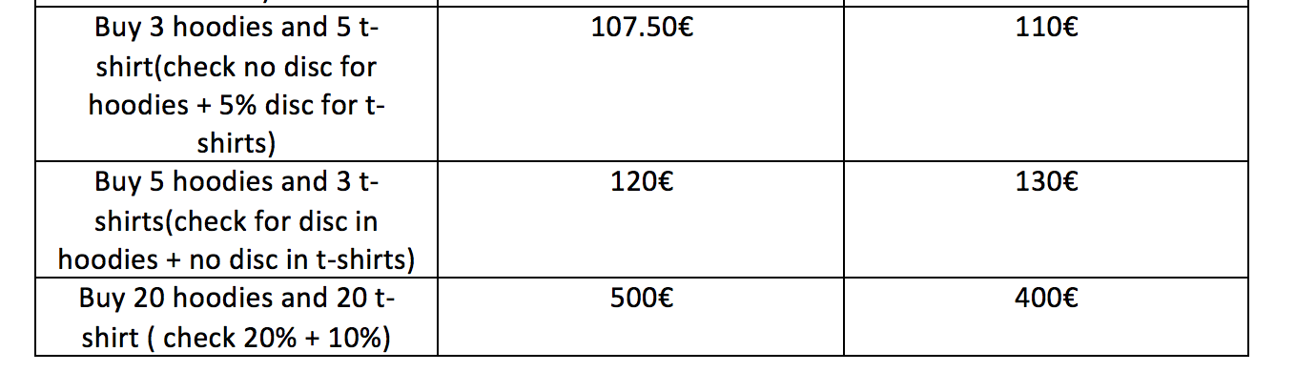

And now when both products have discounts, it displays the proper price:

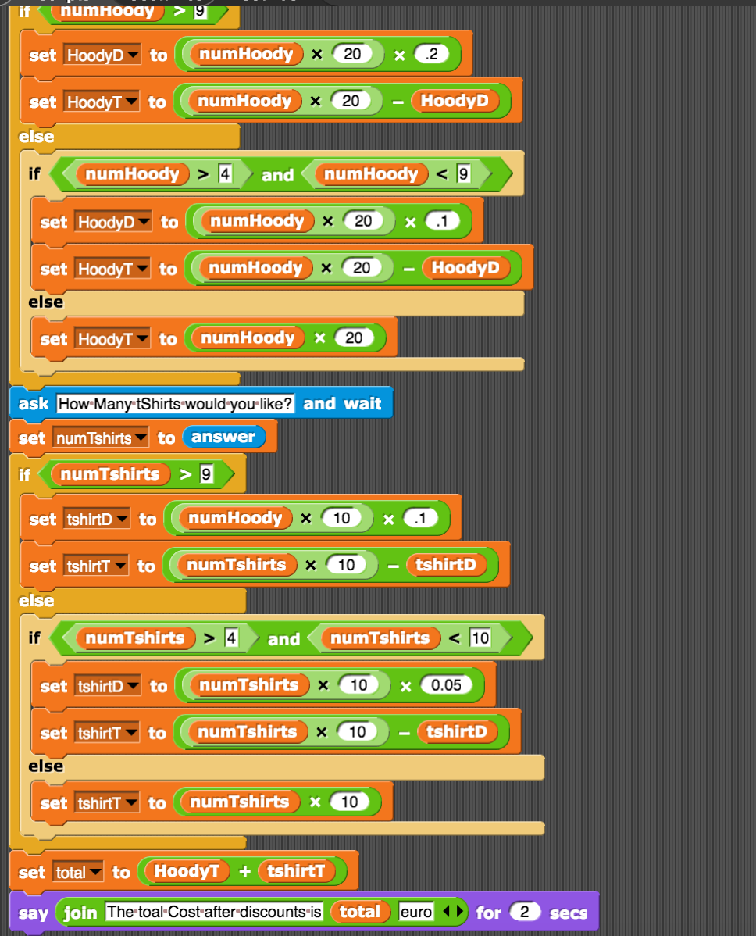

1. Identify three ways in which the program could have been developed differently

1- I would have set 3 discount variables:

disc1= .2

disc2= .1

disc3= 0.05

And I think that could easy up the math calculation if I set the discount straight to the product, respecting the conditions for discount given.

2- Solution:

I would validate the input in case the user put letters or special charactters.

3- Set the variable shirts and hoodies to a fixed price.

1. Upload this completed document to Moodle

**Variables Used:**

numHoody – the number of hoodies the user wants to buy

numTshirts – the number of tshirts the user wants to buy

hoodyD – the discount for the number of hoodys purchased

tshirtD – the discount for the number of tshirts purchased

hoodyT – total cost of hoodies after discount is applied

tshirtT – total cost of tshirts after discount is applied

total – total cost of all hoodies and tshirts after discounts

