QF635 Market Microstructure and Algorithmic Trading
Project Report
A Regime-Switching Crypto Trading System
Order Logic, System Architecture and Risk Management
BTC/USDT & ETH/USDT · Binance (paper / demo) · event-driven engine
Focus of this report: demonstrate how trading decisions are generated, routed and executed, and how risk is controlled — not absolute profitability.

Table of Contents

1. Executive Summary
Objective. This project demonstrates how a quantitative team researches, builds, validates and risk-manages an intraday crypto trading strategy in a professional, event-driven framework. The emphasis is on the full order lifecycle and a multi-layer risk-control system, not on producing a profitable backtest.
Market & strategy. We trade BTC/USDT and ETH/USDT spot on Binance. A regime detector (z-score / volatility) switches between a momentum strategy (MACD + moving-average crossover) in trending markets and a mean-reversion strategy (RSI + Bollinger Bands) in ranging / high-volatility markets. Market data is read from the real Binance mainnet feed (read-only); orders are routed only to a paper account (demo / testnet), never to a live money venue.
Key results (BTC/USDT, 1 year, 1-minute bars). The strategy executed 19,180 trades (9,585 round trips), win rate 36.5%, total return -20.14% versus a buy-and-hold benchmark of -38.92%. Maximum drawdown was 20.28%, at which point the 20% drawdown circuit breaker halted the engine. Cumulative transaction costs were 1,916.513 USDT — approximately the entire loss, with a gross profit factor of 0.91.
Risk-adjusted performance. Sharpe was -25.77 — the strategy has no positive risk-adjusted edge at a 0.1% taker fee. Robustness work (timeframe sweep, 70/30 train-test split, ETH cross-validation, parameter grids, fee-sensitivity) shows the net edge is approximately zero and is consumed by transaction costs.
Main conclusion. The system is a correct, well-controlled trading engine, evidenced by a circuit breaker that fired exactly as designed. The strategy itself is not suitable for real capital: its gross signal edge is positive but small and is entirely eroded by fees. This is an honest, instructive outcome that we discuss in full.

2. Motivation and Market Opportunity
Market selection. Crypto spot markets (BTC, ETH) are liquid, trade 24/7, have public order-book and kline data with no licensing barrier, and offer free paper-trading venues (Binance testnet / demo). This makes them ideal for building and validating a full trading system end-to-end.
Trading opportunity & economic intuition. Two well-documented behaviours motivate the strategy:
- Momentum / trend persistence: once a directional move is underway, order-flow and herding cause it to persist over short horizons — captured by MACD and a fast/slow MA crossover.
- Short-term mean reversion: in the absence of a trend, liquidity provision and over-reaction cause prices to revert to a local mean — captured by RSI extremes at the Bollinger bands.
Why regimes. These two behaviours are mutually exclusive in time. A regime detector routes each market state to the appropriate strategy, so the system is never applying a trend rule in a choppy market or a reversion rule in a strong trend.
Why the opportunity may persist. Retail order flow, funding-driven flows and fragmented liquidity continually reintroduce micro-inefficiencies. Whether these survive transaction costs at the 1-minute horizon is precisely the question our backtest answers.

3. Market Microstructure Analysis
- Market structure: Binance central limit order book, continuous matching, maker/taker fees (0.1% taker baseline). No designated market makers; liquidity is endogenous.
- Order-book behaviour: each market event carries a 10-level order book. We compute the mid-price for marking and a depth-weighted bid/ask imbalance as a microstructure feature.
- Liquidity & price discovery: BTC/ETH top-of-book is deep and tight; price discovery is continuous. The bot polls the book every ~10s and a fresh 1-minute kline each minute.
- Volatility & regimes: crypto exhibits volatility clustering and clear trending vs ranging phases. The detector classifies each symbol into TRENDING, RANGING or HIGH_VOL using a rolling z-score of returns and a volatility ratio.
- Sessions: markets trade continuously; there is no open/close, but liquidity and volatility vary with US/Asia/Europe overlap, which the regime detector adapts to automatically.

4. Strategy Research and Signal Development
Hypothesis. Conditional on the correct regime, a small but positive directional edge exists at the 1-minute horizon. Trading the regime-appropriate signal should beat passive holding on a risk-adjusted basis.
Signals / features. All indicators are computed on the rolling window of 1-minute kline closes:
Feature | What it measures | Role in decision
RSI (14) | Momentum oscillator, over-bought / over-sold | Mean-reversion entry trigger at extremes
Bollinger Bands (20) | Price stretch vs rolling mean / volatility | Confirms reversion entries at the band
MACD | Trend acceleration (histogram) | Momentum entry: sign + strength
MA fast/slow (10/30) | Trend direction via crossover | Momentum entry confirmation
Return z-score / volatility | Regime classification | Selects which strategy is active
Depth imbalance | Order-book pressure | Microstructure context (monitoring)
Trading logic. Momentum BUY requires fast MA > slow MA AND MACD histogram > 0 (both must agree, filtering whipsaws); the mirror for SELL. Mean-reversion BUY requires price ≤ lower band AND RSI ≤ 30; the mirror for SELL. Signal conviction scales with how far the indicator is past its threshold.

5. Model Selection and Justification
Prediction objective. Predict short-horizon return direction (BUY / SELL / HOLD) per symbol per signal interval — a classification of the immediate move, not a price forecast.
Models considered. (i) a single always-on momentum rule; (ii) a single mean-reversion rule; (iii) the regime-switching combination we adopted; a Hidden Markov regime model was scoped as future work.
Selection criteria & choice. We chose the rule-based regime-switching model for interpretability, transparency and computational efficiency — every trade is fully explainable, which is essential for risk review and for this report's teaching goal. Per the QF635 guidance, a simple interpretable model is preferred over a complex one that only marginally improves the backtest.
Advantages / limitations. Advantages: transparent, fast, no training data or overfitting of weights. Limitations: thresholds are fixed; the z-score regime detector is sensitive to its window length (discussed in §12) and the indicators react slowly relative to 1-minute noise.

6. Strategy Implementation Logic
The system is event-driven: a single queue routes events through handlers in a fixed order. Per market event the pipeline is mark-to-market → protective exits → regime update → signal → pre-trade risk → order → fill. Figure 2 shows the per-bar entry decision flow.
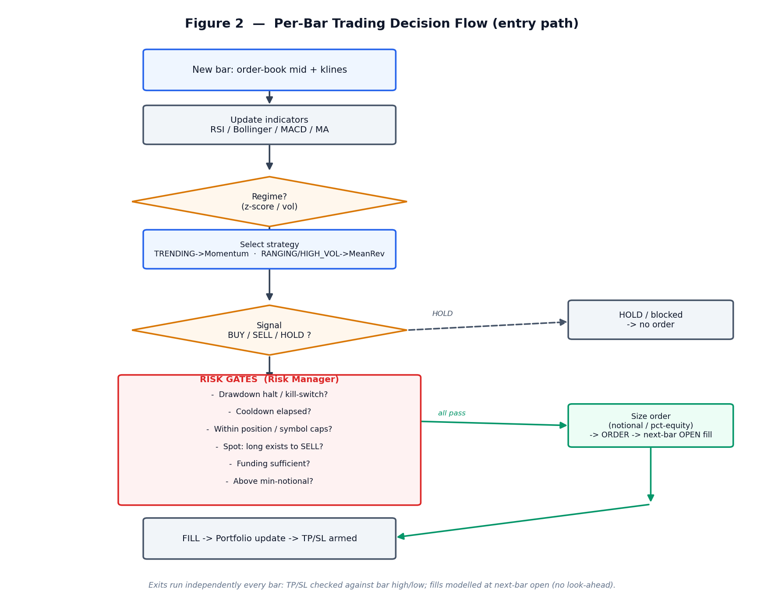
Figure 2 — Per-bar trading decision flow (entry path).
Signal generation: indicators recomputed each bar; at most one signal per symbol per signal interval (60s) to avoid over-reacting to noise.
Entry rules: regime selects the strategy; the strategy emits BUY/SELL/HOLD as in §4.
Exit rules: take-profit (+3%) / stop-loss (−3%) are evaluated every bar and run independently of the entry kill-switch, so an open position is always protected. In the backtest they are checked against the bar high/low to capture intrabar triggers.
Position sizing: configurable — fixed notional (default 100 USDT), fixed base quantity, percent-of-equity, or all-in — then clamped by hard per-order caps.
Trade filtering: cooldown between entries, minimum notional (dust filter), per-symbol and concurrent-position caps, funding check, and spot no-shorting (a SELL only reduces an existing long).
Execution assumptions: market orders fill at the next bar's open (no look-ahead); a 0.1% taker fee is charged on every fill.

7. Trading System Architecture
The system reuses the exact same modules in live trading and in backtesting; only the data producer and broker differ. Modules never call each other — each consumes one event and returns new events, which the engine routes (Figure 1).
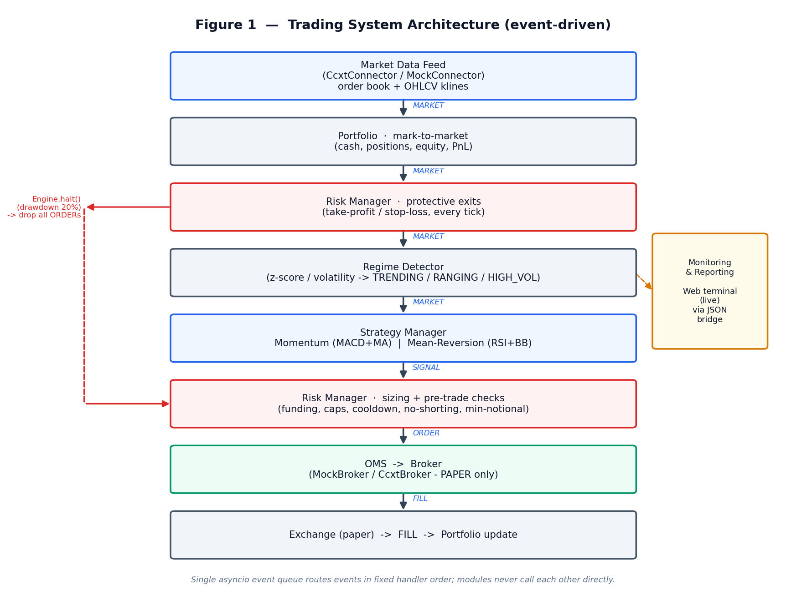
Figure 1 — Trading system architecture (event-driven pipeline).
Module | Responsibility
Data Retrieval | CcxtConnector (real Binance mainnet, read-only) or MockConnector; supplies order book + klines.
Signal Generation | Strategy Manager + Momentum / Mean-Reversion strategies.
Decision / Regime | Regime Detector classifies the market; manager selects the strategy.
Risk / Decision Engine | Risk Manager: pre-trade sizing & checks, plus protective TP/SL exits.
Order Management | OMS tracks order lifecycle, TTL and cancellation.
Execution | Broker — MockBroker (sim) or CcxtBroker (paper demo/testnet, hard-locked).
Position Tracking | Portfolio: cash, positions, realised/unrealised PnL, equity.
Monitoring & Reporting | Web terminal (browser UI) over a JSON bridge (/api/state, /api/control) + standalone backtester with HTML reports.

7.1 Web Terminal — Monitoring and Control Interface
The monitoring and control surface is a single-page browser terminal styled after a professional trading desk. It communicates with the running bot exclusively through the JSON bridge described above (there is no direct coupling), so the interface can be developed, deployed and restarted independently of the trading engine.
Layout (Figure 10). A fixed top bar carries the brand, the view navigation (Terminal / Backtest / Settings), a connection-health indicator and a theme toggle. Beneath it, an account strip presents live metric chips — equity, total / realised / unrealised PnL, cash and drawdown — alongside three control buttons (Enable, Stop, Kill). The main Terminal view is a three-panel grid: a watchlist with a per-symbol regime badge and price (left); a candlestick chart with selectable timeframes and an OHLC read-out (centre); and an order-book ladder with depth-imbalance plus a chronological live feed of signals, fills and regime changes (right). Two further views — Backtest (performance cards with equity and drawdown curves) and Settings (order, sizing, exit and risk parameters) — complete the terminal.
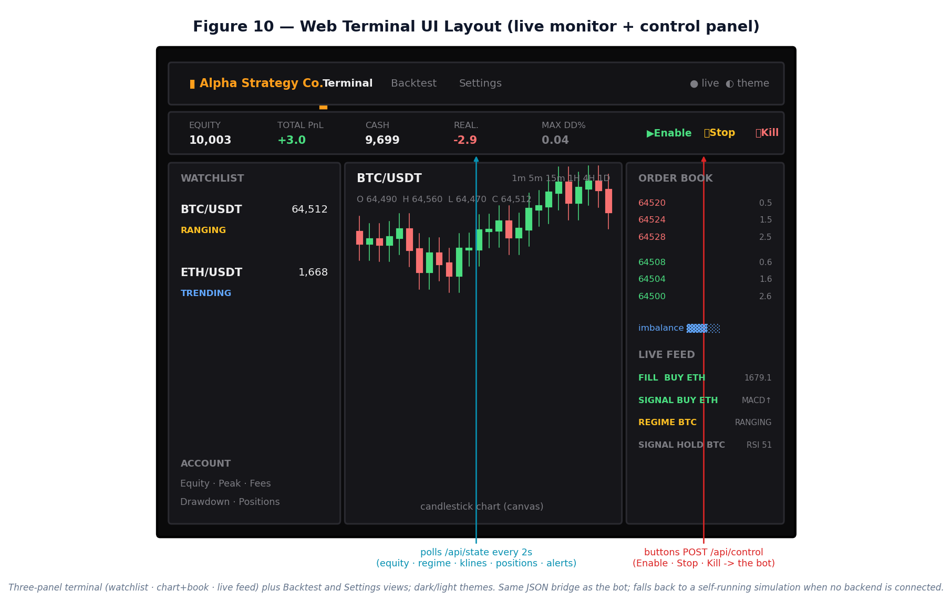
Figure 10 — Web terminal UI layout: top bar, account/metric strip, and the three-panel terminal, with the live data and control channels annotated.
Data flow. The page polls /api/state every two seconds and overlays the bot's real state (equity curve, per-symbol regime, klines, positions and the alerts feed, which surfaces the risk-tier events of §8.1). The three control buttons POST to /api/control, which the bot consumes on its next market tick. The Backtest view calls /api/backtest, which runs the real Part-8 backtester for the chosen symbol, timeframe and window and returns the equity curve, drawdown, trade markers and performance metrics. When no backend is connected the page falls back to a self-contained simulation, so the interface remains demonstrable as a static deployment.
Design rationale. A dark theme (with a light, broadsheet-style alternative) and monospaced numerics follow trading-desk conventions for at-a-glance reading; a consistent colour language (green / amber / red) encodes buy / hold / sell and healthy / warning / critical states across every panel, reducing the cognitive load of monitoring two symbols in real time.

8. Risk Management Framework
This is the core of the system. Risk is enforced at two points every cycle: protective exits on each market mark, and a pre-trade gauntlet on each signal. Controls are layered — including a three-tier drawdown framework (soft de-risk → daily pause → hard halt) — so a single failure cannot cause uncontrolled loss.

Risk measures monitored
- Position exposure — marked notional per symbol and in aggregate.
- Volatility — rolling volatility feeds the regime classifier.
- Maximum drawdown — equity vs running peak, checked every signal.
- Equity / PnL — realised and unrealised, marked every bar.

Risk controls implemented
Control | Type | Setting / behaviour
Soft drawdown de-risk | Soft | At −10% drawdown, scale new-order size to 50% to reduce exposure early
Daily-loss limit | Soft | Pause NEW entries for the day if day P&L ≤ −5%; auto-resume next day
Drawdown circuit breaker | Hard | Halt engine if equity falls 20% below peak; all further orders dropped
Stop-loss / take-profit | Hard | ±3% from entry, checked every bar, bypasses kill-switch
Position sizing | Soft | Notional / base / %-equity / all-in, then clamped
Per-order caps | Hard | Max notional and max base qty per order
Per-symbol exposure cap | Hard | Cap total marked notional per symbol; shrink/deny BUY
Concurrent-position cap | Hard | Max number of symbols held at once
Cooldown | Soft | Minimum time between entries on the same symbol
Funding check | Hard | A BUY can never spend more cash than available
No-shorting (spot) | Hard | A SELL only reduces an existing long
Minimum notional | Soft | Skip dust orders below exchange minimum
Kill-switch | Hard | Master flag / web-terminal Stop disables new entries
Answer to the key question — how are losses controlled if the strategy misbehaves? Independently of any signal, the position-level stop-loss caps the loss on any single trade, and the account-level drawdown circuit breaker halts all trading at −20%. In our 1-year test this was not theoretical: the circuit breaker fired (Figure 4), froze new orders, and capped the loss — exactly the intended fail-safe behaviour.

8.1 Tiered drawdown framework — design and test
A single hard halt at −20% is blunt: it only acts after a large loss. We therefore implemented a three-tier framework and re-ran the full year to test it:
- Tier 1 (soft, −10%): de-risk — scale new-order size to 50% to cut exposure before the hard limit.
- Tier 2 (soft, −5%/day): daily-loss pause — block new entries for the rest of the day, auto-resume next day; protective exits still run.
- Tier 3 (hard, −20%): circuit breaker — permanent halt, human intervention required.
Configuration | Return % | Max DD % | Trades | Fees | Hard halt
Single hard halt (−20%) | -20.14 | 20.28 | 19,180 | 1,917 | fired
Tiered (soft + daily + hard) | -20.01 | 20.05 | 28,205 | 1,906 | fired
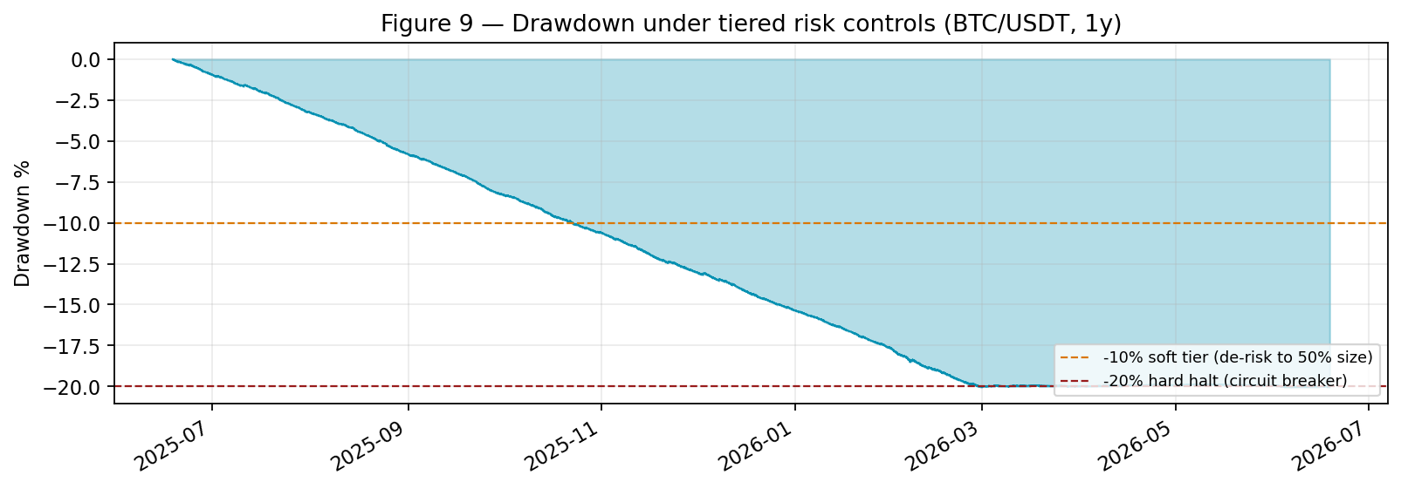
Figure 9 — Drawdown under the tiered framework; soft tier (−10%) and hard halt (−20%) marked.
What the test reveals (an important risk lesson). The tiers fired as designed — the soft −10% de-risk activated and the hard −20% halt still bounded the loss — yet the outcome was essentially unchanged (-20.01% vs -20.14%). The daily-loss limit never triggered, because this strategy does not fail through a sudden daily crash: it fails through a slow, structural bleed of transaction costs spread over months. Tiered controls protect against sudden adverse moves and volatility spikes — exactly the failure mode they target — but they cannot rescue a strategy whose net edge is negative. For this strategy the hard halt remains the only binding control; the real remedy is to fix the edge/cost problem, not to add more risk tiers.

9. Backtesting Methodology
- Data source: real Binance mainnet OHLCV (read-only, no key). Sub-minute studies fetch 1s klines and aggregate to the target bar.
- Sample period: trailing 365 days, 1-minute bars (~525,600 bars) for the headline run; multiple timeframes for robustness.
- Engine: the backtester replays history through the identical live modules (portfolio, regime, strategies, risk), so it validates the real trading code, not a re-implementation.
- Transaction costs: 0.1% taker fee on every fill.
- Execution / slippage: market orders fill at the next bar's open; intrabar TP/SL uses the bar high/low. No additional slippage model (a conservative limitation, see §14).
Look-ahead and overfitting mitigation. Three correctness fixes were made and are integral to the methodology:
- No look-ahead: orders generated on bar i fill at bar i+1's open, never on the same close that produced the signal.
- Honest exits: TP/SL are tested against the bar high/low so intrabar triggers are not missed.
- Time-correct gating: a timestamp bug was found and fixed whereby signals defaulted to wall-clock time, which silently disabled the cooldown gate in fast replay (the backtest appeared to make only 2 trades). After the fix the backtest faithfully reproduces live trading frequency.
Overfitting controls: a 70/30 train/test split, cross-asset validation on ETH, and parameter-sensitivity sweeps (§12). We explicitly did not tune parameters on the test set.

10. Performance Analysis
Results are shown for both traded symbols, 1 year of 1-minute bars, on the original configuration. ETH/USDT serves as an independent cross-asset check (see also §12).

10.1 BTC/USDT
Headline metrics for BTC/USDT, 1 year, 1-minute bars:
Metric | Value
Bars replayed | 525,600
Number of trades | 19,180 (9,585 round trips)
Win rate | 36.5%
Total return | -20.14%
Buy & hold benchmark | -38.92%
Maximum drawdown | 20.28% (circuit breaker fired)
Sharpe (annualised) | -25.77
Gross profit factor | 0.91
Max consecutive losses | 33
Transaction costs paid | 1,916.513 USDT
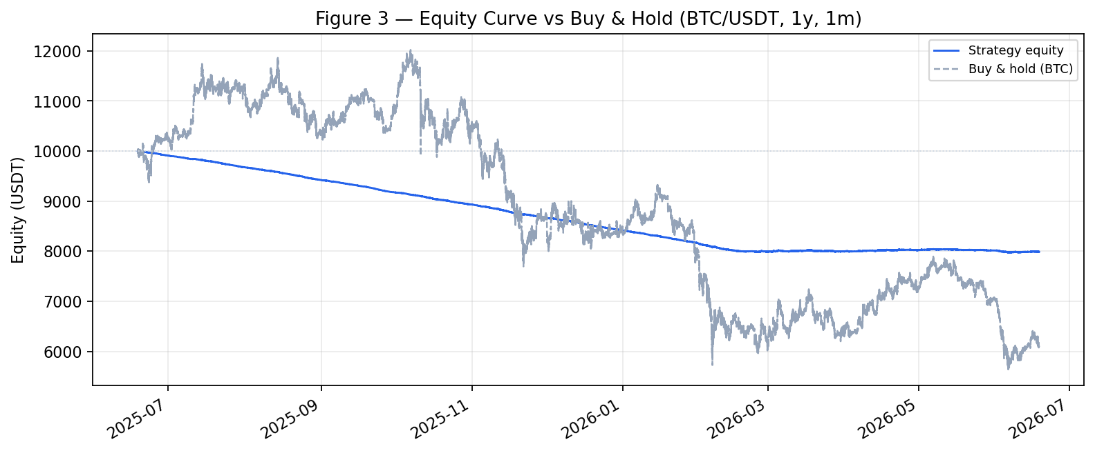
Figure 3 — Equity curve vs buy-and-hold benchmark.
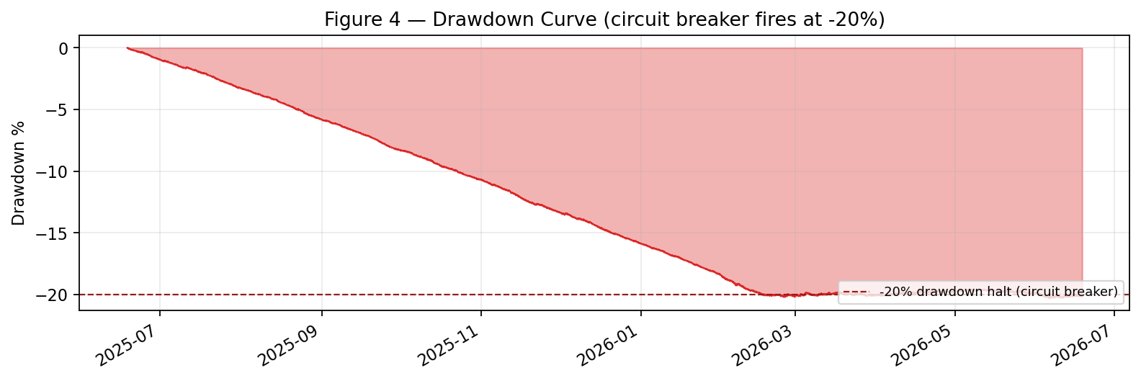
Figure 4 — Drawdown curve; the −20% circuit breaker halts trading.
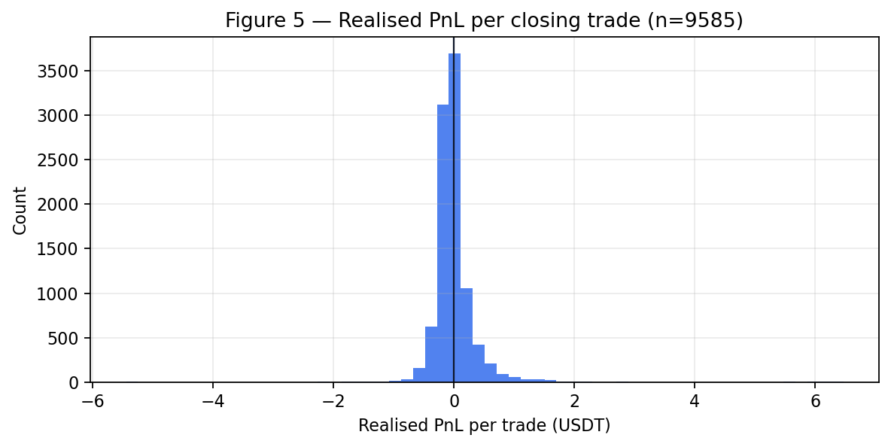
Figure 5 — Distribution of realised PnL per closing trade (BTC/USDT).
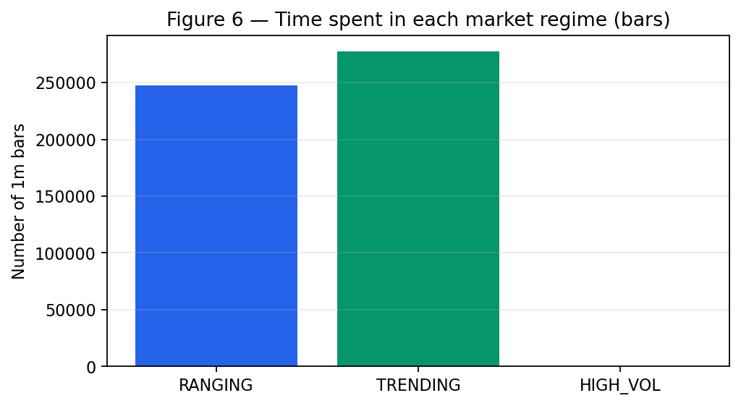
Figure 6 — Time spent in each market regime (BTC/USDT).
Interpretation (risk-adjusted, not absolute). The strategy lost 20.14% while buy-and-hold lost 38.92%; it "outperformed" only because the circuit breaker stopped it after a 20% loss, not through skill. The profit factor of 0.91 (<1) and the fact that fees (1,916.513) approximate the entire loss show the net edge is negative and dominated by transaction costs.

10.2 ETH/USDT (cross-asset)
The identical configuration run on ETH/USDT over the same year:
Metric | Value
Bars replayed | 525,600
Number of trades | 19,608 (9,794 round trips)
Win rate | 35.1%
Total return | -20.14%
Buy & hold benchmark | -31.26%
Maximum drawdown | 20.26% (circuit breaker fired)
Sharpe (annualised) | -23.57
Gross profit factor | 0.98
Max consecutive losses | 23
Transaction costs paid | 1,960.012 USDT
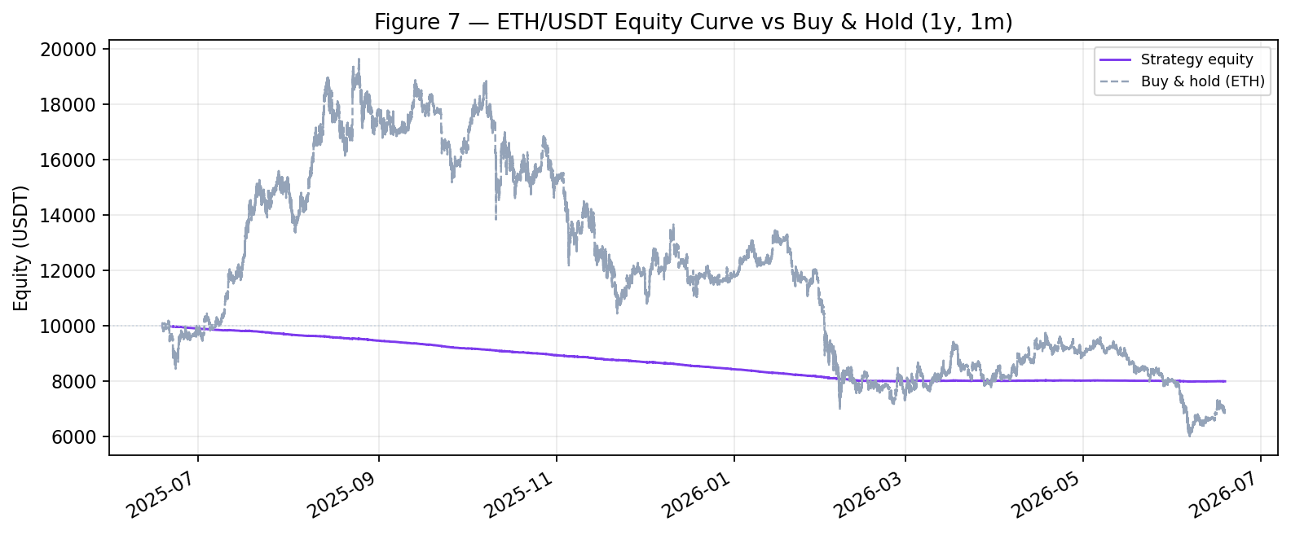
Figure 7 — ETH/USDT equity curve vs buy-and-hold.
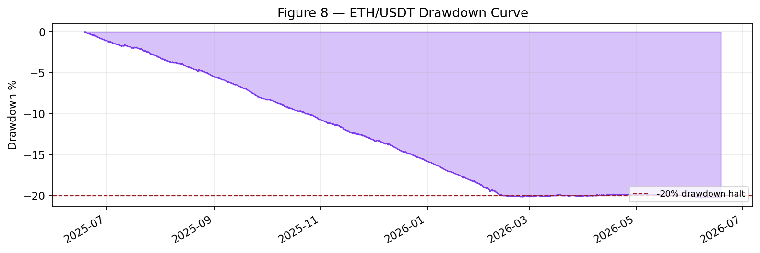
Figure 8 — ETH/USDT drawdown curve.
Cross-asset consistency. ETH/USDT reproduces the BTC pattern — the same regime-switching logic, very low win rate, and a loss dominated by transaction costs — confirming the behaviour is structural to the strategy and not specific to one asset.

11. Strategy Optimisation
We tested structural changes (not curve-fitting), validating each on held-out data.
Timeframe sweep (1 year, default rules):
Timeframe | Trades | Return % | Max DD % | Fees
1m | 19,180 | -20.14 | 20.28 | 1,916
5m | 6,014 | -6.63 | 6.63 | 602
15m | 2,128 | -2.45 | 2.52 | 215
1h | 593 | -1.35 | 1.64 | 65
Finding: longer bars monotonically improve every metric — confirming that fee drag, not signal direction, drives the loss. Moving from 1m to 1h cut the loss from −20% to −1.35%, fees by 97%, and avoided the drawdown halt.
Other levers tested: reducing entry frequency (cooldown) had little effect once on 1h; a TP/SL grid (105 combinations) found no profitable setting; a signal-parameter search reached a break-even ceiling. A fee-sensitivity test showed the configuration becomes marginally positive out-of-sample only when costs fall to ~0.02% (maker-level), i.e. the edge exists gross but is consumed by taker fees.

12. Robustness Testing and Validation
- Train/test split: parameters examined on the first 70% of data, evaluated on the last 30%. The 'longer timeframe is better' result held out-of-sample (1h test ≈ −0.2%).
- Cross-asset validation: the same configuration was run on ETH/USDT (§10.2, Figures 7–8); results were consistent with BTC — same low win rate and fee-dominated loss — indicating no asset-specific overfit.
- Parameter sensitivity: MA windows, RSI thresholds and regime z-threshold were swept; the best out-of-sample outcomes clustered at a higher regime threshold (trade only strong trends), but none produced a robust positive return.
- Regime analysis: performance was attributed across TRENDING / RANGING / HIGH_VOL states (Figure 6); no regime delivered a durable positive edge after costs.
Answer to the key question — would it work under different conditions? Across timeframes, two assets, train/test splits and parameter grids, the net edge is consistently ≈ 0. The negative result is itself robust: the strategy does not have a hidden profitable regime, and any single positive backtest would be statistical luck.

13. Production Deployment Considerations
The codebase already separates the concerns a production system needs:
- Market-data infrastructure: data feed is decoupled from the trading venue; the bot can read real mainnet data while trading on a paper account.
- Order gateway / OMS: an OMS manages order lifecycle, TTL and cancellation; the broker is abstracted (mock / paper / could extend to live).
- Risk systems: pre-trade checks and a hard kill-switch / circuit breaker run inside the engine; a halt drops all subsequent orders.
- Monitoring & alerting: a browser-based web terminal (the frontend) polls the bot's live state via /api/state and shows equity, positions, regime, signals and an alerts feed (including the risk-tier events), with Enable/Stop/Kill controls that POST to /api/control.
- Reconciliation: the portfolio's internal positions can be reconciled against broker balances (fetch_balance) — a necessary live-trading safeguard.
Safety note: the broker is hard-locked to a paper venue (testnet/demo). A guard refuses to run against the production endpoint, so the system cannot place a real-money order.

14. Limitations and Future Enhancements
- No positive net edge: the dominant limitation — gross signal edge is small and eroded by 0.1% taker fees.
- Sampling-rate dependence: the regime window is defined in samples, so its effective horizon differs between the 10s live feed (5 min) and 1m backtest (30 min). It should be redefined in time units.
- Execution realism: no slippage or partial-fill model; limit-order maker rebates are not yet modelled (which the fee-sensitivity analysis shows would matter).
- Risk tiers vs failure mode: we implemented a tiered framework (soft de-risk + daily-loss pause + hard halt, §8.1), but it could not improve the outcome because the strategy fails through a slow cost bleed, not a sudden crash — risk tiers protect exposure, they do not create edge.
- Unimplemented controls: trailing stop and historical VaR are still stubbed; a margin/leverage framework would be needed for a futures (shorting) version.
Future work: redefine the regime window in time; add a maker/limit execution path and slippage model; improve signal quality (multi-timeframe confirmation, volatility and volume filters) to lift win rate above break-even; and upgrade the regime detector to a Hidden Markov model.

15. Conclusion
Key findings. We built a complete, professionally structured, event-driven trading system and validated it rigorously. The trading and risk logic are correct: the order lifecycle works end-to-end and the drawdown circuit breaker fired exactly as designed, capping losses. The strategy's net edge, however, is approximately zero and is consumed by transaction costs.
Strengths. Clean separation of data, signal, risk and execution; identical code in live and backtest; layered, demonstrably-effective risk controls; rigorous, honest validation that surfaced and fixed real methodology bugs (look-ahead and a cooldown timestamp error).
Weaknesses. The signal has no durable edge after fees at intraday horizons; several advanced risk measures (VaR, trailing stop) remain unimplemented; execution modelling is simplified.
Overall assessment — would this be suitable for real capital? No. As a trading strategy it should not be deployed with real money: its expected return after costs is negative-to-zero. As a trading system and risk-management framework it is sound, and it is exactly the kind of controlled environment in which a strategy with genuine alpha could be safely deployed. The project achieves its true objective: demonstrating professional research, system design, and risk management — not a lucky backtest.

