Interim 1 Report

**Group Members**:

Caleb Twiggs (twigg015)

Declan McGraw (mcgra406)

Noah Gilbertson (gilb0360)

**wget request and response**:

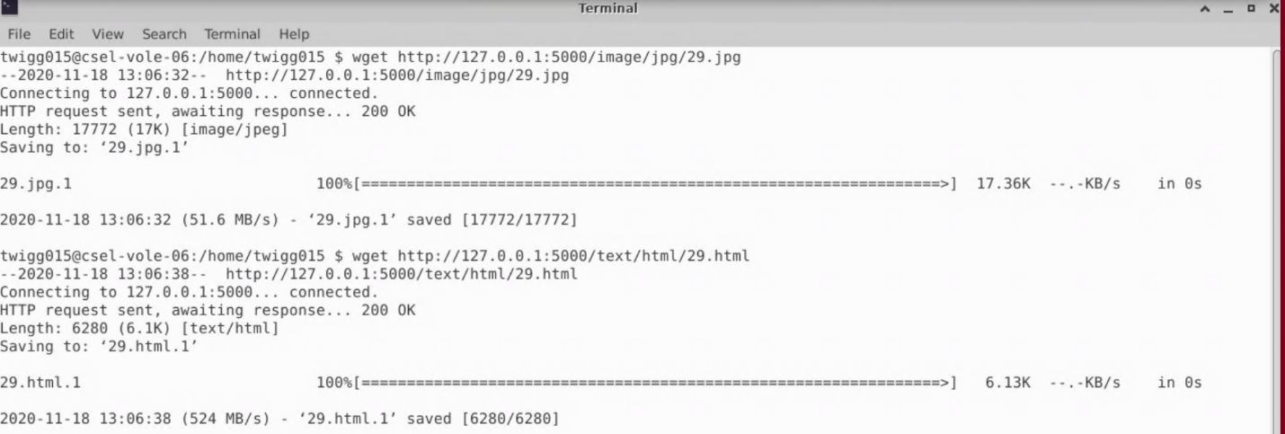

**Plan for work distribution**:

Caleb, Declan, and Noah will distribute the remaining tasks evenly.

We work well together, so it will also be more of a group effort.

**Plan for extra credit A and B**:

We plan to implement both extra credit A and B.  
For the dynamic working thread pool, will think in terms of finding a relation between pending requests and number of worker

threads.

For the caching, since we are confident with the buffering issues, we think we can tackle this fairly easily. We will use the FIFO replacement policy.