Anthony Giles

August 25, 2022

IT FDN 100 B

Assignment 07

Pickling and Error Handling

# Introduction

This week’s assignment involves creating a simple program that will demonstrate the pickling and error handling functions in python. We also will be uploading program data to GitHub.

# Creating the Program

File was created in PyCharm using header per instructions(Figure 1)

***Figure 1: Shows starter file with header***

# Create Pickling example code

Pickle is a serialization and deserialization module. It basically converts Python objects to byte stream and then back again. Very usual for anything that requires a lot of processing and ends in an object. Code was written to display pickling a python dictionary to a binary file then unpickling data from file.(Figure 2). Program pauses and request confirmation of binary file before unpacking and printing data to console.

***Figure 2: Shows pickle demo code***

Create Error Handling Code

Created code demonstrated error handling for a generic error and on for a class-based error. The code will request a file name from the user and attempt to open. Asked user for input and processed for generic error. (Figure 3) Asked user for input and created code for specific error.(Figure 3.1)

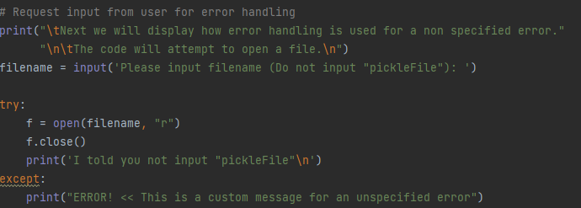

***Figure 3: Shows code for generic error***

***Figure 3.1: Shows code for specific error***

# Executing Program

Per instructions program was executed from PyCharm. (Figure 4)

***Figure 4: Shows program execution***

Display data file from within PyCharm. (Figure 4.1)

***Figure 4.1: Shows item entry in data file***

Per instructions program was executed from terminal. (Figure 4.2)

***Figure 4.2: Shows program execution***

Opened data file to confirm data entry. (Figure 4.3)

***Figure 4.3: Shows binary file opened Notepad***

# Summary

This week’s assignment involved creating a simple program that demonstrated how error handling and pickling worked.