杭州电子科技大学 计算机网络 实验报告

|  |  |  |  |  |  |
| --- | --- | --- | --- | --- | --- |
| 姓名 |  | 学号 |  | | |
| 组别 | 第八组 | 时间 | 2019年10月20日 | | |
| 小组成员 |  | | | | |
| 实验名称 | RIP 路由协议基本配置 | | | 序号 | 10 |

一、实验目的：

掌握在路由器上如何配置 RIP 路由协议。

二、实验内容及原理：

RIP(Routing Information Protocols，路由信息协议)是应用较早、使用较普遍的 IGP

(Interior Gateway Protocol，内部网关协议)，适用于小型同类网络，是典型的距离矢量 (distance-vector)协议。

RIP 协议以跳数做为衡量路径开销的，RIP 协议里规定最大跳数为 15。

RIP 在构造路由表时会使用到 3 种计时器:更新计时器、无效计时器、刷新计时器。 它让每台路由器周期性地向每个相邻的邻居发送完整的路由表。路由表包括每个网络或子网 的信息，以及与之相关的度量值。

三、实验设备及拓扑结构：

路由器2台，PC机4台，PC机用于模拟各自所在网络对其他子网的访问。

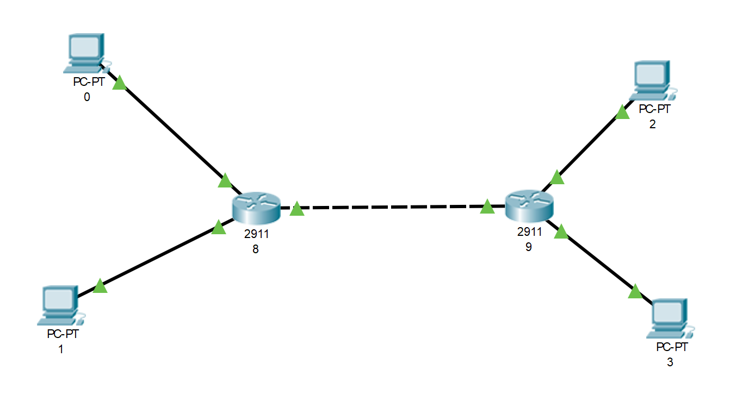

四、实验过程及结果

第一步:配置两台路由器的主机名、接口 IP 地址

RSR20#configure terminal

Enter configuration commands, one per line. End with CNTL/Z. RSR20(config)#hostname RouterA

RouterA(config)#

RouterA(config)#interface fastEthernet 0/0

RouterA(config-if)#ip address 192.168.1.1 255.255.255.0

RouterA(config-if)#no shutdown

RouterA(config-if)#exit

RouterA(config)#

RouterA(config)#interface loopback 0

RouterA(config-if)#Aug 15 23:46:32 RouterA %7:%LINE PROTOCOL CHANGE: Interface Loopback 0, changed state to UP

RouterA(config-if)#ip address 172.16.1.1 255.255.255.0

RouterA(config-if)#exit

RouterA(config)#

RouterA(config)#interface loopback 1

RouterA(config-if)#Aug 15 23:47:00 RouterA %7:%LINE PROTOCOL CHANGE: Interface Loopback 1, changed state to UP

RouterA(config-if)#ip address 172.16.2.1 255.255.255.0

RouterA(config-if)#exit

RSR20#configure terminal

Enter configuration commands, one per line. End with CNTL/Z. RSR20(config)#hostname RouterB

RouterB(config)#

RouterB(config)#interface fastEthernet 0/0

RouterB(config-if)#ip address 192.168.1.2 255.255.255.0

RouterB(config-if)#no shutdown

RouterB(config-if)#exit

RouterB(config)#

RouterB(config)#interface loopback 0

RouterB(config-if)#Aug 8 21:00:00 RouterB %7:%LINE PROTOCOL CHANGE: Interface Loopback 0, changed state to UP

RouterB(config-if)#ip address 10.1.1.1 255.255.255.0

RouterB(config-if)#exit

64 RouterB(config)#

RouterB(config)#interface loopback 1

RouterB(config-if)#Aug 8 21:00:28 RouterB %7:%LINE PROTOCOL CHANGE: Interface Loopback 1, changed state to UP

RouterB(config-if)#ip address 10.2.2.1 255.255.255.0

RouterB(config-if)#exit

第二步:在两台路由器上配置 RIP 路由协议

RouterA(config)#router rip

RouterA(config-router)#network 192.168.1.0 RouterA(config-router)#network 172.16.1.0

RouterA(config-router)#exit RouterB(config)#router rip RouterB(config-router)#network 192.168.1.0

RouterB(config-router)#network 10.0.0.0

RouterB(config-router)#exit

第三步:查看 RIP 配置信息，路由表

RouterA#show ip route

Codes: C - connected, S - static, R - RIP B - BGP O - OSPF, IA - OSPF inter area

N1 - OSPF NSSA external type 1, N2 - OSPF NSSA external type 2 E1 - OSPF external type 1, E2 - OSPF external type 2

i - IS-IS, L1 - IS-IS level-1, L2 - IS-IS level-2, ia - IS-IS inter area

* - candidate default

Gateway of last resort is no set

R 10.0.0.0/8 [120/1] via 192.168.1.2, 00:00:17, FastEthernet 0/0 C 172.16.1.0/24 is directly connected, Loopback 0

C 172.16.1.1/32 is local host.

C 172.16.2.0/24 is directly connected, Loopback 1

C 172.16.2.1/32 is local host.

C 192.168.1.0/24 is directly connected, FastEthernet 0/0

C 192.168.1.1/32 is local host.

RouterA#

Routing Protocol is "rip"

Sending updates every 30 seconds, next due in 21 seconds

Invalid after 180 seconds, flushed after 120 seconds

Outgoing update filter list for all interface is: not set

Incoming update filter list for all interface is: not set

Default redistribution metric is 1

Redistributing:

Default version control: send version 1, receive any version Interface Send Recv Key-chain

65

FastEthernet 0/0 Loopback 0

Loopback 1

Routing for Networks: 172.16.0.0 192.168.1.0

Distance: (default is 120)

12 12

12

1 1

1

RouterA#

RouterB#show ip route

Codes: C - connected, S - static, R - RIP B - BGP

O - OSPF, IA - OSPF inter area

N1 - OSPF NSSA external type 1, N2 - OSPF NSSA external type 2

E1 - OSPF external type 1, E2 - OSPF external type 2

i - IS-IS, L1 - IS-IS level-1, L2 - IS-IS level-2, ia - IS-IS inter area

* - candidate default

Gateway of last resort is no set

C 10.1.1.0/24 is directly connected, Loopback 0

C 10.1.1.1/32 is local host.

C 10.2.2.0/24 is directly connected, Loopback 1

C 10.2.2.1/32 is local host.

R 172.16.0.0/16 [120/1] via 192.168.1.1, 00:00:12, FastEthernet 0/0 C 192.168.1.0/24 is directly connected, FastEthernet 0/0

C 192.168.1.2/32 is local host.

RouterA#show ip rip database

10.0.0.0/8 auto-summary

10.0.0.0/8

[1] via 192.168.1.2 FastEthernet 0/0 00:09 172.16.0.0/16 auto-summary 172.16.1.0/24

[1] directly connected, Loopback 0 172.16.2.0/24

[1] directly connected, Loopback 1 192.168.1.0/24 auto-summary 192.168.1.0/24

[1] directly connected, FastEthernet 0/0

RouterA#show ip rip interface FastEthernet 0/0 is up, line protocol is up Routing Protocol: RIP

Receive RIPv1 and RIPv2 packets

Send RIPv1 packets only

Passive interface: Disabled

66

Split horizon: Enabled

V2 Broadcast: Disabled

Multicast registe: Registed

Interface Summary Rip:Not Configured

IP interface address:192.168.1.1/24 FastEthernet 0/1 is down, line protocol is down RIP is not enabled on this interface

Null 0 is up, line protocol is up

RIP is not enabled on this interface

Loopback 0 is up, line protocol is up

Routing Protocol: RIP

Receive RIPv1 and RIPv2 packets

Send RIPv1 packets only

Passive interface: Disabled

Split horizon: Enabled

V2 Broadcast: Disabled

Multicast registe: Registed

Interface Summary Rip:Not Configured

IP interface address: 172.16.1.1/24

Loopback 1 is up, line protocol is up

Routing Protocol: RIP

Receive RIPv1 and RIPv2 packets

Send RIPv1 packets only

Passive interface: Disabled

Split horizon: Enabled

V2 Broadcast: Disabled

Multicast registe: Registed

Interface Summary Rip:Not Configured

IP interface address:172.16.2.1/24

RouterB#show ip rip

Routing Protocol is "rip"

Sending updates every 30 seconds, next due in 21 seconds Invalid after 180 seconds, flushed after 120 seconds Outgoing update filter list for all interface is: not set Incoming update filter list for all interface is: not set Default redistribution metric is 1

Redistributing:

Default version control: send version 1, receive any version

Interface

FastEthernet 0/0 Loopback 0

Send Recv Key-chain

1 12 1 12

67

Loopback 1 1 12

Routing for Networks: 10.0.0.0

192.168.1.0

Distance: (default is 120)

RouterB#show ip rip database 10.0.0.0/8 auto-summary 10.1.1.0/24

[1] directly connected, Loopback 0 10.2.2.0/24

[1] directly connected, Loopback 1 172.16.0.0/16 auto-summary 172.16.0.0/16

[1] via 192.168.1.1 FastEthernet 0/0 00:08 192.168.1.0/24 auto-summary 192.168.1.0/24

[1] directly connected, FastEthernet 0/0

RouterB#show ip rip interface

FastEthernet 0/0 is up, line protocol is up Routing Protocol: RIP

Receive RIPv1 and RIPv2 packets

Send RIPv1 packets only

Passive interface: Disabled

Split horizon: Enabled

V2 Broadcast: Disabled

Multicast registe: Registed

Interface Summary Rip:Not Configured

IP interface address:192.168.1.2/24 FastEthernet 0/1 is down, line protocol is down RIP is not enabled on this interface

Null 0 is up, line protocol is up

RIP is not enabled on this interface

Loopback 0 is up, line protocol is up

Routing Protocol: RIP

Receive RIPv1 and RIPv2 packets

Send RIPv1 packets only

Passive interface: Disabled

Split horizon: Enabled

V2 Broadcast: Disabled

Multicast registe: Registed

Interface Summary Rip:Not Configured

68

IP interface address:10.1.1.1/24 Loopback 1 is up, line protocol is up Routing Protocol: RIP

Receive RIPv1 and RIPv2 packets Send RIPv1 packets only

Passive interface: Disabled

Split horizon: Enabled

V2 Broadcast: Disabled

Multicast registe: Registed

Interface Summary Rip:Not Configured IP interface address:10.2.2.1/24

第四步:测试网络连通性

RouterA#ping 10.1.1.1

Sending 5, 100-byte ICMP Echoes to 10.1.1.1, timeout is 2 seconds:

< press Ctrl+C to break >

!!!!!

Success rate is 100 percent (5/5), round-trip min/avg/max = 1/1/1 ms

RouterA#ping 10.2.2.1

Sending 5, 100-byte ICMP Echoes to 10.2.2.1, timeout is 2 seconds:

< press Ctrl+C to break >

!!!!!

Success rate is 100 percent (5/5), round-trip min/avg/max = 1/2/10 ms

RouterB#ping 172.16.1.1

Sending 5, 100-byte ICMP Echoes to 172.16.1.1, timeout is 2 seconds: < press Ctrl+C to break >

!!!!!

Success rate is 100 percent (5/5), round-trip min/avg/max = 1/1/1 ms

RouterB#ping 172.16.2.1

Sending 5, 100-byte ICMP Echoes to 172.16.2.1, timeout is 2 seconds: < press Ctrl+C to break >

!!!!!

Success rate is 100 percent (5/5), round-trip min/avg/max = 1/1/1 ms

第五步:用 debug 命令观察路由器接收和发生路由更新的情况

下面是一个完整的 RIP 路由器接收更新和发送更新的过程，从中可以看到 RouterB 接 收到了 RouterA 发送的更新，其中包含一条路由信息 172.16.0.0(可以看到水平分割原则 的作用)，然后刷新了路由表。

RouterB 本身发送的更新报文则在 Fa0/0、Lo0 和 Lo1 三个端口发出，采用广播的方式，

广播地址分别为 192.168.1.255，10.1.1.255，10.2.2.255，使用 UDP 的 520 端口。在水平 69

分割的原则下，每个端口发送的路由信息均不相同。

RouterB#debug ip rip

Aug 8 21:06:08 RouterB %7: [RIP] RIP recveived packet, sock=2125 src=192.168.1.1 len=24

Aug 8 21:06:08 RouterB

Aug 8 21:06:08 RouterB

Aug 8 21:06:08 RouterB %7:

Aug 8 21:06:08 RouterB %7: [RIP]

Aug 8 21:06:08 RouterB %7: [RIP]

Aug 8 21:06:08 RouterB %7: [RIP]

Aug 8 21:06:08 RouterB %7: [RIP]

Old path is: nhop=192.168.1.1 New path is: nhop=192.168.1.1

%7: [RIP] Cancel peer remove timer %7:[RIP] Peer remove timer shedule...

route-entry: family 2 ip 172.16.0.0 metric 1 Received version 1 response packet Translate mask to 16

routesrc=192.168.1.1 intf=1

routesrc=192.168.1.1

Aug 8 21:06:08 RouterB %7: [RIP]

Aug 8 21:06:08 RouterB %7: [RIP]

Aug 8 21:06:08 RouterB %7: [RIP]

Aug 8 21:06:08 RouterB %7: [RIP]

distance=120 metric=1 nexthop_num=1 distance=120 nexhop=192.168.1.1 ifindex=1

[172.16.0.0/16] RIP route refresh!

[172.16.0.0/16] RIP distance apply from 192.168.1.1! [172.16.0.0/16] ready to refresh kernel...

NSM refresh: IPv4 RIP Route 172.16.0.0/16

[RIP] [172.16.0.0/16] cancel route timer

[RIP] [172.16.0.0/16] route timer schedule... [RIP] Output timer expired to send reponse

[RIP] Prepare to send BROADCAST response... [RIP] Building update entries on FastEthernet 0/0

Aug 8 21:06:08 RouterB %7:

Aug 8 21:06:08 RouterB %7:

Aug 8 21:06:23 RouterB %7:

Aug 8 21:06:23 RouterB %7:

Aug 8 21:06:23 RouterB %7:

Aug 8 21:06:23 RouterB %7:

Aug 8 21:06:23 RouterB %7: [RIP] Send packet to 192.168.1.255 Port 520 on FastEthernet 0/0

Aug 8 21:06:23 RouterB %7: Aug 8 21:06:23 RouterB %7: Aug 8 21:06:23 RouterB %7: Aug 8 21:06:23 RouterB %7: Aug 8 21:06:23 RouterB %7: Aug 8 21:06:23 RouterB %7: Aug 8 21:06:23 RouterB %7: Aug 8 21:06:23 RouterB %7: Aug 8 21:06:23 RouterB %7: Aug 8 21:06:23 RouterB %7: Aug 8 21:06:23 RouterB %7: Aug 8 21:06:23 RouterB %7: Aug 8 21:06:23 RouterB %7:

[RIP] Prepare to send BROADCAST response... [RIP] Building update entries on Loopback 0

network 10.2.2.0 metric 1 network 172.16.0.0 metric 2 network 192.168.1.0 metric 1

[RIP] Send packet to 10.1.1.255 Port 520 on Loopback 0 [RIP] Prepare to send BROADCAST response...

[RIP] Building update entries on Loopback 1

network 10.1.1.0 metric 1 network 172.16.0.0 metric 2 network 192.168.1.0 metric 1

[RIP] Send packet to 10.2.2.255 Port 520 on Loopback 1 [RIP] Schedule response send timer

第六步：测试访问情况

从10.1.1.0/24子网内测试：

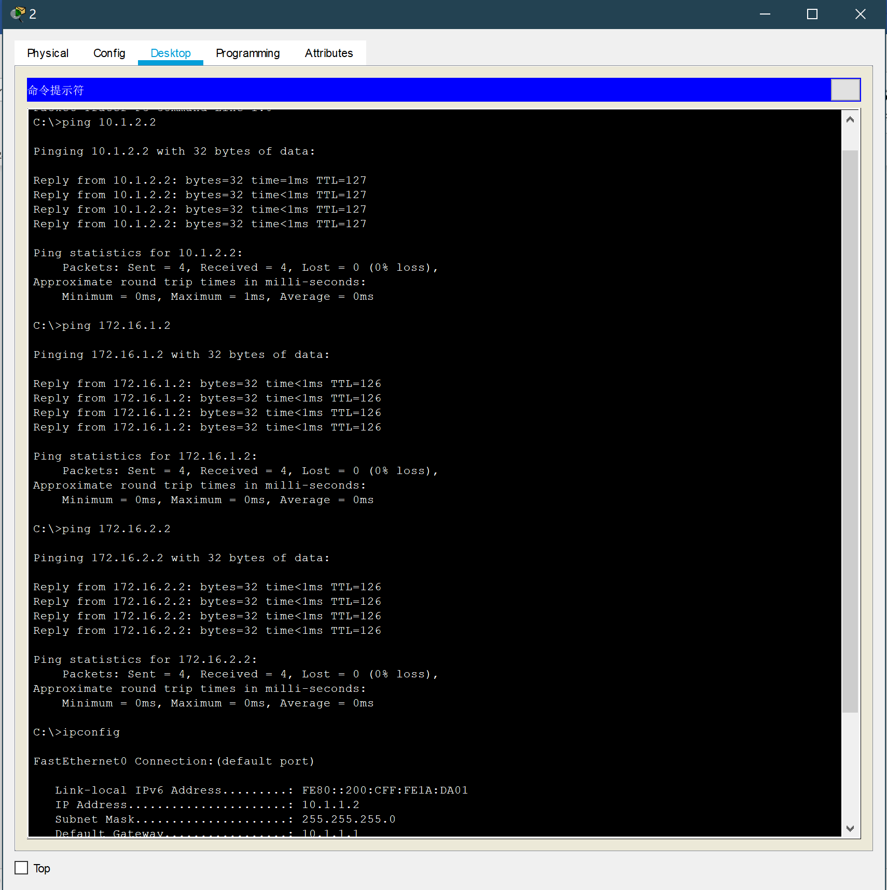

从10.1.2.0/24子网内测试：

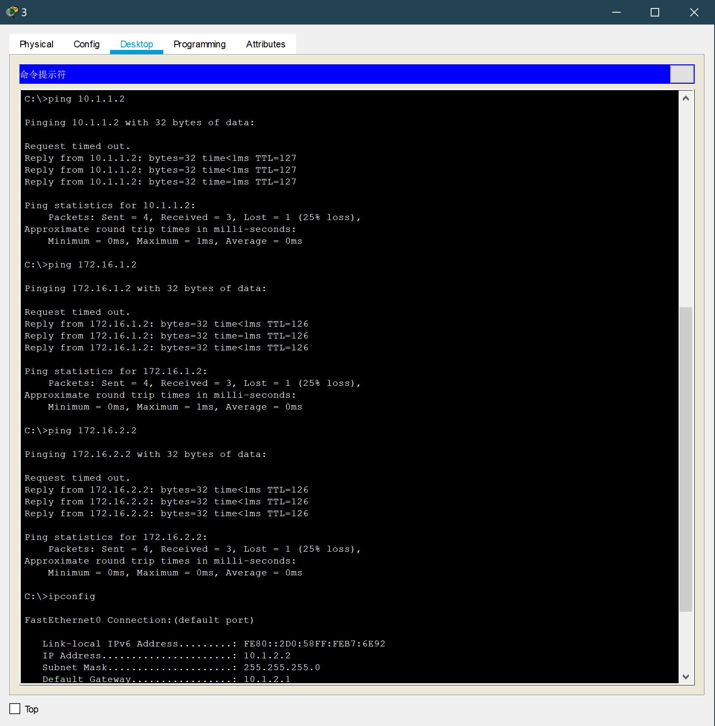

从172.16.1.0/24子网内测试：

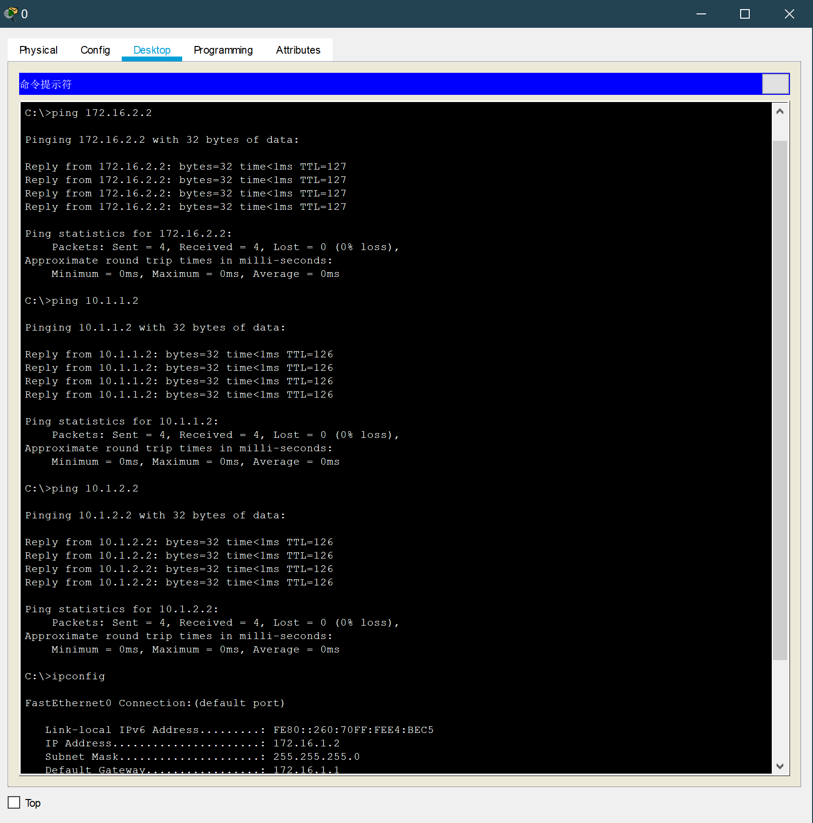

从172.16.2.0/24子网内测试：

