杭州电子科技大学 计算机网络 实验报告

|  |  |  |  |  |  |
| --- | --- | --- | --- | --- | --- |
| 姓名 |  | 学号 |  | | |
| 组别 | 第八组 | 时间 | 2019年10月20日 | | |
| 小组成员 | 1 | | | | |
| 实验名称 | 交换机的基本配置 | | | 序号 | 5 |

一、实验目的：

掌握交换机命令行各种操作模式的区别，能够使用各种帮助信息，以及用命令进行基本的配置。

二、实验内容及原理：

初步了解交换机命令行的各种操作模式，能进行基本的配置。

三、实验设备及拓扑结构：

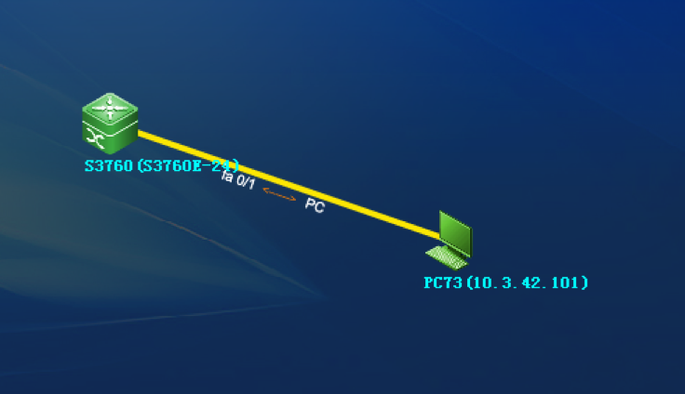

1. 实验过程及结果

一、交换机各个操作模式直接的切换

Swtich>enable  
!使用 enable 命令从用户模式进入特权模式 Swtich#configure terminal  
Enter configuration commands, one per line. End with CNTL/Z. !使用 configure terminal 命令从特权模式进入全局配置模式 Swtich(config)#interface fastEthernet 0/1  
!使用 interface 命令进入接口配置模式Swtich(config-if)#  
Swtich(config-if)#exit  
!使用 exit 命令退回上一级操作模式 Swtich(config)#interface fastEthernet 0/2  
Swtich(config-if)#end  
Swtich#  
!使用 end 命令直接退回特权模式

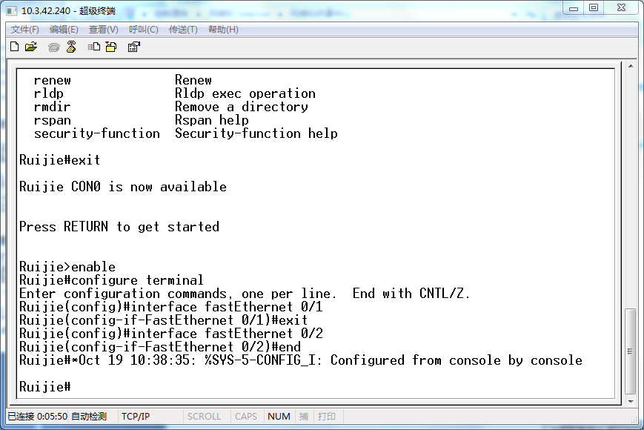

二、交换机命令行界面基本功能

Switch> ?

!显示当前模式下所有可执行的命令

disable enable exit  
help  
ping rcommand show telnet traceroute

Turn off privileged commands Turn on privileged commands

Exit from the EXEC  
Description of the interactive help system

Send echo messages  
Run command on remote switch

Show running system information Open a telnet connection

Trace route to destination

Swtich>en <tab>  
Swtich>enable  
!使用 tab 键补齐命令Swtich#con?  
configure connect !使用?显示当前模式下所有以“con”开头的命令

Swtich#conf t  
Enter configuration commands, one per line. End with CNTL/Z. Swtich(config)#  
!使用命令的简写Swtich(config)#interface ?!显示 interface 命令后可执行的参数

Aggregateport Dialer FastEthernet GigabitEthernet Loopback Multilink

Null  
Tunnel  
Virtual-ppp  
Virtual-template Virtual Template interface Vlan Vlan interface  
range Interface range command

Switch(config)#interface  
Swtich(config)#interface fastEthernet 0/1  
Switch(config-if)# ^Z  
Switch#  
!使用快捷键“Ctrl+Z”可以直接退回到特权模式Switch#ping 1.1.1.1  
sending 5, 100-byte ICMP Echos to 1.1.1.1,  
timeout is 2000 milliseconds.  
. ^C  
Switch#  
!在交换机特权模式下执行 ping 1.1.1.1 命令，发现不能 ping 通目标地址，交换机默

认情况下需要发送 5 个数据包，如不想等到 5 个数据包均不能 ping 通目标地址的反馈出 现，可在数据包未发出 5 个之前通过执行快捷键“Ctrl+C”终止当前操作。

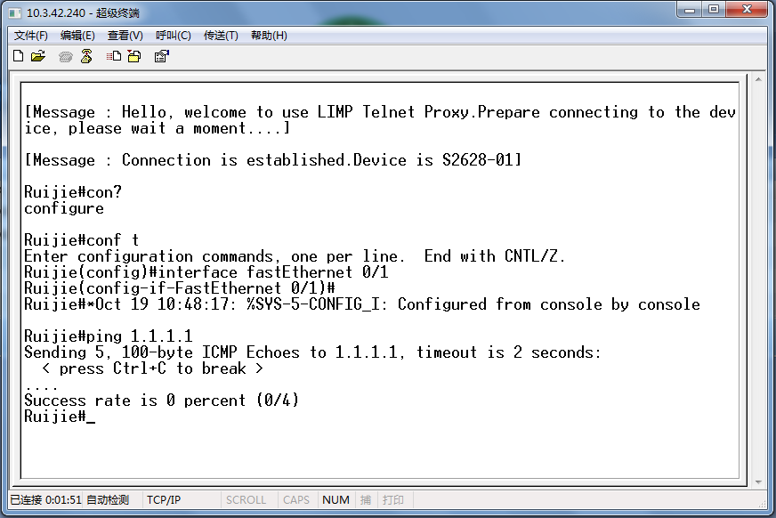

三、配置交换机的名称和每日提示信息

Switch(config)#hostname SW-1  
!使用 hostname 命令更改交换机的名称SW-1(config)#banner motd $  
!使用 banner 命令设置交换机的每日提示信息，参数 motd 指定以哪个字符为信息

的结束符

Enter TEXT message. End with the character '$'.  
Welcome to SW-1, if you are admin, you can config it.  
If you are not admin, please EXIT!  
$  
SW-1(config)#  
SW-1(config)#exit  
SW-1#Nov 25 22:04:01 %SYS-5-CONFIG_I: Configured from console by console SW-1#exit  
SW-1 CON0 is now available  
Press RETURN to get started  
Welcome to SW-1, if you are admin, you can config it.  
If you are not admin, please EXIT!  
SW-1>

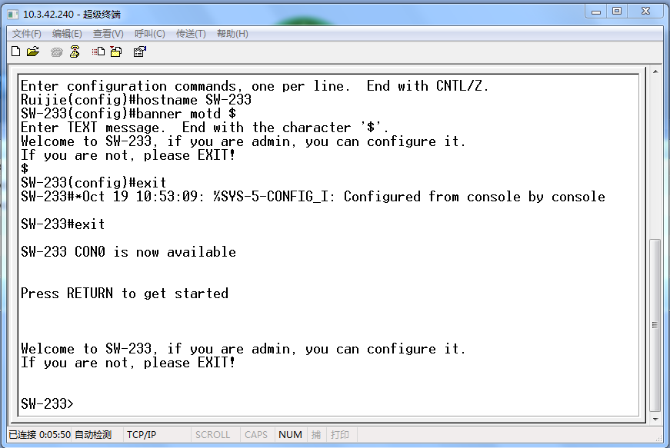

四、配置接口状态

锐捷全系列交换机 Fastethernet 接口默认情况下是 10M/100Mbit/s 自适应端口，双工 模式也为自适应(端口速率、双工模式可配置)。默认情况下，所有交换机端口均开启。

如果网络中存在一些型号比较旧的主机，还在使用 10Mbit/s 半双工的网卡，此时为了 能够实现主机之间的正常访问，应当在交换机上进行相应的配置，把连接这些主机的交换机 端口速率设为 10Mbit/s，传输模式设为半双工。

SW-1(config)#interface fastEthernet 0/1  
!进入端口 F0/1 的配置模式SW-1(config-if)#speed 10  
!配置端口速率为 10M  
SW-1(config-if)#duplex half  
!配置端口的双工模式为半双工SW-1(config-if)#no shutdown !开启端口，使端口转发数据。交换机端口默认已经开启。 SW-1(config-if)#description "This is a Accessport."

!配置端口的描述信息，可作为提示。

SW-1(config-if)#end  
SW-1#Nov 25 22:06:37 %SYS-5-CONFIG_I: Configured from console by console SW-1#  
SW-1#show interface fastEthernet 0/1  
Index(dec):1 (hex):1  
FastEthernet 0/1 is UP , line protocol is UP  
Hardware is marvell FastEthernet  
Description: "This is a Accessport."  
Interface address is: no ip address  
MTU 1500 bytes, BW 10000 Kbit  
Encapsulation protocol is Bridge, loopback not set  
Keepalive interval is 10 sec , set  
Carrier delay is 2 sec  
RXload is 1 ,Txload is 1  
Queueing strategy: WFQ  
Switchport attributes:  
interface's description:""This is a Accessport.""  
medium-type is copper  
lastchange time:329 Day:22 Hour: 5 Minute: 2 Second  
Priority is 0  
admin duplex mode is Force Half Duplex, oper duplex is Half  
admin speed is 10M, oper speed is 10M  
flow control admin status is OFF,flow control oper status is OFF  
broadcast Storm Control is OFF,multicast Storm Control is OFF,unicast Storm Control is OFF  
5 minutes input rate 0 bits/sec, 0 packets/sec  
5 minutes output rate 0 bits/sec, 0 packets/sec  
0 packets input, 0 bytes, 0 no buffer, 0 dropped  
Received 0 broadcasts, 0 runts, 0 giants  
0 input errors, 0 CRC, 0 frame, 0 overrun, 0 abort  
0 packets output, 0 bytes, 0 underruns , 0 dropped  
0 output errors, 0 collisions, 0 interface resets  
SW-1#

如果需要将交换机端口的配置恢复默认值，可以使用 default 命令。 SW-1(config)#interface fastEthernet 0/1  
SW-1(config-if)#default bandwidth  
!恢复端口默认的带宽设置

SW-1(config-if)#default description

!取消端口的描述信息

SW-1(config-if)#default duplex

!恢复端口默认的双工设置

SW-1(config-if)#end  
SW-1#Nov 25 22:11:13 %SYS-5-CONFIG_I: Configured from console by console SW-1#  
SW-1#show interface fastEthernet 0/1  
Index(dec):1 (hex):1  
FastEthernet 0/1 is UP , line protocol is UP  
Hardware is marvell FastEthernet  
Interface address is: no ip address  
MTU 1500 bytes, BW 100000 Kbit  
Encapsulation protocol is Bridge, loopback not set  
Keepalive interval is 10 sec , set  
Carrier delay is 2 sec  
RXload is 1 ,Txload is 1  
Queueing strategy: WFQ  
Switchport attributes:  
interface's description:""  
medium-type is copper  
lastchange time:329 Day:22 Hour:11 Minute:13 Second  
Priority is 0  
admin duplex mode is AUTO, oper duplex is Full  
admin speed is AUTO, oper speed is 100M  
flow control admin status is OFF,flow control oper status is ON  
broadcast Storm Control is OFF,multicast Storm Control is OFF,unicast Storm Control is OFF  
5 minutes input rate 0 bits/sec, 0 packets/sec  
5 minutes output rate 0 bits/sec, 0 packets/sec

0 packets input, 0 bytes, 0 no buffer, 0 dropped Received 0 broadcasts, 0 runts, 0 giants  
0 input errors, 0 CRC, 0 frame, 0 overrun, 0 abort 0 packets output, 0 bytes, 0 underruns , 0 dropped 0 output errors, 0 collisions, 0 interface resets

SW-1#

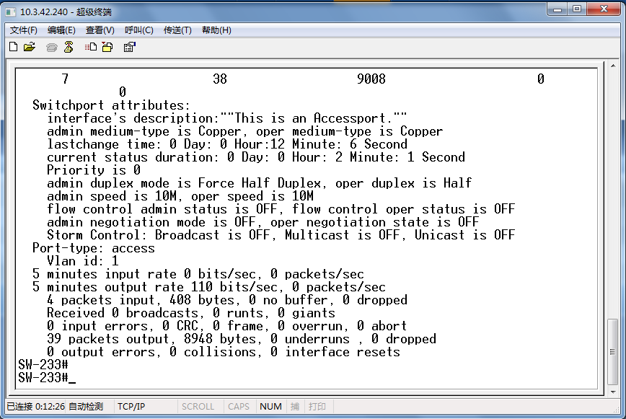

五、查看交换机的系统和配置信息

SW-1#show version

!查看交换机的系统信息

System description : Ruijie Dual Stack Multi-Layer Switch(S3760-24) By Ruijie Network  
!交换机的描述信息(型号等)System start time : 2008-11-25 21:58:44

System hardware version : 1.0

!设备的硬件版本信息

System software version : RGNOS 10.2.00(2), Release(27932)

!操作系统版本信息

System boot version System CTRL version System serial number SW-1#

: 10.2.27014  
: 10.2.24136  
: 0000000000000

SW-1#show running-config

!查看交换机的配置信息

Building configuration...  
Current configuration : 1279 bytes  
!  
version RGNOS 10.2.00(2), Release(27932)(Thu Dec 13 10:31:41 CST 2007 -ngcf32)  
hostname SW-1  
!  
vlan 1  
!  
no service password-encryption

!  
interface FastEthernet 0/1  
!  
interface FastEthernet 0/2  
!  
interface FastEthernet 0/3  
!  
.  
.  
.  
interface GigabitEthernet 0/28  
!  
!  
line con 0  
line vty 0 4  
login  
!  
!  
banner motd ^C  
Welcome to SW-1, if you are admin, you can config it. If you are not admin, please EXIT!  
^C  
!  
end

六、保存配置

下面的 3 条命令都可以保存配置

SW-1#copy running-config startup-config

SW-1#write memory

SW-1#write