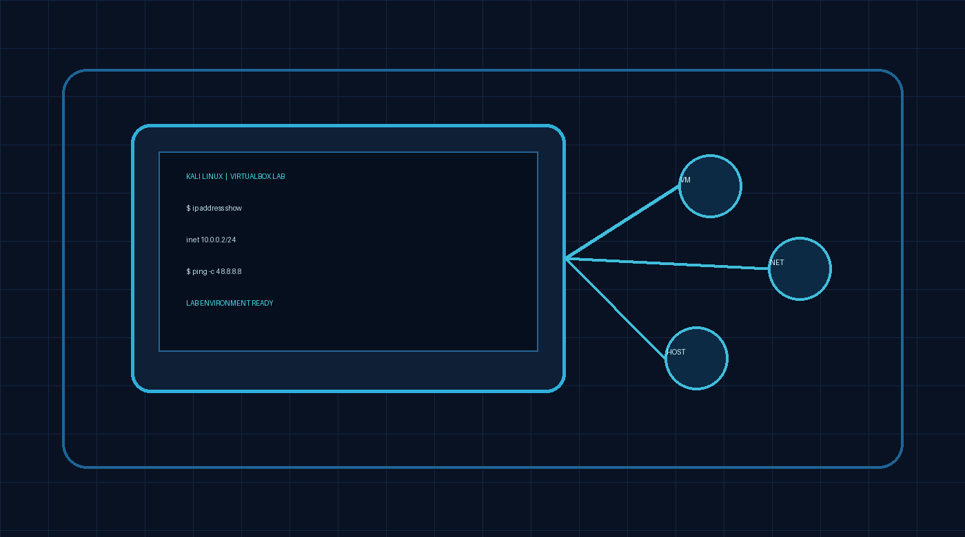

WEEK 1 | PROJECT MODULE 1

Practical Cybersecurity Lab Environment Setup

VirtualBox + Kali Linux • Lab setup report

Prepared by | Kushal Dhillo
Project | Week 1 — Project Module 1
Submission format | GitHub-ready PDF report

Objective
Set up a cybersecurity testing lab on a laptop/PC using Oracle VirtualBox and Kali Linux as a virtual machine. The lab is intended for controlled cybersecurity and ethical-hacking practice.

Required configuration

Component | Requirement from the lab handout
Virtualization | Use the latest VirtualBox version.
Guest OS | Use the latest Kali Linux version as a VM.
Network | NAT Network with subnet 10.0.0.0/24.
Kali address | 10.0.0.2/24.
Integration | Enable clipboard and drag-and-drop in VM settings.
Shared folder | Share the host's /downloads folder with the VM.
Connectivity | Kali Linux should have full Internet access.

Setup workflow
  - Review the instructor's lab video guide.
  - Install 7-Zip.
  - Install VirtualBox.
  - Create a VirtualBox NAT Network using 10.0.0.0/24.
  - Download and import the Kali Linux virtual machine.
  - Configure Kali Linux with IP address 10.0.0.2/24.
  - Take a VM snapshot as a recovery point.

Validation checklist
Use this checklist to document the actual state of your lab. Mark each item only after verifying it on your machine.

Check | Status / evidence
VirtualBox installed | [ ] Verified — add screenshot
Kali VM imported and boots | [ ] Verified — add screenshot
NAT Network subnet is 10.0.0.0/24 | [ ] Verified — add screenshot
Kali IP is 10.0.0.2/24 | [ ] Verified — add terminal screenshot
Clipboard + drag/drop enabled | [ ] Verified — add settings screenshot
/downloads shared folder configured | [ ] Verified — add settings screenshot
Internet access works from Kali | [ ] Verified — add ping/browser screenshot

Check | Status / evidence
VM snapshot created | [ ] Verified — add snapshot screenshot

Troubleshooting note
If Kali has no Internet access, the handout recommends checking that the NAT Network and VM network settings are correct, confirming that no other VM is using 10.0.0.2, and restarting the VM/host as needed. For VirtualBox 7 with Kali Linux 2026.1 or newer, it lists these commands:
sudo nmcli connection modify "Wired connection 1" ipv4.dad-timeout 0 sudo nmcli connection down "Wired connection 1"
sudo nmcli connection up "Wired connection 1"

The handout also notes that 10.0.0.1 may be used if Internet access has issues. Confirm the correct setting for your network before changing it.

Evidence gallery — SCREENSHORTS

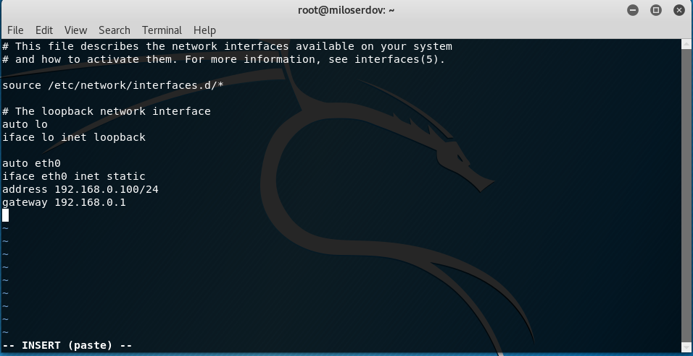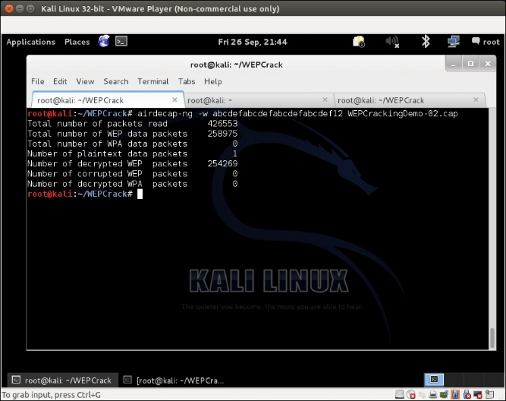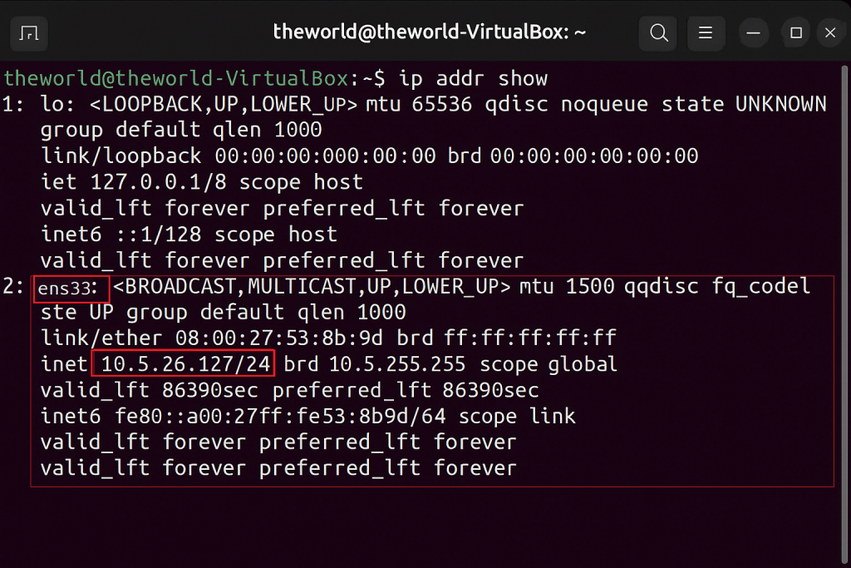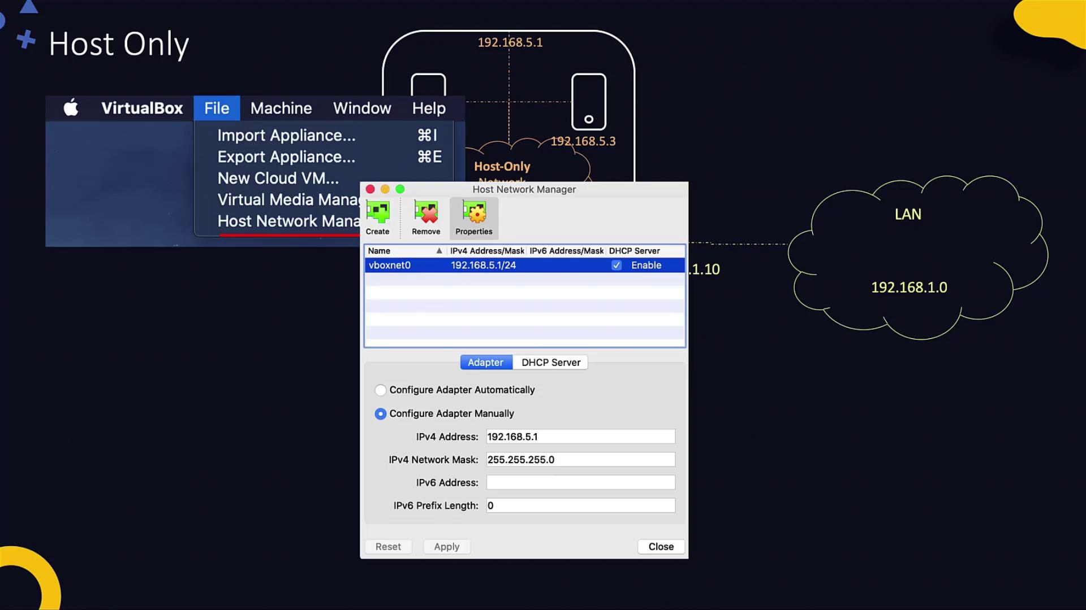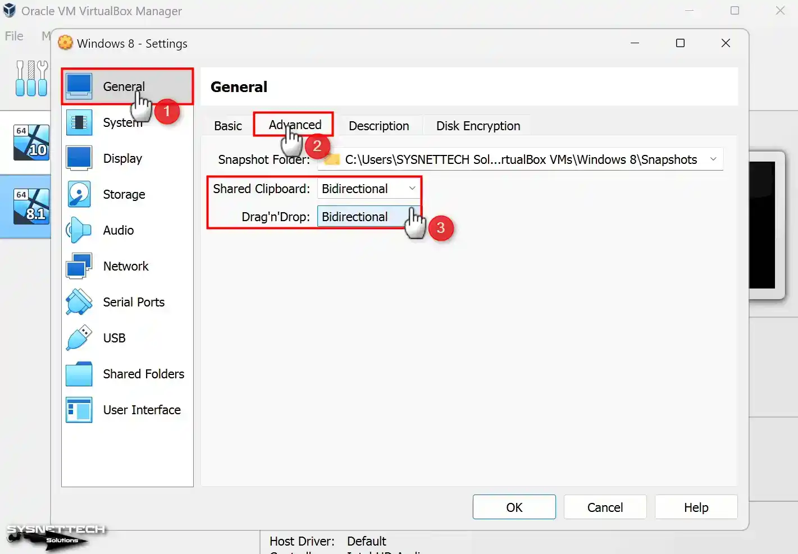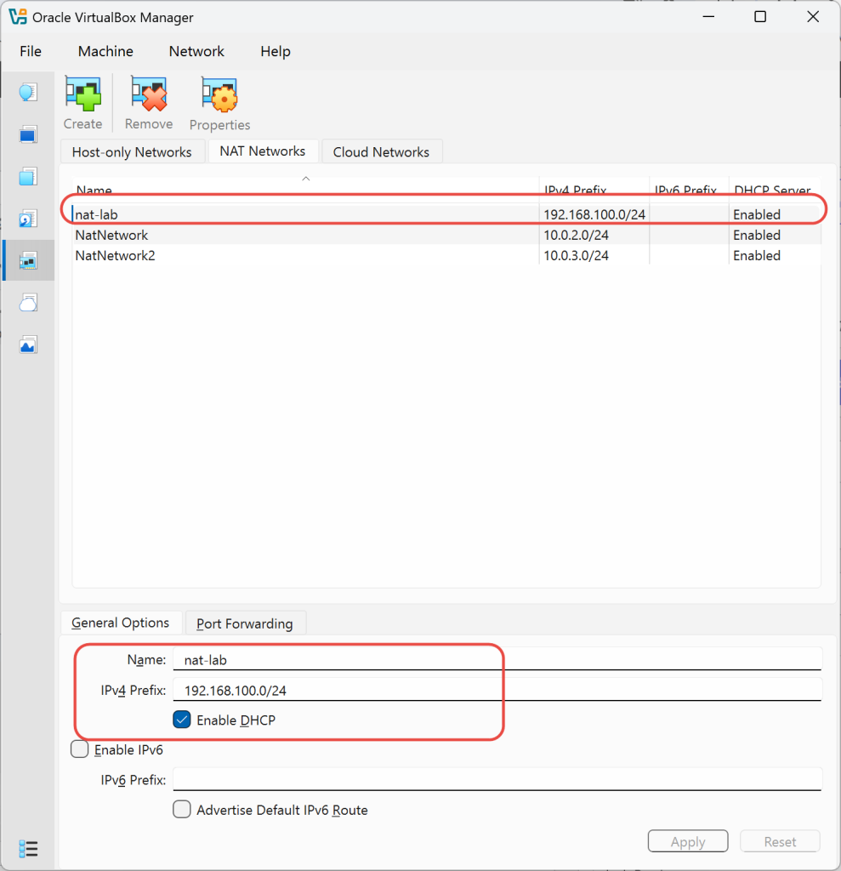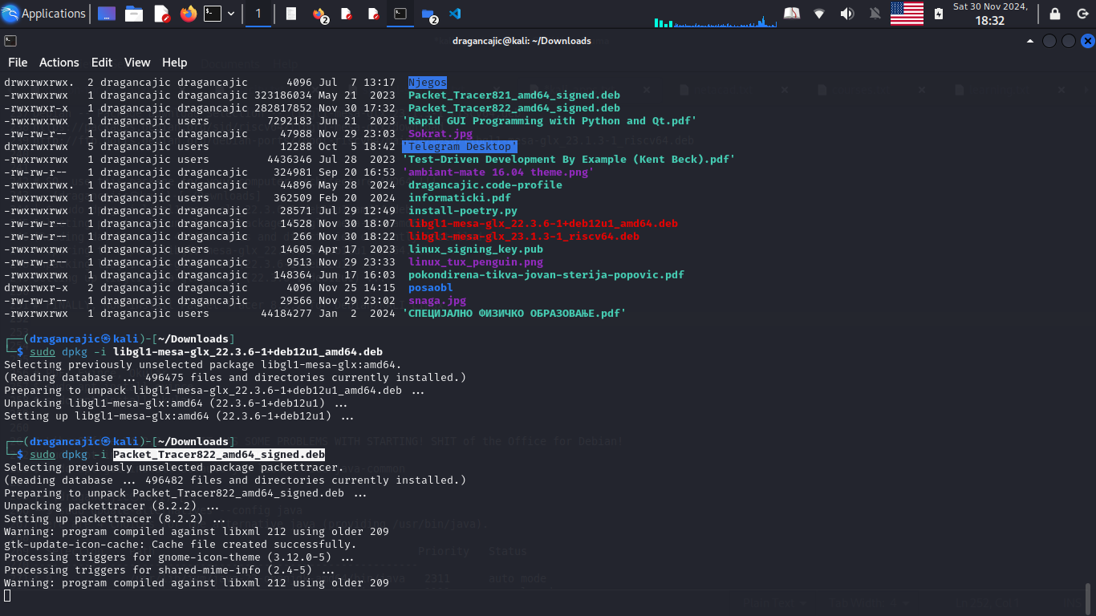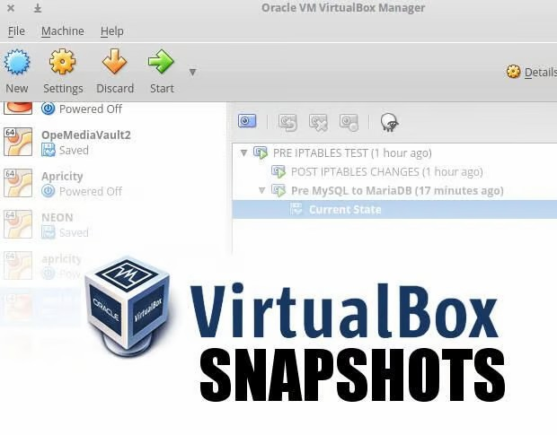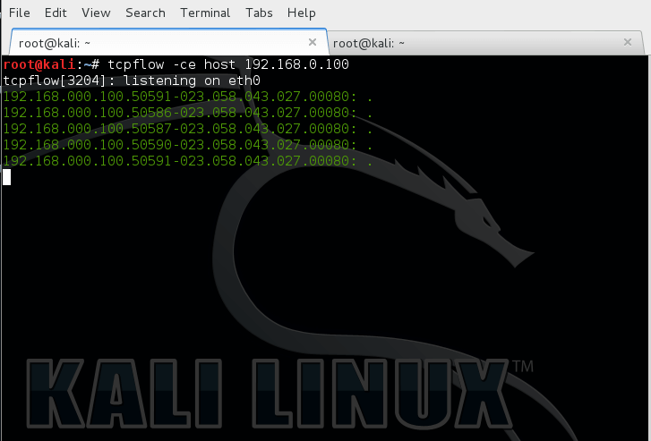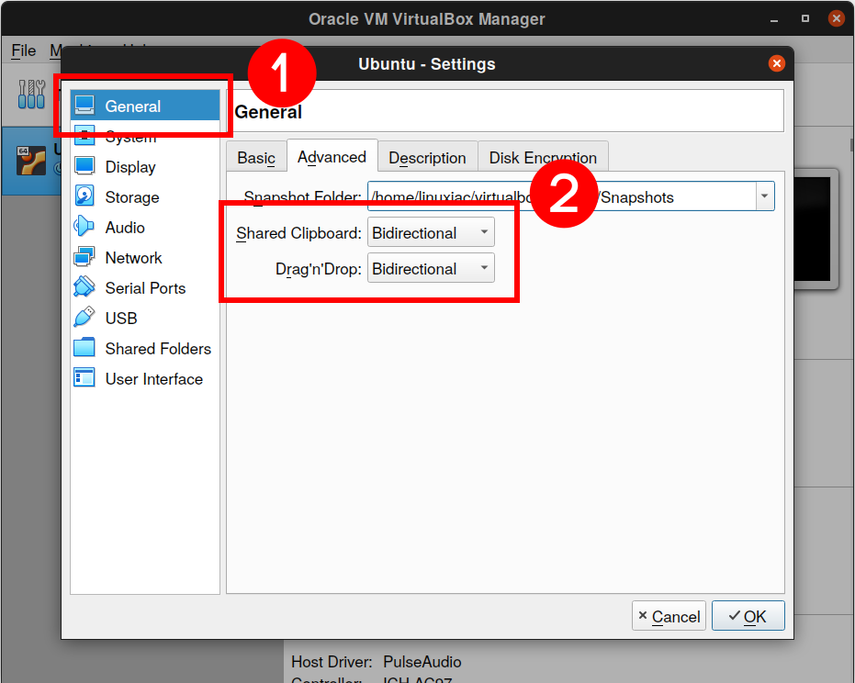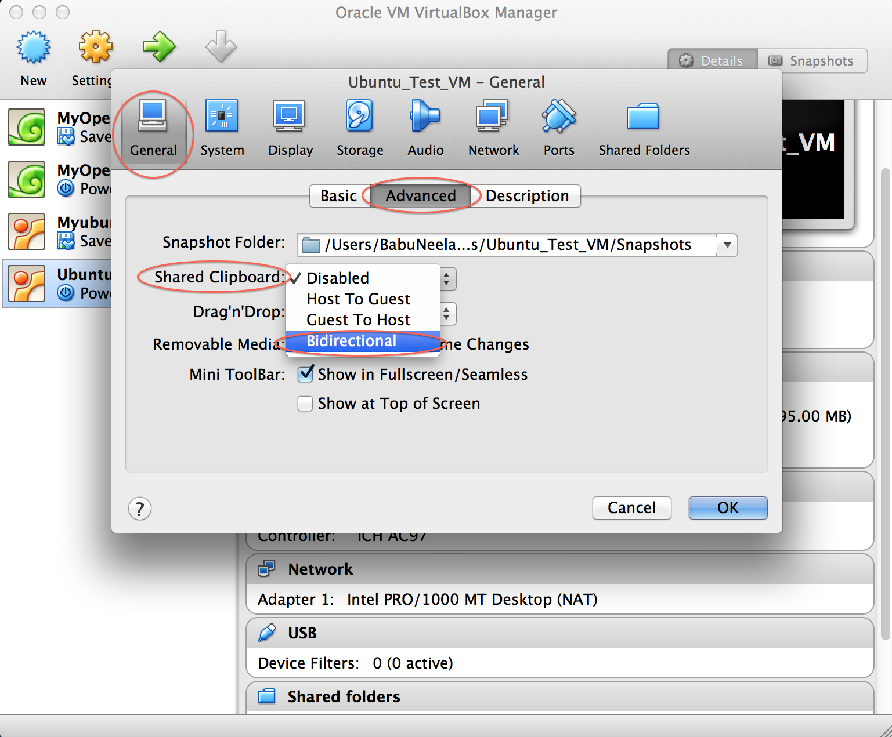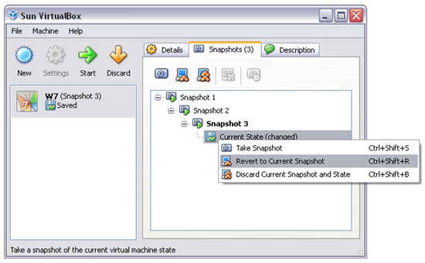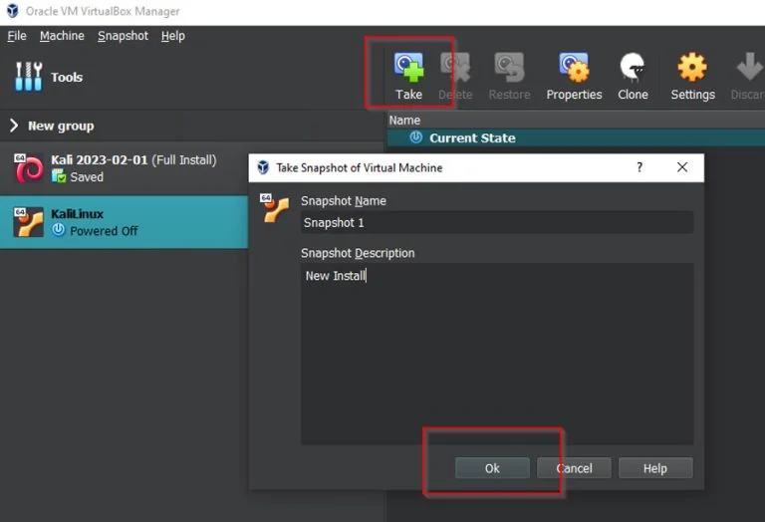

Summary
This report captures the Week 1 lab requirements and setup workflow for a VirtualBox-based Kali Linux environment. Completion should be confirmed by the validation checklist and supported with real screenshots from the configured machine.

Reference
Source: Week 1 | Project Module 1 — Practical Lab Environment Setup (provided lab handout, 14 pages). Instructor video and download references are listed in the original handout.
GitHub repository suggestion: week-1-cybersecurity-lab-setup/README.md and Week_1_Cybersecurity_Lab_Setup_Report.pdf

