- Under section 3A.2 - Endpoint Device and Communication Tools of the Requirement Specs, laptop to be installed with the following programmes:

S/N | Programme | Artifact
i | Windows 10/11 with the latest build or MacOS (Catalina 10.15.4 or later) | 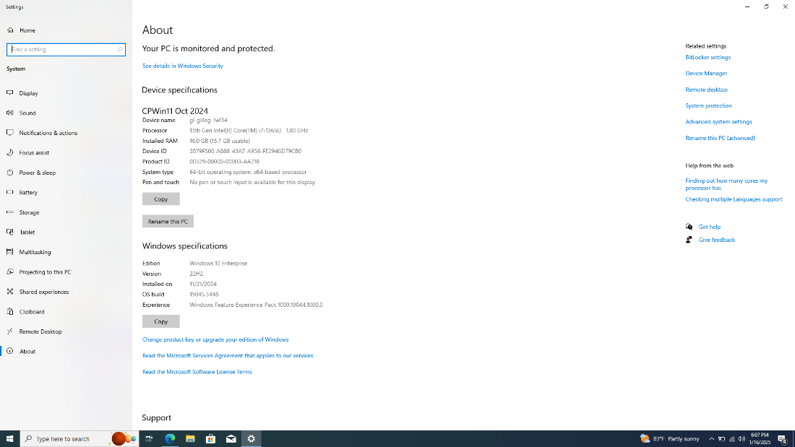
ii | Office Productivity Tools | 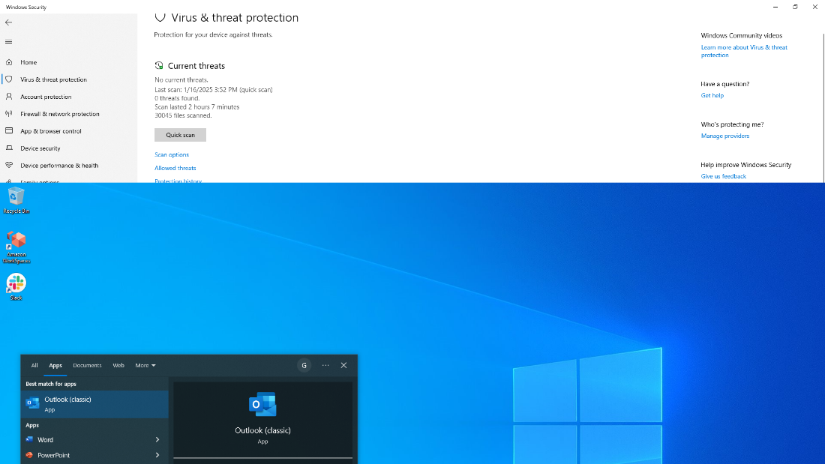
iii | Video Conferencing Applications, such as Microsoft Teams | 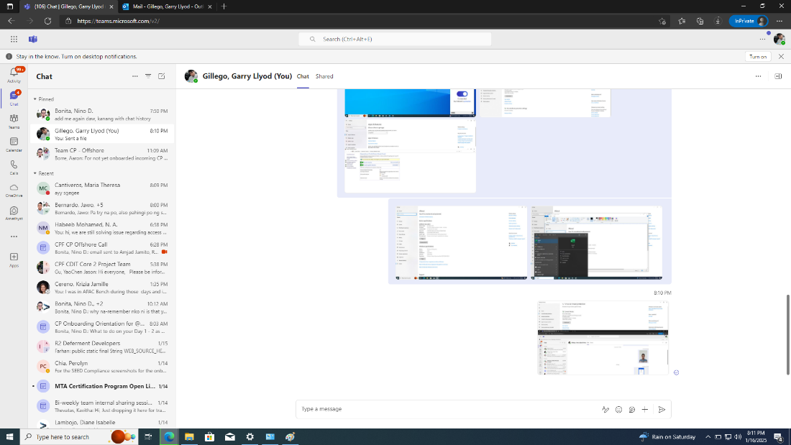
 |  | 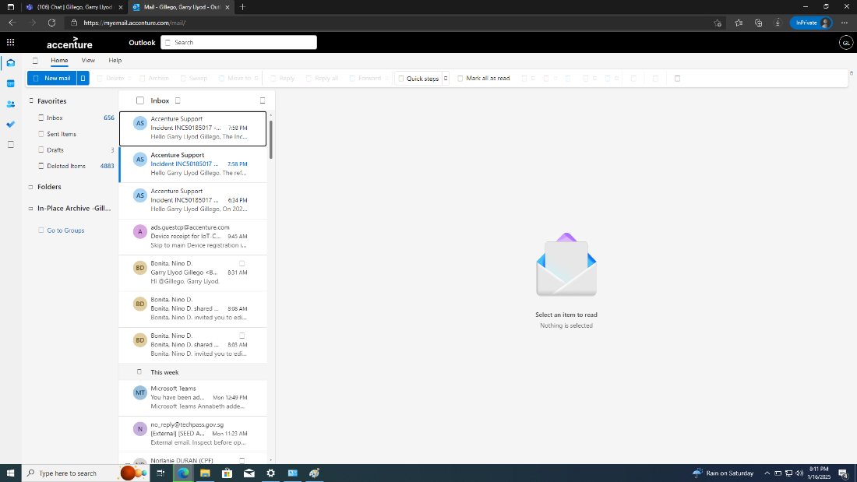
iv | Collaboration Tools | 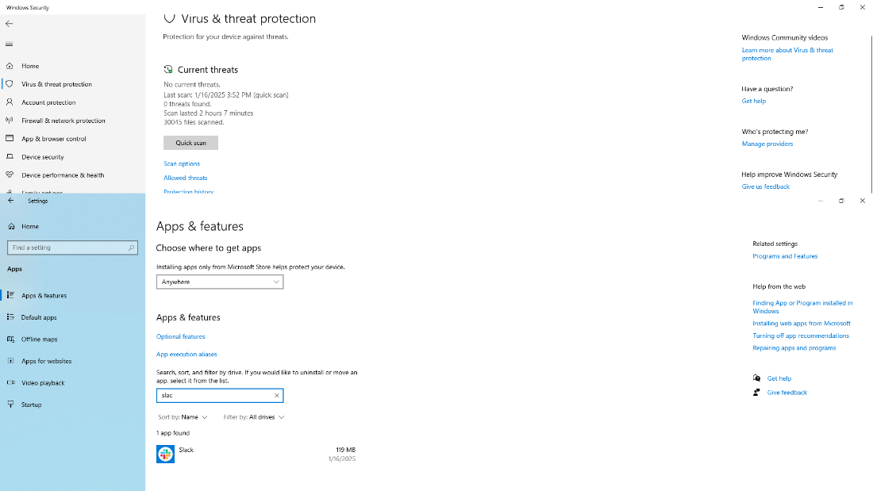
v | Anti-virus Software, such as Norton, Symantec, Sophos, Trend Micro, ESET, Kaspersky or McAfee | 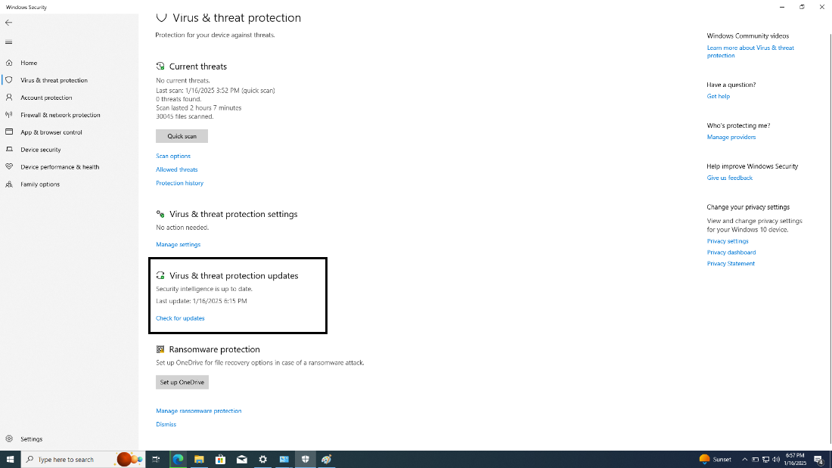
vi | Amazon Web Services (AWS) Workspace Client | 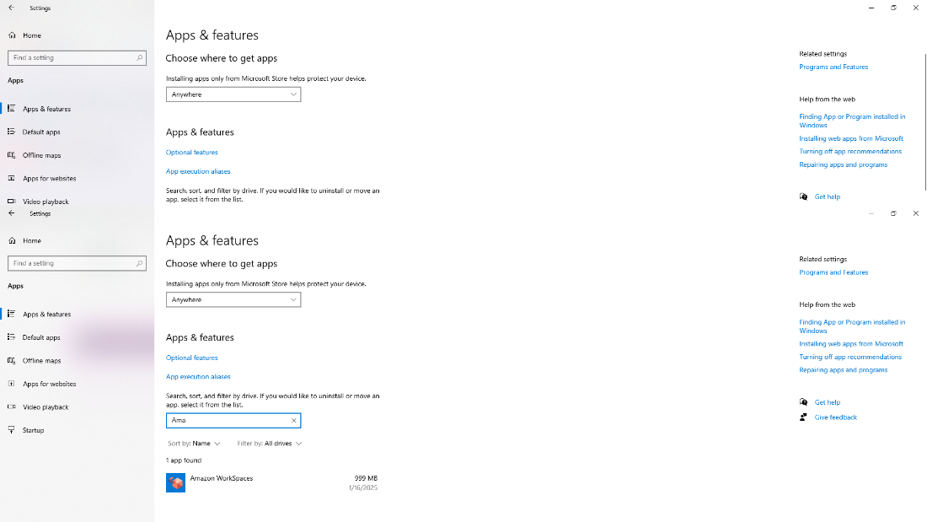
vii | GlobalProtect VPN Client | 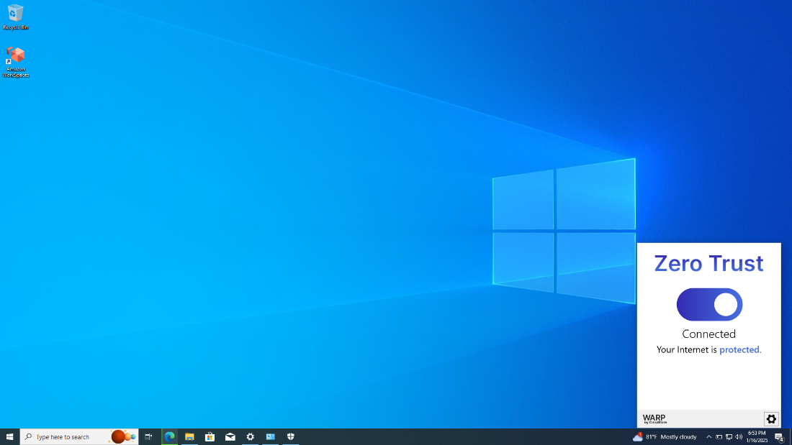

(b) Under 3A.3 - Security for Endpoint Device, Network Security and Other Security Postures of the Requirement Specs, laptop to be equipped with the following features:

S/N |  | Feature | Artifact
viii |  | Disk encryption e.g. Bitlocker enabled by default (status of Bitlocker to be ‘on’) | 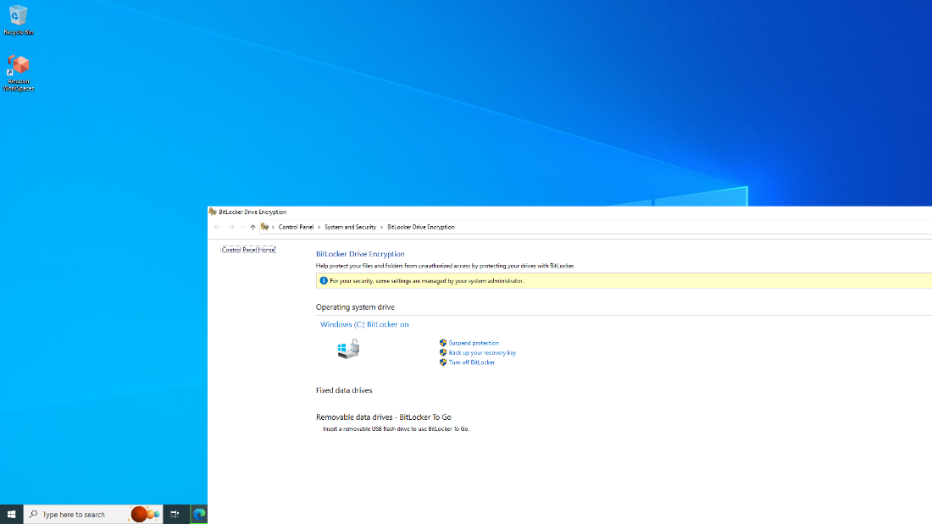
ix |  | Updated with latest security patches and secured and most secure form of Wi-Fi encryption is enabled by default | 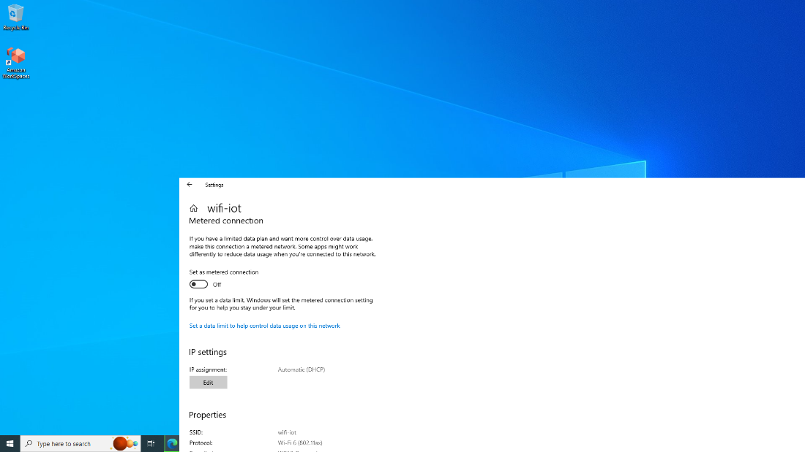
x |  | Antivirus software is updated with regular signature update (not more than 7 days old) and digital certificate issued by the Board is successfully installed | 