README

SWEN 261 Team B: Torchwood

# Install miniconda

Download and install miniconda (Python version 3.5) from this address: <http://conda.pydata.org/miniconda.html>

This must be installed to a location writable by your account. In windows, you should be able to write to anything in your %HOMEPATH%. Make sure the directory you pick is already empty.

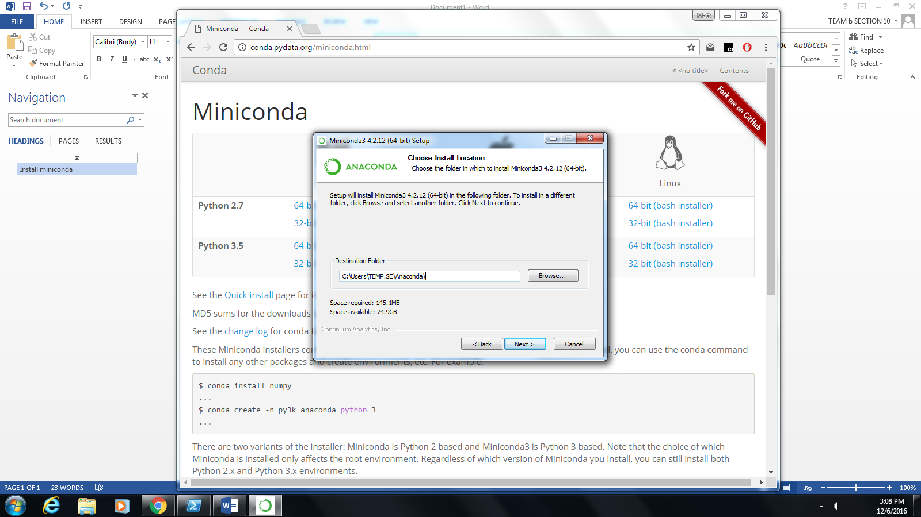

# Installing Project Dependencies

Open the start menu and start searching for the anaconda prompt.

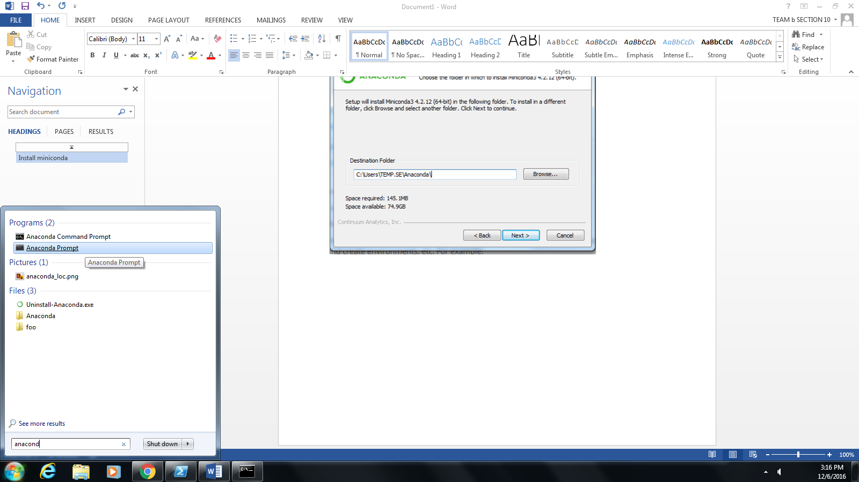

Run the following command:

conda create –-name 261-10-b python=3 && activate 26110b && conda install pip

Extract the Healthnet.zip folder. Navigate to that the root of the extracted folder. From the miniconda prompt, run

pip install –r HealthNet\requirements.txt

Run pip show django-bootstrap3-datetimepicker

Move HealthNet\patch\widgets.py to the location given by this command.

# Running the Project

Still in the anaconda prompt:

cd HealthNet

python manage.py runserver localhost:PORT

Replacing PORT with the desired port number. Likely 8000.

Now go to the url displayed in the prompt window.

# 