**Product Requirements**

**Team: *TEAM b SECTION 10 f261-10b Torchwood***

|  |  |  |  |
| --- | --- | --- | --- |
| ***Revision Number*** | ***Revision Date*** | ***Summary of Changes*** | ***Author(s)*** |
| 0.0 | 9/5/2016 | Initial draft of requirements | Matt, Erikson, Carson, Tony, Luke |
| 0.1 | 9/12/16 | Fixing requirements | Matt, Erikson, Carson, Tony, Luke |
| 0.2 | 10/01/2016 | Checking and Reviewing requirements doc | Matt, Carson, Tony, Luke |
| 0.3 | 10/03/2016 | Checking and reviewing | Matt, Erikson, Carson, Tony, Luke |
| R1 | 10/13/2016 | Updated R1 requirements | Matt, Erikson, Carson, Tony, Luke |
| 1.1 | 10/17/16 | Added R2 requirements | Matt, Erikson, Carson, Tony, Luke |
| 1.2 | 11/8/16 | Added notes in the User Stories section | Matt, Erikson, Carson, Tony, Luke |

# Brief problem statement

US hospitals have difficulty managing their employee and patient records, as well as capturing their interactions for later analysis. **HealthNet** aims to solve for delightful patient enrollment and incredible procedure management for a truly optimal daily workflow. HealthNet will truly capture the power of data and inter-hospital synergies to revolutionize the health tech space and make the world a better place.

# Stakeholders

**HAccelerator Board of Directors** – oversee the projects funding and expenses. Have vested interest in the proven success of the product but are not involved in the planning and execution.

**HAccelerator Product Owner** – will act as principal representative for HealthNet product needs. He/she champions the product with the Board of Directors, helps facilitate product decisions and has the ultimate say on when and what features should be released.

**Software Engineering Team** – is responsible for the day-to-day operations and coordination of all aspects related to the software product's life-cycle. This include, among others: planning and delegation of team roles and responsibilities; elicitation and clarification of requirements; analysis and design; implementation, testing and release of all software components.

**Beta Testing Team** – represent the target user base for HealthNet. Will be available in later phases of the project to conduct acceptance testing and provide feedback on product release.

- represents users of the systems who are under the clinic running HealthNet’s care. They use the system to manage appointments and medical info so the clinic or hospital can stay prepared and ready to treat the patient.

**Doctors** - represents users of the system with high authorization who are employees of the clinic running HealthNet. They are able to manage appointments and provide medical information to the clinic or to patients. They have the authority to manage patient medical information.

**Nurses** - represents users of the system with some authorization who are employees of the clinic running HealthNet. They have the ability to manage appointments and are able to access patient medical information.

# Users profile

The target user must:

* Have basic experience using computers and browsing the internet. Has filled out online forms or surveys and may have purchased or sold a product.
* Have a computer with access to the internet
* Have an interest in improving their health by using an online way of interacting with their hospital
* Be willing to share information such as home address and contact information as well as more personal information such as medical history
* Be willing to learn how to use the interface.
* Have some relationship with the hospital using HealthNet

# System requirements

At a high-level this project will be source controlled in SVN, run on Django using python, sqlite and needs to be compatible with the latest browsers.

Although the application needs to be accessible through the internet, deployments and demonstrations for this phase of the project will take place within the RIT Software Engineering environment. To this end, you must understand and document the target platforms from the perspective of the client browser as well as that of the server. Make sure to capture versions or software dependencies, programming languages and hardware specifications that are available for your use and proceed only after you document and confirm these with the customer.

# Feature requirements (user stories)

The following list of user stories is neither final nor comprehensive. You must consider it your responsibility to maintain its relevance, clarify any misunderstandings and keep it up-to-date. Any changes must be discussed with the Product Owner for approval.

|  |  |  |  |
| --- | --- | --- | --- |
| **No.** | **User Story Name** | **Description** | **Release** |
| **1** | Patient Registration | Users sign up to become a Patient by providing their personal contact information, proof of insurance and unique login credentials.  Additionally, a patient should provide the system with some basic medical profile information, a choice of preferred hospital and emergency contact information (linked to another patient if they are already in the system). | **R1** |
| **2** | Administrator Registration | Doctors, Nurses, and Administrators will be added to the system by other administrators. All information for creating these new accounts will be done through an administrator account. | **R1** |
| **3** | Update Patient Profile Information | Patients can update their profile information. | **R1** |
| **4** | Update Patient Medical Information | ***Doctors and Nurses can update patient medical information.***  ***Completed*** | **R2** |
| **5** | Export Information | Patients will be able to export their information and their test results from the system with relevant privacy warnings. | **R2** |
| **6** | Create or Update Patient Appointment | Patients, doctors and nurses can create or update an appointment with a doctor and at one of the doctor’s available locations.  If the patient or doctor already has an appointment at the time selected, then the system will not allow for the appointment. | **R1** |
| **7** | Cancel Patient Appointment | Patients can cancel their existing appointments.  Doctors can cancel their existing appointments.  Nurses cannot cancel (only modify) existing appointments. | **R1** |
| **8** | Appointment Calendar | Doctors and patients will easily be able to view all of their appointments in a calendar view.  Nurses will be able to see all appointments for the day and week between Patients and Doctors.  So far, appointments are listed on the appointments page. A better design will be implemented in a future update. | **R1** |
| **9** | Add/Remove Prescriptions | Doctors can add or remove a prescription to a patient record.  Nurses can view the prescriptions of patients belonging to the same hospital.  Patients can view their prescriptions from their account.  ***Completed*** | **R2** |
| **10** | Viewing Patient Medical Information, Prescriptions and Tests and Results | Doctors can view all medical information for any patient in the system (regardless of Hospital).  Nurses can only view patient medical information in the hospital they work for.  Patients can view their tests (pending or completed) and view the corresponding results for those tests that have been released by the doctor.  Prescriptions and other non-sensitive information is viewable by the patient without a need for doctor’s release.  ***Completed*** | **R2**  **R2** |
| **11** | Release Test Results | Doctors (within the patient’s hospital) can, upon evaluating a patient’s test results, release them for view by that patient.  Comments may be added to the specific test result for view by the patient.  ***Completed*** | **R2** |
| **12** | Logging System Activity | For security, many actions in the system will be logged for review at a later date.  Some examples of actions to be logged include but are not limited to updating of a Patient’s information, viewing of a Patient’s information/records, and transfers of a Patient from one hospital to another.  So far, the activity log successfully logs account registration, logging out, profile updates, and appointment updates. Logging of appointment creation and deletion will be implemented in a future update. | **R1** |
| **13** | Admission and Discharge to/from Hospital | Doctors and Nurses can admit a patient to the hospital for an extended stay (reasons could be: emergency, observation, surgery, etc.). These are typically unexpected visits but can result from a decision made after a scheduled appointment. This event is recorded by the system.  Doctors are the only ones to approve a patient’s discharge from the Hospital. This event is recorded by the system. | **R2** |
| **14** | Viewing Activity Log | Administrators will be able to view the logs of all system activity for a given time-frame at their hospital. Some examples of this might be:   * breakdown of the viewing activity of patient records or by system user * most common system activities (or by user)   Other important and informative statistics yet to be determined. | **R1** |
| **15** | Viewing System Statistics | Administrators will be able to view compiled statistics for a given time-frame at their hospital. Some examples of this might be:   * number of patients visiting the hospital * average number of visits per patient * average length of stay (from admission to discharge) * most common reasons for being admitted to the hospital * prescription statistics   Other important and informative statistics yet to be determined. | **R2** |
| **16** | Patient Transfer | Patient can be transferred between hospitals.  Transfers can be carried out by either administrators or by doctors (ones who are at the receiving hospital).  ***Completed*** | **R2** |
| **17** | Upload Patient Information | Doctors will be able to upload the results of a patient’s tests if needed.  Doctors will be able to upload images such as those used in X-Rays to update a patient’s record.  Uploads are considered as updates to a patient’s medical information. | **R2** |
| 18 | Send Private Message | Doctors, nurses, patients and administrators can send private messages of limited length via the system. | **R2** |

**Use case context diagram**

**Patient Registration**

**Administrator Registration**

**Update Patient Profile Information**

**Update Patient Medical Information**

**Export Information**

**Create or Update Patient Appointment**

**Cancel Patient Appointment**

**Appointment Calendar**

**Add/Remove Prescriptions**

**Viewing Patient Medical Information, Prescriptions and Tests and Results**

**Release Test Results**

**Logging System Activity**

**Admission and Discharge to/from Hospital**

**Viewing Activity Log**

**Viewing System Statistics**

**Patient Transfer**

**Upload Patient Information**

**Send Private Message**

**Use case description**

|  |  |
| --- | --- |
| **Use Case Number:** | ***UC-01*** |
| **Use Case Name:** | ***Registration*** |
| **Overview:** | ***Registrant shall provide personal, medical, and emergency contact information to the System upon registering and becoming a Patient.*** |
| **Actor(s):** | ***Registrant*** |
| **Pre-condition(s):** | ***- System has been setup and configured.***  ***- System is running and open for registrations.***  ***- Registrant has accessed website via URL*** |
| **Scenario Flow:** | ***Main (success) Flow:***   1. ***Registrant selects option to register*** 2. ***System requests personal information*** 3. ***Registrant provided personal information.*** 4. ***System verifies required information is provided.***  * ***If information is invalid System displays message. Return to Step 2***  1. ***System requests basic medical information*** 2. ***Registrant provides medical information*** 3. ***System verifies required information is provided.***  * ***If information is invalid System displays message. Return to Step 5***  1. ***System requests emergency contact information*** 2. ***Registrant provides emergency contact information*** 3. ***System verifies required information is provided***    * ***If information is invalid System displays message. Return to Step 8*** 4. ***System requests login information*** 5. ***Registrant provides login information*** 6. ***System verifies required information is provided***    * ***If information is invalid System displays message. Return to Step 11*** 7. ***System displays confirmation of registration*** |
| ***Alternate Flows:*** | ***Alternate Flow #1: After Step 2 in success scenario System will display the option to Cancel the registration process. The following steps would occur:***   1. ***Registrant selects option to cancel during registration*** 2. ***System requests confirmation to cancel*** 3. ***Registrant confirms intent*** 4. ***System returns to main screen***   ***Alternate Flow #2: The emergency contact information is an existing user in the system. After step 10 the following steps would occur:***   1. ***Registrant selects option to select an emergency contact from the system*** 2. ***System displays a search bar for the Registrant to input the user’s name*** 3. ***Registrant inputs the user’s name and presses enter*** 4. ***System returns a list of users with matching names*** 5. ***Registrant chooses intended user*** 6. ***System sets that user as an emergency contact*** |
| **Post Condition:** | ***Registrant did not complete registration. System does not store Registrant's information.*** |

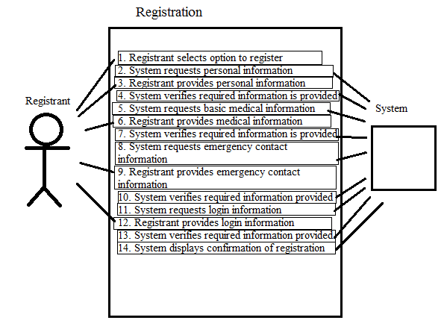

|  |  |
| --- | --- |
| **Use Case Number:** | ***UC-03*** |
| **Use Case Name:** | ***Update Patient Profile Information*** |
| **Overview:** | ***Registrant will update information stored in his/her patient profile by providing the proper*** |
| **Actor(s):** | ***Registrant*** |
| **Pre-condition(s):** | * ***System has been setup and configured*** * ***Registrant has a profile*** * ***Registrant has accessed website via URL*** * ***Registrant is logged in*** |
| **Scenario Flow:** | ***Main (success) Flow:***   1. ***Registrant selects option to update*** 2. ***System requests user to provide updated personal info*** 3. ***Registrant provides updated personal information***    * ***If personal information is invalid, display proper warning and return to Step 2*** 4. ***System asks for confirmation that new information is correct*** 5. ***Registrant confirms updated information*** 6. ***System updates*** |
| ***Alternate Flows:*** | ***Alternate Flow #1: After Step 2 in success scenario System will display the option to Cancel the registration process. The following steps would occur:***   1. ***Registrant selects option to cancel during registration*** 2. ***System requests confirmation to cancel*** 3. ***Registrant confirms intent*** 4. ***System returns to main screen*** |
| **Post Condition:** | ***Registrant did not complete update process. System does not store Registrant's updated information.*** |

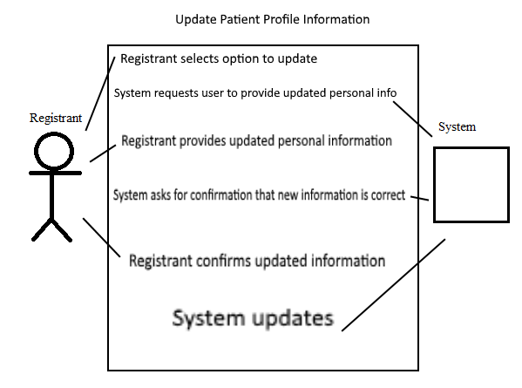

|  |  |
| --- | --- |
| **Use Case Number:** | ***UC-06*** |
| **Use Case Name:** | ***Create or Update Patient Appointment*** |
| **Overview:** | ***Registrant will provide necessary information when setting up or updating an appointment.*** |
| **Actor(s):** | ***Registrant*** |
| **Pre-condition(s):** | * ***System has been set up and configured.*** * ***Registrant has a profile.*** * ***Registrant has accessed website via URL.*** * ***Time slots for appointments are available.*** |
| **Scenario Flow:** | ***Main (success) Flow:***   1. ***Registrant selects option to create a new appointment or to update an existing appointment.*** 2. ***System requests name for appointment.*** 3. ***Registrant provides name for appointment.*** 4. ***System requests a date and time.*** 5. ***Registrant provides a date and time for the appointment.*** 6. ***System checks and verifies if the given date and time is open.***     1. ***If the given date and time is closed, display proper warning and return to step 2.*** 7. ***System requests for a brief description of the appointment.*** 8. ***Registrant provides a brief description of the appointment.*** 9. ***System displays appointment information and requests confirmation.*** 10. ***Registrant confirms information.*** 11. ***System stores information.*** |
| ***Alternate Flows:*** | ***Alternate Flows: Include the post condition for each alternate flow if different from the main flow.***  ***Alternate Flow #1: Registrant selects option to update an existing appointment. The following steps would occur:***   1. ***System requests name of existing appointment.*** 2. ***Registrant provides name of existing appointment.*** 3. ***System asks whether to update date and time or description.*** 4. ***Registrant selects appropriate option and updates information.*** 5. ***System displays appointment information and requests confirmation.*** 6. ***Registrant confirms information.*** 7. ***System updates.*** |
| **Post Condition:** | ***Registrant did not complete appointment process. System does not store appointment information.*** |

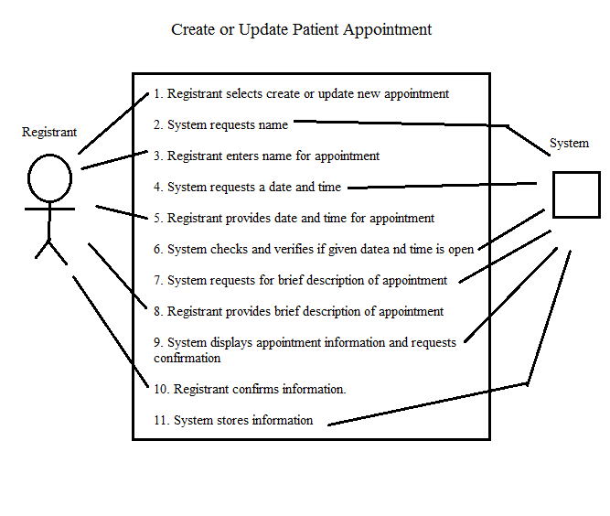

|  |  |
| --- | --- |
| **Use Case Number:** | ***UC-07*** |
| **Use Case Name:** | ***Cancel Patient Appointment*** |
| **Overview:** | ***Patients and doctors can cancel their existing appointments*** |
| **Actor(s):** | ***Patients and Doctors*** |
| **Pre-condition(s):** | ***- System has been setup and configured.***  ***- System is running and open for registrations.***  ***- Registrant has accessed website via URL***  ***- There is an existing appointment.*** |
| **Scenario Flow:** | ***Main (success) Flow:***  ***1.*** ***Patients and doctors login to their account.***  ***2.*** ***System requests personal information***  ***3.*** ***Users provided personal information.***  ***4.*** ***System verifies required information is provided.***  ● ***If information is invalid System displays message. Return to Step 2***  ***5.*** ***Users select option to cancel their existing appointments.***  ***6.*** ***System verifies personal information.***  ● ***If information is invalid System displays message. Return to Step 6***  ***7. Users select the appointments to cancel.***  ***8.*** ***System cancel existing appointments.***  ***9.*** ***System displays confirmation of canceled appointments.*** |
| ***Alternate Flows:*** | ***After step 8 system users click cancel***  ***1.*** ***System ask users are you sure to cancel this appointments***  ***If users click no***  ***1.*** ***Return to step 8.***  ***If users click yes***  ***1.*** ***Go to step 9.*** |
| **Post Condition:** | ***Users’ personal information did not match with 5 times. System force to logout.*** |

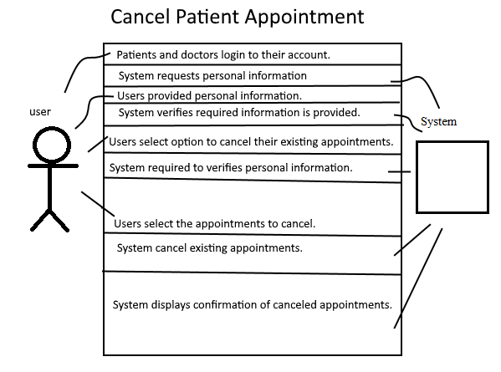

|  |  |
| --- | --- |
| **Use Case Number:** | ***UC-08*** |
| **Use Case Name:** | ***Appointment Calendar*** |
| **Overview:** | ***Doctors and patients will easily be able to view all of their appointments in a calendar view. Nurses will be able to see all appointments for the day and week between Patients and Doctors.*** |
| **Actor(s):** | ***Registrant*** |
| **Pre-condition(s):** | * ***System is setup and configured*** * ***The registrant has an account*** |
| **Scenario Flow:** | ***Main (success) Flow:***   1. ***The registrant selects to view their calendar*** 2. ***If the registrant is a Doctor or Patient, the system displays a calendar with their appointments marked down. If the registrant is a Nurse, the system displays all appointments in week and day form.*** |
| ***Alternate Flows:*** | ***Alternate Flow #1: The registrant clicks on an appointment in the calendar view.***   1. ***The system displays an closeable pop-up box with extensive appointment info. If the registrant is a Doctor, it displays important medical information.*** |
| **Post Condition:** | ***None*** |

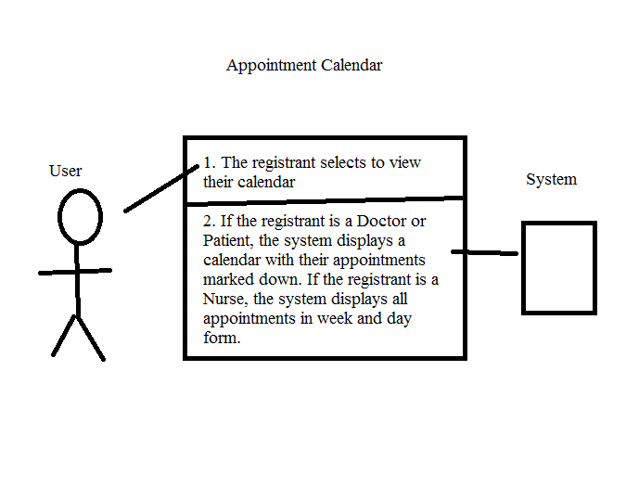

|  |  |
| --- | --- |
| **Use Case Number:** | ***UC-12*** |
| **Use Case Name:** | ***Logging System Activity*** |
| **Overview:** | ***For security, many actions in the system will be logged for review at a later date. Some examples of actions to be logged include but are not limited to updating of a Patient’s information, viewing of a Patients information/records, and transfers of a Patient from one hospital to another.*** |
| **Actor(s):** | ***Registrant*** |
| **Pre-condition(s):** | * ***System setup and configured*** |
| **Scenario Flow:** | ***Main (success) Flow:***   1. ***Registrant updates a patient’s information, views records/information, transfers a Patient, or changes an appointment or patient profile.*** 2. ***The system logs the the change or access in a text file in the same directory as patient information*** |
| ***Alternate Flows:*** | ***Alternate Flow #1: A patient is deleted from the system***   1. ***The system logs the deleted patient’s name in the system archives*** 2. ***The system deletes all personal, medical and contact information from the database*** |
| **Post Condition:** | ***None*** |

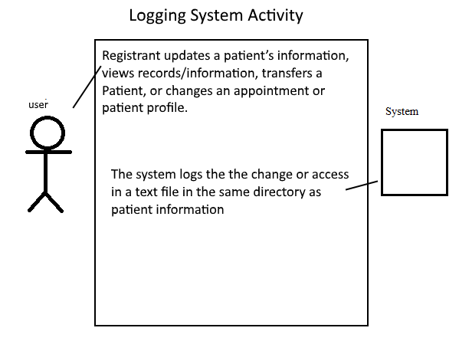

|  |  |
| --- | --- |
| **Use Case Number:** | ***UC-14*** |
| **Use Case Name:** | **Viewing Activity Log** |
| **Overview:** | **Administrators will be able to view the logs of all system activity for a given time-frame at their hospital.** |
| **Actor(s):** | **Administrators** |
| **Pre-condition(s):** | ***- System has been setup and configured.***  ***- System is running and open for Administrators.***  ***- Registrant has accessed website via URL*** |
| **Scenario Flow:** | ***Main (success) Flow:***  ***1.*** ***Administrators login to system***  ***2.*** ***System requests personal information***  ***3.*** ***Administrators provided personal information.***  ***4.*** ***System verifies personal information is matched.***  ● ***If information is invalid System displays message. Return to Step 2***  ***5.*** ***Administrators select the option to view activity log***  ***6.*** ***Pick a time-frame***  ***7.*** ***Choose one to view and check***  ***8.*** ***Administrators logout*** |
| ***Alternate Flows:*** | ***Alternate Flow #1: After step 4 the personal information is not matched:***  ***1.*** ***Administrators selects option to not login and close the system*** |
| **Post Condition:** | ***Administrators did not login to system.*** |

