Instructions (numbers, CONVEX mapping)
Welcome to this study, and thank you for participating!
Please read the following pages carefully. They explain the task and how you will be paid.

Overview
The study consists of 4 sessions of about one hour each, on separate days. Every session follows the same three phases:
- Learn (Phase 1): you look at 25 numbers, spread evenly between 1 and 50, together with their monetary values, at your own pace.
- Practice with feedback (Phase 2): you see a number, type its value, and are shown the correct value.
- Auction (Phase 3): you see a number and bid for it in an auction. There is no feedback. This phase determines your bonus.
Your task is to learn the relation between a number and its monetary value. Each number between 1 and 50 has a specific monetary value assigned to it (like a bank note). The numbers are shown with two decimals, for example 18.18. Note: new numbers keep appearing, so you cannot memorize a list. Learn how the value changes with the number.

Payment
Show-up fee | 15 CHF per session
Auction bonus (Phase 3) | between 10 and 20 CHF per session, on average about 11 CHF if you bid well
Completion bonus | 20 CHF after you have completed all 4 sessions
Total (typical) | about 123 CHF for all 4 sessions
You are paid at the end of each session; the completion bonus is paid at the end of session 4. How the auction bonus is computed is explained under Phase 3. In short: the better you know the value of each number, and the more consistently you bid that value, the more you earn.
Before you start, the experimenter will ask you a few questions to make sure you understand the task and the payment.

Phase 1: learn the values
You are shown 25 numbers, spread evenly between 1 and 50, together with their monetary values (Figure 1). Press the RIGHT ARROW to see the next number and the LEFT ARROW to go back. Take as long as you like. Once you have seen all of them, press the SPACE BAR to continue.
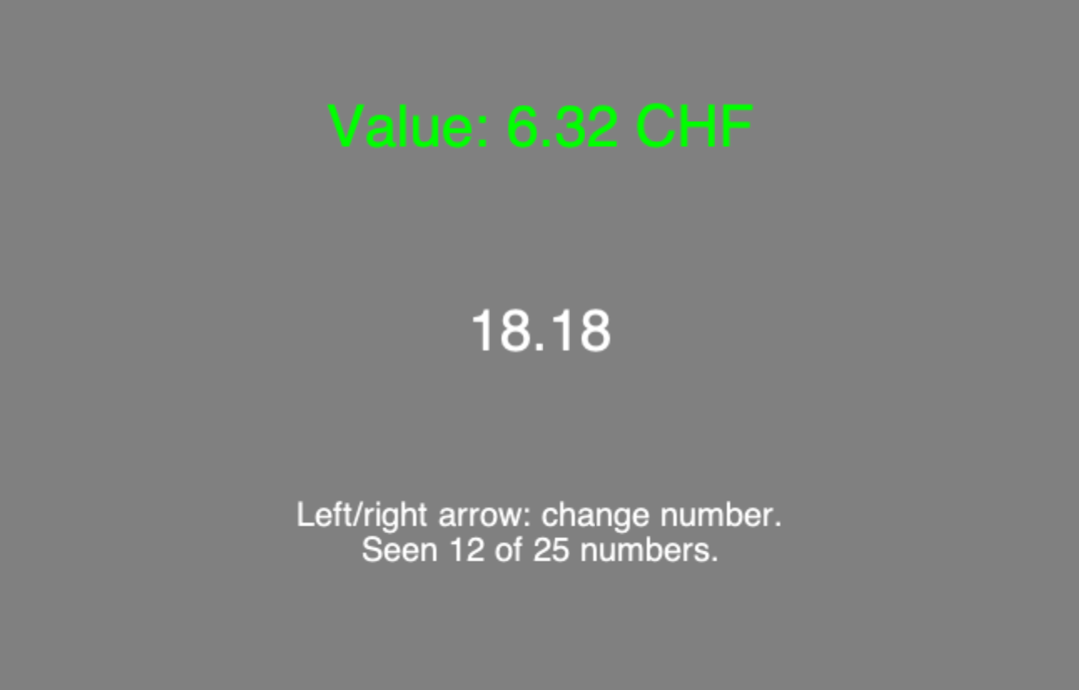
Figure 1: Phase 1 screen, showing one number (18.18) together with its value (6.32 CHF). The text at the bottom counts how many you have seen.
The values range from 1 to 50 CHF. Figure 2 shows exactly how the value depends on the number. The relationship between the number and its value is not linear: the value rises only slowly for small numbers and then increases steeply for large numbers. For example, going from 1 to 13 increases the value by only 3.14 CHF (from 1.00 to 4.14 CHF), whereas going from 30 to 42 increases the value by 16.39 CHF (from 14.51 to 30.90 CHF). This is the relationship you need to learn.
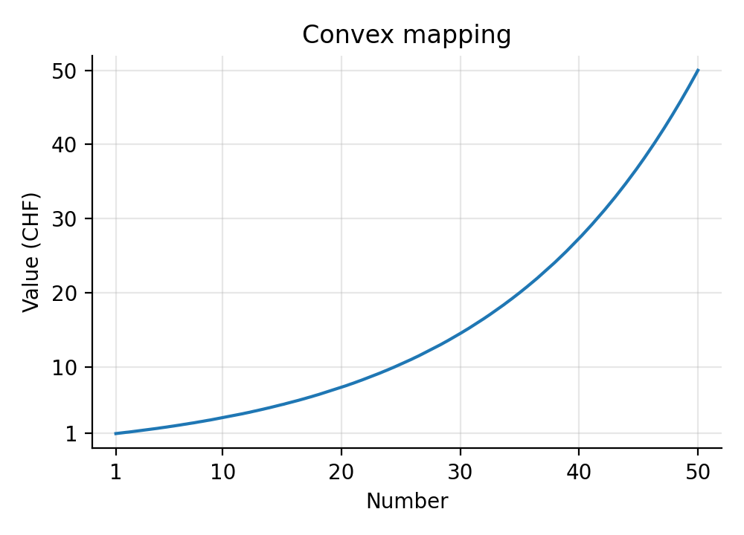
Figure 2: The value of each number (CONVEX mapping). This is the same in all 4 sessions.

Phase 2: practice with feedback
You see a number and type its value. Each round runs as in Figure 3:
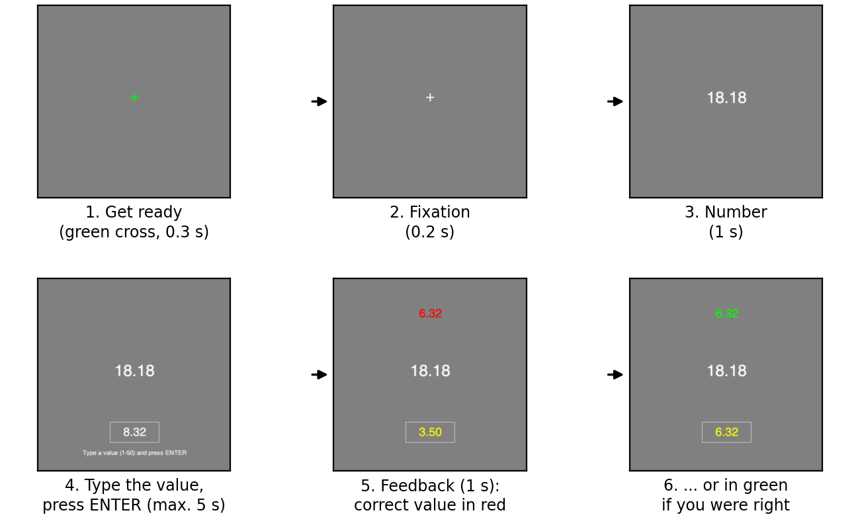
Figure 3: One round of Phase 2.
- A green cross tells you that a new round starts; it turns white.
- The number appears in the centre and stays on the screen.
- After 1 second a box appears below it. Type the value (up to two decimals, for example 23.45) and press ENTER. You can correct typing errors with BACKSPACE. Only values between 1 and 50 are accepted. You have 5 seconds.
- Your answer turns yellow and the correct value appears above the number. If your answer is within 0.50 CHF of the true value, the correct value is shown in green; if it is further away, it is shown in red. If you do not press ENTER in time, you see “Too late!”.
For every number, ask yourself: what is this number worth? How much money would I get if I sold it?
There are 138 rounds in 6 blocks, with a short break between blocks. The numbers are drawn at random, evenly spread between 1 and 50, so most numbers you see will be new. Phase 2 itself is not paid, but it is your chance to learn the values precisely: the better you learn them here, the more you will earn in Phase 3.

Phase 3: the auction
You see a number and bid for it. Each round runs as in Figure 4:
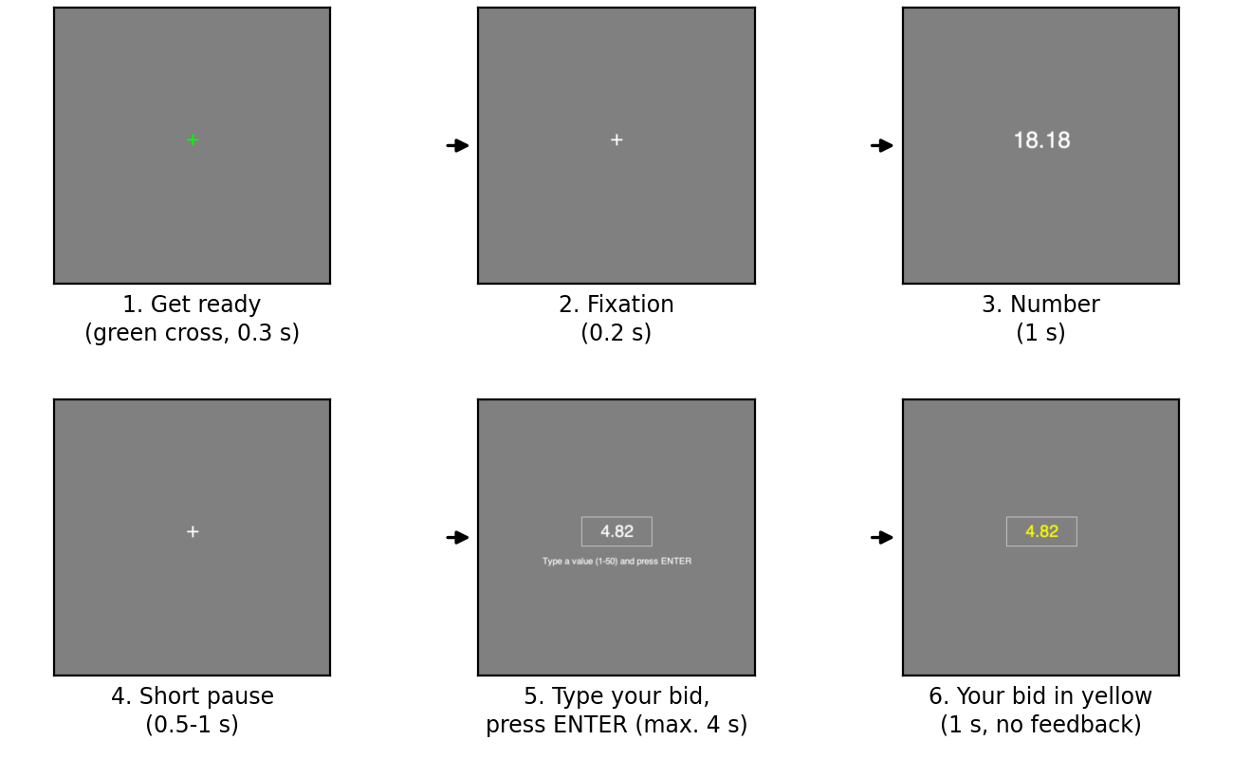
Figure 4: One round of Phase 3.
The differences from Phase 2 are: the number disappears before you answer, you have only 4 seconds, and there is no feedback. Type your bid and press ENTER. If you do not press ENTER in time, your bid is not registered and you earn nothing in that round (not even the budget explained below).
Phase 3 has 4 runs of 46 rounds. After each run you see what you earned so far (Figure 5).
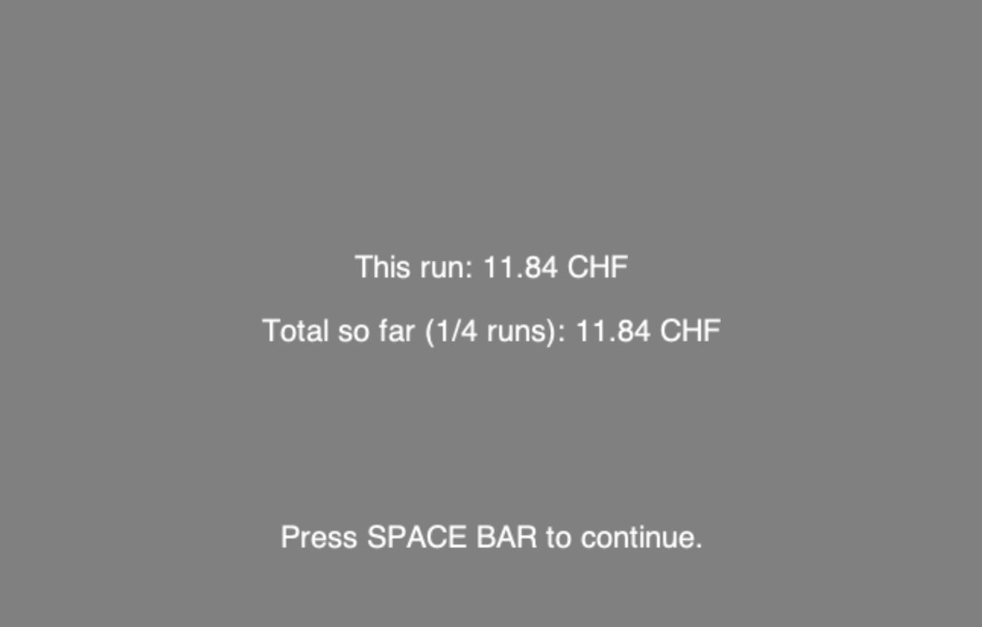
Figure 5: The screen at the end of each run (example amounts).

How the auction works
In every round you have a budget of 50 CHF. After you bid, the computer draws a random price between 1 and 50 CHF (every price is equally likely; your bid does not influence it).
- If your bid is higher than the random price, you buy the number at the random price. You then sell it for its true value. Your result for that round is: 50 CHF − price + true value.
- If your bid is lower than or equal to the random price, you do not buy anything. Your result for that round is the 50 CHF budget.
Your auction bonus for the session is one fifth of your average result per round (that is, the total of all 184 rounds divided by 920). If you bid the true value in every round, each round’s result is between 50 and almost 100 CHF, so your bonus is between 10 and 20 CHF per session, on average about 11 CHF. Missed rounds (no ENTER) and bids above the true value lower your bonus.

Why you should always bid the true value
You might think it is better to bid less than the number is worth. This is incorrect. The price you pay is the random price, not your bid. Your bid only decides whether you buy.
For example, suppose the number is worth 20 CHF:
- If you bid 20, you buy whenever the random price is below 20, so you always pay less than it is worth and make a profit.
- If you bid less, say 5, you still pay the same random price when you buy, but you miss all the chances to buy it at a price between 5 and 20. You lose profit.
- If you bid more, say 35, you also buy when the random price is between 20 and 35. Then you pay more than the number is worth and lose money.
So there is no way to game the auction. The best you can do in every round is to bid what you believe the number is truly worth. When you buy, you pay on average about half of the value.

In short
- You bid on 184 numbers per session (4 runs of 46).
- Treat every bid as if it were the only one.
- Always bid the value you believe is correct, and press ENTER within 4 seconds.
- Your auction bonus is one fifth of your average result per round: between 10 and 20 CHF, on average about 11 CHF.
- Together with the show-up fee of 15 CHF, you earn about 26 CHF per session, plus 20 CHF after the last session.
Thank you again for participating!

