检测器情况

|  |  |  |  |  |
| --- | --- | --- | --- | --- |
| 试验日期 | 试验次数 | 检测器状态 | | |
| 耐磨垫类型 | 提离值（mm） | 传感器安装方向 |
| 20201209 | 3 | 钢珠 | 4.5 | 正向 |
| 20201211 | 3 | 钢珠 | 3 | 正向 |
| 20201217 | 3 | 钢珠 | 3 | 反向 |
| 20210106 | 3 | 棱式 | 4.5 | 正向 |

|  |  |  |
| --- | --- | --- |
| 1长度 | 1宽度 | 1深度 |
| 2长度 | 2宽度 | 2深度 |
| 3长度 | 3宽度 | 3深度 |
| 4长度 | 4宽度 | 4深度 |

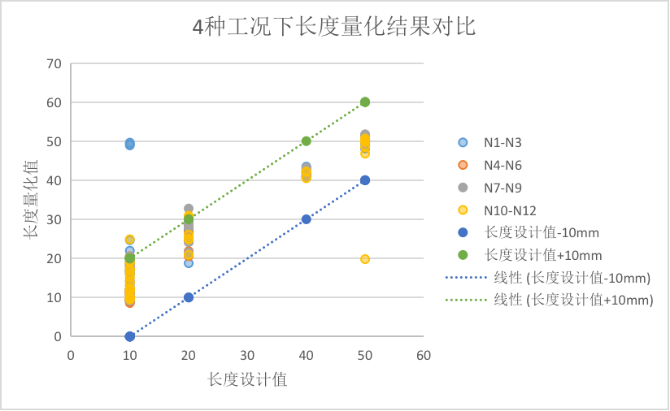

2

1

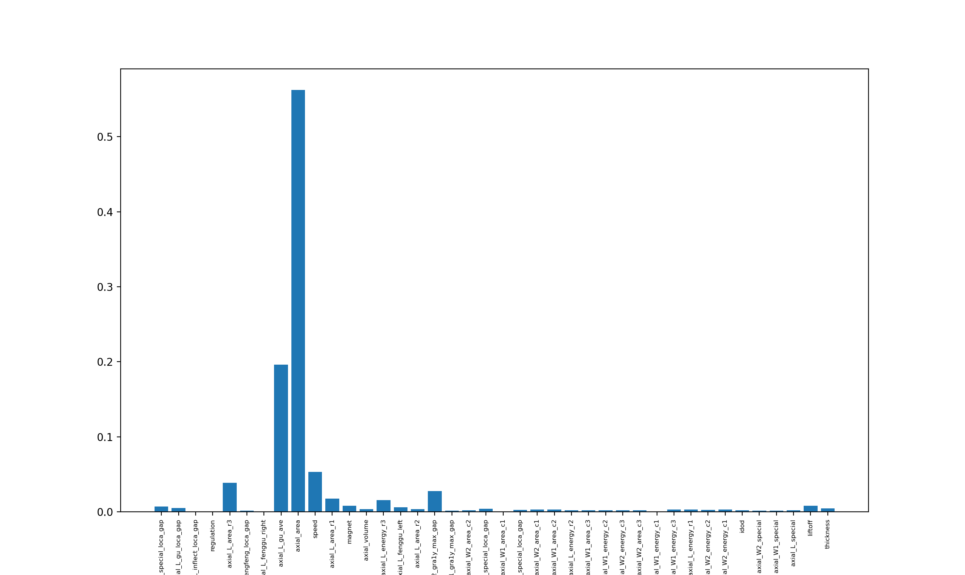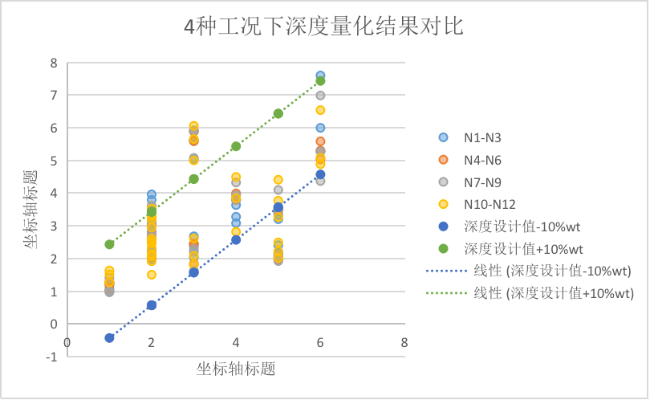

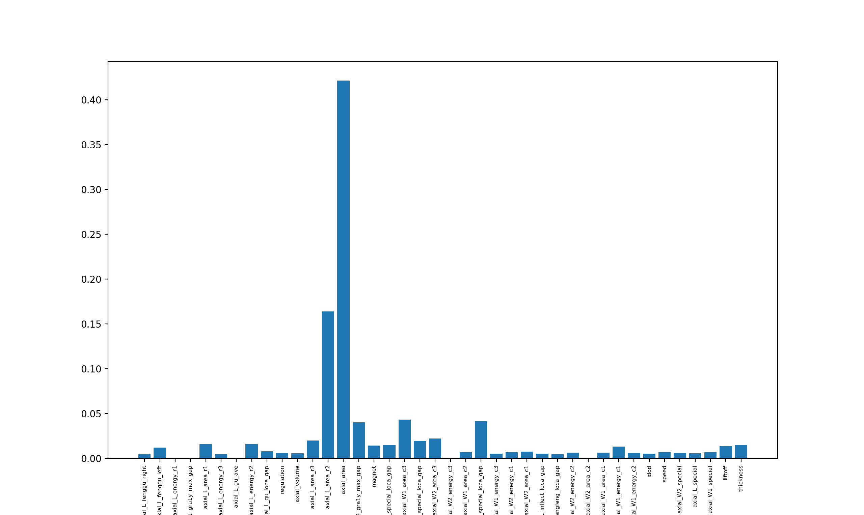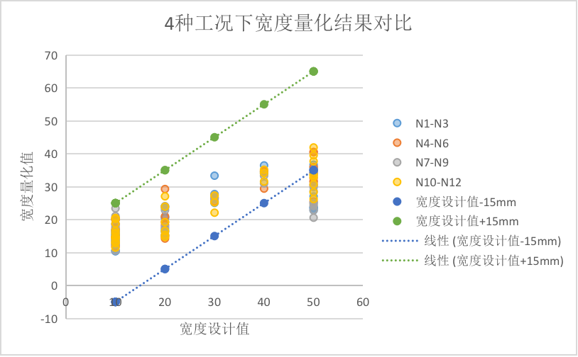

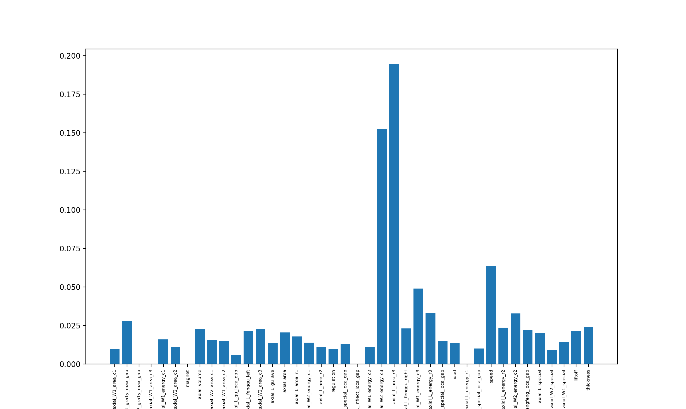

|  |  |  |
| --- | --- | --- |
|  | axial_W2_energy_c3 | axial_L_area_r3 |
| 缺陷1：50*50*2.275 | 5353.028532 | 606.036875 |
| 缺陷2：50*50*2.275 | 5094.86263 | 517.4315625 |
| 缺陷3：50*50*2.275 | 3694.710972 | 444.3440156 |
| 牵拉试验：50*50*2 | 1920.316617 | 720.68025 |

1. 比较宽度和深度的特征，按排序选择前三个特征
2. 对特征提取进行调整

16inch量化结果：

1、长度（10mm）

|  |  |  |  |  |
| --- | --- | --- | --- | --- |
|  | 训练集 | 测试集 | 90%置信度下 | 80%置信度下 |
| 1 | 12inch+武清 | 16inch牵拉试验1#、2#、4# | 12.70mm | 9.15mm |
| 2 | 12inch+武清 | 16inch牵拉试验3#、5# | 13.81mm | 9.80mm |
| 1 | 12inch+武清+16inch牵拉试验1#、2#、4# | 16inch牵拉试验3#、5# | 12.88mm | 8.23mm |

1. 宽度（15mm）

|  |  |  |  |  |
| --- | --- | --- | --- | --- |
|  | 训练集 | 测试集 | 90%置信度下 | 80%置信度下 |
| 1 | 12inch+武清 | 16inch牵拉试验1#、2#、4# | 20.45mm | 12.44mm |
| 2 | 12inch+武清 | 16inch牵拉试验3#、5# | 18.67mm | 15.76mm |
| 1 | 12inch+武清+16inch牵拉试验1#、2#、4# | 16inch牵拉试验3#、5# | 17.13mm | 13.10mm |

1. 深度（0.79）

|  |  |  |  |  |
| --- | --- | --- | --- | --- |
|  | 训练集 | 测试集 | 90%置信度下 | 80%置信度下 |
| 1 | 12inch+武清 | 16inch牵拉试验1#、2#、4# | 1.68mm | 1.30mm |
| 2 | 12inch+武清 | 16inch牵拉试验3#、5# | 1.57mm | 1.34mm |
| 1 | 12inch+武清+16inch牵拉试验1#、2#、4# | 16inch牵拉试验3#、5# | 1.51mm | 1.04mm |