Comparing the bayesian method with the K-NN method

Noël Gillibert¹ Yonatan Ramirez²

¹Université Paul Sabatier
²Université Paul Sabatier

Mon adresse complète
rktkyy@gmail.com

Résumé
Nous comparons une implémentation de la méthode bayésienne (celle indiquée dans le cours [1]) avec l’implémentation de méthode k-NN de sklearn en les testant sur 3 set de données de paramètres de mots traitant les même mots

Mots Clef
Apprentissage,méthode bayésienne,méthode K-NN

Abstract
We compare one implementation of the Bayesian method written in the following course: [1] with the implementation of k-NN written in sklearn [2] by testing those implementations on 3 data sets containing word parameters for the same words

Keywords
Machine learning, Bayesian method, K-NN method

1 Introduction
We started by testing our implementation of the Bayesian method based on [1] and the K-NN method implemented on sklearn [2] on the two dimensional dataset we will use K-NN with K = 3 for all the article.
For creating the test data and the training data since it was sorted by class we simply did a loop that did take X test samples then 100-X training samples from the dataset in order to be sure to have some elements from each class in the training sample and to not have overlap between the training samples and the test samples(because it is too easy to do label guided algorithms that have 100 % recognisance rate for their own training data but that does not recognise new data)

Also that method of splitting test data and training data always have the same result thus allowing reproducibility.
With X=20 we found the following success rate for the methods :68 % for the K-NN method and 28 % for the Gaussian method.

If we make the independence assumption with the Gaussian method the rate falls to 27 % (not a huge difference)
Here are the confusion matrices for those methods(case X=20):
confusion matrix for K-NN
[[ 35. 0. 0. 0. 0. 65. 0. 0. 0. 0.]
[ 0. 55. 0. 0. 0. 0. 15. 5. 0. 25.]
[ 0. 0. 45. 45. 0. 10. 0. 0. 0. 0.]
[ 0. 0. 25. 70. 0. 5. 0. 0. 0. 0.]
[ 0. 0. 0. 0. 80. 0. 20. 0. 0. 0.]
[ 0. 0. 0. 0. 0. 100. 0. 0. 0. 0.]
[ 0. 15. 0. 0. 0. 0. 85. 0. 0. 0.]
[ 0. 5. 0. 0. 10. 0. 0. 85. 0. 0.]
[ 0. 0. 0. 0. 0. 0. 0. 0. 100. 0.]
[ 0. 55. 0. 0. 0. 0. 0. 20. 0. 25.]]
confusion matrix for the Gaussian method
[[ 0. 0. 0. 0. 0. 70. 0. 0. 0. 30.]
[ 0. 0. 0. 0. 0. 0. 0. 0. 0. 100.]
[ 5. 0. 5. 90. 0. 0. 0. 0. 0. 0.]
[ 5. 0. 25. 70. 0. 0. 0. 0. 0. 0.]
[ 0. 0. 0. 0. 0. 0. 65. 35. 0. 0.]
[ 0. 0. 0. 0. 0. 90. 0. 0. 0. 10.]
[ 0. 45. 0. 0. 0. 0. 0. 10. 15. 30.]
[ 0. 0. 0. 0. 0. 0. 35. 0. 0. 65.]
[ 0. 0. 0. 0. 0. 0. 0. 0. 0. 100.]
[ 0. 0. 0. 0. 0. 0. 0. 0. 0. 100.]]
We probably made a mistake with our implementation of the Gaussian method seeing the oddity of having no element of class one or two classified in class one or class two.
We checked the variance matrices and they are not so much far from being singular.
The time complexity of K-NN in theory is of n for training(if you give the labels which is the case here since it is simple assigniation) then dk for getting the predicted classes of d elements.
n being the number of elements in the training set, d being the number of elements to test and k being the number of neighbours to pick for making the choice.
So K-NN should be really swift both at training and at testing data especially since we have an implementation in a library.[no source for that]
The Gaussian Bayes method takes a training time in O((dimension of the elements ^ 2)*(data volume))(since each training element is only within a single class).
But due to our poor implementation our method probably have a training time complexity of O((dimension of the data ^ 2)*(data volume)*(the number of classes)).
The estimation time for our Gaussian Bayes method is O(((dimension of the elements)^3)*(the number of elements to estimate)*(the number of classes))
It could be shortened to the following complexity O(((dimension of the elements)^3)*(the number of classes) + (the number of elements to estimate)*(the number of classes)*((dimension of the elements)^2))
By making the inversion of matrices before the rest of the calculation but it would increase the memory space taken.
So we can see the Gaussian Bayes method takes a lot more time than the K-NN method
The needed memory for Gaussian Bayes depends only on the number of classes and of the number of dimensions(it takes (number of classes)*((number of dimensions)^2) in space) while K-NN needs a memory that depends on the training sample size(which can get huge fast with large databases).
K-NN and the Gaussian Bayes method both works better with clearly split classes(which have no elements right in the middle of clusters of other classes)

We tested both methods with varied values of X(so varied proportions between the test set and the training set)
X is the percentage of data within the test set the x axis is the axis indicating the percentages of data in the test sets while the y axis indicates the precision of the methods
the yellow curve indicate the precision of the K-NN method in function of the percentage of data within the test set while the blue curve indicate the precision of the Gaussian Bayes method in function of the percentage of data within the test set(the more data there is in the test set the less there is within the training set)
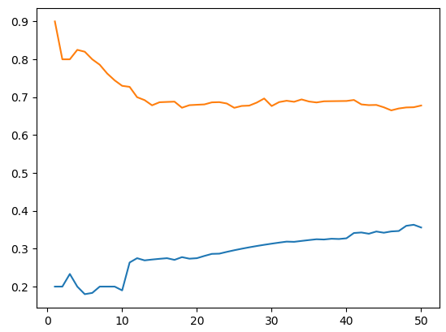
So Gaussian Bayes seems to work better when provided with a smaller training set but it stays overall way less efficient than K-NN in this caseWe can use cross-validation[3] to see how accurate our models will be in practice but unlike what thinks the one who wrote the exercise it does not allows to use more data for learning.
We are now going to try k-fold cross-validation with k = 2, k = 5 and with k = 10 (basically for each segment of 100 we will take 100/k elements in a first set then 100/k elements in the next set and so on for having k set that reunited have all the elements then for each of those k set we test a training set containing all the k-1 sets other sets with that k set as a test set)
With k=10 we find an average precision of 0.28600000000000003 for Gaussian Bayes and a precision of 0.7609999999999999 for K-NN.
With k=5 we find an average precision of 0.28800000000000003 for Gaussian Bayes and a precision of 0.7449999999999999 for K-NN.
With k=2 we find an average precision of 0.314 for Gaussian Bayes and a precision of 0.706 for K-NN.
So we see that again having too much huge training sets makes our implementation of Gaussian Bayes work even worse.

With the second dataset and X=20 we find the following confusion matrices:
confusion matrix for K-NN
[[ 25. 0. 0. 0. 0. 75. 0. 0. 0. 0.]
[ 0. 100. 0. 0. 0. 0. 0. 0. 0. 0.]
[ 0. 0. 55. 45. 0. 0. 0. 0. 0. 0.]
[ 0. 0. 25. 75. 0. 0. 0. 0. 0. 0.]
[ 0. 0. 0. 0. 100. 0. 0. 0. 0. 0.]
[ 0. 0. 0. 0. 0. 100. 0. 0. 0. 0.]
[ 0. 0. 0. 0. 5. 0. 95. 0. 0. 0.]
[ 0. 0. 0. 0. 10. 0. 0. 90. 0. 0.]
[ 0. 0. 0. 0. 0. 0. 0. 0. 100. 0.]
[ 0. 0. 0. 0. 0. 0. 0. 5. 0. 95.]]
confusion matrix for the Gaussian method
[[ 0. 0. 0. 0. 0. 100. 0. 0. 0. 0.]
[ 0. 0. 0. 0. 100. 0. 0. 0. 0. 0.]
[ 90. 0. 0. 0. 0. 10. 0. 0. 0. 0.]
[ 90. 0. 0. 0. 0. 10. 0. 0. 0. 0.]
[ 0. 0. 0. 0. 0. 0. 0. 80. 0. 20.]
[ 15. 0. 0. 0. 0. 85. 0. 0. 0. 0.]
[ 50. 0. 0. 0. 0. 0. 15. 0. 35. 0.]
[ 0. 0. 0. 0. 0. 0. 0. 5. 0. 95.]
[ 0. 0. 0. 0. 0. 0. 55. 0. 0. 45.]
[ 0. 0. 0. 0. 15. 0. 0. 0. 0. 85.]]
And a precision of 0.19 for Gaussian Bayes
as well as a precision of 0.835 for K-NN(so K-NN works better with this dataset that corresponds to the same words but have more information)
We did a graph with the same parameters as before but with the new dataset.

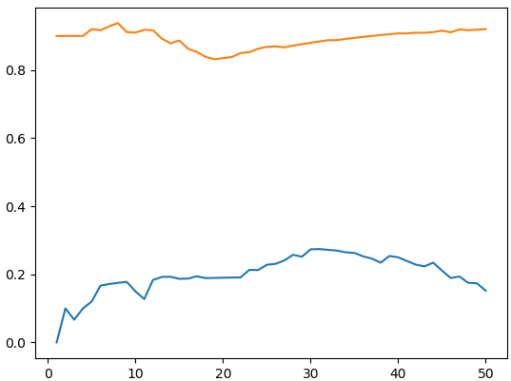
Then we test the implementations of the algorithms on the final dataset from which the two first dataset were built: the full 12 dimension cepstral parametrization
With X=20
precision for the Gaussian Bayes algorithm we use:0.14
precision for K-NN:1.0 (so it have a 100% success rate in this case)
confusion matrix for K-NN
[[100. 0. 0. 0. 0. 0. 0. 0. 0. 0.]
[ 0. 100. 0. 0. 0. 0. 0. 0. 0. 0.]
[ 0. 0. 100. 0. 0. 0. 0. 0. 0. 0.]
[ 0. 0. 0. 100. 0. 0. 0. 0. 0. 0.]
[ 0. 0. 0. 0. 100. 0. 0. 0. 0. 0.]
[ 0. 0. 0. 0. 0. 100. 0. 0. 0. 0.]
[ 0. 0. 0. 0. 0. 0. 100. 0. 0. 0.]
[ 0. 0. 0. 0. 0. 0. 0. 100. 0. 0.]
[ 0. 0. 0. 0. 0. 0. 0. 0. 100. 0.]
[ 0. 0. 0. 0. 0. 0. 0. 0. 0. 100.]]
confusion matrix for the Gaussian method
[[ 0. 0. 0. 0. 70. 0. 30. 0. 0. 0.]
[ 0. 0. 0. 0. 15. 0. 85. 0. 0. 0.]
[ 0. 100. 0. 0. 0. 0. 0. 0. 0. 0.]
[ 0. 0. 0. 45. 0. 50. 5. 0. 0. 0.]
[ 0. 0. 0. 60. 5. 0. 0. 0. 0. 35.]
[ 0. 0. 0. 5. 0. 0. 5. 0. 90. 0.]
[ 0. 0. 0. 0. 5. 0. 95. 0. 0. 0.]
[ 0. 0. 0. 0. 0. 0. 100. 0. 0. 0.]
[ 0. 0. 0. 0. 70. 0. 0. 0. 0. 30.]
[ 0. 0. 0. 100. 0. 0. 0. 0. 0. 0.]]
Here is the graph corresponding to the third dataset(same rules as the two previous graphs)

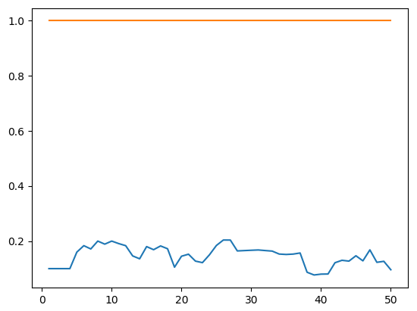

so K-NN is even more precise than before even with only 50 % of the train data while the Gaussian Bayes we wrote barely works.

Annex
Thanks for participation.

Bibliography

[1]A Gaussian Bayes method for classification https://moodle.univ-tlse3.fr/pluginfile.php/331752/mod_resource/content/1/m1-iaa-cours4-avec-notes.pdf
[2]https://scikit-learn.org/stable/modules/generated/sklearn.neighbors.KNeighborsClassifier.html
[3]https://en.wikipedia.org/wiki/Cross-validation_(statistics)

The 3 datasets used in the article can be found at https://moodle.univ-tlse3.fr/mod/folder/view.php?id=158850 they are obtained from the cepstral parametrization of pronounced words
The 3 datasets used in the article can be found at https://moodle.univ-tlse3.fr/mod/folder/view.php?id=158850 they are obtained from the cepstral parametrization of pronounced words
The 3 datasets used in the article can be found at https://moodle.univ-tlse3.fr/mod/folder/view.php?id=158850 they are obtained from the cepstral parametrization of pronounced words

