Disparities

Christelle Colin-Leitzinger

2021-06-28

Table of Contents

Manuscript

# Introduction

The ORIEN Avatar^TM Research Program focuses on patients with advanced primary or metastatic disease, those with limited treatment options, as well as patients who are likely to develop progressive disease, and will capitalize on the disease-area expertise of ORIEN’s research scientists.  
It generates massive amounts of genetic and clinical information on patients consenting to the Total Cancer Care® (TCC) Protocol.  
ORIEN Avatar tracks patient clinical progressions over their lifetime to provide the richest data source for targeted cancer therapy advancement. ORIEN Avatar data solution is optimized for oncology research by providing integrated longitudinal clinical data and whole exome, transcriptome and germline sequencing around consented oncology patients.  
We are focusing on patients with multiple myeloma disease. We will focus on patient with active MM who had WES analyzed on their blood and CH were analyzed.

# I. MM Avatar data description

| Characteristic | N = 5101 |
| --- | --- |
| **CH_status** |  |
| No CH | 448 (88%) |
| CH | 62 (12%) |
| 1n (%) | |

| Characteristic | CH, N = 621 | No CH, N = 4481 | p-value2 |
| --- | --- | --- | --- |
| **Age at MM diagnosis** | 65.16 (60.12, 71.50) | 60.83 (52.36, 67.62) | **<0.001** |
| **Gender** |  |  | 0.5 |
| Male | 38 (61%) | 254 (57%) |  |
| Female | 24 (39%) | 194 (43%) |  |
| **Race1** |  |  | 0.3 |
| White | 55 (93%) | 387 (89%) |  |
| Black | 4 (6.8%) | 48 (11%) |  |
| **Ethnicity1** |  |  | 0.9 |
| Non-Hispanic | 55 (92%) | 407 (91%) |  |
| Hispanic | 5 (8.3%) | 40 (8.9%) |  |
| **ISS** |  |  | 0.11 |
| I | 31 (51%) | 272 (64%) |  |
| II | 20 (33%) | 115 (27%) |  |
| III | 10 (16%) | 41 (9.6%) |  |
| **ISS_grp** |  |  | 0.055 |
| I | 31 (51%) | 272 (64%) |  |
| II-III | 30 (49%) | 156 (36%) |  |
| 1Median (IQR); n (%) | | | |
| 2Wilcoxon rank sum test; Pearson's Chi-squared test | | | |

Within the MM Avatar data, 510 patients had blood sequenced and were analyzed for CH mutations and CH was identified in 62 (12%) patients. Age shows a difference between patient with CH 65.16 (60.12, 71.50) Patients exhibiting CH shows a significant higher age at diagnosis compare to no CH individuals 65.16 (60.12, 71.50) and 60.83 (52.36, 67.62) (p<0.001).  
No differences werw observed in Gender, Race, Ethnicity but a trend toward a higher ISS clinical stage was noted (30 (49%) compare to 156 (36%), p=0.055).

## 1.Demographics of MM patients with WES

| Characteristic | MM patients with WES, N = 5101 |
| --- | --- |
| **Age_at_MMonly_diagnosis** | 61.72 (53.45, 67.95) |
| **Gender** |  |
| Male | 292 (57%) |
| Female | 218 (43%) |
| **Race** |  |
| White | 442 (87%) |
| Black | 52 (10%) |
| Others | 8 (1.6%) |
| Asian | 4 (0.8%) |
| More than one race | 2 (0.4%) |
| Am Indian | 1 (0.2%) |
| Unknown | 1 (0.2%) |
| **Race1** |  |
| White | 442 (89%) |
| Black | 52 (11%) |
| **Ethnicity** |  |
| Non-Hispanic | 462 (91%) |
| Hispanic | 45 (8.8%) |
| Unknown | 3 (0.6%) |
| **Ethnicity1** |  |
| Non-Hispanic | 462 (91%) |
| Hispanic | 45 (8.9%) |
| **ISS** |  |
| I | 303 (62%) |
| II | 135 (28%) |
| III | 51 (10%) |
| **ISS_grp** |  |
| I | 303 (62%) |
| II-III | 186 (38%) |
| 1Median (IQR); n (%) | |

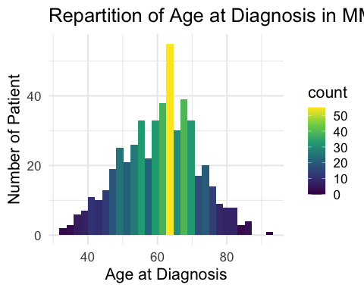

Patients represented in MM Avatar data are characterized by a median age at diagnosis of 61.72 years old. We saw slightly more male 292 (57%), a majority of White 442 (89%) and Non-Hispanic 462 (91%). A higher proportion of patients have a lower clinical stage at diagnosis with 303 (62%) patients with ISS I and 186 (38%) patients with ISS II and III combined.

## 2. CH

| Characteristic | MM patients with WES, N = 5101 |
| --- | --- |
| **CH_status** |  |
| No CH | 448 (88%) |
| CH | 62 (12%) |
| 1n (%) | |

Sequencing data helped us identify CH mutations in 62 (12%). + Add bioinfo results.

## 3. Disease Status

These patients are now all MM but at time of blood collection distribution of disease status is as below. (would probably keep that for a treatment paper)

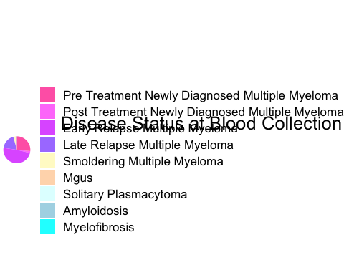

# II. Age Distribution in Disparities

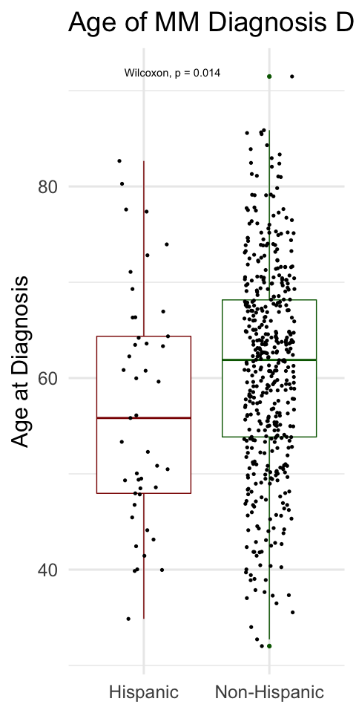

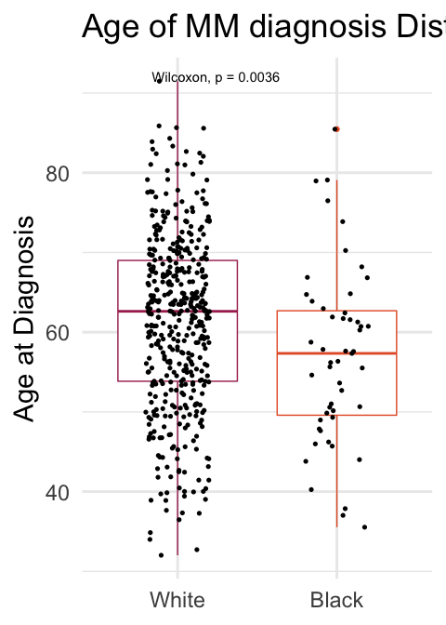

Interestingly, we noticed a significant difference between disparities on the age at diagnosis. Hispanic are diagnosed at an earlier age 56 years old compare to 62 years old (p=0.014). Blacks also exhibit a lower age at diagnosis compare to Whites, respectively 57 years old vs 63 years old (p=0.003).

# III. Ethnicity

## Summary

No difference in gender, ISS, CH and delay between diagnosis and treatment. Most patients received drugs. Should we check the one who didn’t to justify if they are just lost of follow up?

## Survivals

No difference in OS within Ethnicity. The hazard ratio is decreased by 26% for Hispanic population but is not significant. Notably, age at diagnosis, ISS (ISS_grp) and receiving HCT are factor involved in OS in univariate and multivariate analysis. (Give data) We observed that Hispanic population is doing better for PFS with a HR of progression increased by 53% compare to NH and 77% when adjusting by age at diagnosis, gender, ISS (ISS_grp) and receiving HCT We noted that in multivariate analysis being a male increase significantly the HR of progression by 29% (add data, pval = 0.029). Age at diagnosis is not a factor involved in PFS but is in OS. Not surprisingly ISS stage III have a worse survival (OS and PFS) and receiving HCT on the contrary increase it.

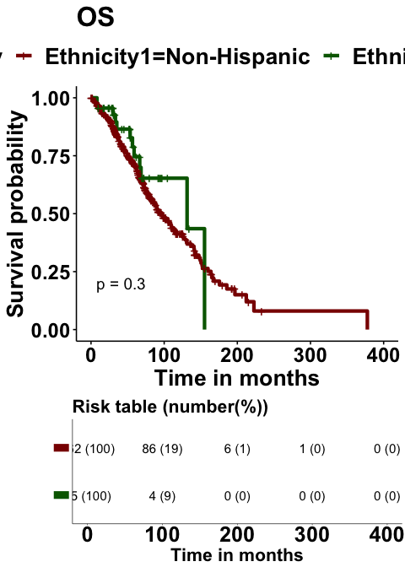

|  | Univariate | | | | | Multivariate | | |
| --- | --- | --- | --- | --- | --- | --- | --- | --- |
| Characteristic | N | Event N | HR1 | 95% CI1 | p-value | HR1 | 95% CI1 | p-value |
| **Ethnicity1** | 507 | 221 |  |  |  |  |  |  |
| *Non-Hispanic* |  |  | — | — |  | — | — |  |
| *Hispanic* |  |  | 0.74 | 0.41, 1.32 | 0.3 | 0.91 | 0.51, 1.64 | 0.8 |
| **Age_at_MMonly_diagnosis** | 507 | 221 | 1.05 | 1.04, 1.07 | **<0.001** | 1.04 | 1.02, 1.05 | **<0.001** |
| **Gender** | 507 | 221 |  |  |  |  |  |  |
| *Female* |  |  | — | — |  | — | — |  |
| *Male* |  |  | 1.20 | 0.92, 1.58 | 0.2 | 1.22 | 0.92, 1.62 | 0.2 |
| **ISS** | 486 | 214 |  |  |  |  |  |  |
| *I* |  |  | — | — |  | — | — |  |
| *II* |  |  | 2.48 | 1.85, 3.34 | **<0.001** | 2.20 | 1.63, 2.96 | **<0.001** |
| *III* |  |  | 2.40 | 1.62, 3.55 | **<0.001** | 2.46 | 1.66, 3.64 | **<0.001** |
| **Drugs_ever** | 507 | 221 |  |  |  |  |  |  |
| *No Drug* |  |  | — | — |  | — | — |  |
| *Drug* |  |  | 3,347,345 | 0.00, Inf | >0.9 | 3,406,022 | 0.00, Inf | >0.9 |
| **HCT_ever** | 507 | 221 |  |  |  |  |  |  |
| *No HCT* |  |  | — | — |  | — | — |  |
| *HCT* |  |  | 0.49 | 0.37, 0.64 | **<0.001** | 0.64 | 0.46, 0.87 | **0.005** |
| 1HR = Hazard Ratio, CI = Confidence Interval | | | | | | | | |

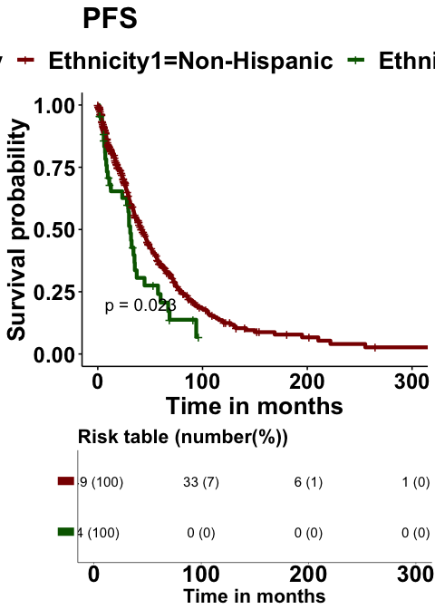

|  | Univariate | | | | | Multivariate | | |
| --- | --- | --- | --- | --- | --- | --- | --- | --- |
| Characteristic | N | Event N | HR1 | 95% CI1 | p-value | HR1 | 95% CI1 | p-value |
| **Ethnicity1** | 493 | 319 |  |  |  |  |  |  |
| *Non-Hispanic* |  |  | — | — |  | — | — |  |
| *Hispanic* |  |  | 1.53 | 1.06, 2.20 | **0.024** | 1.77 | 1.21, 2.59 | **0.003** |
| **Age_at_MMonly_diagnosis** | 493 | 319 | 1.00 | 0.99, 1.02 | 0.4 | 1.00 | 0.99, 1.01 | 0.8 |
| **Gender** | 493 | 319 |  |  |  |  |  |  |
| *Female* |  |  | — | — |  | — | — |  |
| *Male* |  |  | 1.20 | 0.96, 1.50 | 0.11 | 1.29 | 1.03, 1.63 | **0.029** |
| **ISS** | 473 | 306 |  |  |  |  |  |  |
| *I* |  |  | — | — |  | — | — |  |
| *II* |  |  | 1.06 | 0.81, 1.38 | 0.7 | 1.04 | 0.80, 1.36 | 0.8 |
| *III* |  |  | 1.38 | 0.98, 1.96 | 0.068 | 1.43 | 1.00, 2.03 | **0.047** |
| **HCT_ever** | 493 | 319 |  |  |  |  |  |  |
| *No HCT* |  |  | — | — |  | — | — |  |
| *HCT* |  |  | 0.79 | 0.62, 1.00 | **0.047** | 0.77 | 0.60, 0.99 | **0.045** |
| 1HR = Hazard Ratio, CI = Confidence Interval | | | | | | | | |

Age is significantly associated with OS (OR 1.00; 95% CI 0.99, 1.02; p=0.4).

I thought it could be a year effect compare to Taiga said (maybe earlier it wasn’t a difference like he said but now that Hispanic may have more access to care we can see the difference) but no.

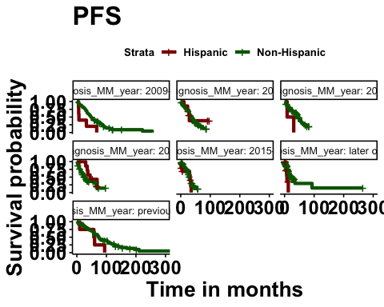

## CH & Ethnicity in PFS

CH in not a factor in PFS as we observed a slight dicrease of the HR of progression for patients with no CH 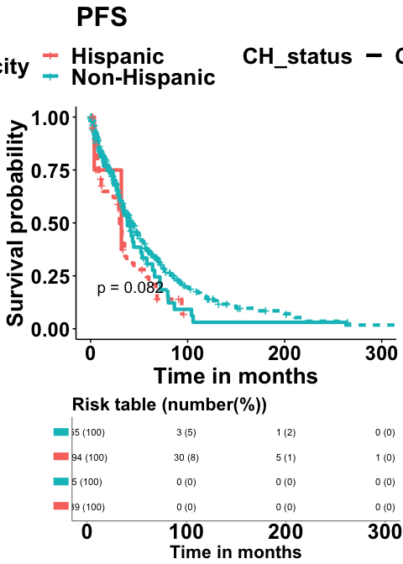

|  | Univariate | | | | | Multivariate | | |
| --- | --- | --- | --- | --- | --- | --- | --- | --- |
| Characteristic | N | Event N | HR1 | 95% CI1 | p-value | HR1 | 95% CI1 | p-value |
| **Ethnicity1** | 493 | 319 |  |  |  |  |  |  |
| *Non-Hispanic* |  |  | — | — |  | — | — |  |
| *Hispanic* |  |  | 1.53 | 1.06, 2.20 | **0.024** | 1.78 | 1.22, 2.60 | **0.003** |
| **Age_at_MMonly_diagnosis** | 493 | 319 | 1.00 | 0.99, 1.02 | 0.4 | 1.00 | 0.99, 1.01 | >0.9 |
| **Gender** | 493 | 319 |  |  |  |  |  |  |
| *Female* |  |  | — | — |  | — | — |  |
| *Male* |  |  | 1.20 | 0.96, 1.50 | 0.11 | 1.29 | 1.03, 1.63 | **0.030** |
| **ISS** | 473 | 306 |  |  |  |  |  |  |
| *I* |  |  | — | — |  | — | — |  |
| *II* |  |  | 1.06 | 0.81, 1.38 | 0.7 | 1.04 | 0.80, 1.36 | 0.8 |
| *III* |  |  | 1.38 | 0.98, 1.96 | 0.068 | 1.41 | 0.99, 2.01 | 0.057 |
| **HCT_ever** | 493 | 319 |  |  |  |  |  |  |
| *No HCT* |  |  | — | — |  | — | — |  |
| *HCT* |  |  | 0.79 | 0.62, 1.00 | **0.047** | 0.77 | 0.60, 1.00 | **0.046** |
| **CH_status** | 493 | 319 |  |  |  |  |  |  |
| *CH* |  |  | — | — |  | — | — |  |
| *No CH* |  |  | 0.83 | 0.59, 1.15 | 0.3 | 0.89 | 0.63, 1.26 | 0.5 |
| 1HR = Hazard Ratio, CI = Confidence Interval | | | | | | | | |

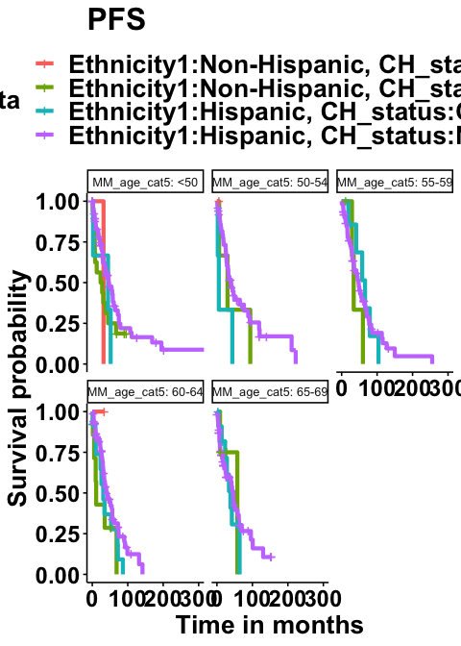

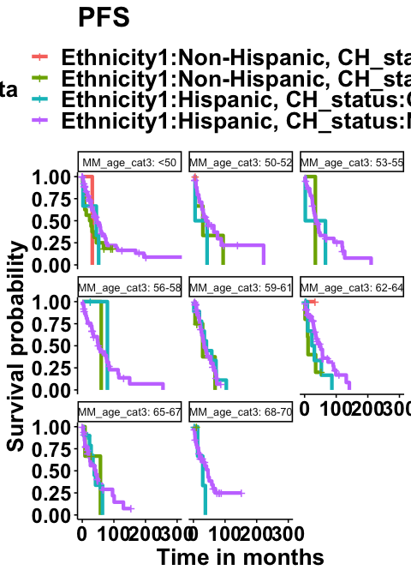

# IV. Race

## Summary

We observed a difference in gender but no difference in ISS, CH and if or type of treatment received. Interestingly a longer delay to receive HCT was observed for Black population.

## Survivals

We observed that while PFS is not different between White and Black, Black shows a greater OS with a HR of death decreased by 49% (data) but this effect is not significant when adjusted by age, gender, ISS, and receiving a treatment. Age at diagnosis ISS and receiving HCT are factor associated with OS in the multivariate analysis. In the multivariate analysis, Gender is associated to better progression free survival.

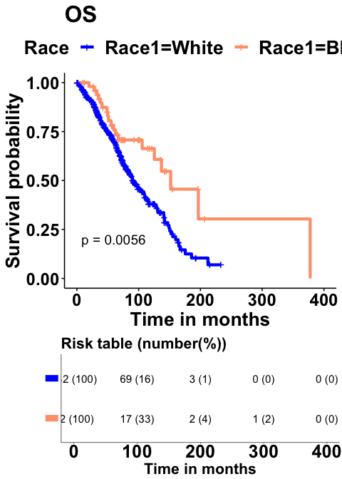

|  | Univariate | | | | | Multivariate | | |
| --- | --- | --- | --- | --- | --- | --- | --- | --- |
| Characteristic | N | Event N | HR1 | 95% CI1 | p-value | HR1 | 95% CI1 | p-value |
| **Race1** | 494 | 215 |  |  |  |  |  |  |
| *White* |  |  | — | — |  | — | — |  |
| *Black* |  |  | 0.51 | 0.31, 0.83 | **0.006** | 0.66 | 0.39, 1.10 | 0.11 |
| **Age_at_MMonly_diagnosis** | 510 | 221 | 1.05 | 1.04, 1.07 | **<0.001** | 1.03 | 1.02, 1.05 | **<0.001** |
| **Gender** | 510 | 221 |  |  |  |  |  |  |
| *Female* |  |  | — | — |  | — | — |  |
| *Male* |  |  | 1.20 | 0.91, 1.57 | 0.2 | 1.21 | 0.91, 1.62 | 0.2 |
| **ISS** | 489 | 214 |  |  |  |  |  |  |
| *I* |  |  | — | — |  | — | — |  |
| *II* |  |  | 2.49 | 1.86, 3.35 | **<0.001** | 2.11 | 1.56, 2.86 | **<0.001** |
| *III* |  |  | 2.41 | 1.63, 3.57 | **<0.001** | 2.34 | 1.56, 3.50 | **<0.001** |
| **Drugs_ever** | 510 | 221 |  |  |  |  |  |  |
| *No Drug* |  |  | — | — |  | — | — |  |
| *Drug* |  |  | 3,346,893 | 0.00, Inf | >0.9 | 3,439,914 | 0.00, Inf | >0.9 |
| **HCT_ever** | 510 | 221 |  |  |  |  |  |  |
| *No HCT* |  |  | — | — |  | — | — |  |
| *HCT* |  |  | 0.49 | 0.37, 0.65 | **<0.001** | 0.61 | 0.44, 0.84 | **0.003** |
| 1HR = Hazard Ratio, CI = Confidence Interval | | | | | | | | |

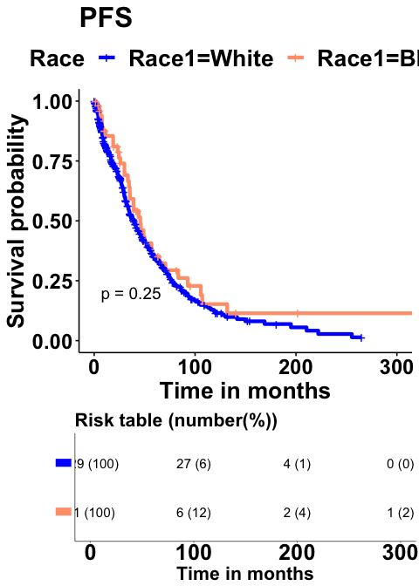

|  | Univariate | | | | | Multivariate | | |
| --- | --- | --- | --- | --- | --- | --- | --- | --- |
| Characteristic | N | Event N | HR1 | 95% CI1 | p-value | HR1 | 95% CI1 | p-value |
| **Race1** | 480 | 310 |  |  |  |  |  |  |
| *White* |  |  | — | — |  | — | — |  |
| *Black* |  |  | 0.81 | 0.57, 1.16 | 0.2 | 0.83 | 0.57, 1.21 | 0.3 |
| **Age_at_MMonly_diagnosis** | 496 | 321 | 1.00 | 0.99, 1.02 | 0.4 | 1.00 | 0.99, 1.01 | 0.9 |
| **Gender** | 496 | 321 |  |  |  |  |  |  |
| *Female* |  |  | — | — |  | — | — |  |
| *Male* |  |  | 1.21 | 0.96, 1.51 | 0.10 | 1.30 | 1.02, 1.64 | **0.031** |
| **ISS** | 476 | 308 |  |  |  |  |  |  |
| *I* |  |  | — | — |  | — | — |  |
| *II* |  |  | 1.05 | 0.81, 1.37 | 0.7 | 1.07 | 0.82, 1.40 | 0.6 |
| *III* |  |  | 1.38 | 0.97, 1.95 | 0.072 | 1.45 | 1.01, 2.06 | **0.043** |
| **HCT_ever** | 496 | 321 |  |  |  |  |  |  |
| *No HCT* |  |  | — | — |  | — | — |  |
| *HCT* |  |  | 0.79 | 0.63, 1.00 | 0.050 | 0.76 | 0.59, 0.99 | **0.041** |
| 1HR = Hazard Ratio, CI = Confidence Interval | | | | | | | | |

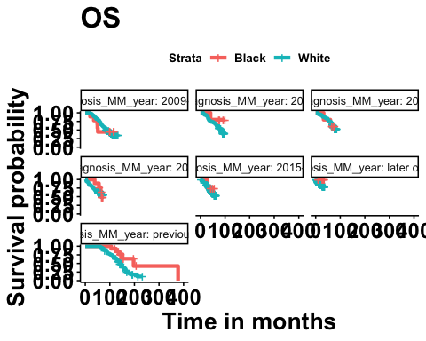

## Black & CH

Very interestingly, we observed that while CH doesn’t impact OS in white population, in Black population, presence of CH decrease drastically the survival rate by 80ish% (data). Age at diagnosis, ISS are associated with OS in blacks alone and in combined White/Black population.

<https://www.biorxiv.org/content/10.1101/782748v1.full.pdf> 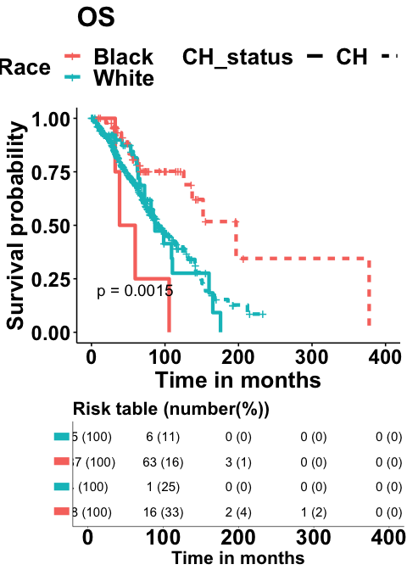

|  | Univariate | | | | | Multivariate | | |
| --- | --- | --- | --- | --- | --- | --- | --- | --- |
| Characteristic | N | Event N | HR1 | 95% CI1 | p-value | HR1 | 95% CI1 | p-value |
| **Race1** | 494 | 215 |  |  |  |  |  |  |
| *White* |  |  | — | — |  | — | — |  |
| *Black* |  |  | 0.51 | 0.31, 0.83 | **0.006** | 0.65 | 0.39, 1.09 | 0.11 |
| **Age_at_MMonly_diagnosis** | 510 | 221 | 1.05 | 1.04, 1.07 | **<0.001** | 1.04 | 1.02, 1.05 | **<0.001** |
| **Gender** | 510 | 221 |  |  |  |  |  |  |
| *Female* |  |  | — | — |  | — | — |  |
| *Male* |  |  | 1.20 | 0.91, 1.57 | 0.2 | 1.22 | 0.91, 1.63 | 0.2 |
| **ISS** | 489 | 214 |  |  |  |  |  |  |
| *I* |  |  | — | — |  | — | — |  |
| *II* |  |  | 2.49 | 1.86, 3.35 | **<0.001** | 2.16 | 1.59, 2.92 | **<0.001** |
| *III* |  |  | 2.41 | 1.63, 3.57 | **<0.001** | 2.54 | 1.68, 3.84 | **<0.001** |
| **Drugs_ever** | 510 | 221 |  |  |  |  |  |  |
| *No Drug* |  |  | — | — |  | — | — |  |
| *Drug* |  |  | 3,346,893 | 0.00, Inf | >0.9 | 3,553,293 | 0.00, Inf | >0.9 |
| **HCT_ever** | 510 | 221 |  |  |  |  |  |  |
| *No HCT* |  |  | — | — |  | — | — |  |
| *HCT* |  |  | 0.49 | 0.37, 0.65 | **<0.001** | 0.60 | 0.43, 0.83 | **0.002** |
| **CH_status** | 510 | 221 |  |  |  |  |  |  |
| *CH* |  |  | — | — |  | — | — |  |
| *No CH* |  |  | 0.87 | 0.59, 1.30 | 0.5 | 1.44 | 0.94, 2.21 | 0.092 |
| 1HR = Hazard Ratio, CI = Confidence Interval | | | | | | | | |

### Summary

## In black

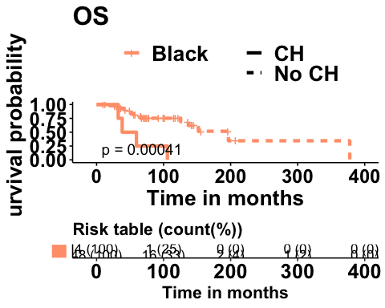

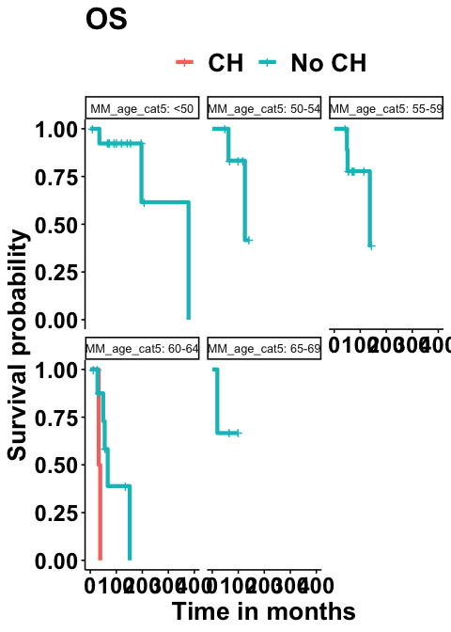

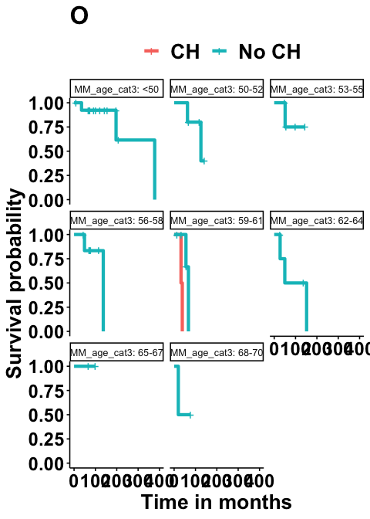

# Others

## 4.CH

### Summary

We see **more male with CH** (66%) vs Female with CH (34%), more Female without CH (45%) vs Male without CH (55%) p=0.079. CH is more represented in **severe ISS** (II-III).

### Survivals

