Survival analysis
Christelle Colin-Leitzinger
2025-07-28
Table of Contents

data_merge <- data_merge %>%
mutate(tnm_stage = case_when(
str_detect(tnm_stage, "0") ~ "0",
str_detect(tnm_stage, "1") ~ "1",
str_detect(tnm_stage, "2") ~ "2",
str_detect(tnm_stage, "3") ~ "3",
str_detect(tnm_stage, "4") ~ "4",
str_detect(tnm_stage, "99") ~ NA_character_,
TRUE ~ tnm_stage
)) %>%
mutate(tnm_stage_cat = case_when(
tnm_stage == "0" |
tnm_stage == "1" |
tnm_stage == "2" ~ "Early stage",
tnm_stage == "3" |
tnm_stage == "4" ~ "Late stage",
TRUE ~ tnm_stage
), tnm_stage_cat = factor(tnm_stage_cat, levels = c("Early stage", "Late stage"))) %>%
mutate_at(c("er", "pr", "her2"), ~ factor(., levels = c("neg", "pos"))) %>%
mutate(status_CH = factor(status_CH, levels = c("noCH", "CH"))) %>%
mutate(cond = case_when(
status_selection == "NegativeSelection" ~ "Neg/Not impacted",
status_selection == "NotChanged" ~ "Neg/Not impacted",
status_selection == "PositiveSelection" ~ "Pos"
), cond = factor(cond, levels = c("Neg/Not impacted", "Pos"))) %>%
mutate(her2 = case_when(
str_detect(deidentified_patient_id, "007422") ~ "neg",
TRUE ~ her2
))
write_rds(data_merge %>%
select(deidentified_patient_id,
age_at_sample, tnm_stage, tnm_stage_cat,
er, pr, her2, status_CH, status_selection, cond,
os_event, os_time_from_tx_start_months, pfs_event, pfs_time_months),
"data_meerge_updated.rds")

OS

Overall population

1. Summary
data_merge %>%
select(age_at_sample, tnm_stage, tnm_stage_cat,
er, pr, her2, status_CH, status_selection, cond) %>%
mutate(age_cat = case_when(
age_at_sample < 40 ~ "20-39",
age_at_sample < 50 ~ "40-49",
age_at_sample < 60 ~ "50-59",
age_at_sample >= 60 ~ "60-80",
)) %>%
tbl_summary() %>%
bold_labels()
Characteristic | N = 171¹
age_at_sample | 58 (50, 66)
tnm_stage
0 | 15 (8.8%)
1 | 81 (48%)
2 | 54 (32%)
3 | 13 (7.6%)
4 | 7 (4.1%)
Unknown | 1
tnm_stage_cat
Early stage | 150 (88%)
Late stage | 20 (12%)
Unknown | 1
er
neg | 30 (18%)
pos | 141 (82%)
pr
neg | 41 (24%)
pos | 130 (76%)
her2
neg | 141 (88%)
pos | 19 (12%)
Unknown | 11
status_CH
noCH | 77 (45%)
CH | 94 (55%)
status_selection
NegativeSelection | 8 (8.8%)
NotChanged | 55 (60%)
PositiveSelection | 28 (31%)
Unknown | 80
cond
Neg/Not impacted | 63 (69%)
Pos | 28 (31%)
Unknown | 80
age_cat
20-39 | 10 (5.8%)
40-49 | 26 (15%)
50-59 | 66 (39%)
60-80 | 69 (40%)
¹Median (Q1, Q3); n (%)

2. Hazard ratios and 95% confidence intervals
tbl1 <- tbl_uvregression(
data_merge,
method = coxph,
y = Surv(time = os_time_from_tx_start_months, event = os_event),
exponentiate = TRUE,
add_estimate_to_reference_rows = TRUE,
include = c("age_at_sample", "tnm_stage_cat",
"er", "pr", "her2", "status_CH"),
# pvalue_fun = label_style_pvalue(digits = 2)
) %>%
bold_p(t = .05) %>%
add_nevent(location = "level") %>% add_n(location = "level") %>%
modify_table_styling(
columns = conf.low,
rows = reference_row %in% TRUE,
missing_symbol = "Reference"
) %>%
modify_column_merge(
pattern = "{stat_n} ({stat_nevent})",
rows = !is.na(stat_nevent)
) %>%
modify_header(stat_n = "**N (Event N)**") %>%
modify_column_merge(
pattern = "{estimate} ({conf.low}, {conf.high})",
rows = !is.na(estimate)
) %>%
modify_header(estimate = "**HR (95% CI)**") %>%
bold_labels() %>% italicize_levels()
tbl2 <- coxph(Surv(time = data_merge$os_time_from_tx_start_months,
event = data_merge$os_event) ~ age_at_sample + tnm_stage_cat + er + pr + her2 + status_CH,
data = data_merge) %>%
tbl_regression(exponentiate = TRUE,
add_estimate_to_reference_rows = TRUE) %>%
bold_p(t = .05) %>%
add_nevent(location = "level") %>% add_n(location = "level") %>%
modify_table_styling(
columns = conf.low,
rows = reference_row %in% TRUE,
missing_symbol = "Reference"
) %>%
modify_column_merge(
pattern = "{stat_n} ({stat_nevent})",
rows = !is.na(stat_nevent)
) %>%
modify_header(stat_n = "**N (Event N)**") %>%
modify_column_merge(
pattern = "{estimate} ({conf.low}, {conf.high})",
rows = !is.na(estimate)
) %>%
modify_header(estimate = "**HR (95% CI)**")
tbl_merge(list(tbl1, tbl2),
tab_spanner = c("**Univariable - each variable HR <br>is non adjusted**",
"**Multivariable - each HR adjusted for <br>variables in table**"))
 | Univariable - each variable HR is non adjusted |  |  | Multivariable - each HR adjusted for variables in table
Characteristic | N (Event N) | HR (95% CI) | p-value | N (Event N) | HR (95% CI) | p-value
age_at_sample | 171 (27) | 1.01 (0.97, 1.05) | 0.7 | 159 (26) | 1.03 (0.99, 1.08) | 0.2
tnm_stage_cat
Early stage | 150 (15) | 1.00 (, ) |  | 139 (15) | 1.00 (, )
Late stage | 20 (11) | 9.20 (4.15, 20.4) | <0.001 | 20 (11) | 12.2 (4.76, 31.5) | <0.001
er
neg | 30 (9) | 1.00 (, ) |  | 30 (9) | 1.00 (, )
pos | 141 (18) | 0.35 (0.16, 0.79) | 0.011 | 129 (17) | 0.19 (0.06, 0.64) | 0.007
pr
neg | 41 (12) | 1.00 (, ) |  | 40 (12) | 1.00 (, )
pos | 130 (15) | 0.33 (0.16, 0.71) | 0.005 | 119 (14) | 0.89 (0.32, 2.51) | 0.8
her2
neg | 141 (20) | 1.00 (, ) |  | 140 (19) | 1.00 (, )
pos | 19 (7) | 2.90 (1.22, 6.87) | 0.016 | 19 (7) | 1.59 (0.61, 4.12) | 0.3
status_CH
noCH | 77 (11) | 1.00 (, ) |  | 74 (11) | 1.00 (, )
CH | 94 (16) | 1.11 (0.51, 2.38) | 0.8 | 85 (15) | 0.87 (0.36, 2.14) | 0.8
Abbreviations: CI = Confidence Interval, HR = Hazard Ratio

3. KM
The KM are not ajusted
ggsurvplot(survfit(Surv(os_time_from_tx_start_months, os_event) ~ status_CH,
data=data_merge),
title = "OS Analysis",
font.main = c(20, "bold", "black"),
font.x = c(18, "bold", "black"),
font.y = c(18, "bold", "black"),
font.legend = c(16, "black"),
font.tickslab = c(16, "bold", "black"),
size = 1.5,
xlab = "Time (months)",
legend = "top",
legend.title = "",
pval = TRUE,
conf.int = FALSE,
# Censor
censor = TRUE
)
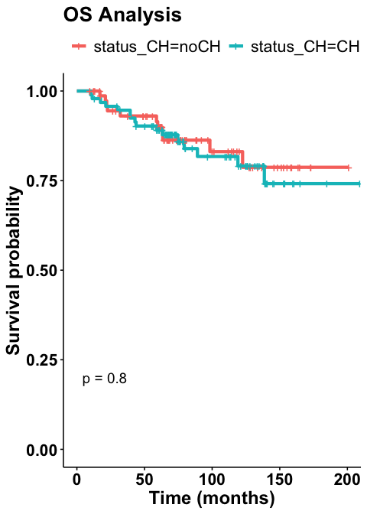

Status selection subset
selection_subset <- data_merge %>%
filter(!is.na(cond))

1. Summary
selection_subset %>%
select(age_at_sample, tnm_stage, tnm_stage_cat,
er, pr, her2, status_CH, status_selection, cond) %>%
tbl_summary() %>%
bold_labels()
Characteristic | N = 91¹
age_at_sample | 63 (55, 68)
tnm_stage
0 | 9 (10%)
1 | 42 (47%)
2 | 30 (33%)
3 | 7 (7.8%)
4 | 2 (2.2%)
Unknown | 1
tnm_stage_cat
Early stage | 81 (90%)
Late stage | 9 (10%)
Unknown | 1
er
neg | 17 (19%)
pos | 74 (81%)
pr
neg | 24 (26%)
pos | 67 (74%)
her2
neg | 74 (88%)
pos | 10 (12%)
Unknown | 7
status_CH
noCH | 0 (0%)
CH | 91 (100%)
status_selection
NegativeSelection | 8 (8.8%)
NotChanged | 55 (60%)
PositiveSelection | 28 (31%)
cond
Neg/Not impacted | 63 (69%)
Pos | 28 (31%)
¹Median (Q1, Q3); n (%)

2. Hazard ratios and 95% confidence intervals
tbl1 <- tbl_uvregression(
selection_subset,
method = coxph,
y = Surv(time = os_time_from_tx_start_months, event = os_event),
exponentiate = TRUE,
add_estimate_to_reference_rows = TRUE,
include = c("age_at_sample", "tnm_stage_cat",
"er", "pr", "her2", "cond"),
# pvalue_fun = label_style_pvalue(digits = 2)
) %>%
bold_p(t = .05) %>%
add_nevent(location = "level") %>% add_n(location = "level") %>%
modify_table_styling(
columns = conf.low,
rows = reference_row %in% TRUE,
missing_symbol = "Reference"
) %>%
modify_column_merge(
pattern = "{stat_n} ({stat_nevent})",
rows = !is.na(stat_nevent)
) %>%
modify_header(stat_n = "**N (Event N)**") %>%
modify_column_merge(
pattern = "{estimate} ({conf.low}, {conf.high})",
rows = !is.na(estimate)
) %>%
modify_header(estimate = "**HR (95% CI)**") %>%
bold_labels() %>% italicize_levels()
tbl2 <- coxph(Surv(time = selection_subset$os_time_from_tx_start_months,
event = selection_subset$os_event) ~ age_at_sample + tnm_stage_cat + er + pr + her2 + cond,
data = selection_subset) %>%
tbl_regression(exponentiate = TRUE,
add_estimate_to_reference_rows = TRUE) %>%
bold_p(t = .05) %>%
add_nevent(location = "level") %>% add_n(location = "level") %>%
modify_table_styling(
columns = conf.low,
rows = reference_row %in% TRUE,
missing_symbol = "Reference"
) %>%
modify_column_merge(
pattern = "{stat_n} ({stat_nevent})",
rows = !is.na(stat_nevent)
) %>%
modify_header(stat_n = "**N (Event N)**") %>%
modify_column_merge(
pattern = "{estimate} ({conf.low}, {conf.high})",
rows = !is.na(estimate)
) %>%
modify_header(estimate = "**HR (95% CI)**") %>%
bold_labels() %>% italicize_levels()
tbl_merge(list(tbl1, tbl2),
tab_spanner = c("**Univariable - each variable HR <br>is non adjusted**",
"**Multivariable - each HR adjusted for <br>variables in table**"))
 | Univariable - each variable HR is non adjusted |  |  | Multivariable - each HR adjusted for variables in table
Characteristic | N (Event N) | HR (95% CI) | p-value | N (Event N) | HR (95% CI) | p-value
age_at_sample | 91 (15) | 1.06 (1.00, 1.13) | 0.061 | 83 (14) | 1.12 (1.01, 1.25) | 0.032
tnm_stage_cat
Early stage | 81 (10) | 1.00 (, ) |  | 74 (10) | 1.00 (, )
Late stage | 9 (4) | 6.49 (1.95, 21.6) | 0.002 | 9 (4) | 4.87 (1.29, 18.4) | 0.019
er
neg | 17 (4) | 1.00 (, ) |  | 17 (4) | 1.00 (, )
pos | 74 (11) | 0.52 (0.17, 1.64) | 0.3 | 66 (10) | 0.32 (0.05, 1.89) | 0.2
pr
neg | 24 (7) | 1.00 (, ) |  | 24 (7) | 1.00 (, )
pos | 67 (8) | 0.32 (0.12, 0.89) | 0.029 | 59 (7) | 1.17 (0.26, 5.28) | 0.8
her2
neg | 74 (11) | 1.00 (, ) |  | 73 (10) | 1.00 (, )
pos | 10 (4) | 2.65 (0.84, 8.35) | 0.10 | 10 (4) | 1.67 (0.46, 5.98) | 0.4
cond
Neg/Not impacted | 63 (5) | 1.00 (, ) |  | 55 (4) | 1.00 (, )
Pos | 28 (10) | 5.63 (1.91, 16.6) | 0.002 | 28 (10) | 6.57 (1.66, 25.9) | 0.007
Abbreviations: CI = Confidence Interval, HR = Hazard Ratio

3. KM
ggsurvplot(survfit(Surv(os_time_from_tx_start_months, os_event) ~ cond,
data=selection_subset),
title = "OS Analysis",
font.main = c(20, "bold", "black"),
font.x = c(18, "bold", "black"),
font.y = c(18, "bold", "black"),
font.legend = c(16, "black"),
font.tickslab = c(16, "bold", "black"),
size = 1.5,
xlab = "Time (months)",
legend = "top",
legend.title = "",
pval = TRUE,
conf.int = FALSE,
# Censor
censor = TRUE
) %++% guides(colour = guide_legend(ncol = 1))
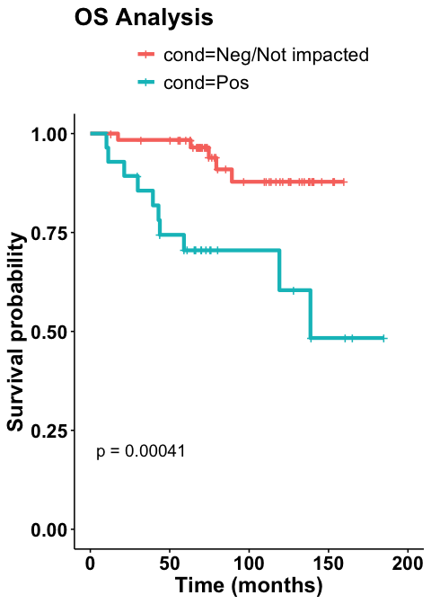

PFS

Overall population

1. Hazard ratios and 95% confidence intervals
tbl1 <- tbl_uvregression(
data_merge,
method = coxph,
y = Surv(time = pfs_time_months, event = pfs_event),
exponentiate = TRUE,
add_estimate_to_reference_rows = TRUE,
include = c("age_at_sample", "tnm_stage_cat",
"er", "pr", "her2", "status_CH"),
# pvalue_fun = label_style_pvalue(digits = 2)
) %>%
bold_p(t = .05) %>%
add_nevent(location = "level") %>% add_n(location = "level") %>%
modify_table_styling(
columns = conf.low,
rows = reference_row %in% TRUE,
missing_symbol = "Reference"
) %>%
modify_column_merge(
pattern = "{stat_n} ({stat_nevent})",
rows = !is.na(stat_nevent)
) %>%
modify_header(stat_n = "**N (Event N)**") %>%
modify_column_merge(
pattern = "{estimate} ({conf.low}, {conf.high})",
rows = !is.na(estimate)
) %>%
modify_header(estimate = "**HR (95% CI)**") %>%
bold_labels() %>% italicize_levels()
tbl2 <- coxph(Surv(time = data_merge$pfs_time_months,
event = data_merge$pfs_event) ~ age_at_sample + tnm_stage_cat + er + pr + her2 + status_CH,
data = data_merge) %>%
tbl_regression(exponentiate = TRUE,
add_estimate_to_reference_rows = TRUE) %>%
bold_p(t = .05) %>%
add_nevent(location = "level") %>% add_n(location = "level") %>%
modify_table_styling(
columns = conf.low,
rows = reference_row %in% TRUE,
missing_symbol = "Reference"
) %>%
modify_column_merge(
pattern = "{stat_n} ({stat_nevent})",
rows = !is.na(stat_nevent)
) %>%
modify_header(stat_n = "**N (Event N)**") %>%
modify_column_merge(
pattern = "{estimate} ({conf.low}, {conf.high})",
rows = !is.na(estimate)
) %>%
modify_header(estimate = "**HR (95% CI)**") %>%
bold_labels() %>% italicize_levels()
tbl_merge(list(tbl1, tbl2),
tab_spanner = c("**Univariable - each variable HR <br>is non adjusted**",
"**Multivariable - each HR adjusted for <br>variables in table**"))
 | Univariable - each variable HR is non adjusted |  |  | Multivariable - each HR adjusted for variables in table
Characteristic | N (Event N) | HR (95% CI) | p-value | N (Event N) | HR (95% CI) | p-value
age_at_sample | 171 (45) | 1.01 (0.98, 1.04) | 0.7 | 159 (42) | 1.03 (1.00, 1.07) | 0.034
tnm_stage_cat
Early stage | 150 (31) | 1.00 (, ) |  | 139 (29) | 1.00 (, )
Late stage | 20 (13) | 6.57 (3.39, 12.7) | <0.001 | 20 (13) | 7.59 (3.64, 15.8) | <0.001
er
neg | 30 (11) | 1.00 (, ) |  | 30 (11) | 1.00 (, )
pos | 141 (34) | 0.57 (0.29, 1.13) | 0.11 | 129 (31) | 0.41 (0.14, 1.20) | 0.10
pr
neg | 41 (15) | 1.00 (, ) |  | 40 (15) | 1.00 (, )
pos | 130 (30) | 0.54 (0.29, 1.00) | 0.049 | 119 (27) | 1.07 (0.40, 2.81) | 0.9
her2
neg | 141 (36) | 1.00 (, ) |  | 140 (35) | 1.00 (, )
pos | 19 (7) | 1.70 (0.76, 3.83) | 0.2 | 19 (7) | 1.27 (0.51, 3.17) | 0.6
status_CH
noCH | 77 (20) | 1.00 (, ) |  | 74 (20) | 1.00 (, )
CH | 94 (25) | 0.95 (0.53, 1.72) | 0.9 | 85 (22) | 0.72 (0.36, 1.42) | 0.3
Abbreviations: CI = Confidence Interval, HR = Hazard Ratio

2. KM
The KM are not ajusted
ggsurvplot(survfit(Surv(pfs_time_months, pfs_event) ~ status_CH,
data=data_merge),
title = "PFS Analysis",
font.main = c(20, "bold", "black"),
font.x = c(18, "bold", "black"),
font.y = c(18, "bold", "black"),
font.legend = c(16, "black"),
font.tickslab = c(16, "bold", "black"),
size = 1.5,
xlab = "Time (months)",
legend = "top",
legend.title = "",
pval = TRUE,
conf.int = FALSE,
# Censor
censor = TRUE
)
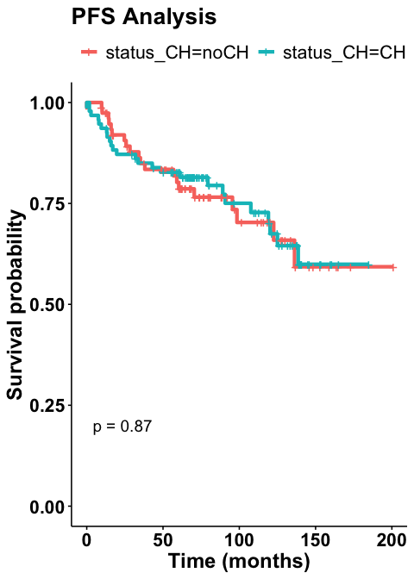

Status selection subset

1. Hazard ratios and 95% confidence intervals
tbl1 <- tbl_uvregression(
selection_subset,
method = coxph,
y = Surv(time = pfs_time_months, event = pfs_event),
exponentiate = TRUE,
add_estimate_to_reference_rows = TRUE,
include = c("age_at_sample", "tnm_stage_cat",
"er", "pr", "her2", "cond"),
# pvalue_fun = label_style_pvalue(digits = 2)
) %>%
bold_p(t = .05) %>%
add_nevent(location = "level") %>% add_n(location = "level") %>%
modify_table_styling(
columns = conf.low,
rows = reference_row %in% TRUE,
missing_symbol = "Reference"
) %>%
modify_column_merge(
pattern = "{stat_n} ({stat_nevent})",
rows = !is.na(stat_nevent)
) %>%
modify_header(stat_n = "**N (Event N)**") %>%
modify_column_merge(
pattern = "{estimate} ({conf.low}, {conf.high})",
rows = !is.na(estimate)
) %>%
modify_header(estimate = "**HR (95% CI)**") %>%
bold_labels() %>% italicize_levels()
tbl2 <- coxph(Surv(time = selection_subset$pfs_time_months,
event = selection_subset$pfs_event) ~ age_at_sample + tnm_stage_cat + er + pr + her2 + cond,
data = selection_subset) %>%
tbl_regression(exponentiate = TRUE,
add_estimate_to_reference_rows = TRUE) %>%
bold_p(t = .05) %>%
add_nevent(location = "level") %>% add_n(location = "level") %>%
modify_table_styling(
columns = conf.low,
rows = reference_row %in% TRUE,
missing_symbol = "Reference"
) %>%
modify_column_merge(
pattern = "{stat_n} ({stat_nevent})",
rows = !is.na(stat_nevent)
) %>%
modify_header(stat_n = "**N (Event N)**") %>%
modify_column_merge(
pattern = "{estimate} ({conf.low}, {conf.high})",
rows = !is.na(estimate)
) %>%
modify_header(estimate = "**HR (95% CI)**") %>%
bold_labels() %>% italicize_levels()
tbl_merge(list(tbl1, tbl2),
tab_spanner = c("**Univariable - each variable HR <br>is non adjusted**",
"**Multivariable - each HR adjusted for <br>variables in table**"))
 | Univariable - each variable HR is non adjusted |  |  | Multivariable - each HR adjusted for variables in table
Characteristic | N (Event N) | HR (95% CI) | p-value | N (Event N) | HR (95% CI) | p-value
age_at_sample | 91 (23) | 1.06 (1.01, 1.12) | 0.020 | 83 (20) | 1.09 (1.01, 1.17) | 0.018
tnm_stage_cat
Early stage | 81 (17) | 1.00 (, ) |  | 74 (15) | 1.00 (, )
Late stage | 9 (5) | 5.73 (2.07, 15.9) | <0.001 | 9 (5) | 5.13 (1.65, 15.9) | 0.005
er
neg | 17 (4) | 1.00 (, ) |  | 17 (4) | 1.00 (, )
pos | 74 (19) | 0.95 (0.32, 2.79) | >0.9 | 66 (16) | 0.69 (0.14, 3.43) | 0.7
pr
neg | 24 (8) | 1.00 (, ) |  | 24 (8) | 1.00 (, )
pos | 67 (15) | 0.53 (0.22, 1.26) | 0.15 | 59 (12) | 0.94 (0.23, 3.80) | >0.9
her2
neg | 74 (17) | 1.00 (, ) |  | 73 (16) | 1.00 (, )
pos | 10 (4) | 1.84 (0.62, 5.47) | 0.3 | 10 (4) | 1.52 (0.41, 5.61) | 0.5
cond
Neg/Not impacted | 63 (12) | 1.00 (, ) |  | 55 (9) | 1.00 (, )
Pos | 28 (11) | 2.53 (1.11, 5.76) | 0.027 | 28 (11) | 2.60 (0.94, 7.17) | 0.064
Abbreviations: CI = Confidence Interval, HR = Hazard Ratio

2. KM
ggsurvplot(survfit(Surv(pfs_time_months, pfs_event) ~ cond,
data=selection_subset),
title = "PFS Analysis",
font.main = c(20, "bold", "black"),
font.x = c(18, "bold", "black"),
font.y = c(18, "bold", "black"),
font.legend = c(16, "black"),
font.tickslab = c(16, "bold", "black"),
size = 1.5,
xlab = "Time (months)",
legend = "top",
legend.title = "",
pval = TRUE,
conf.int = FALSE,
# Censor
censor = TRUE
) %++% guides(colour = guide_legend(ncol = 1))
