CIS355A Week 6 Lab—Database Connectivity

**Objectives**

* Programmatic access to a MySQL database to add and display records

**Problem: Student Management System**

A teacher needs the ability to store and retrieve student data. This includes the following.

* Student name
* Three test scores
* Average
* Letter grade

**Functional Requirements**

You can code the GUI by hand or use NetBeans GUI builder interface.

Create a GUI, which allows for input and display of student data.

It should include buttons to save a record and display all records.

Create a database and table to store student name and three test scores. (Note that average and grade are calculated by app.)

Student Class

Create a Student class to manage the student data. It should have private instance variables of

* student name; and
* three test scores.

The class must have the following methods.

* A default and parameterized constructor
* Sets and gets for all instance variables
* A get method to calculate and return the average
* A get method to calculate and return the letter grade
* toString to display the name of the student

StudentDB Class

Create a StudentDB class that is used to create a connection and interface with the database.

This class should have two methods.

* getAll—reads data from database, returns data in an arraylist of student objects
* add—writes a record to the database

GUI Class

Insert button will take the info from the GUI (student name and three test scores) and insert a record into the table. Input should be cleared from the text boxes.

Display button will read the data from the database and create a report in the console window, sample format below.

Name Test1 Test2 Test3 Avg Grade

Bruce Wayne 90 95 98 94.3 A

Clark Kent 65 70 90 75.0 C

**Sample GUI**

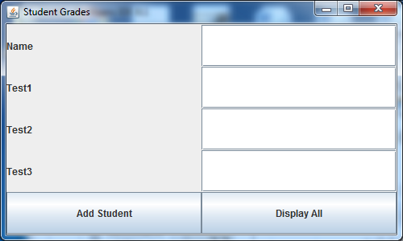

**RUBRIC**

|  |  |
| --- | --- |
| Student class   * It has all required functionality. | 5 |
| GUI class   * Student record can be saved. * All student data can be displayed. | 15 |
| StudentDB class   * Add method inserts a record into db. * Get method reads all records and returns an arraylist. | 15 |
| Code style | 5 |
| Total | 40 |

**Code Style Requirements**

* Include meaningful comments throughout your code.
* Use meaningful names for variables.
* Code must be properly indented.
* Include a comment header at beginning of each file (example below).

**/**********************************************************   
Program Name: ProgramName.java   
Programmer's Name: Student Name   
Program Description: Describe here what this program will do   
***********************************************************/**

**Deliverables**

Submit the following as a single zip folder.

* All Java files

Follow assignment specification regarding class and method names.

Note that your Java file name must match the class name (do not rename).