Week 1 Project—Use Java to Call a RESTful Web Service

# Scenario

In this week’s lab you will call a RESTful web service using Java.

# Rubric

Point distribution for this activity:

|  |  |  |
| --- | --- | --- |
| **Lab Activity** | | |
| **Document** | **Points possible** | **Points received** |
| Part A | 25 |  |
| Part B | 25 |  |
| **Total Points** | **50** |  |

# PART A:

RESTful web services are an industry standard to communicate with web services. Many web applications you use today use RESTful web and JSON to parse the data. This is prevalent on mobile apps.

We will be creating a program that uses a RESTful web service call and JSON to parse the returning information.

1. Install a Java IDE (either Netbeans or Eclipse). We will be using the RESTful service from services.groupkt.com to find the country code for a particular country. There are several RESTful services you can find. Check out government sites or feel free to use: <http://api.geonames.org/postalCodeLookupJSON?postalcode=43207&country=US&username=devry>” or <https://afsl.usgovxml.com/welcome.aspx?loc=43065> for some other options. RESTful web services are a common way to make calls out to other systems (facebook, twitter, etc.).
2. Go to File->New Project and create a new project. If you are using eclipse, create a new class, if Netbeans your class will be created for you. Enter the following code in your Main. This code will ask the user for a zip code. Try a few as all zip codes may not be listed in the service and see what you get. The output will be in a format we will discuss next. When entering this code, you will need to import several java libraries. If you get an error in your code, click on it and you will get a message to import.

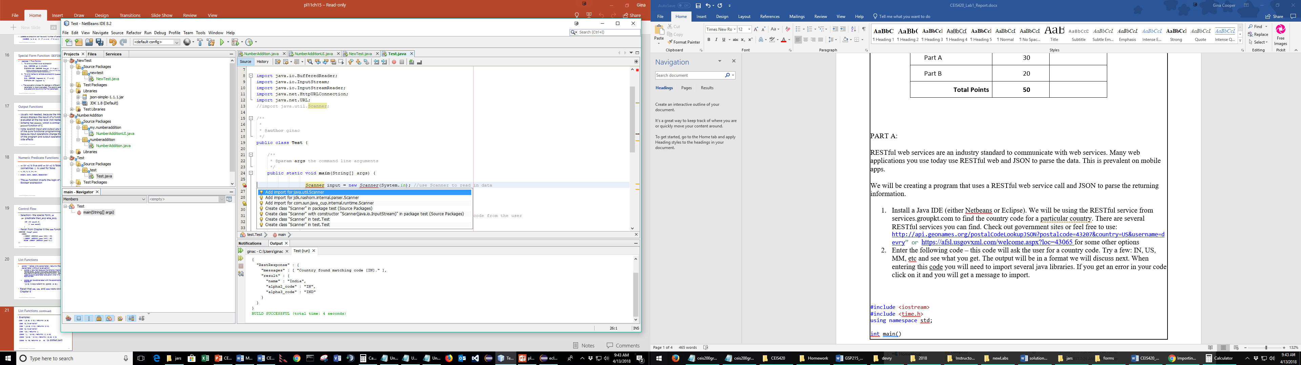

public static void main(String[] args) {

Scanner input = new Scanner(System.in);

String s1="http://api.geonames.org/postalCodeLookupJSON?postalcode=";

String s2="";

System.out.println("Please enter the postal code: ");

s2 = input.nextLine(); //Ask the user for the country code

String s3 = s1+s2+"&country=US&username=devry";

//concatenate string for the RESTful web service

URL url;

try {

url = new URL(s3);//Set up string as a URL

HttpURLConnection connection = (HttpURLConnection) url.openConnection();

connection.setRequestMethod("GET");

InputStream content = (InputStream) connection.getInputStream();

BufferedReader in = new BufferedReader(new InputStreamReader(content)); //Read data from input stream

String line;

while ((line = in.readLine()) != null) { //Loop and print to console

System.out.println(line);

}

} catch (Exception e) {

// TODO Auto-generated catch block

e.printStackTrace();

}

}

1. When you run the code, you can enter the zip code. I typed in 43207 and got the following response.

Please enter the postal code:

43207

{"postalcodes":[{"adminCode2":"049","adminCode1":"OH","adminName2":"Franklin","lng":-82.970334,"countryCode":"US","postalcode":"43207","adminName1":"Ohio","placeName":"Columbus","lat":39.904565}]}

BUILD SUCCESSFUL (total time: 3 seconds)

Copy

Copy and paste the result from your code below. Choose a different zip code and see what you get.

{"postalcodes":[{"adminCode2":"453","adminCode1":"TX","adminName2":"Travis","lng":-97.742559,"countryCode":"US","postalcode":"78701","adminName1":"Texas","placeName":"Austin","lat":30.271289}]}

# PART B:

The format this data is in is a common format for web service responses. This is JSON format and is an industry standard. To parse JSON format you need to know the fields, but often when using Web/database you will be pulling data into specific fields. We will use a JAR file to parse this data. Adding JAR files to a Java project is an important skill. Often there will be JAR files that will be needed in your project to improve the functionality. Jar files are zipped files of Java classes.

1. Create a new Java Project
2. Download json.simple <http://www.java2s.com/Code/Jar/j/Downloadjsonsimple11jar.htm> Unzip it and save it to a location on your computer.
3. Next, you need to add it to your classpath. If you are using Netbeans, right click on Libraries and choose Add JAR/Folder. Navigate to the location of your JAR file and pick OPEN.

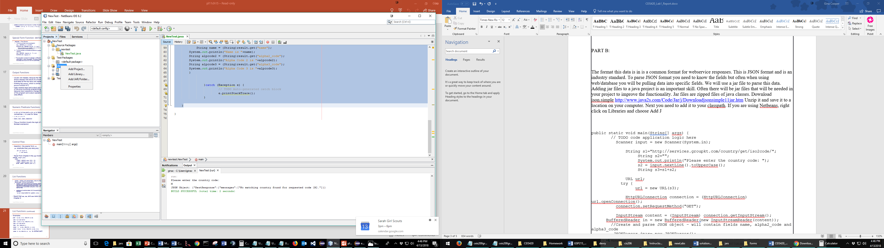

If you are using Eclipse, right click on your project name and choose Build path-> Configure Build path. Click the ClassPath and then choose Add External JARs. Then navigate to the location of your JAR file and choose OPEN.

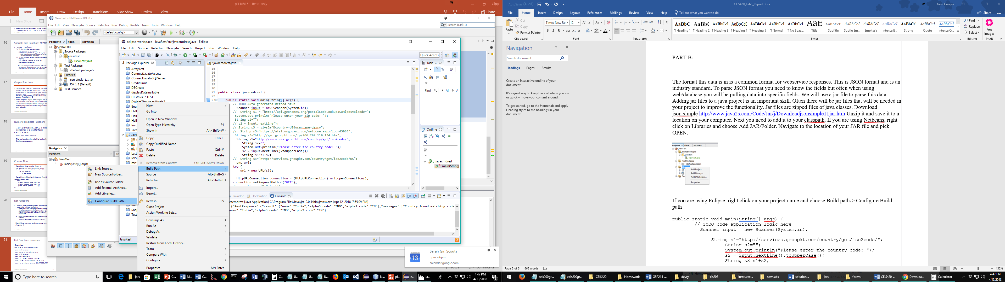

Then add the following code to your MAIN.

Screenshot of output:

