Week 3 Project—Data Types and Assignment Statements

**Scenario**

In this week’s project you will look at data types and memory leaks and look at a variety of IDEs.

**Rubric**

Point distribution for this activity:

|  |  |  |
| --- | --- | --- |
| **Activity** | | |
| **Document** | **Points possible** | **Points received** |
| Part A | 20 |  |
| Part B | 30 |  |
| **Total Points** | **50** |  |

PART A:

One of the dangers with C++ pointers is memory leaks. Run the following code in C++.

#define _CRTDBG_MAP_ALLOC

#define _CRT_SECURE_NO_WARNINGS

#include <stdlib.h>

#include <crtdbg.h>

#include <string>

void memLeak()

{

int *p = new int;

char * string1 = new char[20];

char * string2 = new char[25];

strcpy(string1, "Sheldon");

string2 = string1;

delete p;

}

int main(int argc, char* argv[])

{

memLeak();

_CrtDumpMemoryLeaks();

return 0;

}

When you run this code you should see the following showing the memory leaks: Detected memory leaks!

Dumping objects ->

{72} normal block at 0x02BA6250, 25 bytes long.

Data: < > CD CD CD CD CD CD CD CD CD CD CD CD CD CD CD CD

{71} normal block at 0x02BA97F8, 20 bytes long.

Data: <Sheldon > 53 68 65 6C 64 6F 6E 00 CD CD CD CD CD CD CD CD

How would you fix it so that the value in string1 and string2 are both “Sheldon” but with no memory leaks?

C++ code:

#define _CRTDBG_MAP_ALLOC

#define _CRT_SECURE_NO_WARNINGS

#include <stdlib.h>

#include <crtdbg.h>

#include <string>

void memLeak()

{

int* p = new int;

char* string1 = new char[20];

char* string2 = new char[25];

strcpy(string1, "Sheldon");

strcpy(string2, string1);

delete p;

delete[] string1;

delete[] string2;

}

int main(int argc, char* argv[])

{

memLeak();

_CrtDumpMemoryLeaks();

return 0;

}

Screenshot of output:

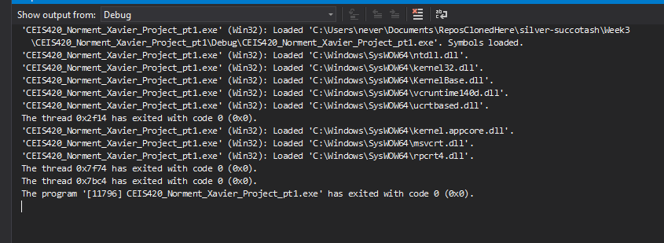

Part B:

In our labs we have always used an IDE. Now let’s compare code by creating the same code using a command line or online compiler. Either use a Linux machine, virtual machine, or use onlinegdb: <https://www.onlinegdb.com/online_c++_compiler> or any online C++ compiler.

Enter the following code:

#include <iostream>

using namespace std;

int main(void)

{

cout << "Hello, World!" << endl;

cout << "Press any key to exit" << flush;

cin.ignore( );

return 0;

}

This will run your code.

Press enter to stop the code.

Next run Hello World in C#, Java (download eclipse or use it in citrix: lab.devry.edu or try netbeans), and Python (IDLE). Python is available by downloading python <https://www.python.org/downloads/> Feel free to try another language (ruby/kotlin/C/perl).

Paste screenshots of all code here:

1. C++

1. C#

1. Java

1. Python

1. Optional – JavaScript

Compare: online compiler, Visual Studio, Netbeans/Eclipse, and Idle. Which do you like the best? Why?

I’m a fan of Visual Studio(2019 specifically), the overall polish and available interactions never cease to amaze me when it comes to the usability and thoughtfulness of the designers. The online compiler/ Linux command line as well as Idle, fill a certain niche that I will always use when it comes to making quick or simple things when testing so they have their uses, but when booting up a program I would much rather use Visual Studio Code and pay with a bit more system resources. Netbeans is the one IDE that I have the most experience with being that I have used it and Java to create my biggest project to date, so it is the one that I am currently using the most due to familiarity.