**山东科技大学校园控制点坐标成果表**

1980年西安坐标系，中央子午线为120°。1985年国家高程基准。

|  |  |  |  |
| --- | --- | --- | --- |
| ~~点ID~~ | ~~北（米）~~ | ~~东（米）~~ | ~~高程（米）~~ |
| ~~1~~ | ~~3985670.197~~ | ~~511282.909~~ | ~~26.935~~ |
| ~~2~~ | ~~3985575.284~~ | ~~511067.963~~ | ~~28.844~~ |
| ~~3~~ | ~~3985538.790~~ | ~~510837.417~~ | ~~31.737~~ |
| ~~4~~ | ~~3985426.864~~ | ~~510600.029~~ | ~~32.921~~ |
| ~~5~~ | ~~3985542.447~~ | ~~510298.019~~ | ~~49.960~~ |
| ~~6~~ | ~~3985757.452~~ | ~~510251.905~~ | ~~41.203~~ |
| ~~7~~ | ~~3985766.395~~ | ~~510535.089~~ | ~~36.415~~ |
| ~~8~~ | ~~3985740.172~~ | ~~510789.385~~ | ~~33.831~~ |
| ~~9~~ | ~~3985920.670~~ | ~~510998.104~~ | ~~30.291~~ |
| ~~10~~ | ~~3985966.134~~ | ~~511223.214~~ | ~~28.372~~ |
| ~~11~~ | ~~3986086.601~~ | ~~511009.178~~ | ~~29.517~~ |
| ~~12~~ | ~~3986012.723~~ | ~~510627.156~~ | ~~31.962~~ |
| ~~13~~ | ~~3985953.362~~ | ~~510356.952~~ | ~~36.271~~ |
| ~~14~~ | ~~3985918.535~~ | ~~510219.218~~ | ~~38.829~~ |
| ~~15~~ | ~~3986297.472~~ | ~~510291.291~~ | ~~33.421~~ |
| ~~16~~ | ~~3986369.046~~ | ~~510706.297~~ | ~~29.985~~ |
| ~~17~~ | ~~3986424.080~~ | ~~510945.509~~ | ~~28.393~~ |

1,,511164.392,3985674.123,26.935

2,,510949.428,3985579.211,28.844

3,,510718.864,3985542.722,31.737

4,,510481.456,3985430.797,32.921

5,,510179.429,3985546.398,49.960

6,,510133.319,3985761.419,41.203

7,,510416.523,3985770.354,36.415

8,,510670.836,3985744.120,33.831

9,,510879.575,3985924.624,30.291

10,,511104.703,3985970.083,28.372

11,,510890.656,3986090.566,29.517

12,,510508.605,3986016.696,31.962

13,,510238.380,3985957.340,36.271

14,,510100.635,3985922.515,38.829

15,,510172.726,3986301.476,33.421

16,,510587.763,3986373.041,29.985

17,,510826.994,3986428.070,28.393

1号点，老钉子，学校东南角，距南侧路边1.5m，距东侧路边2m

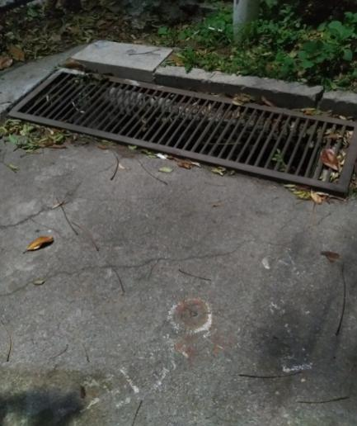  
2号点，新钉子，逸夫楼东南角，丁字路口，距南侧路边83cm

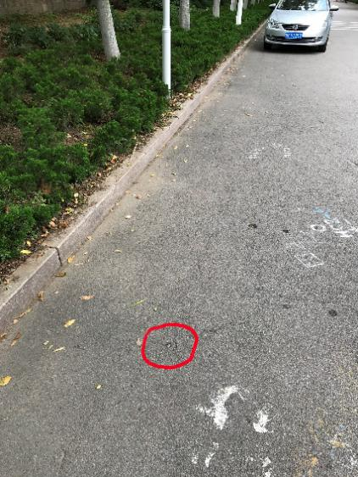  
3号点，新钉子，泰山广场东南侧，丁字路口，距东北角路边2.2m

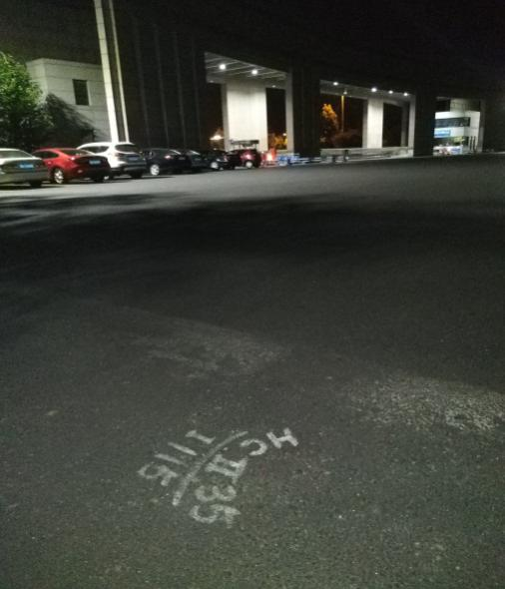  
4号点，新钉子，行政楼西南角丁字路口，距南侧路边70cm，距反光镜1.5m

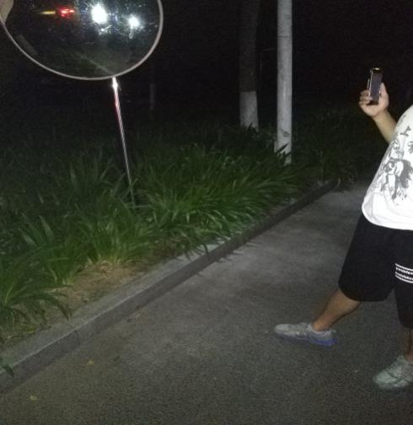  
5号点，新钉子，在实验场地西侧道路，路栏北侧

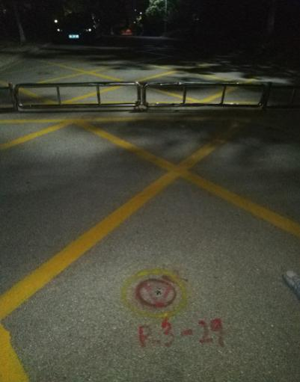

6号点，圆头钉子，校医院南侧通往家属区的拐角处，距路边1.55m

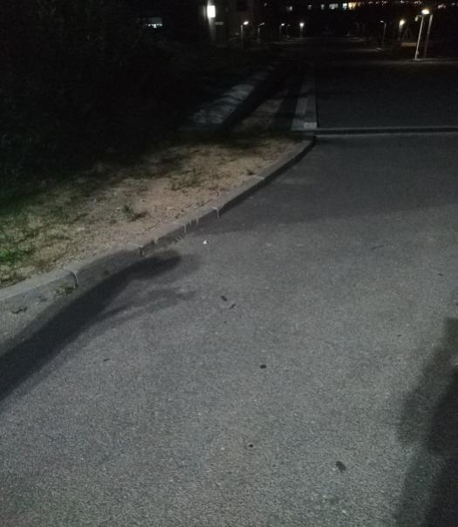  
7号点，新钉子，14教学楼东北角，距西北路边3.3m

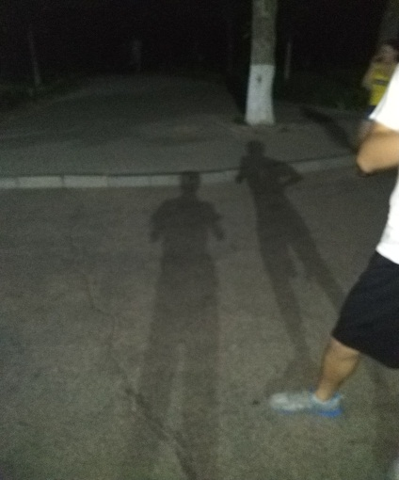  
8号点，新钉子，泰山广场东北角，靠近西南路边1m

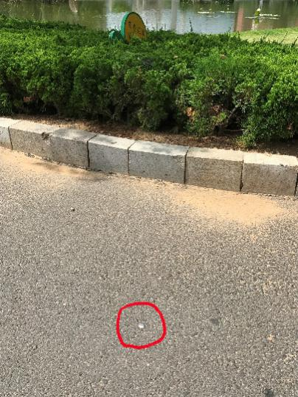  
9号点，老钉子，s1西北角，丁字路口，距路北侧1m

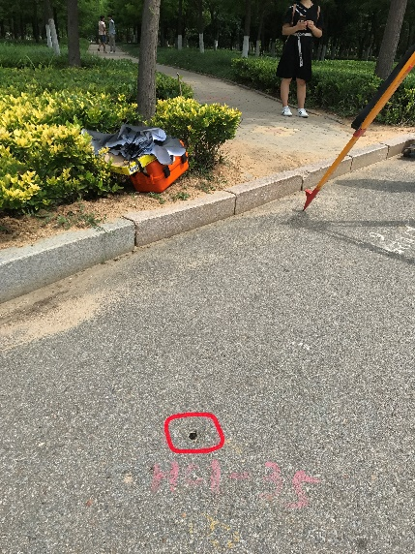  
10号点，老钉子，s1东北角路口，距路北侧80cm

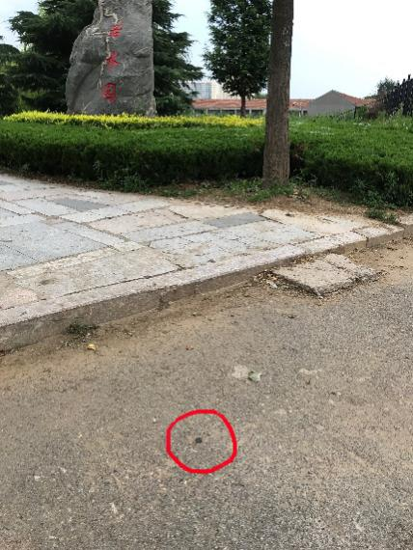

11号点，老钉子，风雨操场东南大圆花坛北侧65cm

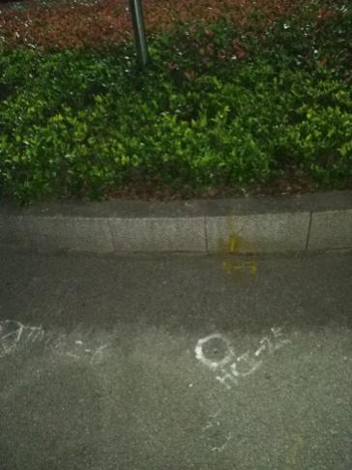  
12号点，新钉子，在a餐西南角丁字路口，从西数第四个和第五个停车位之间，距路南侧2.8m， 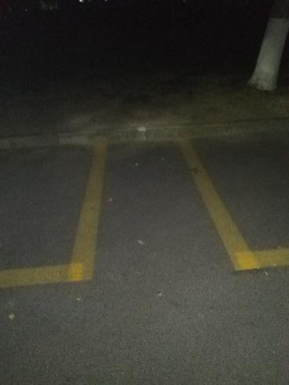  
13号点，新钉子，钟楼广场东南大圆花坛北侧90cm

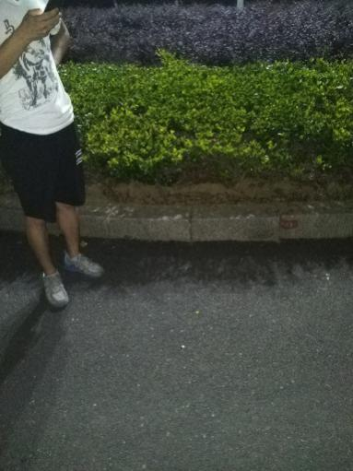  
14号点，新钉子，在c餐正南侧两个花坛之间，距西侧花坛1.7m

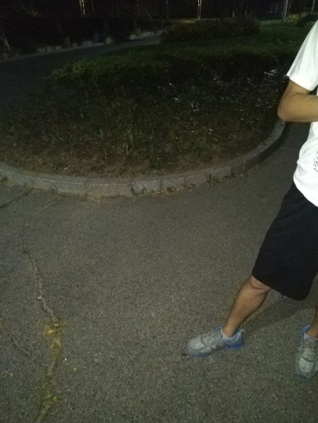

15号点，老钉子，在c9东北角丁字路口，距路北边侧65cm

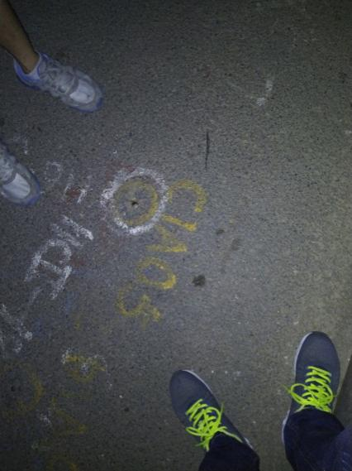  
16号点，新钉子，北门东侧第一个路口，距路口东侧圆弧路边3.1m，限速15路标牌正西

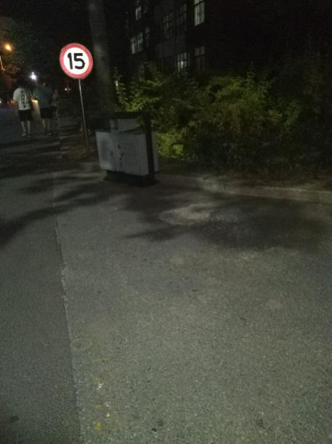  
17号点，老钉子，在学校体育馆东北角，距路北侧80cm，距路东侧2m   
