IN4640 — Assignment 2
Fitting and Alignment
N D G S Dissasekara
215519C

Machine-Vision-Assignment-2.git

Question 1 Total Least Squares & RANSAC Line Fitting

Resulting TLS Parameters
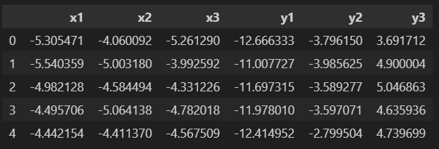

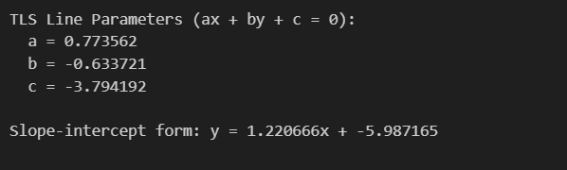

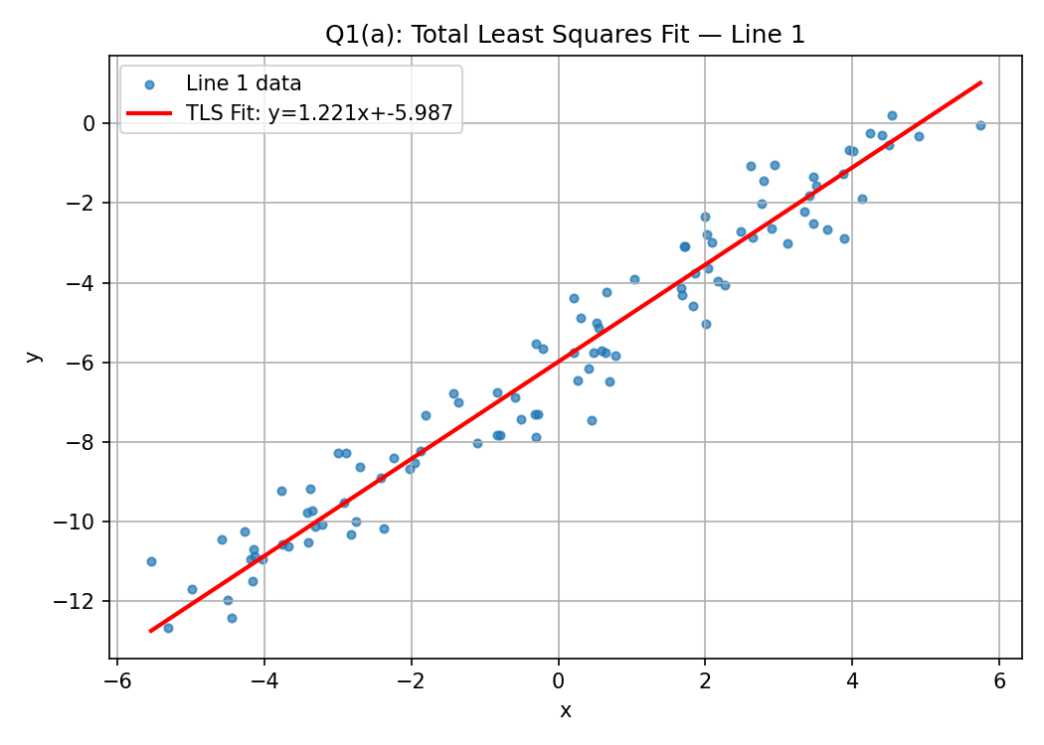

Fitted Line Parameters

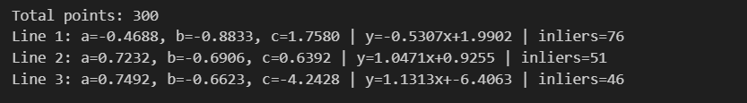

Plot
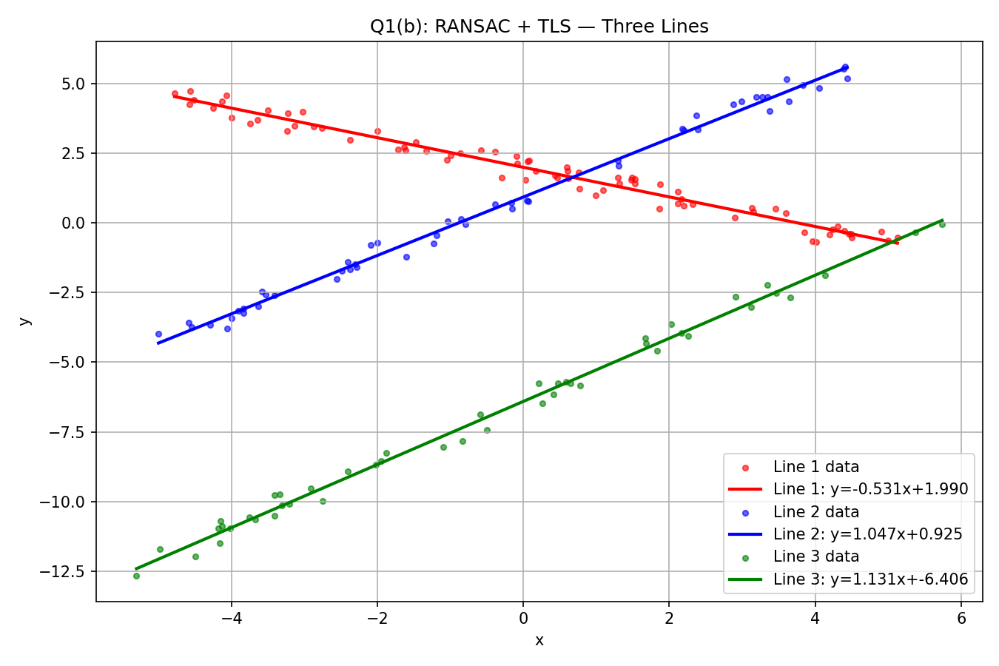

Question 2 Earring Size Estimation
Given a camera with known intrinsic parameters, the real-world size of the earrings was estimated using the thin-lens projection formula.

Camera Parameters
- Focal length (f): 8 mm
- Pixel size: 2.2 µm × 2.2 µm
- Distance from lens to imaging plane (Z): 720 mm

Derivation

$$Real Size = size in pixels ×pixel size on sensor × \frac{Distance from lens}{Focal length}$$

Results
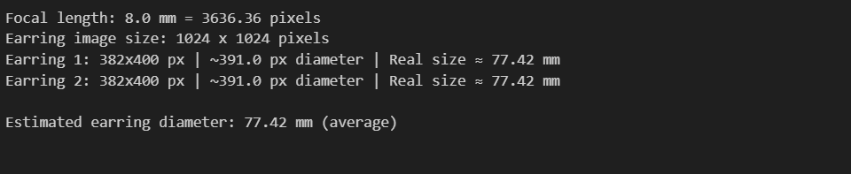

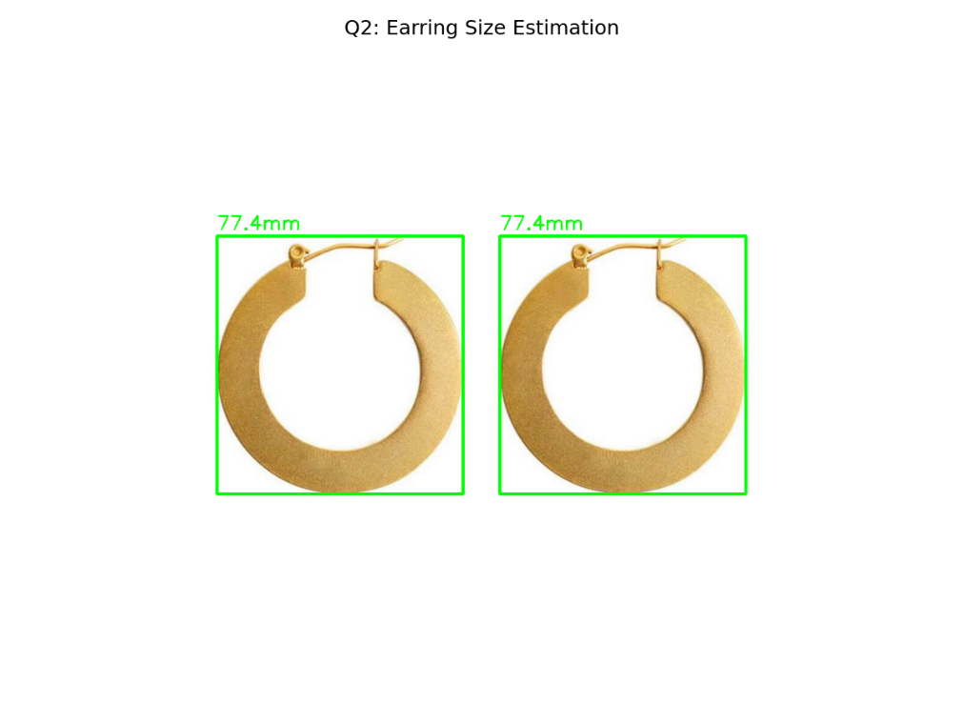

Question 3 Flag Superimposition on Cricket Turf

Methodology
Four corners of the cricket pitch were identified from the image. These served as destination points for the homography. The four corners of the flag image served as source points. OpenCV's findHomography function computed the 3×3 transformation matrix H, and warpPerspective applied it to map the flag into the perspective of the turf.
📌 [INSERT HERE: Paste the code snippet for corner selection and homography computation from your notebook]

Selected Turf Corners
📌 [INSERT HERE: Paste a screenshot showing the turf image with the four selected corner points marked (the quadrangle overlay image)]
📌 [INSERT HERE: Paste the printed coordinates of the four corner points (P1–P4) from your notebook output]

Homography Matrix
📌 [INSERT HERE: Paste the printed 3×3 Homography matrix H from your notebook output]

Result
📌 [INSERT HERE: Paste the final side-by-side result image (q3_flag_on_turf.png) showing the original turf and the turf with the Luxembourg flag superimposed on the pitch]
Discussion:
[Discuss the quality of the result. Does the flag follow the perspective of the turf correctly? Comment on any visible artifacts at the boundary. Discuss what conditions must hold for the homography to be exact (planar surface, calibrated camera).]

