CHAPTER 4 APPROACH

4.1 Introduction
This chapter presents the practical approach adopted to implement the Adversarial Geometric Distillation (AGD) extension. The chapter translates the theoretical foundation established earlier into a working, mesh-centred prototype that validates the key research idea of closed-loop geometric grounding. Rather than attempting full end-to-end text-to-3D synthesis at this stage, the current implementation focuses on the parts of the framework that can be directly tested and measured: mesh ingestion, multi-view rendering, geometric and view-based hallucination detection, spatial grounding, iterative refinement, and quantitative evaluation. This design isolates the main contribution of the research and allows the geometric feedback mechanism to be studied independently of upstream generation noise.
The implemented prototype operates on existing mesh assets in .obj, .ply, and .stl formats. It supports both single-file and batch processing, optional local LLaVA-based inspection, an optional GCN-based critic, dense multi-view rendering, and a multi-metric geometry evaluation suite. In its current form, the system has been exercised on a working set of 13 mesh assets, while large meshes above the configured vertex safety limit are skipped to avoid memory failure during analysis. The chapter therefore documents not only the intended extension design, but also the concrete implementation decisions, constraints, and system behaviour observed in the prototype.

4.2 Hypothesis and Its Inspiration
The implementation is guided by the hypothesis that hallucinations in text-to-3D outputs can be mitigated more effectively when error feedback is represented as direct geometric constraints rather than as natural-language correction prompts. Existing SDS-based methods such as DreamFusion, ProlificDreamer, Fantasia3D, and Magic3D [2]-[5] can generate visually plausible 3D outputs, but they do not directly constrain the geometry being optimised. Similarly, mitigation approaches such as Perp-Neg [7], Entropic Score Distillation [8], and Hallo3D [6] improve specific aspects of guidance or detection, yet they still do not provide a sufficiently precise mechanism for correcting the exact vertices and surface regions where a hallucination occurs. The AGD extension is therefore inspired by the need to replace diffuse, text-mediated correction with a spatial signal defined directly on the mesh.
In the current prototype, this hypothesis is operationalised through a grounded refinement energy applied to the mesh. The refinement objective is defined as
$$E(x)=λL_{\text{geo}}+(1−λ)D$$
where $L_{\text{geo}}$ is a geometry-smoothing term and $D$ is an anchor term that keeps the refined mesh close to its original structure. The update is applied selectively using grounded vertex weights:
$$v←v−η\left(λ∇L_{\text{geo}}+(1−λ)∇D\right)⊙w$$
where $w$ is the spatial weight map obtained from critic scores and view-based evidence. The inspiration for this design comes from combining the strengths of spectral analysis, algebraic topology, graph-based anomaly localisation, and multimodal inspection into a single loop that can detect a structural problem, project it back into 3D space, and refine only the affected region.

4.3 Inputs and Outputs of Extension
In the long-term vision of the research, the extension is intended to sit on top of an SDS-based text-to-3D generator. In the current prototype, however, Stage 1 is simulated by loading an existing mesh from disk. This makes the current implementation suitable for validating the extension independently of a full synthesis backbone.
Table 4.1. Main Inputs to the Implemented Extension
Input Category | Format / Parameter | Role in the Extension
Mesh input | .obj, .ply, .stl | Primary input to the current prototype; represents the generated 3D asset to be analysed and refined
Processing mode | --input-file, --input-dir | Enables single-mesh testing or batch evaluation over a mesh collection
Rendering configuration | --render-views, --view-size, --num-views, --view-method, --fov-deg, --edge-threshold | Controls multi-view acquisition and image-buffer generation
Detection configuration | --use-vlm, --llava-model-path, --llava-model-base, --consistency-threshold, --view-extent, --normal-threshold | Controls optional LLaVA inspection and coarse 2D-to-3D projection behaviour
Optimisation configuration | --iterations, --lr, --lambda-geo, --lambda-distill, --top-fraction, --expand-hops | Controls refinement intensity, smoothing behaviour, and grounded-region expansion
Evaluation configuration | --n-sample-pts, --skip-geometry-metrics | Controls geometric comparison density and runtime cost
The outputs of the extension include both refined geometry and diagnostic evidence. The system writes a refined mesh to the output directory, stores multi-view render buffers, reports topology and spectral statistics before and after refinement, and can compute geometry comparison metrics between the original and refined versions. These outputs are designed to support both qualitative inspection and quantitative evaluation.
Table 4.2. Main Outputs of the Implemented Extension
Output Category | Format | Description
Refined mesh | *_agd.obj/.ply/.stl | Geometry after AGD-based vertex refinement
Rendered views | PNG | Per-view RGB, depth, normal, silhouette, and edge-map images stored for before/after comparison
Topology and spectral report | Console / structured values | Connected components, Euler characteristic, genus, eigenvalue variance, cotangent variance, and Fiedler value
Hallucination score | Float in [0,1] | Composite discriminator score summarising structural anomaly severity
Geometry error report | Structured metrics | Chamfer Distance, Hausdorff Distance, HD95, Normal Consistency, Angular Normal Error, Surface Roughness, Curvature W1, Silhouette IoU, Depth RMSE, SSIM, and Edge-IoU with multi-view aggregates
Grounding signal | Per-vertex weights | Spatial weight map used to determine where refinement is applied most strongly

4.4 Process Workflow for Extension
The implemented extension follows a six-stage workflow that mirrors the proposed AGD architecture while remaining faithful to the current mesh-only prototype. The overall logic of the system is shown in Figure 4.1.
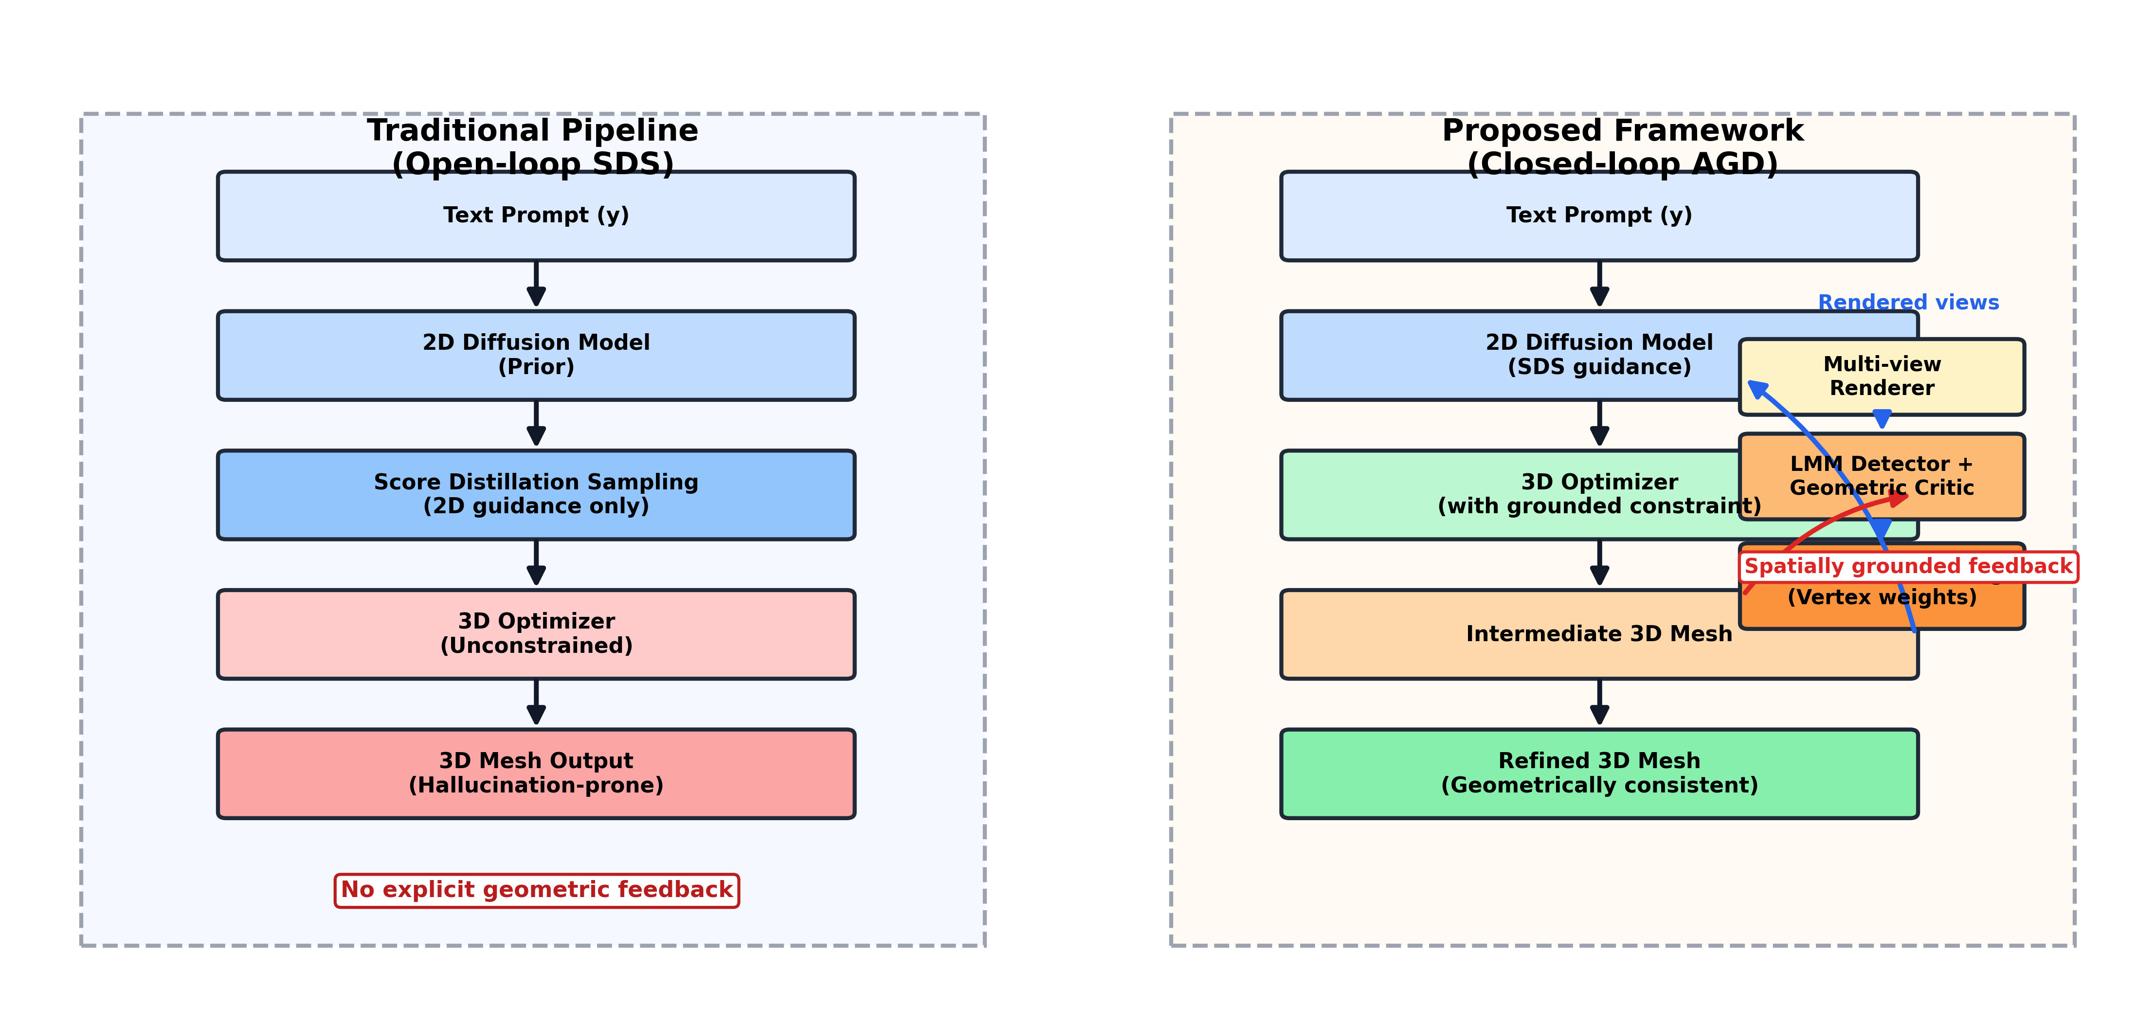
Figure 4.1. High-level workflow of the implemented AGD extension, contrasting the traditional open-loop SDS pipeline with the proposed closed-loop AGD refinement process.
- Mesh ingestion and baseline analysis: The system loads a mesh from disk and computes its initial structural profile. This includes connected components, Euler characteristic, genus, Laplacian eigenvalue variance, cotangent-weighted variance, Fiedler value, and a face-quality penalty derived from aspect ratio, degenerate triangles, and non-manifold edges. In the current implementation, the composite hallucination score is defined as
$$S_{\text{hall}}=0.20P_{\text{cc}}+0.30P_{\text{genus}}+0.15P_{\text{var}}+0.10P_{\text{fiedler}}+0.10P_{\text{cot}}+0.15P_{\text{quality}}$$
- where each penalty term is normalised to the range $[0,1]$.
- Multi-view rendering: If rendering is enabled, the mesh is scanned from either the classical six canonical views or from a denser camera schedule generated by Fibonacci-sphere sampling. The renderer is implemented as a pure-NumPy software rasteriser and produces five buffers per view: RGB, depth, normal map, silhouette, and edge map. This makes the system independent of a GPU display server and suitable for offline batch evaluation.
- View-based anomaly detection: The prototype supports two view-level detectors. The first is a lightweight consistency module that embeds grayscale views into a $32×32$ feature vector and compares opposite directions using cosine similarity. The second is an optional local LLaVA-based detector that inspects each RGB rendering and returns a JSON object containing a severity score and a short descriptive note. The current VLM module provides severity-level feedback rather than pixel-level localisation; therefore, spatial precision is recovered later through geometric grounding.
- Vertex-level critic scoring: The critic module then assigns anomaly scores directly to vertices. The working baseline is a heuristic critic that computes a degree z-score and a mean edge-length z-score for each vertex, combines them through a sigmoid transform, and produces a per-vertex anomaly value in $[0,1]$. An optional GCN-based critic is also provided. It uses two GCNConv layers and can be trained with pseudo-labels generated from the heuristic baseline.
- Geometric grounding: View-level evidence and critic-level evidence are fused into a spatial weight map. The grounding module projects each severe view direction back onto the mesh by selecting vertices near the corresponding directional extent and filtering them using vertex normals. These projected weights are merged with the critic scores and expanded across neighbourhood hops when required. The result is a grounded vertex map $w_{i}∈[w_{\text{min}},w_{\text{max}}]$ that identifies where refinement should be concentrated. Figure 4.2 illustrates this idea.
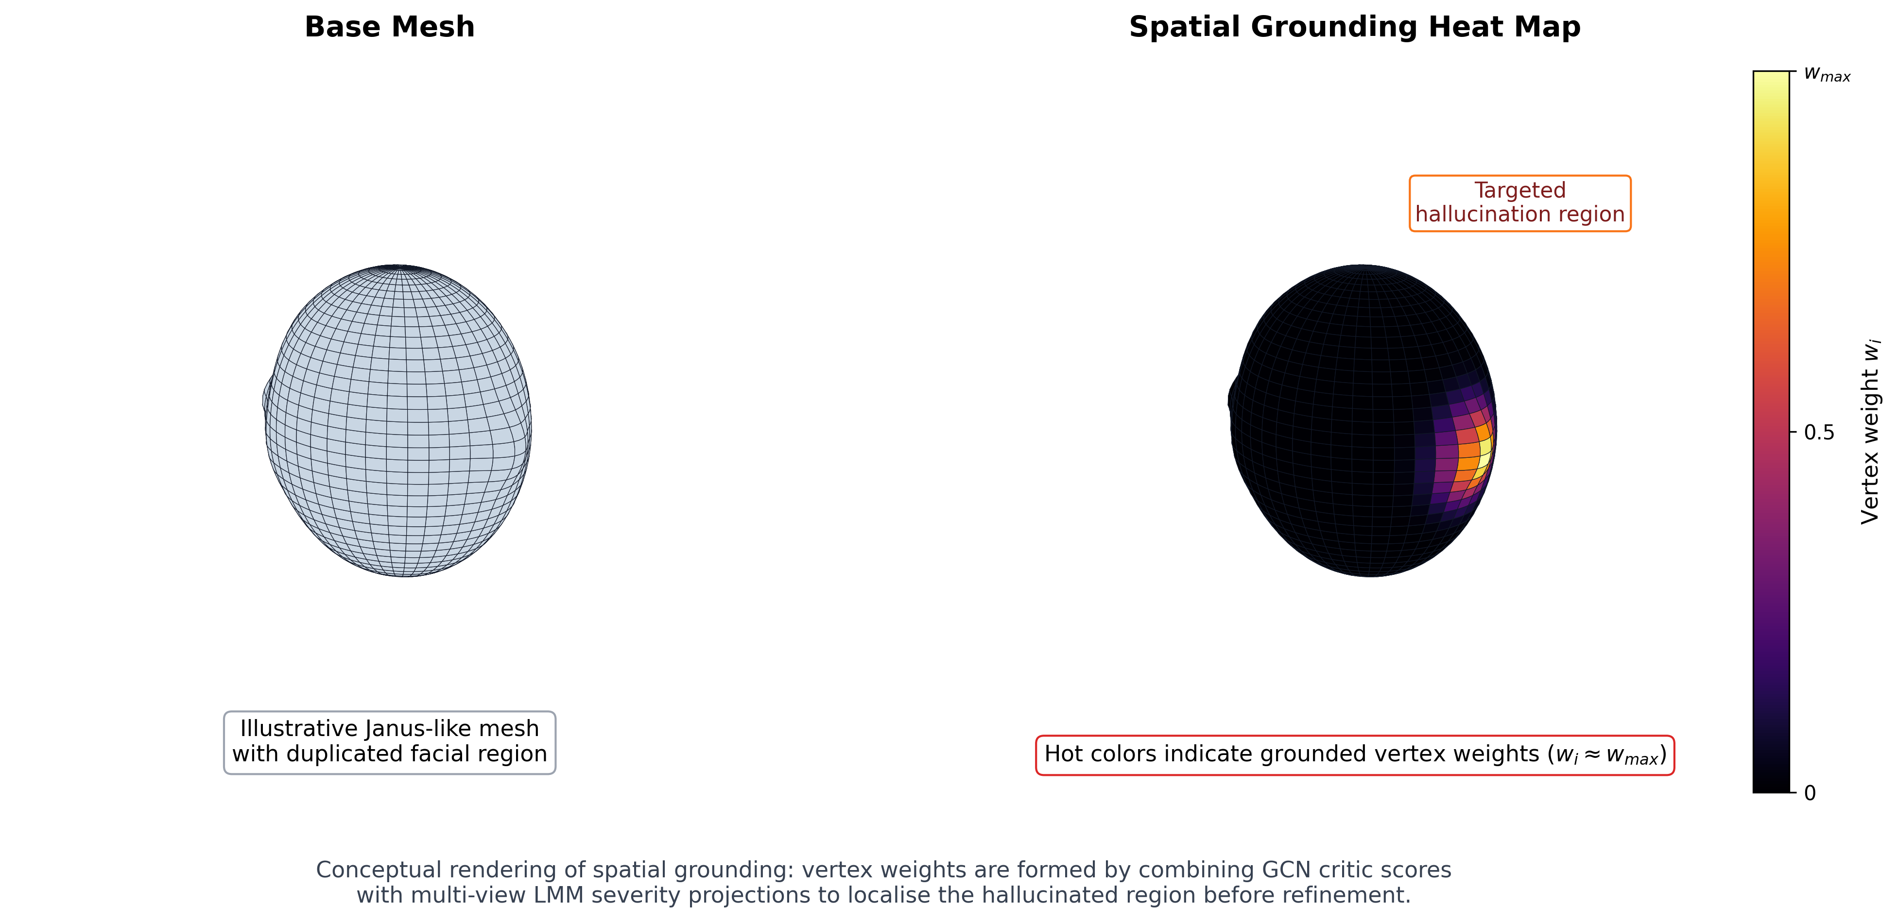
Figure 4.2. Conceptual illustration of spatial grounding in the implemented AGD extension. The base mesh is shown together with a vertex-weight heat map, where hot colours indicate high grounded weights assigned to the hallucinated region targeted for refinement.
- Grounded refinement and export: The weighted update is applied iteratively to the mesh vertices using Laplacian smoothing and an anchor term. After refinement, the system saves the output mesh, re-renders the views if required, and computes before/after geometry comparison metrics. In the current prototype, the refinement modifies vertex positions but does not change mesh topology directly; therefore, improvements are expected to be strongest in local surface regularity rather than in component count or genus.

4.5 Technologies Identified
The extension is built from a set of technologies selected to support mesh processing, rendering, graph analysis, multimodal inspection, optimisation, and evaluation. The emphasis has been on tools that enable experimental flexibility while remaining practical on local research hardware.
Table 4.3. Technologies Used in the Implemented Extension
Category | Technology | Role in the AGD Extension
3D geometry processing | Trimesh | Mesh loading, adjacency access, face and vertex normals, surface sampling
Rendering | NumPy + custom software rasteriser | Multi-view generation of RGB, depth, normal, silhouette, and edge-map buffers
Sparse computation and metrics | SciPy | Sparse Laplacian operations, eigensolver support, cKDTree nearest-neighbour queries
Graph and topology analysis | NetworkX | Connected-component counting through the vertex adjacency graph
Graph-based learning | PyTorch + PyTorch Geometric | Optional GCN critic and pseudo-supervised critic training
Multimodal detection | Local LLaVA v1.5/v1.6 | Per-view hallucination severity detection from rendered RGB images
Image handling | Pillow and scikit-image | Buffer I/O, grayscale conversion, and SSIM computation
Documented future backbone | Threestudio + PyTorch | Planned SDS integration for full text-to-3D generation
The chosen stack reflects the current scope of the prototype. In particular, the renderer, grounding, discriminator, critic, and refinement loop are fully integrated in the local codebase, whereas the SDS generation backbone remains a planned extension point rather than a completed implementation.

4.6 Features of Technological Extension
The implemented extension exhibits several features that are directly aligned with the research objectives:
- Closed-loop geometric grounding: View-level detections are not converted into negative prompts. Instead, they are transformed into a numeric vertex-weight map used directly in the refinement update.
- Dense multi-view scanning: The system supports both six-view canonical inspection and dense Fibonacci-sphere sampling, making it possible to analyse meshes with significantly richer view coverage.
- Five-buffer rendering pipeline: Each view produces RGB, depth, normal, silhouette, and edge outputs, allowing the extension to use both visual and structural cues.
- Composite hallucination scoring: The discriminator combines topology, spectral irregularity, connectivity, and face-quality measures into a single interpretable score.
- Dual critic design: The prototype provides a working heuristic critic and an extendable GCN-based critic, allowing immediate use together with future learning-based upgrades.
- Quantitative evaluation support: The geometry metrics module enables rigorous before/after comparison through a broad suite of surface, view, and distribution-based measures.
- Research-oriented safeguards: The implementation includes a configurable vertex limit and a batch-friendly offline workflow to reduce the risk of memory failure during evaluation of large assets.
Taken together, these features make the extension more than a single correction routine. It functions as a modular research framework for studying how structural hallucinations can be detected, grounded, and reduced through direct geometric feedback.

4.7 Target Users / Use Scenarios
The primary target users of the extension are researchers and developers working on 3D generative AI systems. For this group, the prototype serves as a post-generation refinement and diagnostic layer that can be applied to meshes produced by text-to-3D pipelines, 3D reconstruction systems, or other AI-assisted content tools. It is especially relevant in experimental settings where the objective is to evaluate whether a generated model is structurally coherent rather than merely visually plausible.
Beyond core research use, the extension is also relevant in several practical scenarios:
- Mesh quality auditing: analysing whether a generated asset contains disconnected parts, duplicated structures, spiky regions, or poor face quality before further use;
- Offline refinement of AI-generated models: applying targeted smoothing and grounding-based correction to improve asset quality before visualisation, rigging, or dataset inclusion;
- Benchmarking and ablation studies: comparing hallucination severity before and after refinement using the implemented metric suite;
- Educational and thesis work: demonstrating how geometric deep learning, multimodal inspection, and topology-aware analysis can be combined in a coherent applied system.
The current implementation is best suited to offline research and controlled evaluation rather than real-time production deployment. Its strengths lie in interpretability, modularity, and experimental traceability.

4.8 Positioning the Extension within the AI Body of Knowledge
The AGD extension sits at the intersection of several areas within the broader AI body of knowledge. First, it belongs to generative AI, because its purpose is to improve the structural reliability of outputs produced by text-to-3D systems derived from SDS-based generation [2]-[5]. Second, it draws from multimodal AI, since rendered views are examined by a vision-language model to produce hallucination evidence [6]. Third, it belongs to geometric deep learning, because the mesh is treated as a graph and analysed using vertex-level critics and graph-based operators. Fourth, it is closely related to 3D vision and graphics, since it relies on rendering, topology, spectral analysis, and surface metrics to reason about shape quality.
At the same time, the extension can also be positioned within the area of trustworthy and robust AI systems. Its goal is not simply to produce more images or meshes, but to improve the reliability, inspectability, and structural validity of model outputs. In this sense, the extension contributes a quality-control and post-generation correction perspective to generative AI, addressing hallucination as a measurable geometric problem rather than as a purely semantic or visual one.

4.9 Summary
This chapter presented the practical approach used to implement the AGD extension as a working mesh-based prototype. It described the hypothesis that motivates the system, the current inputs and outputs, the six-stage workflow, the supporting technologies, the key functional features, the intended users, and the extension’s position within the wider AI landscape. Most importantly, the chapter showed how the central research idea of spatially grounded geometric feedback has been translated into an executable architecture that supports real mesh analysis, targeted refinement, and quantitative evaluation. This implementation foundation provides the basis for the next stage of the work, in which the behaviour and effectiveness of the extension can be examined in greater detail through experimental results and discussion.

