DRUG CLASSIFICATION REFERENCE
BNF Style
A Comprehensive Pharmacology Reference
Font: Times New Roman | Size: 11 | Black and White

Chapter 1: Cardiovascular System

Anticoagulants

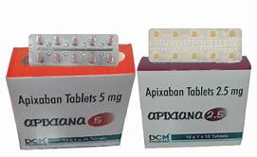

Apixaban
Generic Name: Apixaban
Trade Name: Thromban (or Eliquis)
Mechanism of Action: Apixaban is a potent, oral, reversible, direct, and highly selective Factor Xa inhibitor. It does not require antithrombin III for antithrombotic activity. By directly binding to the active site of Factor Xa (both free and clot-bound), it prevents the conversion of prothrombin to thrombin, thereby decreasing thrombin generation, fibrin formation, and thrombus development. This effectively interrupts both the intrinsic and extrinsic pathways of the blood coagulation cascade without affecting platelet function or fibrinogen directly, providing predictable anticoagulation with a wide therapeutic window and no need for routine coagulation monitoring.
Indications:
- Prevention of stroke and systemic embolism in patients with non-valvular atrial fibrillation (with one or more risk factors).
- Treatment of deep vein thrombosis (DVT) and pulmonary embolism (PE).
- Prevention of recurrent DVT and PE following initial treatment.
- Prophylaxis of venous thromboembolism (VTE) in adult patients who have undergone elective hip or knee replacement surgery.
Dosage:
- Atrial fibrillation stroke prevention: Usually 5 mg twice daily (reduced to 2.5 mg twice daily if the patient meets two or more of the following criteria: age ≥80 years, body weight ≤60 kg, or serum creatinine ≥133 micromol/L; further reduction in severe renal impairment).
- DVT/PE treatment: 10 mg twice daily for the first 7 days, followed by 5 mg twice daily for at least 3–6 months (longer duration based on risk of recurrence).
- VTE prophylaxis after hip/knee replacement: 2.5 mg twice daily starting 12–24 hours post-surgery for 10–14 days (hip) or 2 weeks (knee).
- Dose adjustment required in moderate renal impairment (CrCl 15–29 mL/min) and avoided in severe renal impairment (CrCl <15 mL/min).
Route of Administration: Oral (PO)
Pharmaceutical Preparation: Film-coated tablet
Strength: 2.5 mg and 5 mg tablets
Contraindications:
- Active clinically significant bleeding.
- Hepatic disease associated with coagulopathy and clinically relevant bleeding risk (Child-Pugh B or C).
- Lesion or condition considered a significant risk for major bleeding (e.g., current or recent gastrointestinal ulcer, malignant neoplasm, recent brain or spinal injury).
- Concomitant treatment with any other anticoagulant agent except under specific switch-over circumstances supervised by a specialist.
- Pregnancy and breastfeeding (limited data).
Side Effects:
- Common: Haemorrhage (including epistaxis, gastrointestinal bleeding, haematuria, bruising), anaemia, nausea.
- Uncommon: Thrombocytopenia, hypotension, rash, pruritus.
- Rare: Serious hypersensitivity reactions, liver enzyme elevation.
Nursing Considerations:
- Assessment: Regularly check for signs and symptoms of occult or overt bleeding (hypotension, tachycardia, pallor, unexplained fatigue, black stools, or haematuria); monitor haemoglobin and renal function periodically.
- Surgery/Invasive procedures: Discontinue at least 24–48 hours prior depending on bleeding risk of the procedure and renal function; restart as soon as haemostasis is achieved.
- Education: Instruct the patient to take the dose at the same time every day to maintain steady blood levels. Unlike warfarin, no routine INR monitoring is required, but advise reporting any unusual bleeding or bruising immediately.
- Missed Dose: If a dose is missed, take it as soon as remembered on the same day and continue with the regular twice-daily schedule; do not double the dose.
- Interactions: Avoid strong CYP3A4 and P-gp inhibitors (e.g., ketoconazole, ritonavir); use with caution with NSAIDs or antiplatelets due to increased bleeding risk.
Storage Guidelines: Store at controlled room temperature (20–25°C). Protect from moisture and keep in original packaging.

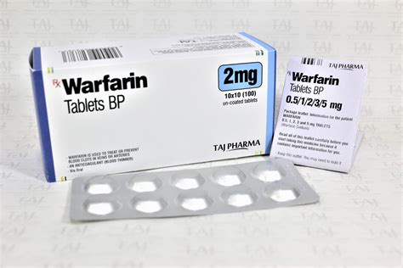

Warfarin sodium
Generic Name: Warfarin sodium
Trade Name: Warfarin (or Marevan)
Mechanism of Action: Warfarin is a vitamin K antagonist that competitively inhibits vitamin K epoxide reductase in the liver. This prevents the recycling of vitamin K and blocks the gamma-carboxylation of vitamin K-dependent clotting factors (II, VII, IX, and X), leading to the production of non-functional clotting factors. The anticoagulant effect develops gradually over several days as existing functional factors are cleared from the circulation, ultimately impairing the blood coagulation cascade.
Indications:
- Prevention of stroke and systemic embolism in non-valvular atrial fibrillation.
- Treatment and secondary prevention of deep vein thrombosis and pulmonary embolism.
- Prophylaxis in patients with mechanical heart valves or rheumatic heart disease.
- Secondary prevention after myocardial infarction.
Dosage:
- Initial loading dose: 5–10 mg once daily for 2 days (lower in elderly, malnourished, or those with liver impairment).
- Maintenance: 3–9 mg once daily, titrated daily according to INR (target usually 2.0–3.0; 2.5–3.5 for mechanical mitral valves).
- Dose adjustment required in hepatic impairment, elderly patients, and those with interacting drugs or diet changes.
Route of Administration: Oral (PO)
Pharmaceutical Preparation: Tablet
Strength: 0.5 mg, 1 mg, 3 mg, and 5 mg tablets
Contraindications:
- Active bleeding or high risk of haemorrhage.
- Pregnancy (teratogenic effects and fetal haemorrhage).
- Severe uncontrolled hypertension.
- Known hypersensitivity to warfarin.
- Recent haemorrhagic stroke or major surgery.
Side Effects:
- Common: Minor haemorrhage (e.g., epistaxis, bruising).
- Uncommon: Major haemorrhage, skin necrosis (early in treatment), purple toe syndrome.
- Rare: Alopecia, hypersensitivity reactions, calciphylaxis.
Nursing Considerations:
- Assessment: Monitor INR daily during initiation and at least weekly during maintenance; check for signs of bleeding (bruising, petechiae, haematuria, melaena).
- Surgery: Discontinue 5 days before elective surgery and bridge with low-molecular-weight heparin if high thrombotic risk.
- Education: Emphasise consistent vitamin K intake (avoid sudden large changes in green vegetables or alcohol); inform about numerous drug–drug and drug–food interactions; carry anticoagulation alert card.
- Missed Dose: Take as soon as remembered unless the next dose is due; do not double the dose.
- Interactions: Many (e.g., amiodarone, NSAIDs, antibiotics increase INR; rifampicin decreases INR).
Storage Guidelines: Store below 25°C. Protect from light and moisture.

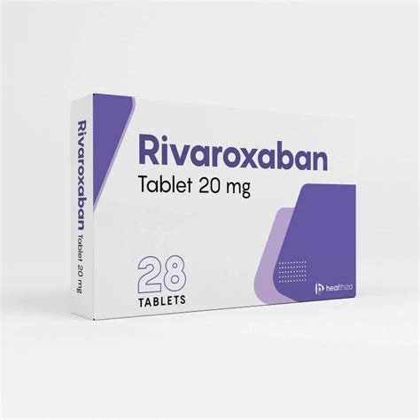

Rivaroxaban
Generic Name: Rivaroxaban
Trade Name: Xarelto
Mechanism of Action: Rivaroxaban is a direct, selective, and reversible inhibitor of Factor Xa. It does not require antithrombin III and inhibits both free and clot-bound Factor Xa, thereby reducing thrombin generation and preventing thrombus formation in the coagulation cascade. Its predictable pharmacokinetics allow fixed dosing without routine monitoring.
Indications:
- Prevention of stroke and systemic embolism in non-valvular atrial fibrillation.
- Treatment of deep vein thrombosis and pulmonary embolism.
- Prevention of recurrent deep vein thrombosis and pulmonary embolism.
- Prophylaxis of venous thromboembolism after hip or knee replacement surgery.
- Prevention of atherothrombotic events after acute coronary syndrome (in combination with aspirin).
Dosage:
- Atrial fibrillation: 20 mg once daily (15 mg once daily if creatinine clearance 15–49 mL/min).
- DVT/PE treatment: 15 mg twice daily for 21 days, then 20 mg once daily.
- VTE prophylaxis after surgery: 10 mg once daily for 2–5 weeks depending on procedure.
- Dose adjustment in renal impairment; avoid in severe renal impairment (CrCl <15 mL/min).
Route of Administration: Oral (PO)
Pharmaceutical Preparation: Film-coated tablet
Strength: 2.5 mg, 10 mg, 15 mg, and 20 mg tablets
Contraindications:
- Active bleeding.
- Severe renal impairment (creatinine clearance <15 mL/min).
- Concomitant strong CYP3A4 and P-gp inhibitors.
- Pregnancy and breastfeeding.
Side Effects:
- Common: Bleeding, anaemia, nausea, dizziness.
- Uncommon: Thrombocytopenia, hypotension, rash.
- Rare: Serious hypersensitivity, liver enzyme elevation.
Nursing Considerations:
- Assessment: Monitor renal function periodically and watch for bleeding signs; check haemoglobin in high-risk patients.
- Surgery: Discontinue at least 24–48 hours before procedures.
- Education: Take 15 mg and 20 mg doses with food for better absorption. No routine coagulation monitoring required.
- Missed Dose: Take immediately if remembered on the same day; do not double the dose.
- Interactions: Avoid strong CYP3A4/P-gp inhibitors or inducers.
Storage Guidelines: Store below 25°C in the original blister pack. Protect from moisture.

Antiplatelets

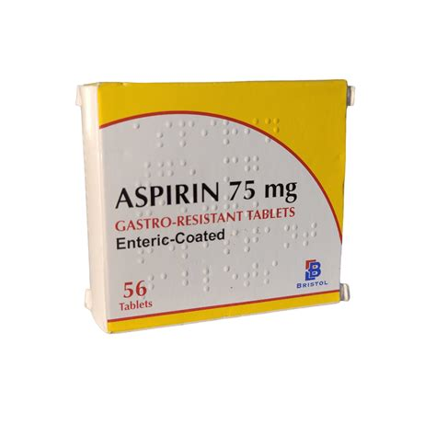

Aspirin
Generic Name: Aspirin
Trade Name: Gastro-resistant Aspirin (or Nu-Seals)
Mechanism of Action: Aspirin irreversibly acetylates cyclo-oxygenase-1 in platelets, inhibiting the synthesis of thromboxane A2. This prevents platelet aggregation and reduces the risk of thrombus formation for the lifetime of the platelet (7–10 days). The gastro-resistant coating minimises gastric irritation.
Indications:
- Secondary prevention of myocardial infarction and ischaemic stroke.
- Acute coronary syndromes.
- Prevention of graft occlusion after coronary artery bypass grafting.
- Primary prevention in high-risk patients (under specialist supervision).
Dosage:
- Secondary prevention: 75 mg once daily.
- Acute coronary syndrome: 150–300 mg loading dose, then 75 mg daily.
Route of Administration: Oral (PO)
Pharmaceutical Preparation: Gastro-resistant tablet
Strength: 75 mg and 100 mg tablets
Contraindications:
- Active peptic ulcer or gastrointestinal bleeding.
- Bleeding disorders.
- Third-trimester pregnancy.
- Known hypersensitivity to aspirin or NSAIDs.
Side Effects:
- Common: Gastrointestinal bleeding, dyspepsia.
- Uncommon: Hypersensitivity reactions, tinnitus (high doses).
- Rare: Reye's syndrome in children, bronchospasm in asthmatics.
Nursing Considerations:
- Assessment: Monitor for signs of gastrointestinal bleeding or bruising; consider proton-pump inhibitor co-prescription in high-risk patients.
- Surgery: Discontinue 7 days before elective surgery if possible.
- Education: Take with food or a proton-pump inhibitor if high gastrointestinal risk; report black stools or prolonged bleeding immediately.
- Missed Dose: Take as soon as remembered unless the next dose is due.
Storage Guidelines: Store below 25°C in original packaging.

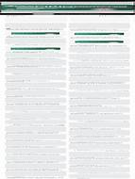

Aspirin + Glycine
Generic Name: Aspirin + Glycine
Trade Name: Aspirin 100 mg & Glycine 45 mg (buffered)
Mechanism of Action: The aspirin component irreversibly inhibits platelet cyclo-oxygenase-1 and thromboxane A2 synthesis; glycine acts as a buffer to reduce gastric irritation and improve gastrointestinal tolerability compared with plain aspirin.
Indications:
- Secondary prevention of cardiovascular events in patients with mild gastrointestinal sensitivity.
Dosage:
- 100 mg once daily.
Route of Administration: Oral (PO)
Pharmaceutical Preparation: Tablet
Strength: Aspirin 100 mg + Glycine 45 mg per tablet
Contraindications:
- Active peptic ulcer or bleeding disorders.
Side Effects:
- Reduced gastrointestinal irritation compared with plain aspirin; still carries risk of bleeding and hypersensitivity.
Nursing Considerations:
- Assessment: Monitor for bleeding.
- Education: Suitable for patients who experience dyspepsia with standard aspirin.
- Missed Dose: Take as soon as remembered unless the next dose is due.
Storage Guidelines: Store below 25°C. Protect from moisture.

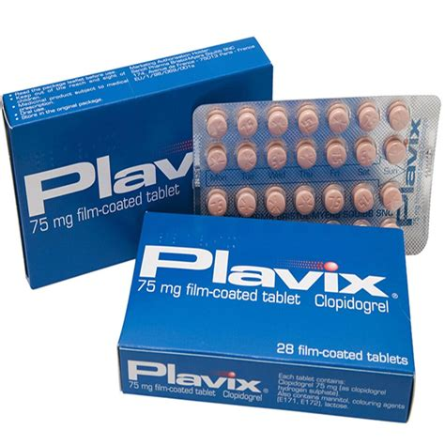

Clopidogrel
Generic Name: Clopidogrel
Trade Name: Plavix (or generic)
Mechanism of Action: Clopidogrel is a prodrug metabolised to an active thiol metabolite that irreversibly binds to the P2Y12 ADP receptor on platelets, inhibiting ADP-mediated platelet activation and aggregation for the life of the platelet.
Indications:
- Acute coronary syndrome.
- Recent myocardial infarction or ischaemic stroke.
- Peripheral arterial disease.
Dosage:
- 75 mg once daily (loading dose 300 mg in acute coronary syndrome).
Route of Administration: Oral (PO)
Pharmaceutical Preparation: Film-coated tablet
Strength: 75 mg tablets
Contraindications:
- Active bleeding.
- Severe hepatic impairment.
Side Effects:
- Common: Bleeding, bruising, dyspepsia.
- Uncommon: Rash, pruritus.
- Rare: Thrombotic thrombocytopenic purpura.
Nursing Considerations:
- Assessment: Monitor for bleeding; consider CYP2C19 genotyping in high-risk patients.
- Education: Advise on bleeding risk and to report prolonged bleeding.
- Missed Dose: Take as soon as remembered.
Storage Guidelines: Store below 25°C.

Angiotensin Converting Enzyme Inhibitors

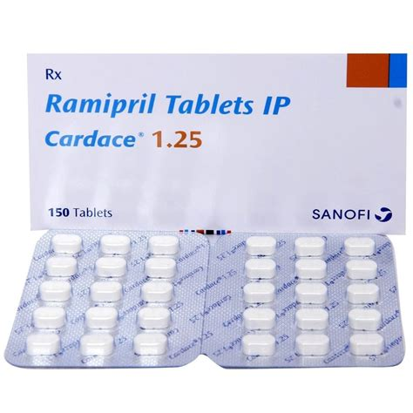

Ramipril
Generic Name: Ramipril
Trade Name: Tritace
Mechanism of Action: Ramipril is a prodrug converted to ramiprilat, which inhibits angiotensin-converting enzyme. This prevents the conversion of angiotensin I to angiotensin II, leading to vasodilation, reduced aldosterone secretion, decreased sodium and water retention, and reduced vascular remodelling.
Indications:
- Hypertension.
- Heart failure.
- Post-myocardial infarction left ventricular dysfunction.
- Diabetic nephropathy with proteinuria.
Dosage:
- Hypertension: 2.5–10 mg once daily.
- Heart failure: Start at 1.25 mg once daily and titrate to 10 mg.
- Post-MI: Start low and titrate.
Route of Administration: Oral (PO)
Pharmaceutical Preparation: Capsule or tablet
Strength: 1.25 mg, 2.5 mg, 5 mg, and 10 mg
Contraindications:
- History of angioedema with ACE inhibitors.
- Bilateral renal artery stenosis.
- Pregnancy (foetal toxicity).
Side Effects:
- Common: Dry cough, hypotension.
- Uncommon: Hyperkalaemia, renal impairment.
- Rare: Angioedema, pancreatitis.
Nursing Considerations:
- Assessment: Monitor blood pressure, urea and electrolytes, and renal function before and during treatment.
- Education: Advise the patient to report swelling of the face or lips immediately.
- Missed Dose: Take as soon as remembered unless the next dose is due.
Storage Guidelines: Store below 25°C.

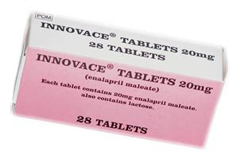

Enalapril maleate
Generic Name: Enalapril maleate
Trade Name: Innovace
Mechanism of Action: Enalapril is a prodrug hydrolysed to enalaprilat, an ACE inhibitor that reduces angiotensin II formation, causing vasodilation and decreased aldosterone secretion.
Indications:
- Hypertension.
- Symptomatic heart failure.
Dosage:
- 5–40 mg daily in one or two divided doses.
Route of Administration: Oral (PO)
Pharmaceutical Preparation: Tablet
Strength: 2.5 mg, 5 mg, 10 mg, and 20 mg
Contraindications:
- History of angioedema with ACE inhibitors.
- Bilateral renal artery stenosis.
- Pregnancy.
Side Effects:
- Common: Dry cough, hypotension.
- Uncommon: Hyperkalaemia, renal impairment.
- Rare: Angioedema.
Nursing Considerations:
- Assessment: Monitor first-dose hypotension, especially in volume-depleted patients.
- Education: Same as ramipril.
Storage Guidelines: Store below 25°C.



Lisinopril
Generic Name: Lisinopril
Trade Name: Zestril
Mechanism of Action: Lisinopril is an ACE inhibitor that directly inhibits angiotensin-converting enzyme, reducing angiotensin II levels and aldosterone secretion, resulting in vasodilation and reduced blood pressure.
Indications:
- Hypertension.
- Heart failure.
- Post-myocardial infarction.
Dosage:
- 5–40 mg once daily.
Route of Administration: Oral (PO)
Pharmaceutical Preparation: Tablet
Strength: 2.5 mg, 5 mg, 10 mg, and 20 mg
Contraindications:
- History of angioedema with ACE inhibitors.
- Bilateral renal artery stenosis.
- Pregnancy.
Side Effects:
- Common: Dry cough, hypotension.
- Uncommon: Hyperkalaemia, renal impairment.
- Rare: Angioedema.
Nursing Considerations:
- Assessment: Monitor renal function and potassium levels.
Storage Guidelines: Store below 25°C.

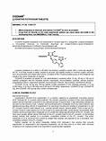

Losartan potassium
Generic Name: Losartan potassium
Trade Name: Cozaar (or generic)
Mechanism of Action: Losartan is a selective, competitive angiotensin II receptor (type AT1) antagonist. It blocks the vasoconstrictor and aldosterone-secreting effects of angiotensin II without affecting ACE, thereby avoiding the cough associated with ACE inhibitors.
Indications:
- Hypertension.
- Heart failure with reduced ejection fraction.
- Diabetic nephropathy with proteinuria.
Dosage:
- 50–100 mg once daily.
Route of Administration: Oral (PO)
Pharmaceutical Preparation: Film-coated tablet
Strength: 25 mg, 50 mg, and 100 mg
Contraindications:
- Pregnancy.
- Bilateral renal artery stenosis.
Side Effects:
- Dizziness, hyperkalaemia, renal impairment.
Nursing Considerations:
- Assessment: Monitor blood pressure and renal function.
- Education: Alternative to ACE inhibitors in patients who develop cough.
Storage Guidelines: Store below 25°C.

Beta Blockers

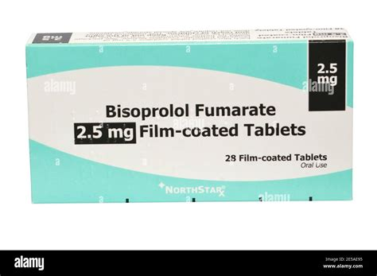

Bisoprolol fumarate
Generic Name: Bisoprolol fumarate
Trade Name: Bisoprolol (or Cardicor)
Mechanism of Action: Bisoprolol is a highly selective β1-adrenoceptor blocker that reduces heart rate, myocardial contractility, and atrioventricular conduction velocity, thereby decreasing myocardial oxygen demand.
Indications:
- Hypertension.
- Angina pectoris.
- Chronic heart failure.
Dosage:
- Hypertension and angina: 5–10 mg once daily.
- Heart failure: Start at 1.25 mg once daily and titrate slowly to 10 mg.
Route of Administration: Oral (PO)
Pharmaceutical Preparation: Tablet
Strength: 2.5 mg, 5 mg, and 10 mg
Contraindications:
- Asthma or severe COPD.
- Severe bradycardia or heart block.
- Uncontrolled heart failure.
Side Effects:
- Common: Bradycardia, fatigue, cold extremities.
- Uncommon: Dizziness, depression.
- Rare: Worsening heart failure.
Nursing Considerations:
- Assessment: Monitor heart rate and blood pressure; check for signs of worsening heart failure.
- Education: Do not stop abruptly because of the risk of rebound tachycardia.
- Missed Dose: Take as soon as remembered unless the next dose is due.
Storage Guidelines: Store below 25°C.

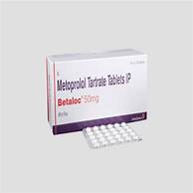

Metoprolol tartrate
Generic Name: Metoprolol tartrate
Trade Name: Betaloc
Mechanism of Action: Metoprolol is a selective β1-adrenoceptor blocker that decreases heart rate, cardiac output, and blood pressure by blocking sympathetic stimulation of the heart.
Indications:
- Hypertension.
- Angina.
- Post-myocardial infarction.
Dosage:
- 50–100 mg two to three times daily (immediate-release).
Route of Administration: Oral (PO)
Pharmaceutical Preparation: Tablet
Strength: 50 mg and 100 mg
Contraindications:
- Asthma or severe COPD.
- Severe bradycardia or heart block.
- Uncontrolled heart failure.
Side Effects:
- Common: Bradycardia, fatigue, cold extremities.
- Uncommon: Dizziness, depression.
Nursing Considerations:
- Assessment: Use the tartrate form for immediate-release needs; monitor pulse.
Storage Guidelines: Store below 25°C.

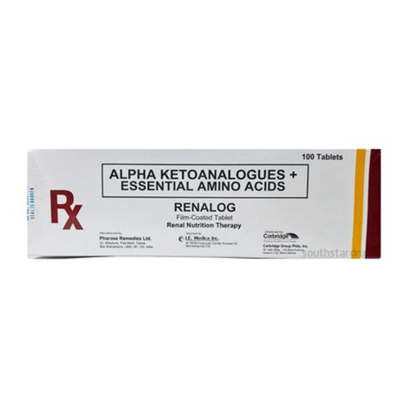

Nebivolol
Generic Name: Nebivolol
Trade Name: Nebilet
Mechanism of Action: Nebivolol is a highly selective β1-blocker with additional endothelium-dependent vasodilating properties mediated by nitric oxide release, reducing peripheral vascular resistance.
Indications:
- Hypertension.
Dosage:
- 5 mg once daily.
Route of Administration: Oral (PO)
Pharmaceutical Preparation: Tablet
Strength: 5 mg
Contraindications:
- Asthma or severe COPD.
- Severe bradycardia or heart block.
Side Effects:
- Headache, dizziness, fatigue.
Nursing Considerations:
- Assessment: Monitor blood pressure; beneficial in patients with endothelial dysfunction.
Storage Guidelines: Store below 25°C.

Calcium Channel Blockers



Amlodipine
Generic Name: Amlodipine
Trade Name: Istin (or Norvasc)
Mechanism of Action: Amlodipine is a dihydropyridine calcium-channel blocker that inhibits the influx of calcium ions into vascular smooth muscle and cardiac muscle cells, causing peripheral vasodilation and reduced peripheral vascular resistance.
Indications:
- Hypertension.
- Stable angina.
Dosage:
- 5–10 mg once daily.
Route of Administration: Oral (PO)
Pharmaceutical Preparation: Tablet
Strength: 5 mg and 10 mg
Contraindications:
- Severe aortic stenosis.
- Cardiogenic shock.
Side Effects:
- Common: Ankle oedema, flushing, headache.
- Uncommon: Palpitations.
Nursing Considerations:
- Assessment: Monitor for peripheral oedema; advise on posture changes.
- Education: Oedema is common but usually benign.
Storage Guidelines: Store below 25°C.

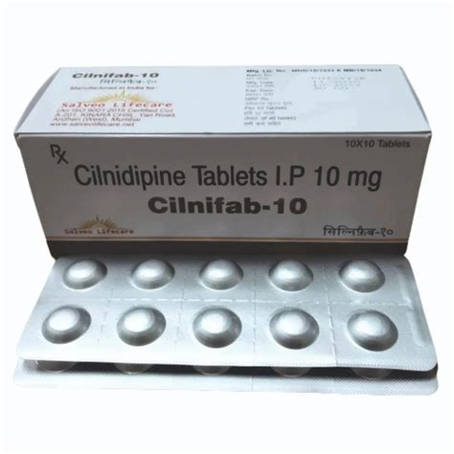

Cilnidipine
Generic Name: Cilnidipine
Trade Name: Cilnidipine (various generics)
Mechanism of Action: Cilnidipine is a dual L- and N-type calcium-channel blocker that inhibits calcium influx in vascular smooth muscle (L-type) and sympathetic nerve terminals (N-type), causing vasodilation with less reflex tachycardia.
Indications:
- Hypertension.
Dosage:
- 10–20 mg once daily.
Route of Administration: Oral (PO)
Pharmaceutical Preparation: Tablet
Strength: 10 mg and 20 mg
Contraindications:
- Severe aortic stenosis.
- Cardiogenic shock.
Side Effects:
- Oedema, headache.
Nursing Considerations:
- Assessment: Monitor blood pressure; less reflex tachycardia than some calcium-channel blockers.
Storage Guidelines: Store below 25°C.

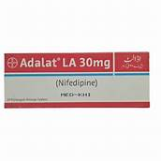

Nifedipine
Generic Name: Nifedipine
Trade Name: Adalat LA
Mechanism of Action: Nifedipine is a dihydropyridine calcium-channel blocker that inhibits calcium ion entry into vascular smooth muscle, leading to vasodilation and reduced blood pressure.
Indications:
- Hypertension.
- Angina.
Dosage:
- 10–20 mg twice daily or 30–60 mg modified-release once daily.
Route of Administration: Oral (PO)
Pharmaceutical Preparation: Modified-release tablet
Strength: 10 mg, 20 mg, 30 mg, and 60 mg
Contraindications:
- Cardiogenic shock.
- Acute angina attack.
Side Effects:
- Headache, flushing, oedema.
Nursing Considerations:
- Assessment: Do not chew or crush modified-release forms.
Storage Guidelines: Store below 25°C. Protect from light.

Cholesterol Lowering Agents

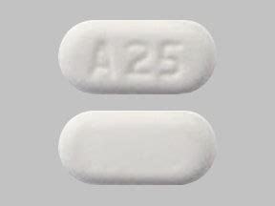

Ezetimibe
Generic Name: Ezetimibe
Trade Name: Ezetrol
Mechanism of Action: Ezetimibe selectively inhibits the intestinal absorption of cholesterol by blocking the Niemann-Pick C1-like 1 transporter on the brush border of the small intestine, reducing the delivery of cholesterol to the liver and lowering circulating LDL-cholesterol.
Indications:
- Primary hypercholesterolaemia (alone or in combination with a statin).
- Homozygous familial hypercholesterolaemia.
Dosage:
- 10 mg once daily.
Route of Administration: Oral (PO)
Pharmaceutical Preparation: Tablet
Strength: 10 mg
Contraindications:
- Active liver disease when combined with a statin.
Side Effects:
- Common: Diarrhoea, headache, myalgia.
Nursing Considerations:
- Assessment: Monitor liver function tests if combined with a statin; advise on diet.
Storage Guidelines: Store below 25°C.

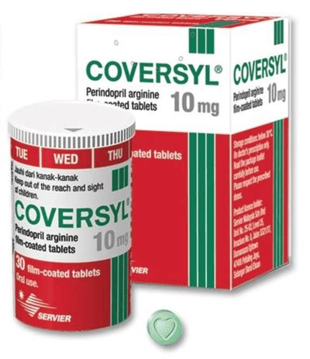

Rosuvastatin
Generic Name: Rosuvastatin
Trade Name: Crestor
Mechanism of Action: Rosuvastatin competitively inhibits HMG-CoA reductase, the rate-limiting enzyme in cholesterol biosynthesis, leading to upregulation of LDL receptors and increased clearance of LDL-cholesterol from the blood.
Indications:
- Hypercholesterolaemia.
- Prevention of cardiovascular events in high-risk patients.
Dosage:
- 5–40 mg once daily.
Route of Administration: Oral (PO)
Pharmaceutical Preparation: Tablet
Strength: 5 mg, 10 mg, 20 mg, and 40 mg
Contraindications:
- Active liver disease.
- Pregnancy.
Side Effects:
- Common: Myalgia, headache, raised transaminases.
Nursing Considerations:
- Assessment: Monitor creatine kinase and liver function tests; advise the patient to report unexplained muscle pain.
Storage Guidelines: Store below 25°C.

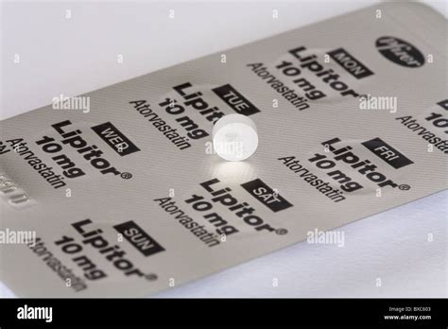

Atorvastatin
Generic Name: Atorvastatin
Trade Name: Lipitor
Mechanism of Action: Atorvastatin is a potent HMG-CoA reductase inhibitor that reduces hepatic cholesterol synthesis, upregulates LDL receptors, and lowers circulating LDL-cholesterol.
Indications:
- Hypercholesterolaemia.
- Cardiovascular prevention.
Dosage:
- 10–80 mg once daily.
Route of Administration: Oral (PO)
Pharmaceutical Preparation: Tablet
Strength: 10 mg, 20 mg, 40 mg, and 80 mg
Contraindications:
- Active liver disease.
- Pregnancy.
Side Effects:
- Common: Myalgia, headache, raised transaminases.
Nursing Considerations:
- Assessment: High-intensity statin; monitor creatine kinase and liver function tests; advise on muscle symptoms.
Storage Guidelines: Store below 25°C.

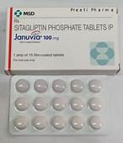

Sitagliptin phosphate
Generic Name: Sitagliptin phosphate
Trade Name: Januvia
Mechanism of Action: Sitagliptin is a dipeptidyl peptidase-4 inhibitor that prevents the inactivation of incretin hormones (GLP-1 and GIP). This increases insulin secretion and suppresses glucagon release in a glucose-dependent manner, improving glycaemic control with low hypoglycaemia risk.
Indications:
- Type 2 diabetes mellitus (often in patients with cardiovascular risk).
Dosage:
- 100 mg once daily (reduce in moderate to severe renal impairment).
Route of Administration: Oral (PO)
Pharmaceutical Preparation: Film-coated tablet
Strength: 25 mg, 50 mg, and 100 mg
Contraindications:
- Severe renal impairment (dose adjustment required).
- History of pancreatitis (caution).
Side Effects:
- Common: Headache, nasopharyngitis, upper respiratory tract infection.
- Rare: Pancreatitis.
Nursing Considerations:
- Assessment: Monitor blood glucose and renal function.
- Education: Advise on hypoglycaemia risk when combined with sulfonylureas or insulin.
Storage Guidelines: Store below 25°C.

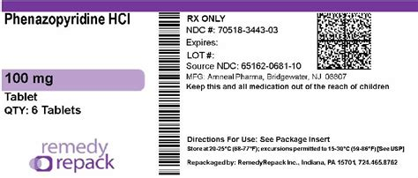

Gliclazide
Generic Name: Gliclazide
Trade Name: Diamicron
Mechanism of Action: Gliclazide is a sulfonylurea that binds to ATP-sensitive potassium channels on pancreatic beta cells, causing depolarisation, calcium influx, and insulin release.
Indications:
- Type 2 diabetes mellitus (in patients with cardiovascular risk).
Dosage:
- 40–160 mg daily (immediate-release) or 30–120 mg once daily (modified-release).
Route of Administration: Oral (PO)
Pharmaceutical Preparation: Tablet or modified-release tablet
Strength: 80 mg (standard) or 30 mg modified-release
Contraindications:
- Type 1 diabetes.
- Diabetic ketoacidosis.
Side Effects:
- Common: Hypoglycaemia, weight gain.
- Uncommon: Gastrointestinal upset.
Nursing Considerations:
- Assessment: Monitor blood glucose regularly; advise on hypoglycaemia symptoms and treatment.
Storage Guidelines: Store below 25°C.

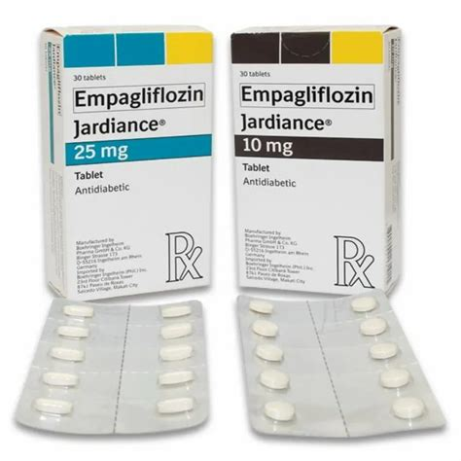

Empagliflozin
Generic Name: Empagliflozin
Trade Name: Jardiance
Mechanism of Action: Empagliflozin is a sodium-glucose co-transporter 2 inhibitor that blocks glucose reabsorption in the proximal renal tubule, promoting urinary glucose excretion and lowering blood glucose independently of insulin. It also reduces cardiac preload and afterload through natriuresis and osmotic diuresis.
Indications:
- Type 2 diabetes mellitus.
- Heart failure with reduced ejection fraction.
- Chronic kidney disease (cardiovascular protection).
Dosage:
- 10–25 mg once daily.
Route of Administration: Oral (PO)
Pharmaceutical Preparation: Tablet
Strength: 10 mg and 25 mg
Contraindications:
- Severe renal impairment (dose adjustment or avoidance).
Side Effects:
- Common: Genital mycotic infections, urinary tract infections, dehydration.
- Rare: Euglycaemic ketoacidosis.
Nursing Considerations:
- Assessment: Monitor renal function and volume status; advise genital hygiene.
- Education: Maintain adequate fluid intake.
Storage Guidelines: Store below 25°C.

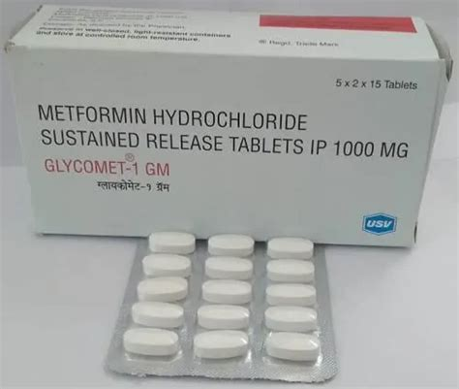

Metformin
Generic Name: Metformin
Trade Name: Glucophage
Mechanism of Action: Metformin decreases hepatic glucose production, reduces intestinal absorption of glucose, and improves peripheral insulin sensitivity by activating AMP-activated protein kinase.
Indications:
- Type 2 diabetes mellitus (first-line agent with cardiovascular benefit).
Dosage:
- 500 mg–2 g daily in divided doses (titrate slowly).
Route of Administration: Oral (PO)
Pharmaceutical Preparation: Tablet or modified-release tablet
Strength: 500 mg, 850 mg, and 1 g
Contraindications:
- Severe renal impairment.
- Acute metabolic acidosis.
Side Effects:
- Common: Gastrointestinal upset (nausea, diarrhoea).
- Long-term: Vitamin B12 deficiency.
- Rare: Lactic acidosis.
Nursing Considerations:
- Assessment: Monitor estimated glomerular filtration rate; stop during acute illness or dehydration.
- Education: Take with meals to reduce gastrointestinal side effects.
Storage Guidelines: Store below 25°C.

Digitalis Preparations

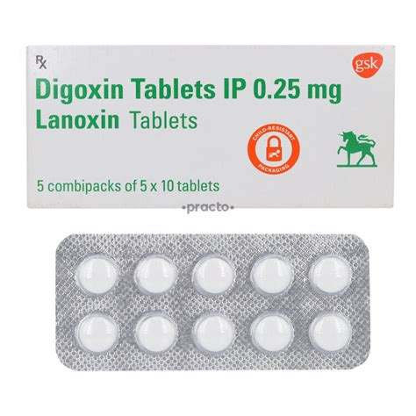

Digoxin
Generic Name: Digoxin
Trade Name: Lanoxin
Mechanism of Action: Digoxin inhibits the sodium-potassium ATPase pump in cardiac myocytes, increasing intracellular calcium and enhancing myocardial contractility (positive inotrope). It also slows atrioventricular node conduction via vagal stimulation, providing rate control in atrial fibrillation.
Indications:
- Heart failure with atrial fibrillation.
- Rate control in atrial fibrillation or flutter.
Dosage:
- Loading: 0.75–1.5 mg in divided doses over 24 hours.
- Maintenance: 62.5–250 micrograms daily (adjusted by serum levels and renal function).
Route of Administration: Oral (PO) or intravenous
Pharmaceutical Preparation: Tablet or solution for injection
Strength: 62.5 micrograms, 125 micrograms, and 250 micrograms tablets
Contraindications:
- Ventricular arrhythmias.
- Hypertrophic obstructive cardiomyopathy.
- Hypokalaemia.
Side Effects:
- Common: Nausea, vomiting.
- Uncommon: Arrhythmias, visual disturbances (xanthopsia).
Nursing Considerations:
- Assessment: Monitor serum digoxin levels (0.5–2 micrograms/L), electrolytes, and ECG; toxicity risk is high in the elderly or in renal impairment.
- Education: Advise the patient to report nausea or visual changes.
Storage Guidelines: Store below 25°C. Protect from light.



Digoxin
Generic Name: Digoxin
Trade Name: Lanoxin (injection)
Mechanism of Action: Same as oral digoxin but provides rapid onset for acute situations.
Indications:
- Acute heart failure or rate control when the oral route is unavailable.
Dosage:
- Loading: 0.5–1 mg intravenously over 30–120 minutes.
Route of Administration: Intravenous (slow)
Pharmaceutical Preparation: Solution for injection
Strength: 500 micrograms/2 mL ampoule
Contraindications:
- Ventricular arrhythmias.
- Hypertrophic obstructive cardiomyopathy.
- Hypokalaemia.
Side Effects:
- Higher arrhythmia risk with the intravenous route.
Nursing Considerations:
- Assessment: Continuous ECG monitoring during loading; dilute and administer slowly.
Storage Guidelines: Store below 25°C. Protect from light.

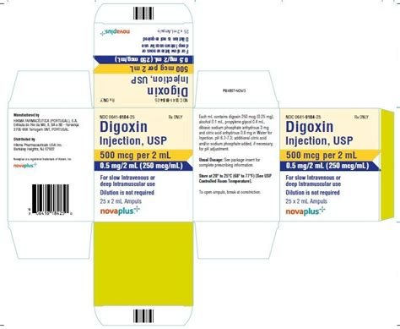

Digitoxin
Generic Name: Digitoxin
Trade Name: Digitoxin (rarely used – BNF reference)
Mechanism of Action: Cardiac glycoside similar to digoxin but with longer half-life; inhibits Na+/K+-ATPase, increasing intracellular calcium and contractility.
Indications:
- Heart failure or atrial fibrillation (when digoxin is unsuitable).
Dosage:
- Loading: 0.6–1.2 mg.
- Maintenance: 50–300 micrograms daily.
Route of Administration: Oral (PO)
Pharmaceutical Preparation: Tablet
Strength: 50 micrograms and 100 micrograms
Contraindications:
- Ventricular arrhythmias.
- Hypertrophic obstructive cardiomyopathy.
- Hypokalaemia.
Side Effects:
- Same as digoxin.
Nursing Considerations:
- Assessment: Longer half-life requires careful level monitoring.
Storage Guidelines: Store below 25°C.

Vasodilators

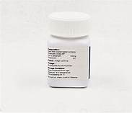

Sildenafil citrate
Generic Name: Sildenafil citrate
Trade Name: Viagra (or Revatio for PAH)
Mechanism of Action: Sildenafil inhibits phosphodiesterase type 5, increasing cyclic GMP levels, which causes smooth muscle relaxation and vasodilation in the pulmonary vasculature and corpus cavernosum.
Indications:
- Pulmonary arterial hypertension.
- Erectile dysfunction.
Dosage:
- Pulmonary arterial hypertension: 20 mg three times daily.
- Erectile dysfunction: 50 mg as needed (range 25–100 mg).
Route of Administration: Oral (PO)
Pharmaceutical Preparation: Tablet
Strength: 20 mg, 25 mg, 50 mg, and 100 mg
Contraindications:
- Concomitant nitrates or nitric oxide donors.
- Severe hypotension.
Side Effects:
- Common: Headache, flushing, dyspepsia.
- Uncommon: Visual disturbances.
Nursing Considerations:
- Assessment: Monitor blood pressure; advise timing with sexual activity.
- Education: Do not combine with nitrates.
Storage Guidelines: Store below 25°C.

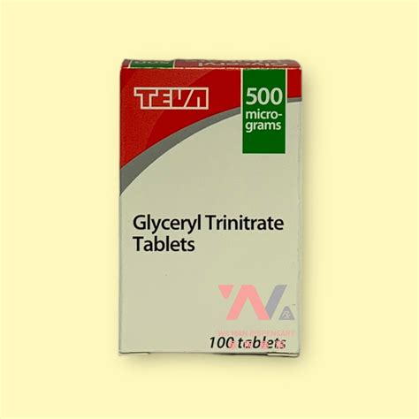

Glyceryl trinitrate
Generic Name: Glyceryl trinitrate
Trade Name: Nitromin or GTN
Mechanism of Action: Organic nitrate that is metabolised to nitric oxide, which activates guanylate cyclase, increases cyclic GMP, and causes venous and arterial vasodilation, reducing preload and myocardial oxygen demand.
Indications:
- Acute angina.
- Acute heart failure.
Dosage:
- 0.3–1 mg sublingual as needed (repeat every 5 minutes up to 3 doses).
Route of Administration: Sublingual, buccal, transdermal, or intravenous
Pharmaceutical Preparation: Sublingual tablet, spray, or patch
Strength: 0.3 mg, 0.5 mg, and 0.6 mg tablets
Contraindications:
- Hypotension.
- Concomitant PDE5 inhibitors.
Side Effects:
- Common: Headache, hypotension, flushing.
Nursing Considerations:
- Assessment: Sit or lie down when taking; monitor blood pressure.
- Education: Ensure a nitrate-free interval to prevent tolerance.
Storage Guidelines: Cool, dark place; tablets in original bottle (volatile).

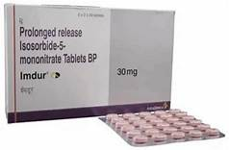

Isosorbide mononitrate
Generic Name: Isosorbide mononitrate
Trade Name: Imdur
Mechanism of Action: Organic nitrate converted to nitric oxide, causing vasodilation and reduced cardiac preload and oxygen demand.
Indications:
- Angina.
- Heart failure.
Dosage:
- 30–120 mg once daily (modified-release).
Route of Administration: Oral (PO)
Pharmaceutical Preparation: Modified-release tablet
Strength: 30 mg and 60 mg
Contraindications:
- Hypotension.
- Concomitant PDE5 inhibitors.
Side Effects:
- Headache, flushing, hypotension.
Nursing Considerations:
- Assessment: Ensure a nitrate-free interval (usually 8–12 hours).
Storage Guidelines: Store below 25°C.

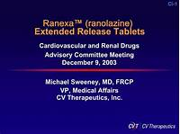

Ranolazine
Generic Name: Ranolazine
Trade Name: Ranexa
Mechanism of Action: Ranolazine inhibits the late sodium current in cardiac myocytes, reducing intracellular calcium overload and thereby decreasing myocardial oxygen demand without affecting heart rate or blood pressure.
Indications:
- Chronic stable angina (add-on therapy).
Dosage:
- 375–750 mg twice daily (extended-release).
Route of Administration: Oral (PO)
Pharmaceutical Preparation: Prolonged-release tablet
Strength: 375 mg, 500 mg, and 750 mg
Contraindications:
- Severe renal or hepatic impairment.
- QT prolongation.
Side Effects:
- Common: Dizziness, constipation, nausea.
Nursing Considerations:
- Assessment: Monitor ECG/QT interval; avoid strong CYP3A4 inhibitors.
Storage Guidelines: Store below 25°C.

Inotropes

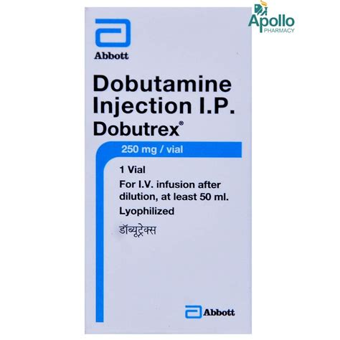

Dobutamine
Generic Name: Dobutamine
Trade Name: Dobutrex
Mechanism of Action: Dobutamine is a synthetic catecholamine that primarily stimulates β1-receptors, increasing myocardial contractility and cardiac output with minimal effect on heart rate at therapeutic doses.
Indications:
- Acute heart failure.
- Cardiogenic shock.
Dosage:
- 2–20 micrograms/kg/min by continuous intravenous infusion.
Route of Administration: Intravenous infusion
Pharmaceutical Preparation: Concentrate for infusion
Strength: 250 mg/20 mL vial
Contraindications:
- Hypertrophic obstructive cardiomyopathy.
- Phaeochromocytoma.
Side Effects:
- Common: Tachycardia, arrhythmias.
- Uncommon: Hypotension.
Nursing Considerations:
- Assessment: Central line preferred; continuous cardiac monitoring required.
Storage Guidelines: Store below 25°C. Protect from light.

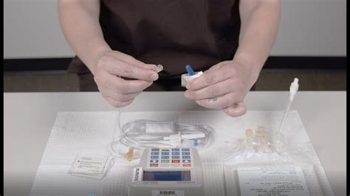

Milrinone
Generic Name: Milrinone
Trade Name: Primacor
Mechanism of Action: Milrinone is a phosphodiesterase-3 inhibitor that increases intracellular cyclic AMP, enhancing myocardial contractility and causing vasodilation.
Indications:
- Acute decompensated heart failure.
Dosage:
- Loading 50 micrograms/kg intravenously, then 0.375–0.75 micrograms/kg/min infusion.
Route of Administration: Intravenous
Pharmaceutical Preparation: Solution for infusion
Strength: 10 mg/10 mL ampoule
Contraindications:
- Severe hypotension.
- Hypertrophic cardiomyopathy.
Side Effects:
- Common: Arrhythmias, hypotension.
- Uncommon: Thrombocytopenia.
Nursing Considerations:
- Assessment: Monitor blood pressure and ECG; renal dose adjustment needed.
Storage Guidelines: Store below 25°C.

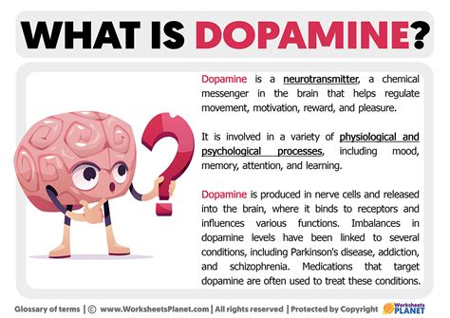

Dopamine hydrochloride
Generic Name: Dopamine hydrochloride
Trade Name: Dopamine (generic)
Mechanism of Action: Dopamine acts on dopaminergic, β1-, and α-receptors in a dose-dependent manner: low doses improve renal perfusion, medium doses increase cardiac output, high doses cause vasoconstriction.
Indications:
- Cardiogenic shock.
- Hypotension.
Dosage:
- 2–20 micrograms/kg/min intravenous infusion.
Route of Administration: Intravenous infusion
Pharmaceutical Preparation: Concentrate for infusion
Strength: 200 mg/5 mL ampoule
Contraindications:
- Phaeochromocytoma.
- Uncorrected tachyarrhythmias.
Side Effects:
- Common: Tachycardia, arrhythmias.
- Uncommon: Hypertension.
Nursing Considerations:
- Assessment: Central line and continuous monitoring required.
Storage Guidelines: Store below 25°C. Protect from light.

Anti-arrhythmias

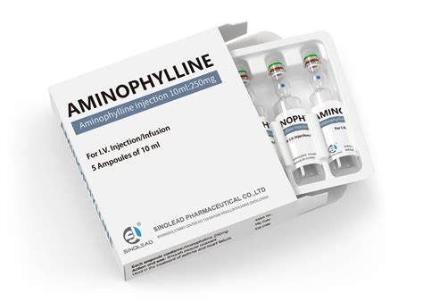

Amiodarone hydrochloride
Generic Name: Amiodarone hydrochloride
Trade Name: Cordarone
Mechanism of Action: Amiodarone is a class III antiarrhythmic that prolongs the action potential duration and refractory period by blocking potassium channels; it also has class I, II, and IV effects.
Indications:
- Atrial fibrillation.
- Ventricular arrhythmias.
Dosage:
- Loading: 200 mg three times daily for 1 week, then maintenance 200 mg daily.
Route of Administration: Oral (PO) or intravenous
Pharmaceutical Preparation: Tablet
Strength: 100 mg and 200 mg
Contraindications:
- Bradycardia or sinoatrial block.
- Thyroid dysfunction.
Side Effects:
- Common: Thyroid dysfunction, photosensitivity.
- Uncommon: Pulmonary toxicity.
- Rare: Corneal microdeposits.
Nursing Considerations:
- Assessment: Baseline thyroid, liver, lung function tests; regular monitoring required.
- Education: Advise sun protection and regular eye checks.
Storage Guidelines: Store below 25°C.

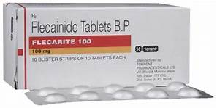

Flecainide acetate
Generic Name: Flecainide acetate
Trade Name: Tambocor
Mechanism of Action: Flecainide is a class Ic antiarrhythmic that blocks sodium channels, slowing conduction in the His-Purkinje system and prolonging the refractory period.
Indications:
- Supraventricular arrhythmias.
Dosage:
- 50–150 mg twice daily.
Route of Administration: Oral (PO)
Pharmaceutical Preparation: Tablet
Strength: 50 mg and 100 mg
Contraindications:
- Structural heart disease.
- Heart failure.
Side Effects:
- Common: Proarrhythmia, dizziness.
- Uncommon: Visual disturbance.
Nursing Considerations:
- Assessment: ECG monitoring; avoid in ischaemic heart disease.
Storage Guidelines: Store below 25°C.

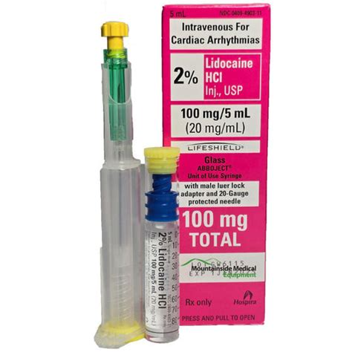

Lidocaine hydrochloride
Generic Name: Lidocaine hydrochloride
Trade Name: Lidocaine
Mechanism of Action: Lidocaine is a class Ib antiarrhythmic that blocks sodium channels in ventricular myocardium, shortening the action potential duration and suppressing ventricular ectopy.
Indications:
- Ventricular arrhythmias post-myocardial infarction.
Dosage:
- Loading 1–1.5 mg/kg intravenously, then infusion 1–4 mg/min.
Route of Administration: Intravenous
Pharmaceutical Preparation: Injection
Strength: 1% (10 mg/mL) and 2% (20 mg/mL)
Contraindications:
- Severe heart block.
- Porphyria.
Side Effects:
- Common: Central nervous system toxicity (drowsiness).
- Uncommon: Hypotension.
- Rare: Seizures.
Nursing Considerations:
- Assessment: Monitor ECG; therapeutic levels 1.5–5 mg/L.
Storage Guidelines: Store below 25°C.

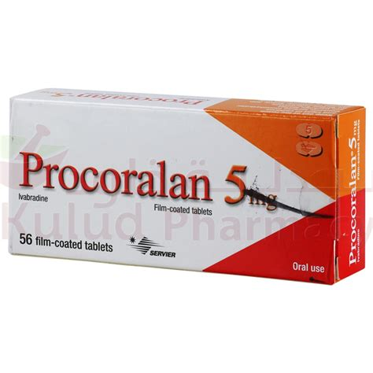

Ivabradine
Generic Name: Ivabradine
Trade Name: Procoralan
Mechanism of Action: Ivabradine selectively inhibits the If ("funny") current in the sinoatrial node, reducing heart rate without affecting myocardial contractility or blood pressure.
Indications:
- Chronic stable angina.
- Chronic heart failure (sinus rhythm, resting heart rate ≥75 bpm).
Dosage:
- 5–7.5 mg twice daily.
Route of Administration: Oral (PO)
Pharmaceutical Preparation: Tablet
Strength: 5 mg and 7.5 mg
Contraindications:
- Resting heart rate <60 bpm.
- Sick sinus syndrome.
Side Effects:
- Common: Bradycardia.
- Uncommon: Luminous phenomena (phosphenes).
Nursing Considerations:
- Assessment: Monitor resting heart rate; avoid with strong CYP3A4 inhibitors.
Storage Guidelines: Store below 25°C.

Chapter 2: Urinary System

Antibiotics

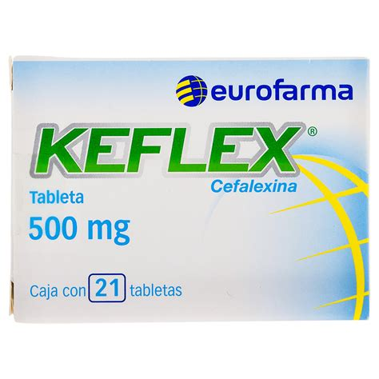

Cefalexin
Generic Name: Cefalexin
Trade Name: Keflex
Mechanism of Action: First-generation cephalosporin that inhibits bacterial cell wall synthesis by binding to penicillin-binding proteins, leading to cell lysis.
Indications:
- Urinary tract infections.
- Skin and soft tissue infections.
Dosage:
- 250–500 mg every 6 hours (maximum 4 g daily).
Route of Administration: Oral (PO)
Pharmaceutical Preparation: Capsule
Strength: 250 mg and 500 mg
Contraindications:
- Hypersensitivity to cephalosporins or penicillins.
Side Effects:
- Common: Gastrointestinal upset, rash.
- Uncommon: Clostridium difficile infection.
Nursing Considerations:
- Assessment: Complete the full course; monitor renal function.
- Education: Advise the patient on signs of allergic reaction.
Storage Guidelines: Store below 25°C.

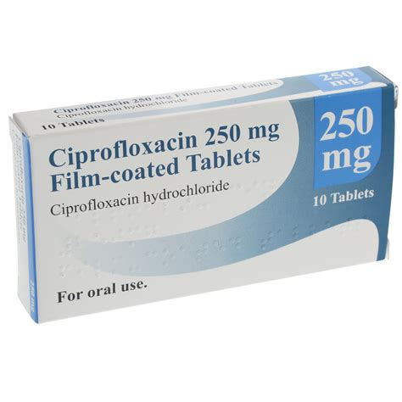

Ciprofloxacin
Generic Name: Ciprofloxacin
Trade Name: Ciproxin
Mechanism of Action: Fluoroquinolone that inhibits bacterial DNA gyrase and topoisomerase IV, preventing DNA replication and repair.
Indications:
- Complicated urinary tract infections.
Dosage:
- 250–500 mg twice daily.
Route of Administration: Oral (PO)
Pharmaceutical Preparation: Tablet
Strength: 250 mg and 500 mg
Contraindications:
- History of tendon disorders with quinolones.
- Pregnancy.
Side Effects:
- Common: Nausea.
- Uncommon: Tendonitis, QT prolongation.
Nursing Considerations:
- Assessment: Take with plenty of water; avoid dairy products.
Storage Guidelines: Store below 25°C.

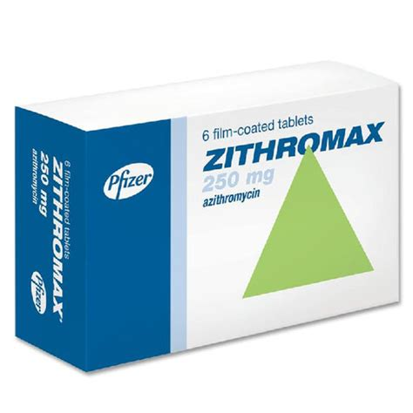

Azithromycin
Generic Name: Azithromycin
Trade Name: Zithromax
Mechanism of Action: Macrolide antibiotic that binds to the 50S ribosomal subunit, inhibiting bacterial protein synthesis.
Indications:
- Genito-urinary infections (e.g., chlamydia).
Dosage:
- 1 g single dose or 500 mg on day 1 then 250 mg daily for 4 days.
Route of Administration: Oral (PO)
Pharmaceutical Preparation: Capsule
Strength: 250 mg and 500 mg
Contraindications:
- Severe hepatic impairment.
Side Effects:
- Common: Gastrointestinal upset.
- Uncommon: QT prolongation.
Nursing Considerations:
- Assessment: Take 1 hour before or 2 hours after food.
Storage Guidelines: Store below 25°C.

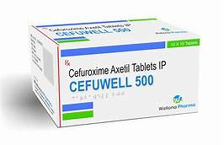

Cefuroxime axetil
Generic Name: Cefuroxime axetil
Trade Name: Zinnat
Mechanism of Action: Second-generation cephalosporin that inhibits bacterial cell wall synthesis.
Indications:
- Urinary tract and genito-urinary infections.
Dosage:
- 250–500 mg twice daily.
Route of Administration: Oral (PO)
Pharmaceutical Preparation: Tablet
Strength: 250 mg and 500 mg
Contraindications:
- Cephalosporin hypersensitivity.
Side Effects:
- Common: Gastrointestinal upset, rash.
Nursing Considerations:
- Assessment: Complete the full course.
Storage Guidelines: Store below 25°C.

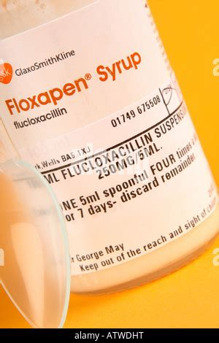

Flucloxacillin
Generic Name: Flucloxacillin
Trade Name: Floxapen
Mechanism of Action: Beta-lactamase-resistant penicillin that inhibits cell wall synthesis in staphylococci.
Indications:
- Skin/soft tissue and genito-urinary infections caused by staphylococci.
Dosage:
- 250–500 mg every 6 hours.
Route of Administration: Oral (PO)
Pharmaceutical Preparation: Capsule
Strength: 250 mg and 500 mg
Contraindications:
- Penicillin hypersensitivity.
Side Effects:
- Uncommon: Cholestatic jaundice (rare with prolonged use).
Nursing Considerations:
- Assessment: Take on an empty stomach.
Storage Guidelines: Store below 25°C.

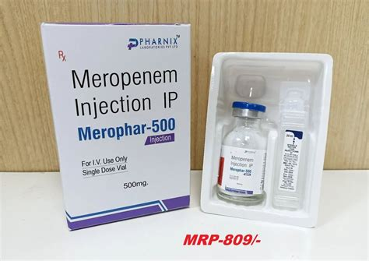

Meropenem
Generic Name: Meropenem
Trade Name: Meronem
Mechanism of Action: Carbapenem beta-lactam antibiotic that inhibits bacterial cell wall synthesis by binding to penicillin-binding proteins.
Indications:
- Severe genito-urinary infections.
Dosage:
- 0.5–1 g every 8 hours intravenously.
Route of Administration: Intravenous
Pharmaceutical Preparation: Powder for injection
Strength: 500 mg and 1 g vial
Contraindications:
- Carbapenem hypersensitivity.
Side Effects:
- Common: Gastrointestinal upset.
- Rare: Seizures.
Nursing Considerations:
- Assessment: Monitor renal function; administer by slow intravenous infusion.
Storage Guidelines: Store below 25°C (reconstituted per BNF).

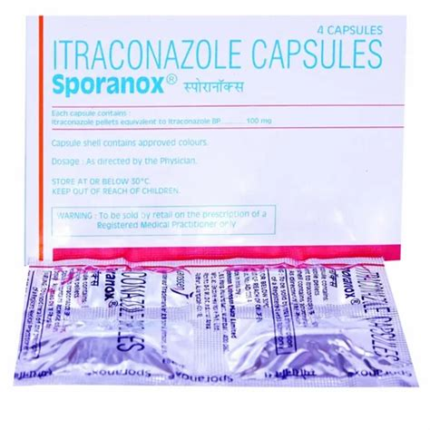

Itraconazole
Generic Name: Itraconazole
Trade Name: Sporanox
Mechanism of Action: Triazole antifungal that inhibits lanosterol 14α-demethylase, disrupting ergosterol synthesis in fungal cell membranes.
Indications:
- Systemic fungal infections (including genito-urinary candidiasis).
Dosage:
- 100–200 mg daily (or twice daily for some indications).
Route of Administration: Oral (PO)
Pharmaceutical Preparation: Capsule
Strength: 100 mg
Contraindications:
- Pregnancy.
- Heart failure (caution).
Side Effects:
- Common: Gastrointestinal upset.
- Uncommon: Hepatotoxicity.
Nursing Considerations:
- Assessment: Take with food or acidic drink; monitor liver function tests.
Storage Guidelines: Store below 25°C.

Diuretics

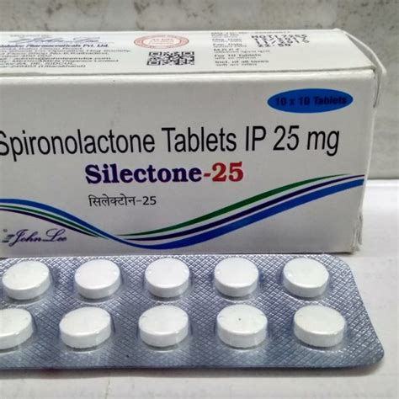

Spironolactone
Generic Name: Spironolactone
Trade Name: Aldactone
Mechanism of Action: Competitive aldosterone antagonist that blocks mineralocorticoid receptors in the distal tubule, promoting sodium and water excretion while sparing potassium.
Indications:
- Oedema in heart failure or ascites.
- Resistant hypertension.
Dosage:
- 25–100 mg daily (higher doses in ascites).
Route of Administration: Oral (PO)
Pharmaceutical Preparation: Tablet
Strength: 25 mg, 50 mg, and 100 mg
Contraindications:
- Hyperkalaemia.
- Addison's disease.
Side Effects:
- Common: Hyperkalaemia.
- Uncommon: Gynaecomastia.
Nursing Considerations:
- Assessment: Monitor electrolytes and renal function regularly.
Storage Guidelines: Store below 25°C.

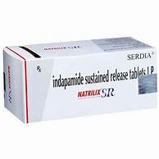

Indapamide
Generic Name: Indapamide
Trade Name: Natrilix SR
Mechanism of Action: Thiazide-like diuretic that inhibits sodium reabsorption in the distal convoluted tubule, increasing urinary sodium and water excretion.
Indications:
- Hypertension.
Dosage:
- 1.5 mg once daily (sustained-release).
Route of Administration: Oral (PO)
Pharmaceutical Preparation: Sustained-release tablet
Strength: 1.5 mg
Contraindications:
- Severe renal impairment.
Side Effects:
- Common: Hypokalaemia, hyponatraemia.
Nursing Considerations:
- Assessment: Monitor electrolytes.
Storage Guidelines: Store below 25°C.



Hydrochlorothiazide
Generic Name: Hydrochlorothiazide
Trade Name: Various (often in combinations)
Mechanism of Action: Thiazide diuretic that inhibits the sodium-chloride symporter in the distal convoluted tubule, promoting natriuresis and diuresis.
Indications:
- Hypertension.
- Oedema.
Dosage:
- 12.5–25 mg daily.
Route of Administration: Oral (PO)
Pharmaceutical Preparation: Tablet
Strength: 12.5 mg and 25 mg
Contraindications:
- Anuria.
- Severe renal impairment.
Side Effects:
- Common: Electrolyte imbalance.
- Uncommon: Photosensitivity.
Nursing Considerations:
- Assessment: Monitor electrolytes and glucose.
Storage Guidelines: Store below 25°C.

Carbonic Anhydrase Inhibitors

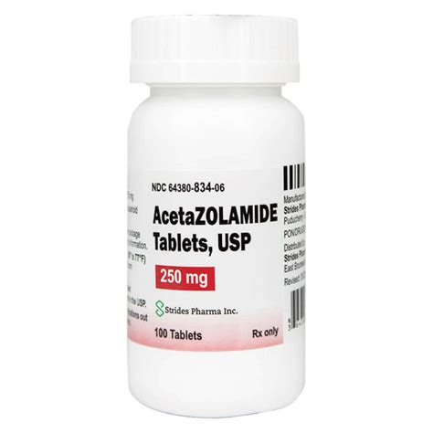

Acetazolamide
Generic Name: Acetazolamide
Trade Name: Diamox
Mechanism of Action: Carbonic anhydrase inhibitor that reduces bicarbonate reabsorption in the proximal tubule, causing diuresis and metabolic acidosis; also reduces intraocular pressure.
Indications:
- Glaucoma.
- Altitude sickness.
- Diuretic use in specific conditions.
Dosage:
- 250–1 000 mg daily in divided doses.
Route of Administration: Oral (PO)
Pharmaceutical Preparation: Tablet
Strength: 250 mg
Contraindications:
- Hypokalaemia.
- Severe renal impairment.
Side Effects:
- Common: Paraesthesia.
- Uncommon: Metabolic acidosis, renal stones.
Nursing Considerations:
- Assessment: Monitor electrolytes and hydration.
Storage Guidelines: Store below 25°C.



Methazolamide
Generic Name: Methazolamide
Trade Name: Methazolamide (generic)
Mechanism of Action: Carbonic anhydrase inhibitor with similar action to acetazolamide but longer duration.
Indications:
- Glaucoma.
Dosage:
- 50–100 mg two to three times daily.
Route of Administration: Oral (PO)
Pharmaceutical Preparation: Tablet
Strength: 50 mg
Contraindications:
- Hypokalaemia.
- Severe renal impairment.
Side Effects:
- Paraesthesia, metabolic acidosis.
Nursing Considerations:
- Assessment: Monitor electrolytes.
Storage Guidelines: Store below 25°C.

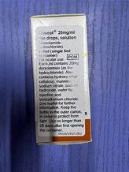

Dorzolamide
Generic Name: Dorzolamide
Trade Name: Trusopt
Mechanism of Action: Topical carbonic anhydrase inhibitor that reduces aqueous humour production, lowering intraocular pressure.
Indications:
- Glaucoma (ocular hypertension).
Dosage:
- 1 drop three times daily.
Route of Administration: Ophthalmic
Pharmaceutical Preparation: Eye drops
Strength: 2% solution
Contraindications:
- Hypersensitivity.
Side Effects:
- Common: Ocular burning.
- Uncommon: Bitter taste.
Nursing Considerations:
- Assessment: Apply correctly; remove contact lenses before use.
Storage Guidelines: Store below 25°C; discard 4 weeks after opening.

Cholinergic Agents



Bethanechol chloride
Generic Name: Bethanechol chloride
Trade Name: Myotonine
Mechanism of Action: Direct muscarinic (cholinergic) agonist that stimulates bladder detrusor muscle contraction and increases ureteric peristalsis.
Indications:
- Non-obstructive urinary retention.
Dosage:
- 10–50 mg three to four times daily.
Route of Administration: Oral (PO)
Pharmaceutical Preparation: Tablet
Strength: 10 mg and 25 mg
Contraindications:
- Asthma.
- Peptic ulcer.
- Bradycardia.
Side Effects:
- Common: Sweating, salivation, abdominal cramps.
Nursing Considerations:
- Assessment: Give on an empty stomach; have atropine available for overdose.
Storage Guidelines: Store below 25°C.

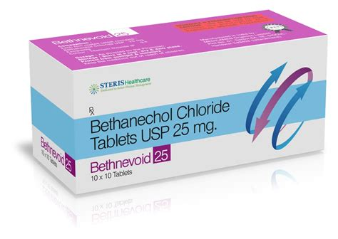

Bethanechol
Generic Name: Bethanechol
Trade Name: Bethanechol (injection form)
Mechanism of Action: Same as oral form — direct muscarinic agonist.
Indications:
- Postoperative urinary retention.
Dosage:
- 2.5–5 mg subcutaneously.
Route of Administration: Subcutaneous
Pharmaceutical Preparation: Injection
Strength: 5 mg/mL
Contraindications:
- Asthma.
- Peptic ulcer.
- Bradycardia.
Side Effects:
- Common: Sweating, salivation, abdominal cramps.
Nursing Considerations:
- Assessment: Same as oral form.
Storage Guidelines: Store below 25°C.

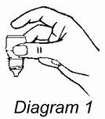

Carbachol
Generic Name: Carbachol
Trade Name: Isopto Carbachol
Mechanism of Action: Cholinergic agonist used topically.
Indications:
- Glaucoma (may aid urinary function in some contexts).
Dosage:
- 1–2 drops up to four times daily.
Route of Administration: Ophthalmic
Pharmaceutical Preparation: Eye drops
Strength: 3% solution
Contraindications:
- Asthma.
- Bradycardia.
Side Effects:
- Ocular irritation.
Nursing Considerations:
- Assessment: Same as bethanechol.
Storage Guidelines: Store below 25°C.

Anticholinergic Drugs

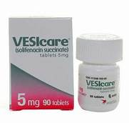

Solifenacin succinate
Generic Name: Solifenacin succinate
Trade Name: Vesicare
Mechanism of Action: Muscarinic receptor antagonist that relaxes detrusor muscle, increasing bladder capacity.
Indications:
- Overactive bladder, urinary incontinence.
Dosage:
- 5–10 mg once daily.
Route of Administration: Oral (PO)
Pharmaceutical Preparation: Tablet
Strength: 5 mg and 10 mg
Contraindications:
- Urinary retention.
- Severe gastrointestinal disease.
- Narrow-angle glaucoma.
Side Effects:
- Common: Dry mouth, constipation.
- Uncommon: Blurred vision.
Nursing Considerations:
- Assessment: Advise on fluid intake; monitor for retention.
Storage Guidelines: Store below 25°C.

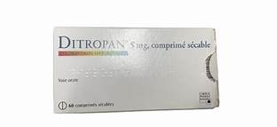

Oxybutynin hydrochloride
Generic Name: Oxybutynin hydrochloride
Trade Name: Ditropan
Mechanism of Action: Antimuscarinic that relaxes detrusor muscle.
Indications:
- Urinary frequency and incontinence.
Dosage:
- 5 mg two to three times daily (modified-release 5–20 mg daily).
Route of Administration: Oral (PO)
Pharmaceutical Preparation: Tablet or modified-release tablet
Strength: 2.5 mg and 5 mg
Contraindications:
- Urinary retention.
- Severe gastrointestinal disease.
- Narrow-angle glaucoma.
Side Effects:
- Common: Dry mouth, constipation.
- Uncommon: Blurred vision.
Nursing Considerations:
- Assessment: Elderly patients are more prone to side effects.
Storage Guidelines: Store below 25°C.



Darifenacin
Generic Name: Darifenacin
Trade Name: Emselex
Mechanism of Action: Selective M3 muscarinic antagonist.
Indications:
- Overactive bladder.
Dosage:
- 7.5–15 mg once daily.
Route of Administration: Oral (PO)
Pharmaceutical Preparation: Modified-release tablet
Strength: 7.5 mg and 15 mg
Contraindications:
- Urinary retention.
- Severe gastrointestinal disease.
- Narrow-angle glaucoma.
Side Effects:
- Dry mouth, constipation.
Nursing Considerations:
- Assessment: Fewer central nervous system effects than non-selective agents.
Storage Guidelines: Store below 25°C.

Adrenergic Antagonists

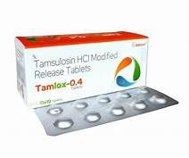

Tamsulosin hydrochloride
Generic Name: Tamsulosin hydrochloride
Trade Name: Flomax
Mechanism of Action: Selective α1A-adrenoceptor antagonist that relaxes prostatic smooth muscle and improves urine flow.
Indications:
- Benign prostatic hyperplasia (lower urinary tract symptoms).
Dosage:
- 400 micrograms once daily.
Route of Administration: Oral (PO)
Pharmaceutical Preparation: Modified-release capsule
Strength: 400 micrograms
Contraindications:
- Orthostatic hypotension history.
Side Effects:
- Common: Dizziness.
- Uncommon: Retrograde ejaculation.
Nursing Considerations:
- Assessment: Take after the same meal; monitor for first-dose hypotension.
Storage Guidelines: Store below 25°C.

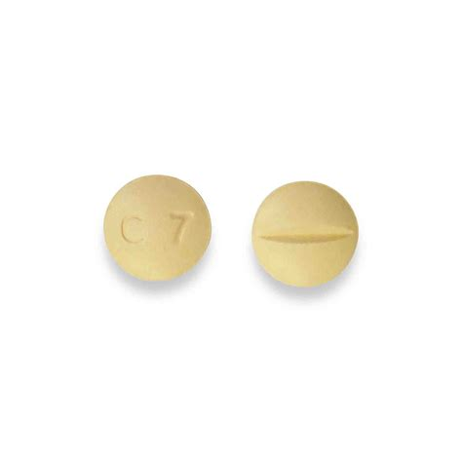

Doxazosin
Generic Name: Doxazosin
Trade Name: Cardura
Mechanism of Action: α1-adrenoceptor antagonist that relaxes prostatic and vascular smooth muscle.
Indications:
- Benign prostatic hyperplasia.
- Hypertension.
Dosage:
- 4–8 mg once daily (modified-release).
Route of Administration: Oral (PO)
Pharmaceutical Preparation: Tablet or modified-release tablet
Strength: 1 mg, 2 mg, 4 mg, and 8 mg
Contraindications:
- Orthostatic hypotension history.
Side Effects:
- Postural hypotension, dizziness.
Nursing Considerations:
- Assessment: Titrate slowly.
Storage Guidelines: Store below 25°C.

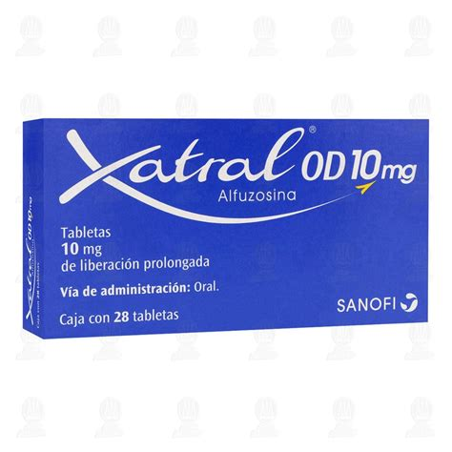

Alfuzosin
Generic Name: Alfuzosin
Trade Name: Xatral
Mechanism of Action: α1-adrenoceptor antagonist.
Indications:
- Benign prostatic hyperplasia.
Dosage:
- 10 mg once daily (modified-release).
Route of Administration: Oral (PO)
Pharmaceutical Preparation: Prolonged-release tablet
Strength: 10 mg
Contraindications:
- Orthostatic hypotension history.
Side Effects:
- Postural hypotension, dizziness.
Nursing Considerations:
- Assessment: Same as tamsulosin.
Storage Guidelines: Store below 25°C.

Antidiuretic Hormones

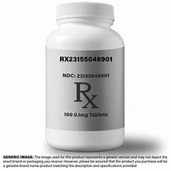

Desmopressin acetate
Generic Name: Desmopressin acetate
Trade Name: DDAVP or DesmoMelt
Mechanism of Action: Synthetic vasopressin analogue that increases water reabsorption in the kidneys by acting on V2 receptors.
Indications:
- Diabetes insipidus.
- Nocturnal enuresis.
Dosage:
- 0.1–0.2 mg three times daily (oral) or 10–40 micrograms intranasally.
Route of Administration: Oral, intranasal, or sublingual
Pharmaceutical Preparation: Tablet, melt, or oral solution
Strength: 0.1 mg and 0.2 mg tablets
Contraindications:
- Hyponatraemia.
- Cardiac failure.
Side Effects:
- Common: Headache.
- Uncommon: Hyponatraemia, fluid retention.
Nursing Considerations:
- Assessment: Monitor serum sodium; restrict fluid intake.
Storage Guidelines: Store below 25°C.

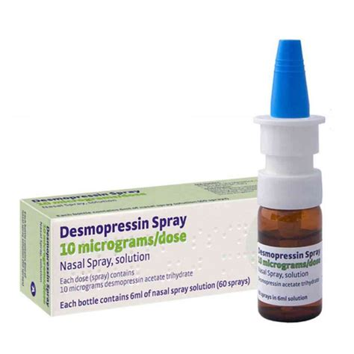

Desmopressin
Generic Name: Desmopressin
Trade Name: Desmopressin nasal spray
Mechanism of Action: Same as tablet form — synthetic vasopressin analogue acting on V2 receptors.
Indications:
- Diabetes insipidus, nocturia.
Dosage:
- 10–40 micrograms daily.
Route of Administration: Intranasal
Pharmaceutical Preparation: Nasal spray
Strength: 10 micrograms per spray
Contraindications:
- Hyponatraemia.
- Cardiac failure.
Side Effects:
- Common: Headache.
- Uncommon: Hyponatraemia, fluid retention.
Nursing Considerations:
- Assessment: Monitor serum sodium; restrict fluid intake.
Storage Guidelines: Store below 25°C. Protect from light.

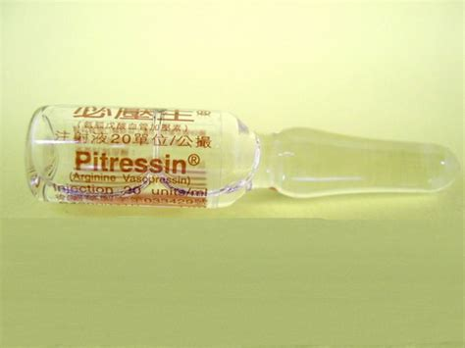

Vasopressin (ADH)
Generic Name: Vasopressin (ADH)
Trade Name: Pitressin
Mechanism of Action: Vasopressin receptor agonist.
Indications:
- Diabetes insipidus (parenteral use).
Dosage:
- 5–20 units intramuscularly or subcutaneously every 4 hours.
Route of Administration: Intramuscular or subcutaneous
Pharmaceutical Preparation: Injection
Strength: 20 units/mL
Contraindications:
- Coronary artery disease.
Side Effects:
- Hypertension, abdominal cramps.
Nursing Considerations:
- Assessment: Monitor for vasoconstriction.
Storage Guidelines: Refrigerate.

Urinary Alkalizers



Potassium citrate
Generic Name: Potassium citrate
Trade Name: Potassium Citrate Mixture BP
Mechanism of Action: Alkalinises urine by increasing bicarbonate excretion.
Indications:
- Urinary tract discomfort, cystitis.
Dosage:
- 10–20 mL three times daily, diluted.
Route of Administration: Oral
Pharmaceutical Preparation: Oral solution
Strength: 1.5 g/5 mL equivalent
Contraindications:
- Hyperkalaemia.
- Renal impairment.
Side Effects:
- Common: Gastrointestinal upset.
- Uncommon: Hyperkalaemia.
Nursing Considerations:
- Assessment: Monitor electrolytes; dilute well.
Storage Guidelines: Store below 25°C.

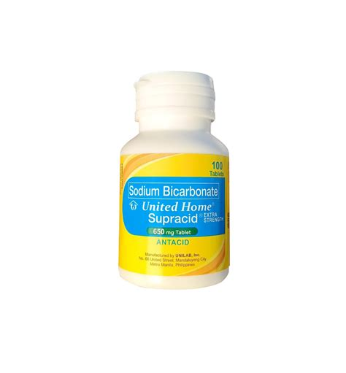

Sodium bicarbonate
Generic Name: Sodium bicarbonate
Trade Name: Sodium Bicarbonate
Mechanism of Action: Urinary alkaliser.
Indications:
- Urinary alkalinisation.
Dosage:
- 1–5 g daily in divided doses.
Route of Administration: Oral
Pharmaceutical Preparation: Tablets or powder
Strength: 600 mg tablets
Contraindications:
- Metabolic alkalosis.
- Sodium retention.
Side Effects:
- Flatulence, sodium overload.
Nursing Considerations:
- Assessment: Monitor acid-base balance.
Storage Guidelines: Store below 25°C.

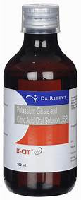

Citric acid + potassium citrate
Generic Name: Citric acid + potassium citrate
Trade Name: Effercitrate or similar
Mechanism of Action: Urinary alkaliser.
Indications:
- Urinary tract discomfort.
Dosage:
- 1–2 sachets two to three times daily.
Route of Administration: Oral (dissolved)
Pharmaceutical Preparation: Effervescent granules
Strength: Equivalent to 3 g potassium citrate
Contraindications:
- Hyperkalaemia.
- Renal impairment.
Side Effects:
- Gastrointestinal upset.
Nursing Considerations:
- Assessment: Monitor electrolytes.
Storage Guidelines: Store below 25°C in airtight container.

Medication for Urinary Incontinence

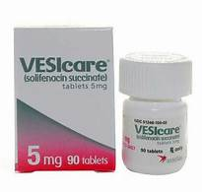

Solifenacin succinate
Generic Name: Solifenacin succinate
Trade Name: Vesicare
Mechanism of Action: Muscarinic receptor antagonist that relaxes detrusor muscle.
Indications:
- Overactive bladder, urge incontinence.
Dosage:
- 5–10 mg once daily.
Route of Administration: Oral (PO)
Pharmaceutical Preparation: Tablet
Strength: 5 mg and 10 mg
Contraindications:
- Urinary retention.
- Severe gastrointestinal disease.
Side Effects:
- Common: Dry mouth, constipation.
Nursing Considerations:
- Assessment: Monitor residual urine volume.
Storage Guidelines: Store below 25°C.



Oxybutynin
Generic Name: Oxybutynin
Trade Name: Ditropan
Mechanism of Action: Antimuscarinic.
Indications:
- Urinary frequency and incontinence.
Dosage:
- 5 mg two to three times daily.
Route of Administration: Oral (PO)
Pharmaceutical Preparation: Tablet
Strength: 2.5 mg and 5 mg
Contraindications:
- Urinary retention.
- Severe gastrointestinal disease.
- Narrow-angle glaucoma.
Side Effects:
- Common: Dry mouth, constipation.
Nursing Considerations:
- Assessment: Same as above.
Storage Guidelines: Store below 25°C.

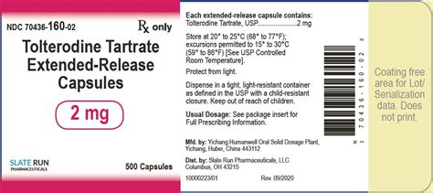

Tolterodine tartrate
Generic Name: Tolterodine tartrate
Trade Name: Detrusitol
Mechanism of Action: Antimuscarinic.
Indications:
- Overactive bladder.
Dosage:
- 2 mg twice daily (or 4 mg modified-release once daily).
Route of Administration: Oral (PO)
Pharmaceutical Preparation: Tablet or modified-release tablet
Strength: 1 mg and 2 mg
Contraindications:
- Urinary retention.
- Severe gastrointestinal disease.
- Narrow-angle glaucoma.
Side Effects:
- Dry mouth, headache.
Nursing Considerations:
- Assessment: Same as solifenacin.
Storage Guidelines: Store below 25°C.

Miscellaneous Renal Drugs

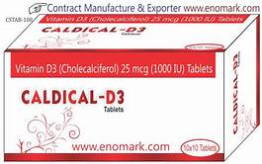

Cholecalciferol (Vitamin D3)
Generic Name: Cholecalciferol (Vitamin D3)
Trade Name: Deplus (2000 IU or Forte)
Mechanism of Action: Increases intestinal calcium absorption and regulates bone and mineral metabolism.
Indications:
- Vitamin D deficiency.
- Osteoporosis.
- Renal bone disease.
Dosage:
- 1000–2000 IU daily (or as prescribed).
Route of Administration: Oral (PO)
Pharmaceutical Preparation: Tablet
Strength: 1000 IU and 2000 IU
Contraindications:
- Hypercalcaemia.
Side Effects:
- Hypercalcaemia (rare at standard doses).
Nursing Considerations:
- Assessment: Monitor serum calcium and phosphate in renal patients.
Storage Guidelines: Store below 25°C.

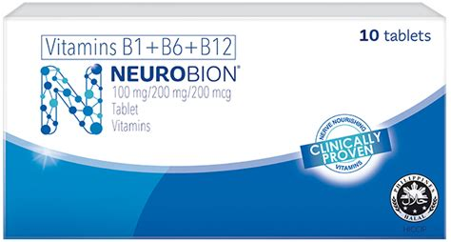

Vitamin B1 (thiamine) + B6 (pyridoxine) + B12 (cyanocobalamin)
Generic Name: Vitamin B1 (thiamine) + B6 (pyridoxine) + B12 (cyanocobalamin)
Trade Name: Neurobion or generic B-complex
Mechanism of Action: Essential cofactors for nerve function and energy metabolism.
Indications:
- B-vitamin deficiency.
- Neuropathy.
Dosage:
- 1 tablet daily.
Route of Administration: Oral (PO)
Pharmaceutical Preparation: Tablet
Strength: Standard B1 100 mg + B6 200 mg + B12 200 micrograms (typical)
Contraindications:
- Hypersensitivity (rare).
Side Effects:
- None common at therapeutic doses.
Nursing Considerations:
- Assessment: Assess for deficiency symptoms.
Storage Guidelines: Store below 25°C.



Vitamin E (alpha-tocopherol)
Generic Name: Vitamin E (alpha-tocopherol)
Trade Name: Various
Mechanism of Action: Antioxidant that protects cell membranes.
Indications:
- Vitamin E deficiency.
- Antioxidant support.
Dosage:
- 400–800 IU daily.
Route of Administration: Oral (PO)
Pharmaceutical Preparation: Capsule
Strength: 400 IU
Contraindications:
- None major.
Side Effects:
- Gastrointestinal upset (high doses).
Nursing Considerations:
- Assessment: Monitor bleeding risk with anticoagulants.
Storage Guidelines: Store below 25°C.

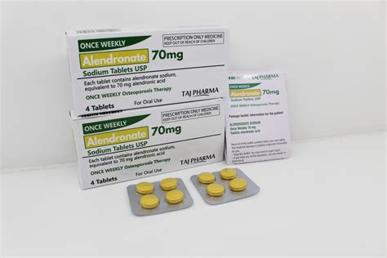

Alendronate sodium
Generic Name: Alendronate sodium
Trade Name: Fosamax
Mechanism of Action: Bisphosphonate that inhibits osteoclast-mediated bone resorption.
Indications:
- Osteoporosis.
- Renal bone disease.
Dosage:
- 70 mg once weekly.
Route of Administration: Oral (PO)
Pharmaceutical Preparation: Tablet
Strength: 70 mg
Contraindications:
- Oesophageal disorders.
- Inability to sit upright for 30 minutes.
Side Effects:
- Common: Oesophageal irritation.
- Uncommon: Hypocalcaemia.
Nursing Considerations:
- Assessment: Take on an empty stomach with water; remain upright for 30 minutes.
Storage Guidelines: Store below 25°C.

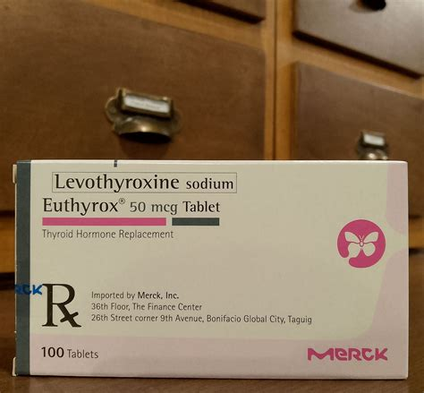

Levothyroxine sodium
Generic Name: Levothyroxine sodium
Trade Name: Euthyrox
Mechanism of Action: Thyroid hormone replacement.
Indications:
- Hypothyroidism (common in renal disease).
Dosage:
- 50–200 micrograms once daily.
Route of Administration: Oral (PO)
Pharmaceutical Preparation: Tablet
Strength: 25–200 micrograms
Contraindications:
- Thyrotoxicosis.
- Acute myocardial infarction.
Side Effects:
- Common: Tachycardia (over-replacement).
- Uncommon: Weight loss.
Nursing Considerations:
- Assessment: Take on an empty stomach; monitor TSH.
Storage Guidelines: Store below 25°C.

Chapter 3: Respiratory System

Antihistamines

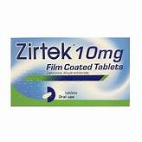

Cetirizine hydrochloride
Generic Name: Cetirizine hydrochloride
Trade Name: Zirtek
Mechanism of Action: Selective H1-receptor antagonist that blocks the action of histamine on H1 receptors, reducing allergic symptoms.
Indications:
- Allergic rhinitis.
- Urticaria.
Dosage:
- 10 mg once daily.
Route of Administration: Oral (PO)
Pharmaceutical Preparation: Tablet
Strength: 10 mg
Contraindications:
- Severe renal impairment (dose adjustment required).
Side Effects:
- Common: Mild drowsiness, dry mouth.
Nursing Considerations:
- Assessment: Non-sedating at standard dose.
Storage Guidelines: Store below 25°C.

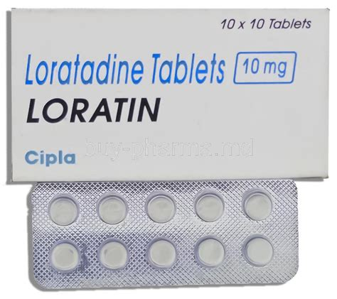

Loratadine
Generic Name: Loratadine
Trade Name: Clarityn
Mechanism of Action: Non-sedating H1-antagonist that blocks histamine H1 receptors.
Indications:
- Allergic rhinitis.
- Urticaria.
Dosage:
- 10 mg once daily.
Route of Administration: Oral (PO)
Pharmaceutical Preparation: Tablet
Strength: 10 mg
Contraindications:
- None major.
Side Effects:
- Common: Headache.
- Rare: Drowsiness.
Nursing Considerations:
- Assessment: Suitable for daytime use.
Storage Guidelines: Store below 25°C.



Chlorpheniramine maleate
Generic Name: Chlorpheniramine maleate
Trade Name: Piriton
Mechanism of Action: Sedating H1-antagonist that blocks histamine H1 receptors and has anticholinergic effects.
Indications:
- Allergic conditions.
Dosage:
- 4 mg every 4–6 hours.
Route of Administration: Oral (PO)
Pharmaceutical Preparation: Tablet
Strength: 4 mg
Contraindications:
- Narrow-angle glaucoma.
Side Effects:
- Common: Drowsiness, anticholinergic effects.
Nursing Considerations:
- Assessment: Warn about sedation and driving.
Storage Guidelines: Store below 25°C.

Anti-asthmatics

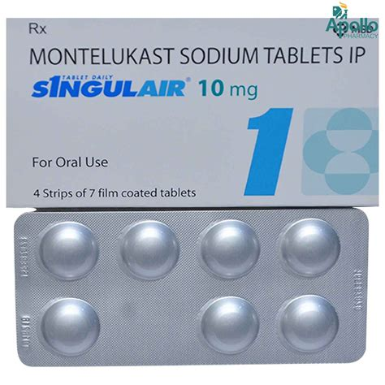

Montelukast
Generic Name: Montelukast
Trade Name: Singulair
Mechanism of Action: Leukotriene receptor antagonist that blocks the action of cysteinyl leukotrienes, reducing airway inflammation and bronchoconstriction.
Indications:
- Asthma prophylaxis.
- Allergic rhinitis.
Dosage:
- 10 mg once daily (evening).
Route of Administration: Oral (PO)
Pharmaceutical Preparation: Tablet or chewable tablet
Strength: 10 mg
Contraindications:
- None major.
Side Effects:
- Common: Headache, upper respiratory infection.
Nursing Considerations:
- Assessment: Not for acute asthma attack.
Storage Guidelines: Store below 25°C.



Sodium cromoglicate
Generic Name: Sodium cromoglicate
Trade Name: Intal
Mechanism of Action: Mast-cell stabiliser that prevents the release of inflammatory mediators.
Indications:
- Allergic asthma.
Dosage:
- 10 mg inhaled four times daily.
Route of Administration: Inhalation
Pharmaceutical Preparation: Aerosol inhaler
Strength: 5 mg per actuation
Contraindications:
- None major.
Side Effects:
- Common: Cough, throat irritation.
Nursing Considerations:
- Assessment: Use regularly; not for acute relief.
Storage Guidelines: Store below 25°C.

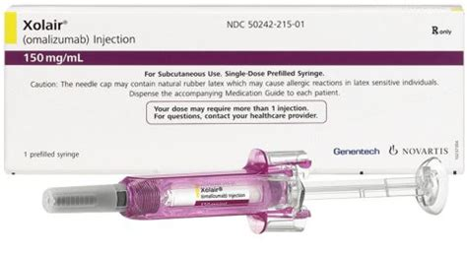

Omalizumab
Generic Name: Omalizumab
Trade Name: Xolair
Mechanism of Action: Anti-IgE monoclonal antibody that binds free IgE, preventing it from attaching to mast cells and basophils.
Indications:
- Severe allergic asthma.
Dosage:
- 150–375 mg subcutaneously every 2–4 weeks (weight/IgE based).
Route of Administration: Subcutaneous
Pharmaceutical Preparation: Pre-filled syringe
Strength: 150 mg
Contraindications:
- Hypersensitivity.
Side Effects:
- Common: Injection-site reactions.
Nursing Considerations:
- Assessment: Specialist initiation only.
Storage Guidelines: Refrigerate.

Bronchodilators

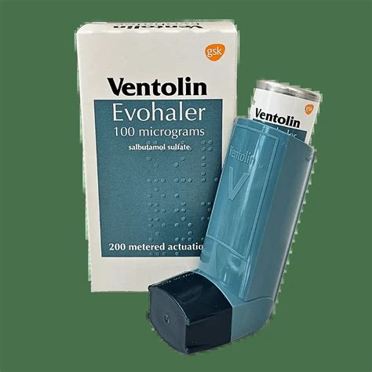

Salbutamol
Generic Name: Salbutamol
Trade Name: Ventolin
Mechanism of Action: Selective β2-agonist that relaxes bronchial smooth muscle by increasing cyclic AMP.
Indications:
- Asthma.
- Chronic obstructive pulmonary disease.
Dosage:
- 100–200 micrograms inhaled as needed (maximum 8 puffs daily).
Route of Administration: Inhalation
Pharmaceutical Preparation: Metered-dose inhaler
Strength: 100 micrograms per actuation
Contraindications:
- None major.
Side Effects:
- Common: Tremor, tachycardia.
Nursing Considerations:
- Assessment: Use spacer if technique is poor.
Storage Guidelines: Store below 25°C.

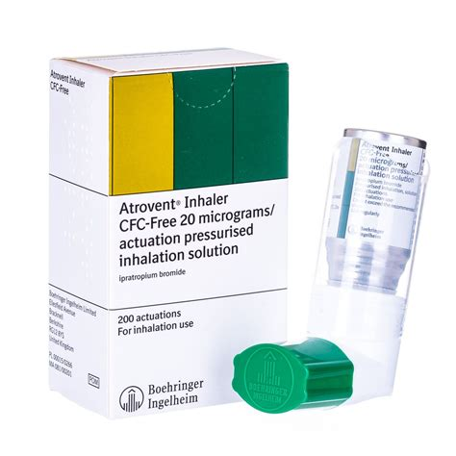

Ipratropium bromide
Generic Name: Ipratropium bromide
Trade Name: Atrovent
Mechanism of Action: Short-acting muscarinic antagonist that relaxes bronchial smooth muscle.
Indications:
- Asthma.
- Chronic obstructive pulmonary disease.
Dosage:
- 20–40 micrograms inhaled three to four times daily.
Route of Administration: Inhalation
Pharmaceutical Preparation: Metered-dose inhaler
Strength: 20 micrograms per actuation
Contraindications:
- None major.
Side Effects:
- Common: Dry mouth.
- Uncommon: Urinary retention.
Nursing Considerations:
- Assessment: May be combined with a β2-agonist.
Storage Guidelines: Store below 25°C.

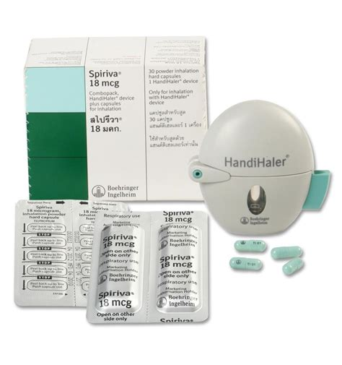

Tiotropium
Generic Name: Tiotropium
Trade Name: Spiriva
Mechanism of Action: Long-acting muscarinic antagonist that provides sustained bronchodilation.
Indications:
- Chronic obstructive pulmonary disease.
Dosage:
- 18 micrograms once daily (HandiHaler) or 2.5 micrograms two puffs (Respimat).
Route of Administration: Inhalation
Pharmaceutical Preparation: Dry-powder capsule or soft-mist inhaler
Strength: 18 micrograms capsule or 2.5 micrograms
Contraindications:
- None major.
Side Effects:
- Common: Dry mouth.
Nursing Considerations:
- Assessment: Once-daily maintenance.
Storage Guidelines: Store below 25°C.

Decongestants

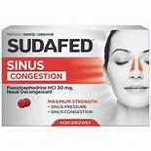

Pseudoephedrine hydrochloride
Generic Name: Pseudoephedrine hydrochloride
Trade Name: Sudafed
Mechanism of Action: α1-agonist that causes vasoconstriction of nasal mucosa.
Indications:
- Nasal congestion.
Dosage:
- 60 mg every 4–6 hours (maximum 240 mg daily).
Route of Administration: Oral (PO)
Pharmaceutical Preparation: Tablet
Strength: 60 mg
Contraindications:
- Severe hypertension.
- Ischaemic heart disease.
Side Effects:
- Common: Insomnia, tachycardia.
- Uncommon: Hypertension.
Nursing Considerations:
- Assessment: Limit duration to 5–7 days.
Storage Guidelines: Store below 25°C.



Phenylephrine
Generic Name: Phenylephrine
Trade Name: Various nasal sprays
Mechanism of Action: α1-agonist.
Indications:
- Nasal congestion.
Dosage:
- 2–3 sprays per nostril every 4 hours.
Route of Administration: Nasal
Pharmaceutical Preparation: Nasal spray
Strength: 0.5% solution
Contraindications:
- Severe hypertension.
- Ischaemic heart disease.
Side Effects:
- Common: Rebound congestion if prolonged.
Nursing Considerations:
- Assessment: Short-term use only.
Storage Guidelines: Store below 25°C.

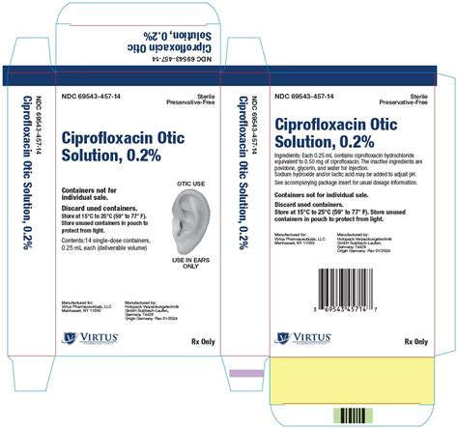

Xylometazoline
Generic Name: Xylometazoline
Trade Name: Otrivine
Mechanism of Action: α-agonist decongestant.
Indications:
- Nasal congestion.
Dosage:
- 2–3 drops per nostril two to three times daily.
Route of Administration: Nasal
Pharmaceutical Preparation: Nasal drops or spray
Strength: 0.1% solution
Contraindications:
- Severe hypertension.
- Ischaemic heart disease.
Side Effects:
- Common: Rebound congestion if prolonged.
Nursing Considerations:
- Assessment: Short-term use only.
Storage Guidelines: Store below 25°C.

Expectorants

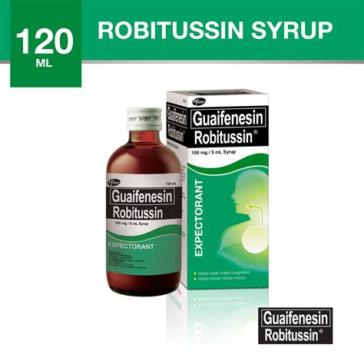

Guaifenesin
Generic Name: Guaifenesin
Trade Name: Robitussin (or generic)
Mechanism of Action: Increases respiratory tract fluid volume and reduces mucus viscosity.
Indications:
- Productive cough.
Dosage:
- 200–400 mg every 4 hours.
Route of Administration: Oral (PO)
Pharmaceutical Preparation: Tablet or syrup
Strength: 200 mg tablets
Contraindications:
- None major.
Side Effects:
- Gastrointestinal upset.
Nursing Considerations:
- Assessment: Encourage hydration.
Storage Guidelines: Store below 25°C.

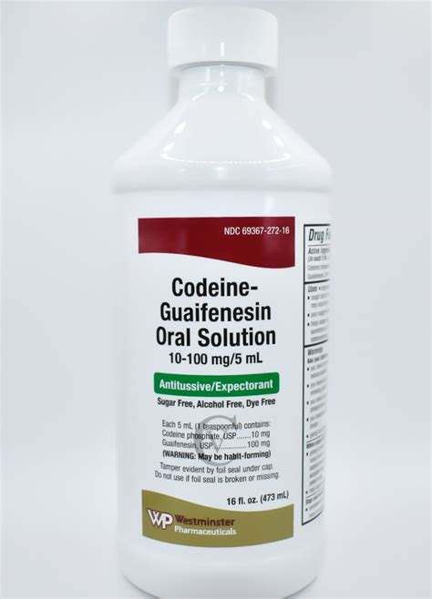

Guaifenesin
Generic Name: Guaifenesin
Trade Name: Various expectorant syrups
Mechanism of Action: Same as tablets — increases respiratory tract fluid volume and reduces mucus viscosity.
Indications:
- Productive cough.
Dosage:
- 100–200 mg every 4 hours (syrup).
Route of Administration: Oral
Pharmaceutical Preparation: Oral solution
Strength: 100 mg/5 mL
Contraindications:
- None major.
Side Effects:
- Gastrointestinal upset.
Nursing Considerations:
- Assessment: Encourage hydration.
Storage Guidelines: Store below 25°C.



Potassium iodide
Generic Name: Potassium iodide
Trade Name: Potassium Iodide Solution
Mechanism of Action: Traditional expectorant.
Indications:
- Productive cough.
Dosage:
- 0.3–1 mL diluted three times daily.
Route of Administration: Oral
Pharmaceutical Preparation: Oral solution
Strength: 1 g/10 mL
Contraindications:
- Hyperthyroidism.
Side Effects:
- Iodism (metallic taste, rash).
Nursing Considerations:
- Assessment: Short-term use.
Storage Guidelines: Store below 25°C.

Mucolytics

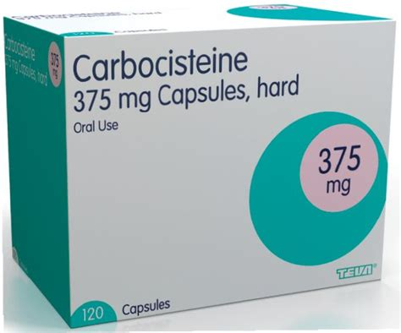

Carbocisteine
Generic Name: Carbocisteine
Trade Name: Mucodyne
Mechanism of Action: Reduces mucus viscosity by breaking disulphide bonds.
Indications:
- Chronic obstructive pulmonary disease with productive cough.
Dosage:
- 750 mg three times daily, then 750 mg twice daily.
Route of Administration: Oral (PO)
Pharmaceutical Preparation: Capsule
Strength: 375 mg
Contraindications:
- Active peptic ulcer.
Side Effects:
- Common: Gastrointestinal upset.
- Uncommon: Rash.
Nursing Considerations:
- Assessment: Review after 4 weeks.
Storage Guidelines: Store below 25°C.

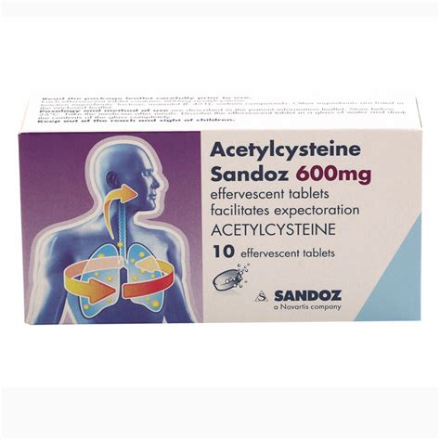

Acetylcysteine
Generic Name: Acetylcysteine
Trade Name: Fluimucil
Mechanism of Action: Mucolytic that breaks disulphide bonds.
Indications:
- Viscid mucus in respiratory disease.
Dosage:
- 200 mg three times daily.
Route of Administration: Oral
Pharmaceutical Preparation: Effervescent sachets
Strength: 200 mg
Contraindications:
- None major.
Side Effects:
- Gastrointestinal upset.
Nursing Considerations:
- Assessment: Dissolve in water.
Storage Guidelines: Store below 25°C.

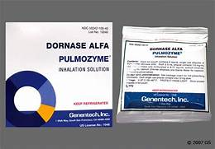

Dornase alfa
Generic Name: Dornase alfa
Trade Name: Pulmozyme
Mechanism of Action: Recombinant DNase that degrades DNA in sputum.
Indications:
- Cystic fibrosis.
Dosage:
- 2.5 mg nebulised once daily.
Route of Administration: Inhalation (nebuliser)
Pharmaceutical Preparation: Nebuliser solution
Strength: 2.5 mg/2.5 mL ampoule
Contraindications:
- None major.
Side Effects:
- Common: Voice alteration.
- Uncommon: Rash.
Nursing Considerations:
- Assessment: Specialist use only.
Storage Guidelines: Refrigerate.

Steroids (Inhaled)

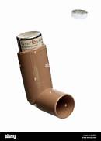

Beclometasone dipropionate
Generic Name: Beclometasone dipropionate
Trade Name: Clenil or Qvar
Mechanism of Action: Corticosteroid that reduces airway inflammation by inhibiting inflammatory mediator release.
Indications:
- Asthma prophylaxis.
Dosage:
- 200–400 micrograms twice daily (adjust per device).
Route of Administration: Inhalation
Pharmaceutical Preparation: Metered-dose inhaler
Strength: 50, 100, 250 micrograms per actuation
Contraindications:
- None major for inhaled use.
Side Effects:
- Common: Oral candidiasis, hoarseness.
Nursing Considerations:
- Assessment: Rinse mouth after use; use spacer.
Storage Guidelines: Store below 25°C.

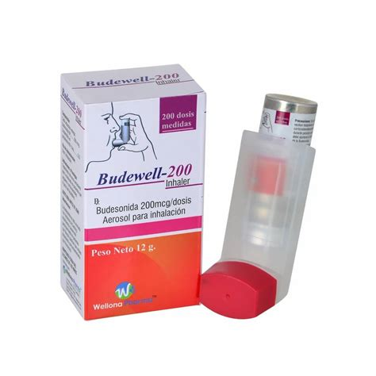

Budesonide
Generic Name: Budesonide
Trade Name: Pulmicort
Mechanism of Action: Inhaled corticosteroid.
Indications:
- Asthma.
- Chronic obstructive pulmonary disease.
Dosage:
- 200–800 micrograms twice daily.
Route of Administration: Inhalation
Pharmaceutical Preparation: Turbohaler or nebuliser
Strength: 100, 200, 400 micrograms
Contraindications:
- None major.
Side Effects:
- Common: Oral candidiasis, hoarseness.
Nursing Considerations:
- Assessment: Rinse mouth after use; use spacer.
Storage Guidelines: Store below 25°C.

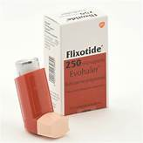

Fluticasone propionate
Generic Name: Fluticasone propionate
Trade Name: Flixotide
Mechanism of Action: Inhaled corticosteroid.
Indications:
- Asthma.
Dosage:
- 100–1 000 micrograms twice daily.
Route of Administration: Inhalation
Pharmaceutical Preparation: Accuhaler or inhaler
Strength: 50–500 micrograms
Contraindications:
- None major.
Side Effects:
- Common: Oral candidiasis, hoarseness.
Nursing Considerations:
- Assessment: Rinse mouth after use; use spacer.
Storage Guidelines: Store below 25°C.

Respiratory Miscellaneous Drugs

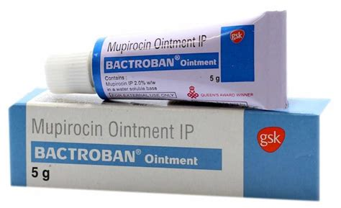

Mupirocin
Generic Name: Mupirocin
Trade Name: Bactroban
Mechanism of Action: Inhibits bacterial protein synthesis.
Indications:
- Bacterial skin infections (may be used in respiratory tract entry sites).
Dosage:
- Apply thinly three times daily.
Route of Administration: Topical
Pharmaceutical Preparation: Ointment
Strength: 2% w/w
Contraindications:
- Hypersensitivity.
Side Effects:
- Local irritation.
Nursing Considerations:
- Assessment: Apply to clean dry skin; avoid eyes.
Storage Guidelines: Store below 25°C.

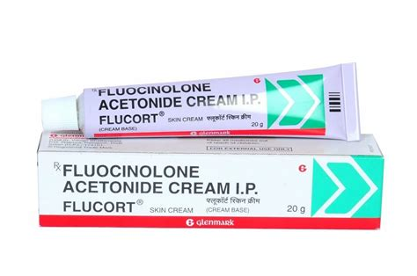

Fluocinolone acetonide + miconazole nitrate
Generic Name: Fluocinolone acetonide + miconazole nitrate
Trade Name: Various combination creams
Mechanism of Action: Corticosteroid (anti-inflammatory) + imidazole antifungal.
Indications:
- Inflamed fungal skin infections (may include respiratory-related dermatitis).
Dosage:
- Apply thinly one to two times daily.
Route of Administration: Topical
Pharmaceutical Preparation: Ointment or cream
Strength: Fluocinolone 0.025% + miconazole 2%
Contraindications:
- Viral skin infections.
Side Effects:
- Skin atrophy (prolonged use).
Nursing Considerations:
- Assessment: Short-term use; avoid face if possible.
Storage Guidelines: Store below 25°C.

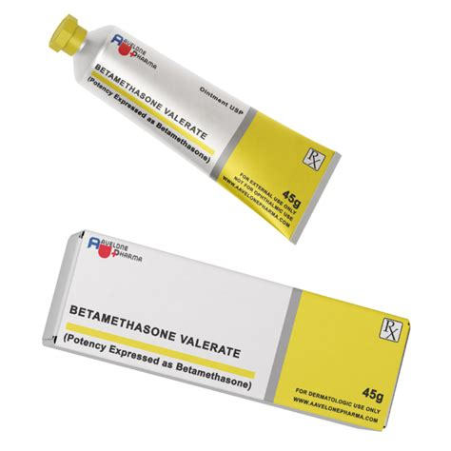

Betamethasone valerate
Generic Name: Betamethasone valerate
Trade Name: Betnovate
Mechanism of Action: Potent topical corticosteroid.
Indications:
- Inflammatory skin conditions.
Dosage:
- Apply thinly one to two times daily.
Route of Administration: Topical
Pharmaceutical Preparation: Cream
Strength: 0.1%
Contraindications:
- Untreated infection.
Side Effects:
- Skin thinning.
Nursing Considerations:
- Assessment: Use lowest strength and shortest duration.
Storage Guidelines: Store below 25°C.

Chapter 4: Gastrointestinal Tract

Antacids



Magnesium trisilicate
Generic Name: Magnesium trisilicate
Trade Name: Magnesium Trisilicate Mixture BP
Mechanism of Action: Neutralises gastric acid.
Indications:
- Dyspepsia.
- Heartburn.
Dosage:
- 10–20 mL as required.
Route of Administration: Oral
Pharmaceutical Preparation: Oral suspension
Strength: Standard mixture
Contraindications:
- Severe renal impairment.
Side Effects:
- Common: Diarrhoea (magnesium), constipation (aluminium).
Nursing Considerations:
- Assessment: Give after meals.
Storage Guidelines: Store below 25°C.

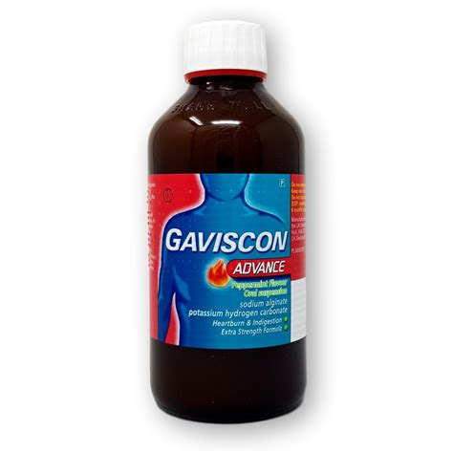

Sodium alginate + potassium bicarbonate
Generic Name: Sodium alginate + potassium bicarbonate
Trade Name: Gaviscon Advance
Mechanism of Action: Forms a raft on gastric contents to prevent reflux.
Indications:
- Reflux.
- Heartburn.
Dosage:
- 5–10 mL after meals and at bedtime.
Route of Administration: Oral
Pharmaceutical Preparation: Oral suspension
Strength: Standard
Contraindications:
- None major.
Side Effects:
- None common.
Nursing Considerations:
- Assessment: Low-sodium formulation available.
Storage Guidelines: Store below 25°C.



Aluminum hydroxide
Generic Name: Aluminum hydroxide
Trade Name: Alu-Cap or generic
Mechanism of Action: Antacid.
Indications:
- Dyspepsia.
Dosage:
- 500 mg–1 g as required.
Route of Administration: Oral
Pharmaceutical Preparation: Capsule
Strength: 500 mg
Contraindications:
- Hypophosphataemia.
Side Effects:
- Constipation.
Nursing Considerations:
- Assessment: May bind other drugs.
Storage Guidelines: Store below 25°C.

Antidiarrhoeals

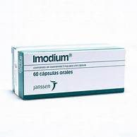

Loperamide hydrochloride
Generic Name: Loperamide hydrochloride
Trade Name: Imodium
Mechanism of Action: Opioid receptor agonist that slows gut motility.
Indications:
- Acute diarrhoea.
Dosage:
- 4 mg initially then 2 mg after each loose stool (maximum 16 mg daily).
Route of Administration: Oral (PO)
Pharmaceutical Preparation: Capsule
Strength: 2 mg
Contraindications:
- Acute ulcerative colitis.
- Dysentery.
Side Effects:
- Common: Constipation, abdominal cramps.
Nursing Considerations:
- Assessment: Rehydrate the patient; not for children under 4 years.
Storage Guidelines: Store below 25°C.

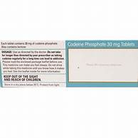

Codeine phosphate
Generic Name: Codeine phosphate
Trade Name: Codeine
Mechanism of Action: Opioid that reduces peristalsis.
Indications:
- Acute diarrhoea.
Dosage:
- 30 mg up to four times daily.
Route of Administration: Oral (PO)
Pharmaceutical Preparation: Tablet
Strength: 15 mg and 30 mg
Contraindications:
- Respiratory depression.
Side Effects:
- Common: Constipation, drowsiness.
Nursing Considerations:
- Assessment: Controlled drug; monitor respiration.
Storage Guidelines: Store below 25°C.

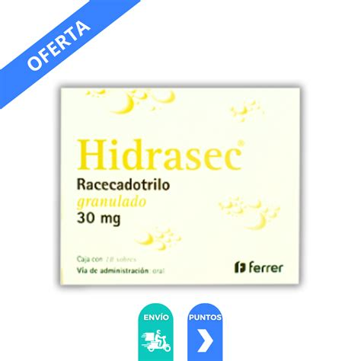

Racecadotril
Generic Name: Racecadotril
Trade Name: Hidrasec
Mechanism of Action: Enkephalinase inhibitor that reduces intestinal secretion.
Indications:
- Acute diarrhoea.
Dosage:
- 100 mg three times daily.
Route of Administration: Oral (PO)
Pharmaceutical Preparation: Capsule
Strength: 100 mg
Contraindications:
- None major.
Side Effects:
- Headache.
Nursing Considerations:
- Assessment: Adjunct to rehydration.
Storage Guidelines: Store below 25°C.

Digestive Enzymes

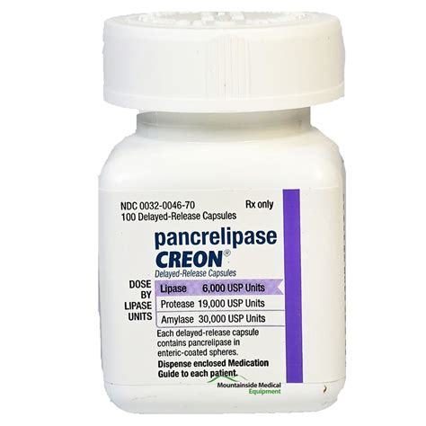

Pancreatin
Generic Name: Pancreatin
Trade Name: Creon
Mechanism of Action: Replaces pancreatic enzymes (lipase, amylase, protease).
Indications:
- Pancreatic insufficiency.
- Cystic fibrosis.
Dosage:
- 1–2 capsules with each meal (adjust per fat intake).
Route of Administration: Oral (PO)
Pharmaceutical Preparation: Gastro-resistant capsule
Strength: 10 000, 25 000 lipase units
Contraindications:
- None major.
Side Effects:
- Common: Abdominal discomfort.
- Uncommon: Hyperuricaemia.
Nursing Considerations:
- Assessment: Take with food; do not crush.
Storage Guidelines: Store below 25°C.

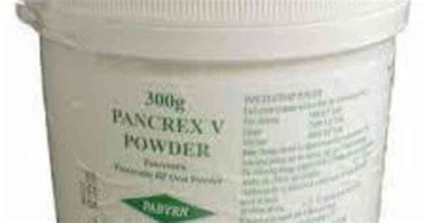

Pancreatin
Generic Name: Pancreatin
Trade Name: Pancrex
Mechanism of Action: Replaces pancreatic enzymes (lipase, amylase, protease).
Indications:
- Pancreatic insufficiency.
- Cystic fibrosis.
Dosage:
- 1–2 sachets with meals.
Route of Administration: Oral (sprinkled)
Pharmaceutical Preparation: Granules
Strength: Variable enzyme units
Contraindications:
- None major.
Side Effects:
- Abdominal discomfort.
Nursing Considerations:
- Assessment: Take with food.
Storage Guidelines: Store below 25°C.

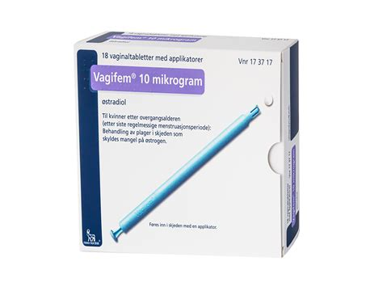

Simeticone
Generic Name: Simeticone
Trade Name: Infacol or generic
Mechanism of Action: Reduces surface tension of gas bubbles.
Indications:
- Flatulence.
- Colic.
Dosage:
- 40–125 mg as required.
Route of Administration: Oral
Pharmaceutical Preparation: Tablet or drops
Strength: 40 mg
Contraindications:
- None.
Side Effects:
- None.
Nursing Considerations:
- Assessment: Often combined with enzymes.
Storage Guidelines: Store below 25°C.

Anticholinergic / Antispasmodics

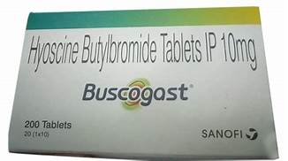

Hyoscine butylbromide
Generic Name: Hyoscine butylbromide
Trade Name: Buscopan
Mechanism of Action: Antimuscarinic that relaxes smooth muscle.
Indications:
- Abdominal colic.
- Irritable bowel syndrome.
Dosage:
- 20 mg four times daily.
Route of Administration: Oral (also intramuscular or intravenous)
Pharmaceutical Preparation: Tablet
Strength: 10 mg and 20 mg
Contraindications:
- Narrow-angle glaucoma.
- Myasthenia gravis.
Side Effects:
- Common: Dry mouth, tachycardia.
Nursing Considerations:
- Assessment: Oral absorption is poor; injectable form is used for acute relief.
Storage Guidelines: Store below 25°C.

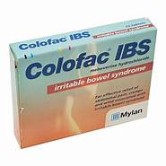

Mebeverine hydrochloride
Generic Name: Mebeverine hydrochloride
Trade Name: Colofac
Mechanism of Action: Direct smooth-muscle relaxant.
Indications:
- Irritable bowel syndrome.
Dosage:
- 135 mg three times daily.
Route of Administration: Oral (PO)
Pharmaceutical Preparation: Tablet
Strength: 135 mg
Contraindications:
- Paralytic ileus.
Side Effects:
- Rare.
Nursing Considerations:
- Assessment: Take 20 minutes before food.
Storage Guidelines: Store below 25°C.



Peppermint oil
Generic Name: Peppermint oil
Trade Name: Colpermin
Mechanism of Action: Antispasmodic (carminative).
Indications:
- Irritable bowel syndrome.
- Colic.
Dosage:
- 1–2 capsules three times daily.
Route of Administration: Oral (PO)
Pharmaceutical Preparation: Gastro-resistant capsule
Strength: 0.2 mL oil
Contraindications:
- None major.
Side Effects:
- Heartburn.
Nursing Considerations:
- Assessment: Swallow whole.
Storage Guidelines: Store below 25°C.

Gallstone Solubilising Agents

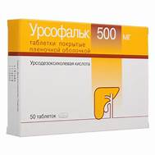

Ursodeoxycholic acid
Generic Name: Ursodeoxycholic acid
Trade Name: Ursofalk
Mechanism of Action: Reduces cholesterol saturation of bile.
Indications:
- Cholesterol gallstones.
Dosage:
- 8–12 mg/kg daily in two to three divided doses.
Route of Administration: Oral (PO)
Pharmaceutical Preparation: Tablet or capsule
Strength: 150 mg and 300 mg
Contraindications:
- Non-functioning gall bladder.
Side Effects:
- Diarrhoea.
Nursing Considerations:
- Assessment: Monitor liver function tests; long-term therapy (6–24 months).
Storage Guidelines: Store below 25°C.

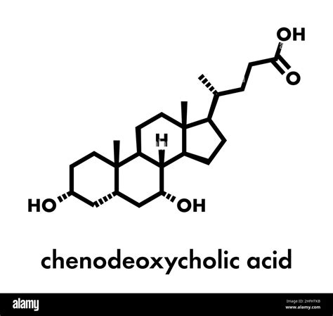

Chenodeoxycholic acid
Generic Name: Chenodeoxycholic acid
Trade Name: Chenodeoxycholic acid (generic)
Mechanism of Action: Bile acid that dissolves cholesterol stones.
Indications:
- Gallstones.
Dosage:
- 10–15 mg/kg daily.
Route of Administration: Oral (PO)
Pharmaceutical Preparation: Capsule
Strength: 250 mg
Contraindications:
- Non-functioning gall bladder.
Side Effects:
- Diarrhoea.
Nursing Considerations:
- Assessment: Specialist use.
Storage Guidelines: Store below 25°C.

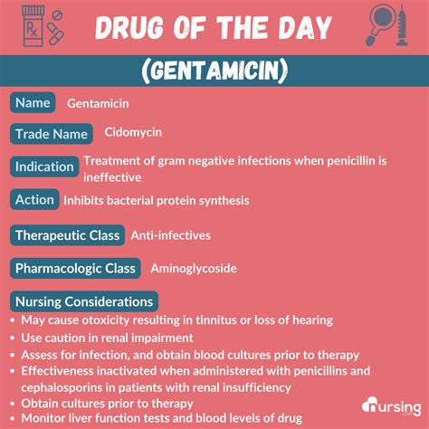

Ursodiol (ursodeoxycholic acid)
Generic Name: Ursodiol (ursodeoxycholic acid)
Trade Name: Actigall
Mechanism of Action: Same as ursodeoxycholic acid — reduces cholesterol saturation of bile.
Indications:
- Cholesterol gallstones.
Dosage:
- 8–12 mg/kg daily in two to three divided doses.
Route of Administration: Oral (PO)
Pharmaceutical Preparation: Capsule
Strength: 300 mg
Contraindications:
- Non-functioning gall bladder.
Side Effects:
- Diarrhoea.
Nursing Considerations:
- Assessment: Monitor liver function tests.
Storage Guidelines: Store below 25°C.

Gastrointestinal Stimulants

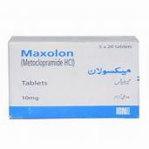

Metoclopramide hydrochloride
Generic Name: Metoclopramide hydrochloride
Trade Name: Maxolon
Mechanism of Action: Dopamine antagonist that increases gastric motility.
Indications:
- Gastroparesis.
- Nausea.
Dosage:
- 10 mg three times daily (maximum 30 mg daily).
Route of Administration: Oral (PO)
Pharmaceutical Preparation: Tablet
Strength: 10 mg
Contraindications:
- Gastrointestinal obstruction.
- Phaeochromocytoma.
Side Effects:
- Common: Extrapyramidal effects (especially in young patients).
Nursing Considerations:
- Assessment: Short-term use only (maximum 5 days).
Storage Guidelines: Store below 25°C.

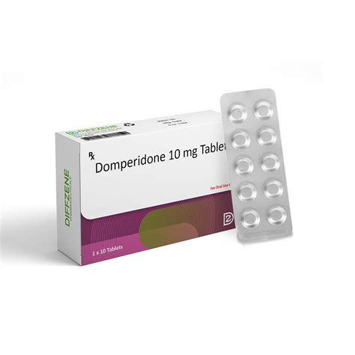

Domperidone
Generic Name: Domperidone
Trade Name: Motilium
Mechanism of Action: Peripheral dopamine antagonist.
Indications:
- Nausea.
- Gastroparesis.
Dosage:
- 10 mg three times daily.
Route of Administration: Oral (PO)
Pharmaceutical Preparation: Tablet
Strength: 10 mg
Contraindications:
- QT prolongation risk.
Side Effects:
- QT prolongation.
Nursing Considerations:
- Assessment: Perform ECG if cardiac risk.
Storage Guidelines: Store below 25°C.

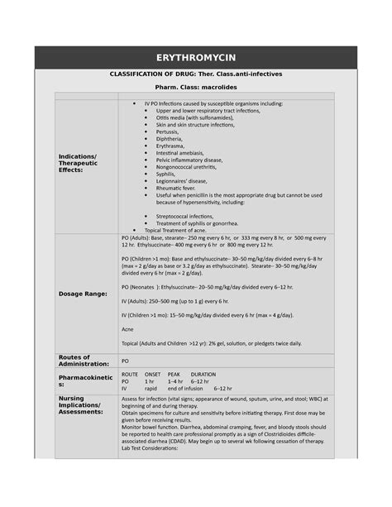

Erythromycin
Generic Name: Erythromycin
Trade Name: Erythromycin
Mechanism of Action: Macrolide with motilin agonist effect.
Indications:
- Gastroparesis.
Dosage:
- 250 mg three times daily.
Route of Administration: Oral (PO)
Pharmaceutical Preparation: Tablet
Strength: 250 mg
Contraindications:
- QT prolongation.
Side Effects:
- Gastrointestinal upset.
Nursing Considerations:
- Assessment: Off-label use.
Storage Guidelines: Store below 25°C.

Helicobacter pylori Eradicating Agents

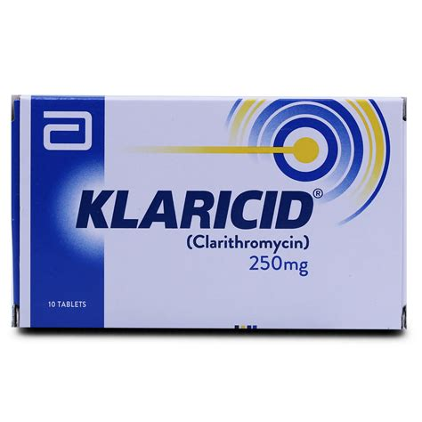

Clarithromycin
Generic Name: Clarithromycin
Trade Name: Klaricid
Mechanism of Action: Macrolide antibiotic; part of triple therapy.
Indications:
- Helicobacter pylori eradication (with proton-pump inhibitor and amoxicillin or metronidazole).
Dosage:
- 500 mg twice daily for 7 days.
Route of Administration: Oral (PO)
Pharmaceutical Preparation: Tablet
Strength: 250 mg and 500 mg
Contraindications:
- Severe hepatic impairment.
Side Effects:
- Common: Gastrointestinal upset, taste disturbance.
Nursing Considerations:
- Assessment: Part of combination regimen.
Storage Guidelines: Store below 25°C.

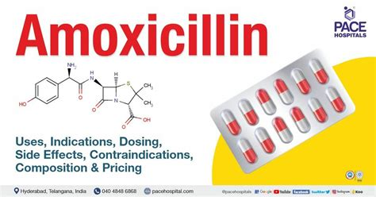

Amoxicillin
Generic Name: Amoxicillin
Trade Name: Amoxil
Mechanism of Action: Beta-lactam antibiotic.
Indications:
- Helicobacter pylori eradication.
Dosage:
- 1 g twice daily for 7 days.
Route of Administration: Oral (PO)
Pharmaceutical Preparation: Capsule
Strength: 500 mg
Contraindications:
- Penicillin hypersensitivity.
Side Effects:
- Common: Rash, diarrhoea.
Nursing Considerations:
- Assessment: Part of triple therapy.
Storage Guidelines: Store below 25°C.

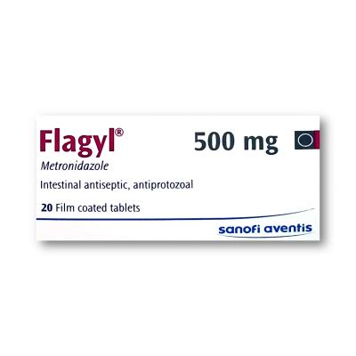

Metronidazole
Generic Name: Metronidazole
Trade Name: Flagyl
Mechanism of Action: Nitroimidazole antibiotic.
Indications:
- Helicobacter pylori eradication (second-line).
Dosage:
- 400 mg twice daily for 7–14 days.
Route of Administration: Oral (PO)
Pharmaceutical Preparation: Tablet
Strength: 200 mg and 400 mg
Contraindications:
- Alcohol (disulfiram reaction).
Side Effects:
- Common: Metallic taste, nausea.
Nursing Considerations:
- Assessment: Avoid alcohol.
Storage Guidelines: Store below 25°C.

H2 Receptor Antagonists

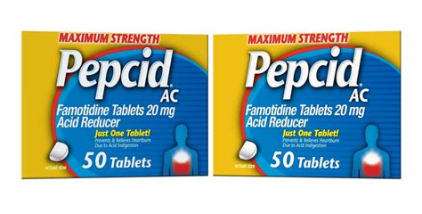

Famotidine
Generic Name: Famotidine
Trade Name: Pepcid
Mechanism of Action: Competitive H2-receptor antagonist that reduces gastric acid secretion.
Indications:
- Peptic ulcer.
- Gastro-oesophageal reflux disease.
- Dyspepsia.
Dosage:
- 20–40 mg once or twice daily.
Route of Administration: Oral (PO)
Pharmaceutical Preparation: Tablet
Strength: 20 mg and 40 mg
Contraindications:
- None major.
Side Effects:
- Common: Headache, dizziness.
- Uncommon: Constipation.
Nursing Considerations:
- Assessment: Take with or without food; monitor for long-term use.
Storage Guidelines: Store below 25°C.

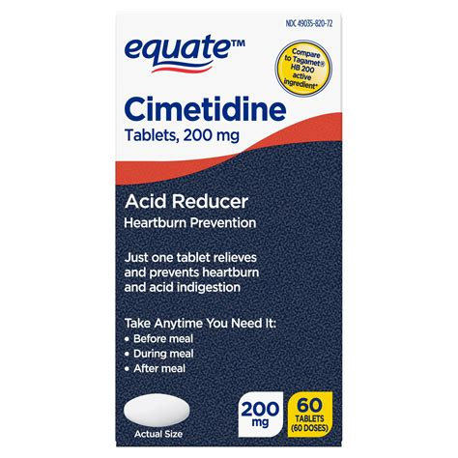

Cimetidine
Generic Name: Cimetidine
Trade Name: Tagamet
Mechanism of Action: H2-receptor antagonist.
Indications:
- Peptic ulcer.
- Gastro-oesophageal reflux disease.
- Dyspepsia.
Dosage:
- 400 mg two to four times daily.
Route of Administration: Oral (PO)
Pharmaceutical Preparation: Tablet
Strength: 200 mg, 400 mg, and 800 mg
Contraindications:
- None major.
Side Effects:
- Common: Confusion in the elderly, gynaecomastia.
- Uncommon: Drug interactions (CYP450 inhibitor).
Nursing Considerations:
- Assessment: Check for drug interactions.
Storage Guidelines: Store below 25°C.

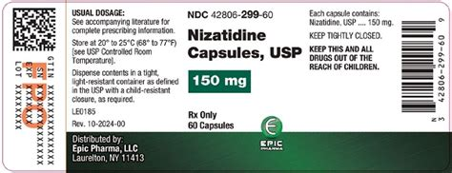

Nizatidine
Generic Name: Nizatidine
Trade Name: Axid
Mechanism of Action: H2-receptor antagonist.
Indications:
- Peptic ulcer.
- Gastro-oesophageal reflux disease.
- Dyspepsia.
Dosage:
- 150 mg twice daily or 300 mg at night.
Route of Administration: Oral (PO)
Pharmaceutical Preparation: Capsule
Strength: 150 mg and 300 mg
Contraindications:
- None major.
Side Effects:
- Headache, dizziness.
Nursing Considerations:
- Assessment: Fewer CYP interactions than cimetidine.
Storage Guidelines: Store below 25°C.

Proton Pump Inhibitors

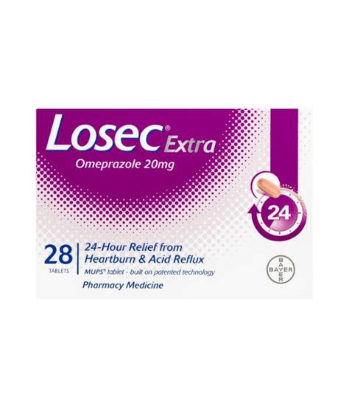

Omeprazole
Generic Name: Omeprazole
Trade Name: Losec
Mechanism of Action: Irreversible proton pump inhibitor that blocks the H+/K+-ATPase enzyme in gastric parietal cells.
Indications:
- Gastro-oesophageal reflux disease.
- Peptic ulcer.
- Helicobacter pylori eradication.
Dosage:
- 20–40 mg once daily.
Route of Administration: Oral (PO)
Pharmaceutical Preparation: Gastro-resistant capsule or tablet
Strength: 10 mg, 20 mg, and 40 mg
Contraindications:
- None major.
Side Effects:
- Common: Headache, gastrointestinal upset.
- Long-term: Hypomagnesaemia, bone fractures.
Nursing Considerations:
- Assessment: Take before food; monitor long-term use.
Storage Guidelines: Store below 25°C.

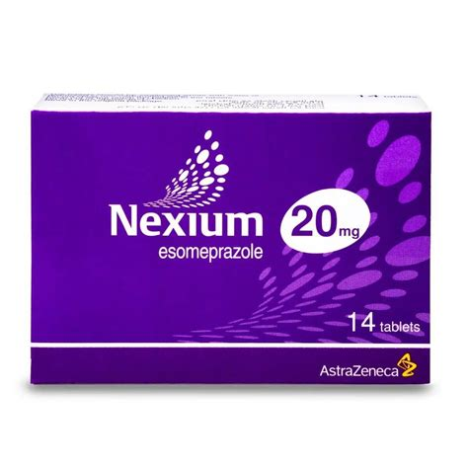

Esomeprazole
Generic Name: Esomeprazole
Trade Name: Nexium
Mechanism of Action: Proton pump inhibitor (S-isomer of omeprazole).
Indications:
- Gastro-oesophageal reflux disease.
- Peptic ulcer.
Dosage:
- 20–40 mg once daily.
Route of Administration: Oral (PO)
Pharmaceutical Preparation: Gastro-resistant tablet
Strength: 20 mg and 40 mg
Contraindications:
- None major.
Side Effects:
- Common: Headache, gastrointestinal upset.
Nursing Considerations:
- Assessment: Take before food.
Storage Guidelines: Store below 25°C.

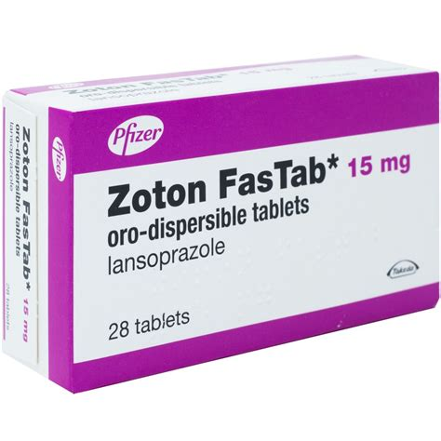

Lansoprazole
Generic Name: Lansoprazole
Trade Name: Zoton
Mechanism of Action: Proton pump inhibitor.
Indications:
- Gastro-oesophageal reflux disease.
- Peptic ulcer.
Dosage:
- 15–30 mg once daily.
Route of Administration: Oral (PO)
Pharmaceutical Preparation: Gastro-resistant capsule
Strength: 15 mg and 30 mg
Contraindications:
- None major.
Side Effects:
- Common: Headache, gastrointestinal upset.
Nursing Considerations:
- Assessment: Take before food.
Storage Guidelines: Store below 25°C.

Laxatives

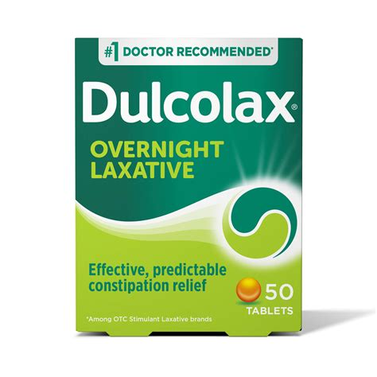

Bisacodyl
Generic Name: Bisacodyl
Trade Name: Dulcolax
Mechanism of Action: Stimulant laxative that increases peristalsis.
Indications:
- Constipation.
Dosage:
- 5–10 mg at night.
Route of Administration: Oral (PO)
Pharmaceutical Preparation: Gastro-resistant tablet
Strength: 5 mg
Contraindications:
- Intestinal obstruction.
Side Effects:
- Abdominal cramps.
Nursing Considerations:
- Assessment: Short-term use.
Storage Guidelines: Store below 25°C.



Senna
Generic Name: Senna
Trade Name: Senokot
Mechanism of Action: Stimulant laxative.
Indications:
- Constipation.
Dosage:
- 7.5–15 mg at night.
Route of Administration: Oral (PO)
Pharmaceutical Preparation: Tablet
Strength: 7.5 mg
Contraindications:
- Intestinal obstruction.
Side Effects:
- Abdominal cramps.
Nursing Considerations:
- Assessment: Short-term use.
Storage Guidelines: Store below 25°C.

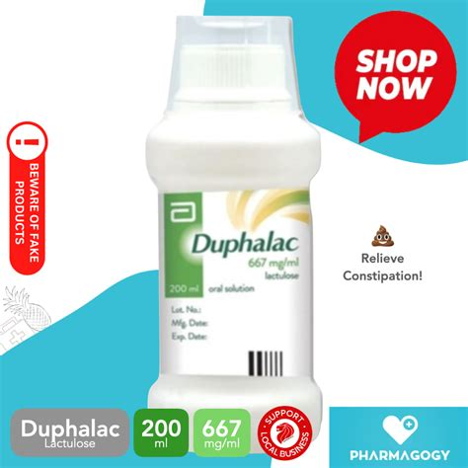

Lactulose
Generic Name: Lactulose
Trade Name: Duphalac
Mechanism of Action: Osmotic laxative.
Indications:
- Constipation.
- Hepatic encephalopathy.
Dosage:
- 15–30 mL twice daily.
Route of Administration: Oral
Pharmaceutical Preparation: Oral solution
Strength: 3.35 g/5 mL
Contraindications:
- Galactosaemia.
Side Effects:
- Common: Flatulence, cramps.
Nursing Considerations:
- Assessment: May take 48 hours to act.
Storage Guidelines: Store below 25°C.

Chapter 5: Central Nervous System

Analgesics

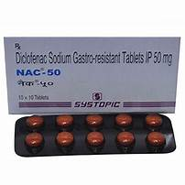

Diclofenac sodium
Generic Name: Diclofenac sodium
Trade Name: Voltarol (gastro-resistant)
Mechanism of Action: Non-steroidal anti-inflammatory drug that inhibits cyclo-oxygenase-1 and cyclo-oxygenase-2, reducing prostaglandin synthesis.
Indications:
- Pain and inflammation.
Dosage:
- 50 mg two to three times daily.
Route of Administration: Oral (PO)
Pharmaceutical Preparation: Gastro-resistant tablet
Strength: 25 mg, 50 mg, and 75 mg
Contraindications:
- Active peptic ulcer.
- Severe heart failure.
- Third-trimester pregnancy.
Side Effects:
- Common: Gastrointestinal bleeding, cardiovascular risk.
- Uncommon: Renal impairment.
Nursing Considerations:
- Assessment: Use the lowest effective dose for the shortest duration; co-prescribe a proton-pump inhibitor if high gastrointestinal risk.
Storage Guidelines: Store below 25°C.

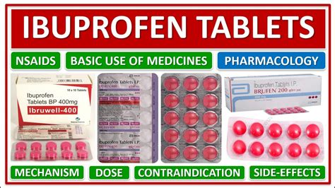

Ibuprofen
Generic Name: Ibuprofen
Trade Name: Brufen
Mechanism of Action: Non-steroidal anti-inflammatory drug.
Indications:
- Mild to moderate pain.
- Inflammation.
Dosage:
- 400 mg three times daily.
Route of Administration: Oral (PO)
Pharmaceutical Preparation: Tablet
Strength: 200 mg, 400 mg, and 600 mg
Contraindications:
- Active peptic ulcer.
- Severe heart failure.
- Third-trimester pregnancy.
Side Effects:
- Common: Gastrointestinal bleeding, cardiovascular risk.
Nursing Considerations:
- Assessment: Take with food.
Storage Guidelines: Store below 25°C.

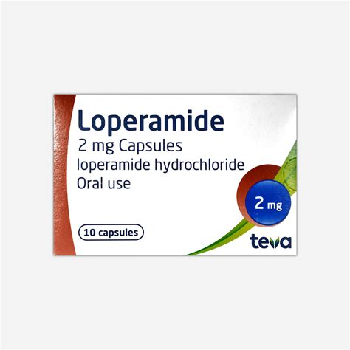

Paracetamol
Generic Name: Paracetamol
Trade Name: Panadol
Mechanism of Action: Central cyclo-oxygenase inhibition; analgesic and antipyretic.
Indications:
- Mild to moderate pain.
- Fever.
Dosage:
- 500 mg–1 g up to four times daily (maximum 4 g daily).
Route of Administration: Oral (PO)
Pharmaceutical Preparation: Tablet
Strength: 500 mg
Contraindications:
- Severe hepatic impairment.
Side Effects:
- Hepatotoxicity in overdose.
Nursing Considerations:
- Assessment: Check total daily dose from all sources; advise on liver risk.
Storage Guidelines: Store below 25°C.

Anorexiants

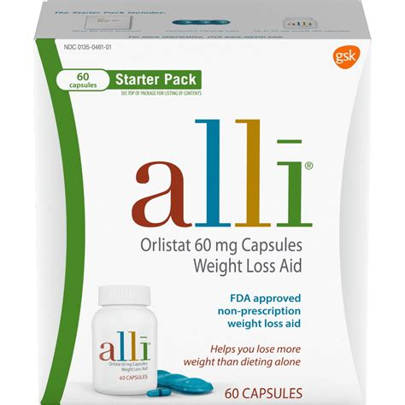

Orlistat
Generic Name: Orlistat
Trade Name: Xenical
Mechanism of Action: Lipase inhibitor that reduces fat absorption in the intestine.
Indications:
- Obesity (BMI ≥30).
Dosage:
- 120 mg three times daily with meals.
Route of Administration: Oral (PO)
Pharmaceutical Preparation: Capsule
Strength: 120 mg
Contraindications:
- Chronic malabsorption syndrome.
Side Effects:
- Common: Steatorrhoea, flatulence.
Nursing Considerations:
- Assessment: Multivitamin supplementation; low-fat diet required.
Storage Guidelines: Store below 25°C.

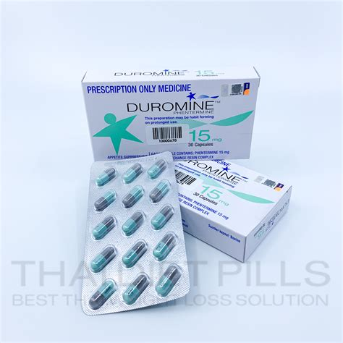

Phentermine
Generic Name: Phentermine
Trade Name: Duromine (in some regions)
Mechanism of Action: Sympathomimetic appetite suppressant.
Indications:
- Short-term obesity management.
Dosage:
- 15–30 mg once daily.
Route of Administration: Oral (PO)
Pharmaceutical Preparation: Capsule
Strength: 15 mg and 30 mg
Contraindications:
- Cardiovascular disease.
Side Effects:
- Common: Insomnia, hypertension.
Nursing Considerations:
- Assessment: Short-term use only (controlled in many countries).
Storage Guidelines: Store below 25°C.

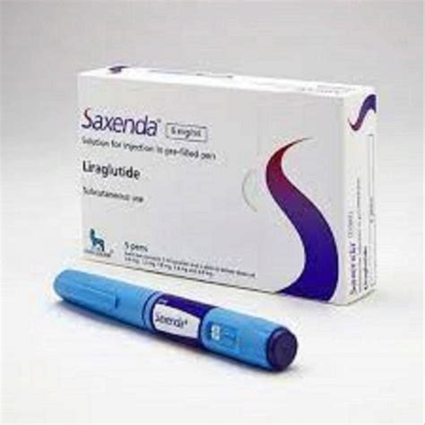

Liraglutide (3 mg)
Generic Name: Liraglutide (3 mg)
Trade Name: Saxenda
Mechanism of Action: GLP-1 receptor agonist that reduces appetite.
Indications:
- Obesity.
Dosage:
- 3 mg subcutaneously once daily (titrated).
Route of Administration: Subcutaneous
Pharmaceutical Preparation: Pre-filled pen
Strength: 6 mg/mL
Contraindications:
- History of medullary thyroid carcinoma.
Side Effects:
- Common: Nausea, vomiting.
Nursing Considerations:
- Assessment: Specialist weight-management clinic.
Storage Guidelines: Refrigerate.

Anticonvulsants

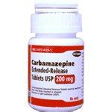

Carbamazepine
Generic Name: Carbamazepine
Trade Name: Tegretol
Mechanism of Action: Sodium channel blocker.
Indications:
- Epilepsy.
- Trigeminal neuralgia.
Dosage:
- 100–200 mg two to three times daily (titrate).
Route of Administration: Oral (PO)
Pharmaceutical Preparation: Tablet
Strength: 100 mg and 200 mg
Contraindications:
- Atrioventricular block.
- Bone marrow depression.
Side Effects:
- Common: Rash, dizziness.
- Uncommon: Hyponatraemia.
Nursing Considerations:
- Assessment: Monitor plasma levels and full blood count.
Storage Guidelines: Store below 25°C.

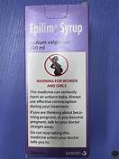

Sodium valproate
Generic Name: Sodium valproate
Trade Name: Epilim
Mechanism of Action: Increases GABA; multiple mechanisms.
Indications:
- Epilepsy.
- Bipolar disorder.
Dosage:
- 600–2 500 mg daily in divided doses.
Route of Administration: Oral (PO)
Pharmaceutical Preparation: Tablet
Strength: 200 mg and 500 mg
Contraindications:
- Liver disease.
- Pregnancy (high teratogenic risk).
Side Effects:
- Common: Weight gain, tremor.
- Uncommon: Hepatotoxicity.
Nursing Considerations:
- Assessment: Monitor liver function tests; pregnancy prevention programme required.
Storage Guidelines: Store below 25°C.



Lamotrigine
Generic Name: Lamotrigine
Trade Name: Lamictal
Mechanism of Action: Sodium channel blocker.
Indications:
- Epilepsy.
- Bipolar disorder.
Dosage:
- 25–200 mg daily (slow titration).
Route of Administration: Oral (PO)
Pharmaceutical Preparation: Dispersible or chewable tablet
Strength: 25 mg, 50 mg, and 100 mg
Contraindications:
- None major.
Side Effects:
- Common: Rash (Stevens-Johnson risk).
Nursing Considerations:
- Assessment: Slow titration to reduce rash risk.
Storage Guidelines: Store below 25°C.

Anti-emetics

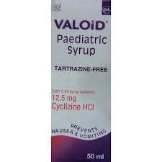

Cyclizine
Generic Name: Cyclizine
Trade Name: Valoid
Mechanism of Action: Antihistamine with anticholinergic action.
Indications:
- Nausea.
- Vertigo.
Dosage:
- 50 mg up to three times daily.
Route of Administration: Oral (PO)
Pharmaceutical Preparation: Tablet
Strength: 50 mg
Contraindications:
- None major.
Side Effects:
- Common: Drowsiness, dry mouth.
Nursing Considerations:
- Assessment: Sedating.
Storage Guidelines: Store below 25°C.

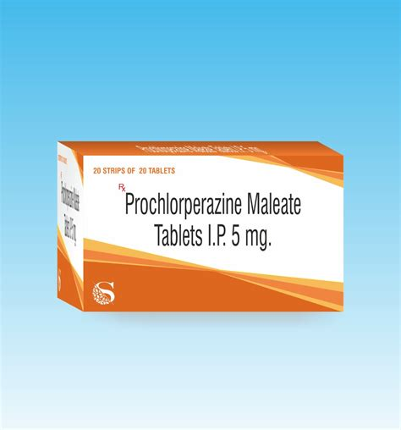

Prochlorperazine
Generic Name: Prochlorperazine
Trade Name: Stemetil
Mechanism of Action: Dopamine D2 antagonist.
Indications:
- Nausea.
- Vertigo.
Dosage:
- 5–10 mg three to four times daily.
Route of Administration: Oral (also buccal)
Pharmaceutical Preparation: Tablet
Strength: 5 mg
Contraindications:
- Parkinson's disease.
Side Effects:
- Common: Extrapyramidal effects.
Nursing Considerations:
- Assessment: Buccal form for rapid action.
Storage Guidelines: Store below 25°C.

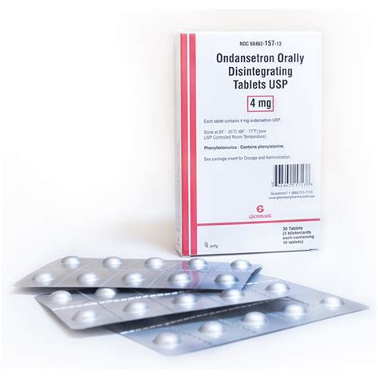

Ondansetron
Generic Name: Ondansetron
Trade Name: Zofran
Mechanism of Action: 5HT3 receptor antagonist.
Indications:
- Chemotherapy-induced nausea.
- Postoperative nausea.
Dosage:
- 8 mg twice daily.
Route of Administration: Oral (PO)
Pharmaceutical Preparation: Tablet
Strength: 4 mg and 8 mg
Contraindications:
- Congenital QT prolongation.
Side Effects:
- Common: Constipation, headache.
Nursing Considerations:
- Assessment: Perform ECG if cardiac risk.
Storage Guidelines: Store below 25°C.

Anti-vertigo Agents

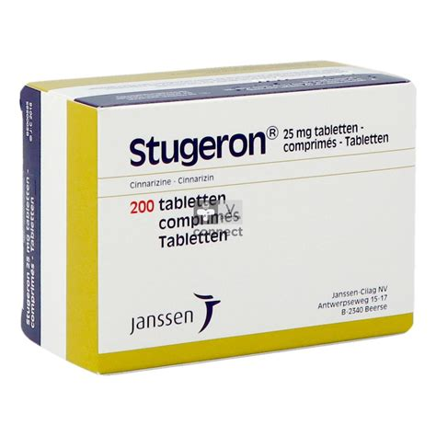

Cinnarizine
Generic Name: Cinnarizine
Trade Name: Stugeron
Mechanism of Action: Antihistamine with calcium-channel blocking and vestibular suppressant activity.
Indications:
- Vertigo.
- Motion sickness.
- Meniere's disease.
Dosage:
- 15–30 mg three times daily.
Route of Administration: Oral (PO)
Pharmaceutical Preparation: Tablet
Strength: 15 mg
Contraindications:
- Parkinson's disease (caution).
Side Effects:
- Common: Drowsiness, dry mouth.
Nursing Considerations:
- Assessment: Advise on sedation.
Storage Guidelines: Store below 25°C.

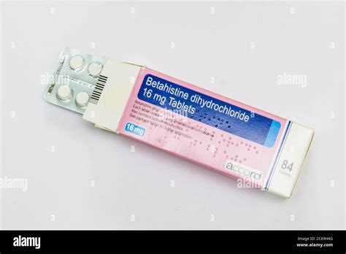

Betahistine
Generic Name: Betahistine
Trade Name: Serc
Mechanism of Action: Histamine analogue that improves labyrinthine microcirculation.
Indications:
- Meniere's disease.
- Vertigo.
Dosage:
- 16 mg three times daily.
Route of Administration: Oral (PO)
Pharmaceutical Preparation: Tablet
Strength: 8 mg and 16 mg
Contraindications:
- Phaeochromocytoma.
Side Effects:
- Gastrointestinal upset, headache.
Nursing Considerations:
- Assessment: Take with food.
Storage Guidelines: Store below 25°C.

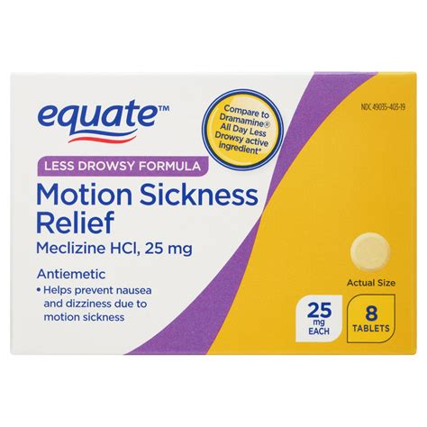

Meclizine
Generic Name: Meclizine
Trade Name: Antivert
Mechanism of Action: Antihistamine with anticholinergic effects.
Indications:
- Motion sickness.
- Vertigo.
Dosage:
- 25–50 mg daily.
Route of Administration: Oral (PO)
Pharmaceutical Preparation: Tablet
Strength: 25 mg
Contraindications:
- None major.
Side Effects:
- Drowsiness.
Nursing Considerations:
- Assessment: Sedating.
Storage Guidelines: Store below 25°C.

Anti-Parkinson Agents

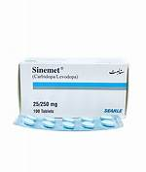

Co-careldopa (levodopa + carbidopa)
Generic Name: Co-careldopa (levodopa + carbidopa)
Trade Name: Sinemet
Mechanism of Action: Levodopa is a dopamine precursor that crosses the blood-brain barrier and is converted to dopamine; carbidopa inhibits peripheral decarboxylation, increasing central availability.
Indications:
- Parkinson's disease.
Dosage:
- 100/25 mg three times daily (titrate).
Route of Administration: Oral (PO)
Pharmaceutical Preparation: Tablet
Strength: 100/25 mg and 250/25 mg
Contraindications:
- Narrow-angle glaucoma.
Side Effects:
- Common: Dyskinesia, nausea.
Nursing Considerations:
- Assessment: Take with food to reduce nausea.
Storage Guidelines: Store below 25°C.

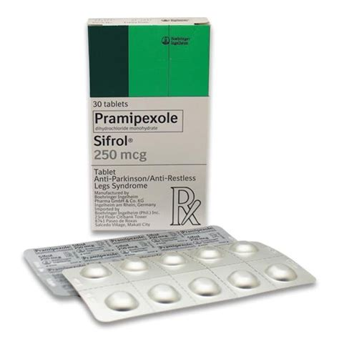

Pramipexole
Generic Name: Pramipexole
Trade Name: Mirapexin
Mechanism of Action: Dopamine D2/D3 agonist.
Indications:
- Parkinson's disease.
Dosage:
- 0.088 mg three times daily (titrate).
Route of Administration: Oral (PO)
Pharmaceutical Preparation: Tablet
Strength: 0.088 mg, 0.18 mg, and 0.7 mg
Contraindications:
- None major.
Side Effects:
- Common: Impulse control disorders, somnolence.
Nursing Considerations:
- Assessment: Monitor for sudden sleep attacks.
Storage Guidelines: Store below 25°C.

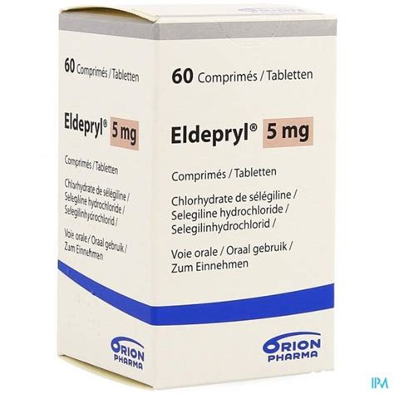

Selegiline
Generic Name: Selegiline
Trade Name: Eldepryl
Mechanism of Action: MAO-B inhibitor.
Indications:
- Parkinson's disease.
Dosage:
- 5–10 mg daily.
Route of Administration: Oral (PO)
Pharmaceutical Preparation: Tablet
Strength: 5 mg and 10 mg
Contraindications:
- Concomitant MAOIs or pethidine.
Side Effects:
- Insomnia, hypotension.
Nursing Considerations:
- Assessment: Avoid tyramine-rich foods at high doses.
Storage Guidelines: Store below 25°C.

Anxiolytics / Sedatives

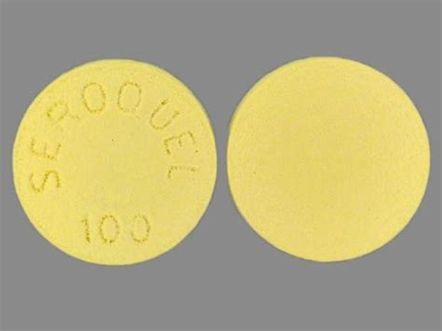

Quetiapine
Generic Name: Quetiapine
Trade Name: Seroquel
Mechanism of Action: Atypical antipsychotic; dopamine and serotonin antagonist.
Indications:
- Schizophrenia.
- Bipolar disorder.
- Adjunct in anxiety or depression.
Dosage:
- 25–300 mg daily (titrate).
Route of Administration: Oral (PO)
Pharmaceutical Preparation: Tablet or modified-release tablet
Strength: 25 mg, 50 mg, 100 mg, 200 mg, and 300 mg
Contraindications:
- QT prolongation risk.
Side Effects:
- Common: Sedation, weight gain.
- Uncommon: Metabolic effects.
Nursing Considerations:
- Assessment: Monitor metabolic parameters.
Storage Guidelines: Store below 25°C.



Citalopram
Generic Name: Citalopram
Trade Name: Cipramil
Mechanism of Action: Selective serotonin reuptake inhibitor.
Indications:
- Depression.
- Panic disorder.
- Anxiety.
Dosage:
- 20–40 mg once daily.
Route of Administration: Oral (PO)
Pharmaceutical Preparation: Tablet
Strength: 10 mg, 20 mg, and 40 mg
Contraindications:
- Concomitant MAOIs.
Side Effects:
- Common: Nausea, sexual dysfunction.
- Uncommon: QT prolongation (dose-dependent).
Nursing Considerations:
- Assessment: Monitor for suicidal ideation initially.
Storage Guidelines: Store below 25°C.

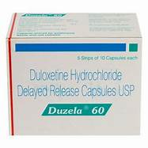

Duloxetine hydrochloride
Generic Name: Duloxetine hydrochloride
Trade Name: Cymbalta
Mechanism of Action: Serotonin and noradrenaline reuptake inhibitor.
Indications:
- Depression.
- Anxiety.
- Neuropathic pain.
Dosage:
- 60 mg once daily.
Route of Administration: Oral (PO)
Pharmaceutical Preparation: Delayed-release capsule
Strength: 30 mg and 60 mg
Contraindications:
- Uncontrolled hypertension.
- Hepatic impairment.
Side Effects:
- Common: Nausea, dry mouth, insomnia.
Nursing Considerations:
- Assessment: Monitor blood pressure; do not crush capsules.
Storage Guidelines: Store below 25°C.

Drugs for Alcohol Dependence

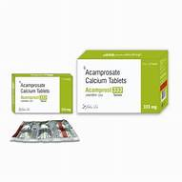

Acamprosate calcium
Generic Name: Acamprosate calcium
Trade Name: Campral
Mechanism of Action: Modulates glutamate and GABA; reduces craving.
Indications:
- Maintenance of alcohol abstinence.
Dosage:
- 666 mg three times daily.
Route of Administration: Oral (PO)
Pharmaceutical Preparation: Enteric-coated tablet
Strength: 333 mg
Contraindications:
- Severe renal impairment.
Side Effects:
- Diarrhoea.
Nursing Considerations:
- Assessment: Continue even if relapse occurs.
Storage Guidelines: Store below 25°C.

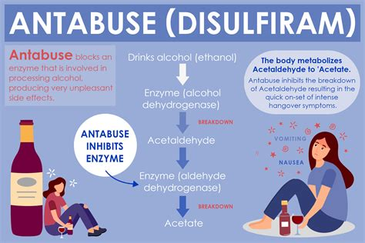

Disulfiram
Generic Name: Disulfiram
Trade Name: Antabuse
Mechanism of Action: Inhibits aldehyde dehydrogenase; causes unpleasant reaction with alcohol.
Indications:
- Alcohol dependence (aversion therapy).
Dosage:
- 200 mg once daily.
Route of Administration: Oral (PO)
Pharmaceutical Preparation: Tablet
Strength: 200 mg
Contraindications:
- Cardiac disease.
- Psychosis.
Side Effects:
- Common: Drowsiness, halitosis.
Nursing Considerations:
- Assessment: Warn about alcohol in food or medicines; supervised therapy.
Storage Guidelines: Store below 25°C.

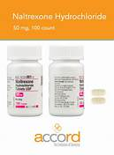

Naltrexone
Generic Name: Naltrexone
Trade Name: Adepend or Revia
Mechanism of Action: Opioid receptor antagonist; reduces craving and reward.
Indications:
- Alcohol dependence.
Dosage:
- 50 mg once daily.
Route of Administration: Oral (PO)
Pharmaceutical Preparation: Tablet
Strength: 50 mg
Contraindications:
- Current opioid use.
Side Effects:
- Common: Nausea, headache.
Nursing Considerations:
- Assessment: Liver function monitoring.
Storage Guidelines: Store below 25°C.

Muscle Relaxants

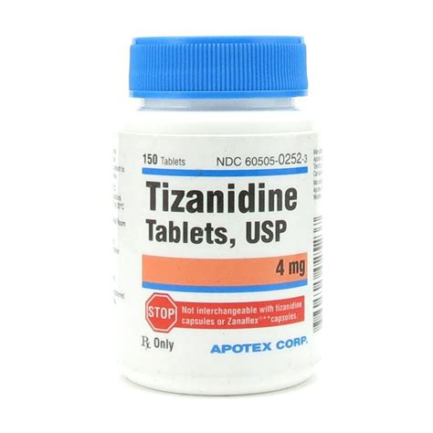

Tizanidine
Generic Name: Tizanidine
Trade Name: Zanaflex
Mechanism of Action: Central α2-adrenergic agonist that inhibits spinal motor neurons.
Indications:
- Muscle spasticity.
Dosage:
- 2–4 mg three to four times daily (maximum 36 mg daily).
Route of Administration: Oral (PO)
Pharmaceutical Preparation: Tablet
Strength: 2 mg and 4 mg
Contraindications:
- Severe hepatic impairment.
Side Effects:
- Common: Drowsiness, hypotension, dry mouth.
Nursing Considerations:
- Assessment: Monitor liver function tests; avoid abrupt withdrawal.
Storage Guidelines: Store below 25°C.

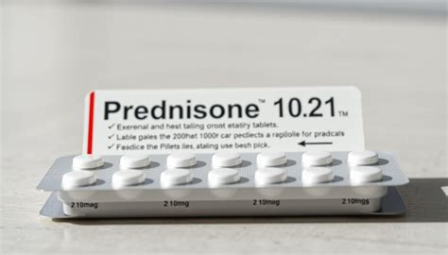

Baclofen
Generic Name: Baclofen
Trade Name: Lioresal
Mechanism of Action: GABA-B agonist that inhibits spinal reflexes.
Indications:
- Spasticity.
Dosage:
- 5–20 mg three times daily (titrate).
Route of Administration: Oral (PO)
Pharmaceutical Preparation: Tablet
Strength: 10 mg
Contraindications:
- Peptic ulcer (caution).
Side Effects:
- Common: Drowsiness, weakness.
- Uncommon: Withdrawal seizures.
Nursing Considerations:
- Assessment: Taper on discontinuation.
Storage Guidelines: Store below 25°C.

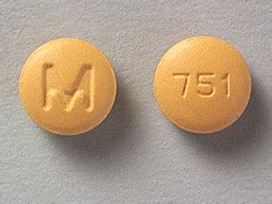

Cyclobenzaprine
Generic Name: Cyclobenzaprine
Trade Name: Flexeril
Mechanism of Action: Centrally acting skeletal muscle relaxant (structurally related to tricyclic antidepressants).
Indications:
- Muscle spasm.
Dosage:
- 5–10 mg three times daily.
Route of Administration: Oral (PO)
Pharmaceutical Preparation: Tablet
Strength: 5 mg and 10 mg
Contraindications:
- Hyperthyroidism.
- Recent myocardial infarction.
Side Effects:
- Common: Drowsiness, dry mouth.
Nursing Considerations:
- Assessment: Short-term use only.
Storage Guidelines: Store below 25°C.

Cholinesterase Inhibitors

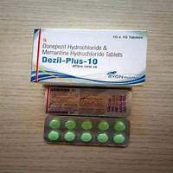

Donepezil hydrochloride
Generic Name: Donepezil hydrochloride
Trade Name: Aricept
Mechanism of Action: Reversible acetylcholinesterase inhibitor.
Indications:
- Mild to moderate Alzheimer's disease.
Dosage:
- 5–10 mg once daily.
Route of Administration: Oral (PO)
Pharmaceutical Preparation: Tablet
Strength: 5 mg and 10 mg
Contraindications:
- None major.
Side Effects:
- Common: Nausea.
- Uncommon: Bradycardia.
Nursing Considerations:
- Assessment: Take at bedtime; monitor heart rate.
Storage Guidelines: Store below 25°C.

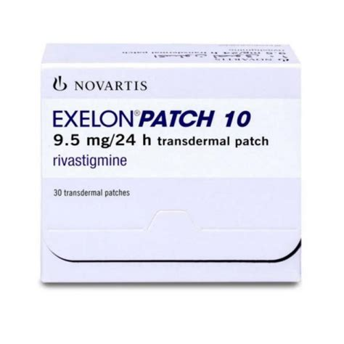

Rivastigmine
Generic Name: Rivastigmine
Trade Name: Exelon
Mechanism of Action: Acetyl and butyrylcholinesterase inhibitor.
Indications:
- Alzheimer's disease.
- Dementia in Parkinson's disease.
Dosage:
- 1.5–6 mg twice daily (titrate).
Route of Administration: Oral (PO)
Pharmaceutical Preparation: Capsule
Strength: 1.5 mg, 3 mg, 4.5 mg, and 6 mg
Contraindications:
- None major.
Side Effects:
- Common: Gastrointestinal upset.
- Uncommon: Bradycardia.
Nursing Considerations:
- Assessment: Slow titration.
Storage Guidelines: Store below 25°C.

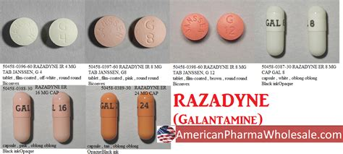

Galantamine
Generic Name: Galantamine
Trade Name: Reminyl
Mechanism of Action: Acetylcholinesterase inhibitor plus nicotinic modulator.
Indications:
- Mild to moderate Alzheimer's disease.
Dosage:
- 8–12 mg twice daily (modified-release once daily).
Route of Administration: Oral (PO)
Pharmaceutical Preparation: Tablet
Strength: 8 mg and 12 mg
Contraindications:
- Severe renal or hepatic impairment.
Side Effects:
- Common: Nausea, dizziness.
Nursing Considerations:
- Assessment: Modified-release preferred.
Storage Guidelines: Store below 25°C.

