

# **TCP2201 Object-Oriented Analysis and Design**

Student information:

| Student ID | Student Name | Email address |
| --- | --- | --- |
| 1201101815 | LIM ZHENG ZHIAN | 1201101815@student.mmu.edu.my |

**Use Case Diagram**

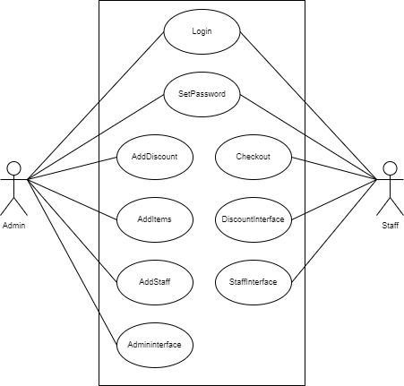

**Class Diagram**

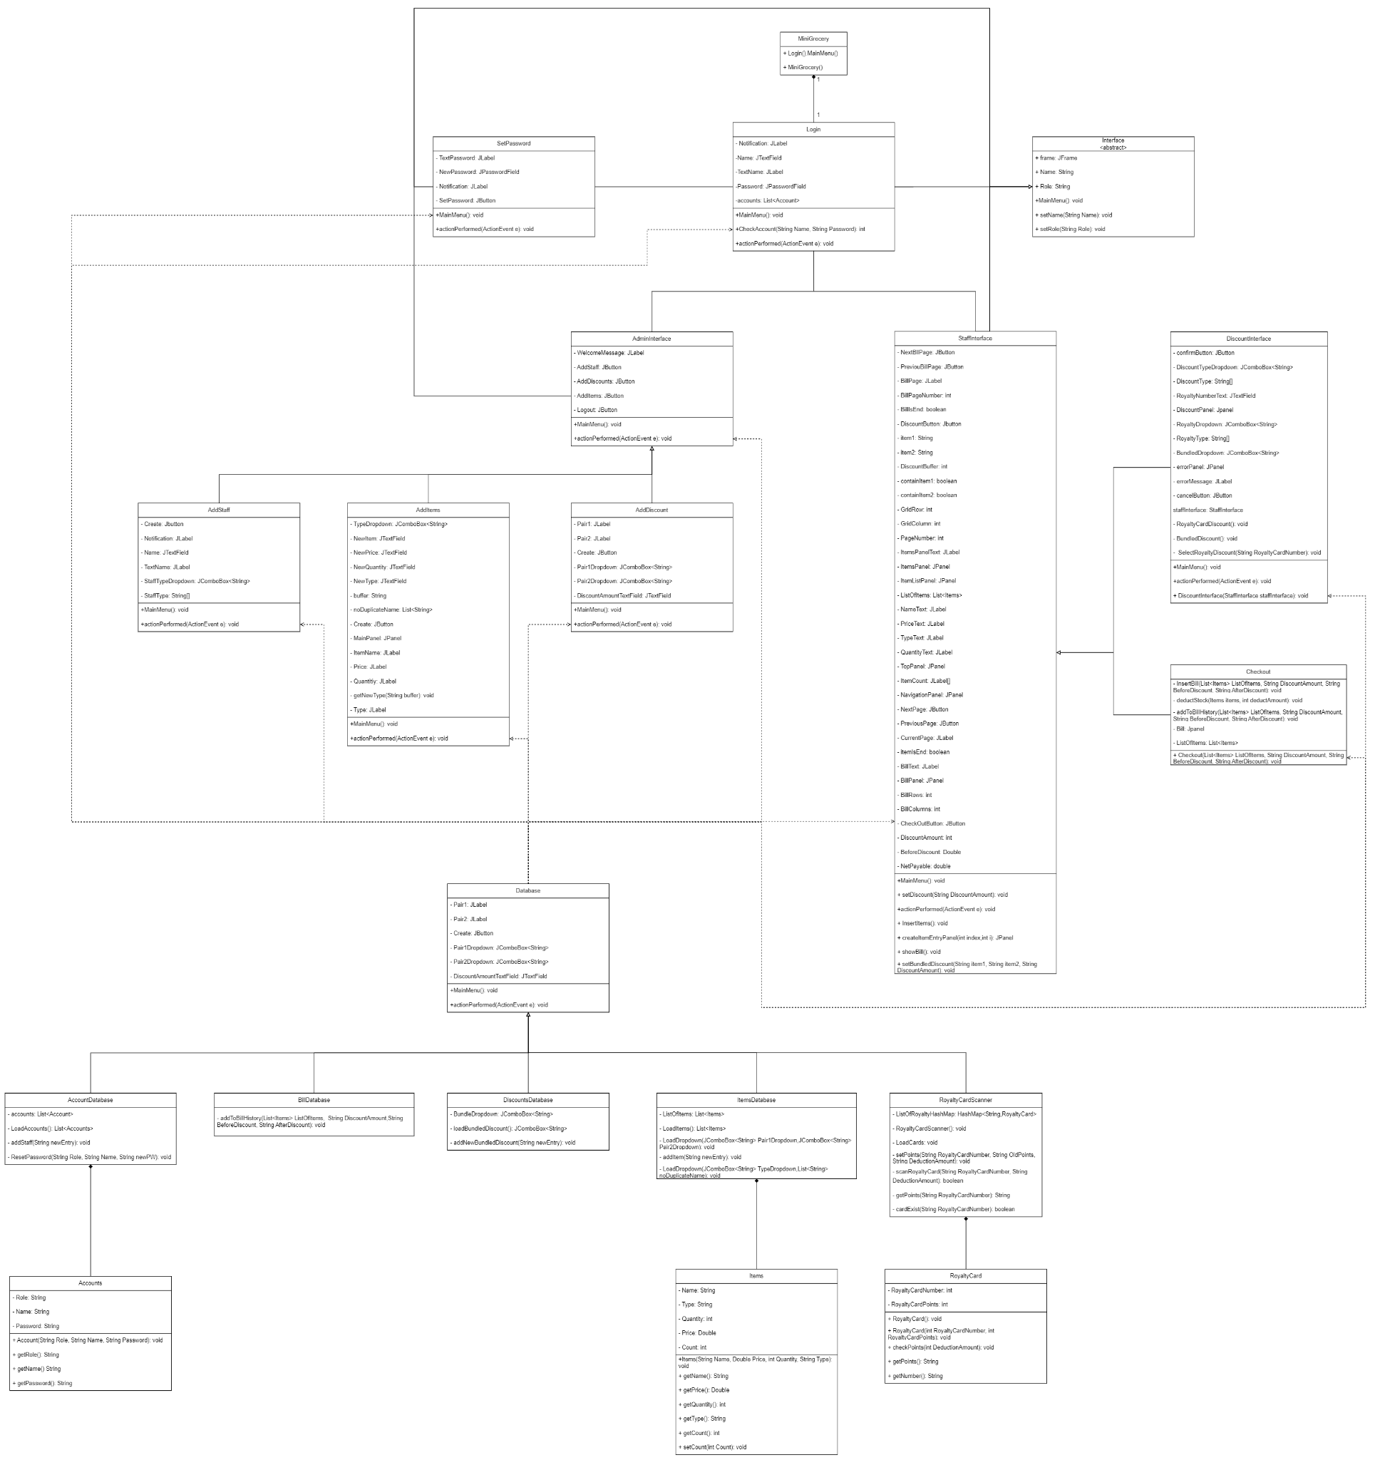

**Admin Sequence Diagram**

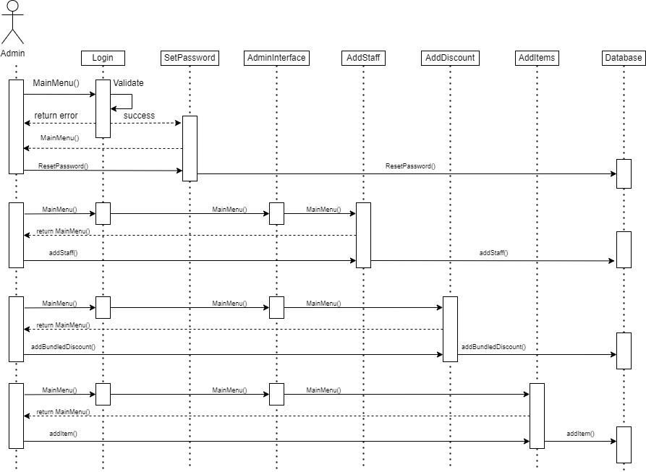

**Staff Sequence Diagram**

