Bodimkarayo.lk

Slide 1: Project Title & Team Details
• Project Title: Bodimkarayo.lk
• Subtitle: Smart Roommate & Property Finder Platform (Web & Mobile)
• Academic Department: Department of Computer Engineering, Faculty of Engineering, University of Ruhuna
• Project Sponsor / Client: Saranga Bandara
Team Member Name
Registration NumberRole / Specialization
Senuja Bodhinayake - EG/2022/4967
Thamindu Dambewela - EG/2022/4979
Dushan Senith - EG/2022/5057
Gimhani Hangawaththa - EG/2022/5393

Slide 2: Project Overview, Problem Statement & Solution
1. Problem Statement
• Fragmented & Manual Process: Traditional boarding searches in Sri Lanka rely on physical roadside posters, random Facebook groups, and word-of-mouth.
• Lack of Trust & Safety: No verified landlords, unverified properties, and hidden costs cause safety concerns for university students and young professionals.
• Roommate Incompatibility: No systematic way to find roommates with matching study habits, cleanliness standards, sleep schedules, and shared budgets.
2. Our Solution (Bodimkarayo.lk)
• All-in-One Digital Hub: A unified web and mobile platform for verified property listings and roommate discovery.
• Map-Based Spatial Search: Dynamic interactive map filtering rooms by proximity to universities and workplaces.
• AI-Powered Matchmaking: Intelligent scoring algorithm that pairs prospective roommates based on mutual preferences and habits.

Slide 3: Key Features
• 🤖 AI-Powered Roommate Matching: Uses Gemini AI to analyze lifestyle preferences (sleep schedule, study environment, cleanliness, smoking/diet habits, budget) to generate accurate compatibility scores.
• 📍 Map-Based Spatial Search: Real-time exploration powered by Leaflet.js with interactive markers, distance calculations, and multi-parameter filters (price, amenities, gender).
• 📱 Cross-Platform Ecosystem: Unified user experience across React.js Web and cross-platform Flutter Mobile (Android & iOS).
• 🛡️ Verified Profiles & Trust Score: Identity verification for landlords/tenants along with authentic user reviews and rating mechanisms.
• 📊 Centralized Admin Moderation: Powerful dashboard for approving listings, managing reports, and monitoring system analytics.

Slide 4: Technology Stack
• Frontend (Web): React.js, Tailwind CSS, Leaflet.js (OpenStreetMap), Axios
• Mobile (Cross-Platform): Flutter (Dart) for Android & iOS with responsive state management
• Backend Layer: Spring Boot (Java 17/21), Spring Security, JWT (Stateless Authentication)
• Databases & Search Engine: MariaDB (Relational Data), Elasticsearch (High-speed search & geo-indexing)
• AI & Media Services: Google Gemini AI API (Matchmaking Engine), Cloudinary (Media management & CDN)
• DevOps & Cloud Deployment: AWS (Amazon EC2 for API hosting, Amazon RDS for MariaDB, Amazon S3), Docker, GitHub Actions CI/CD

Slide 5: System Architecture & Deployment
System Flow Diagram:
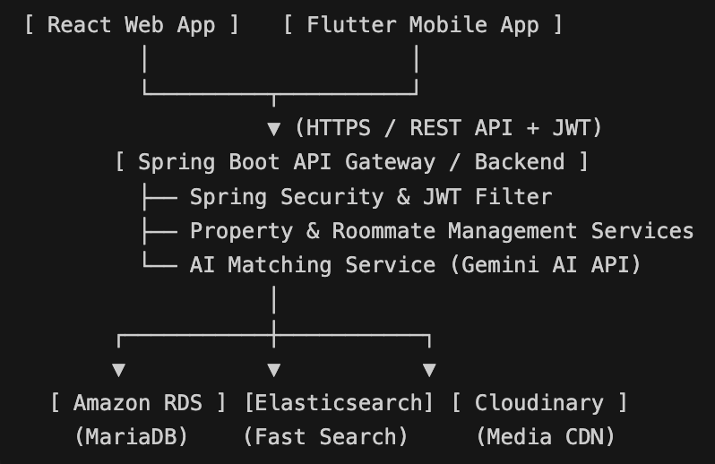

Architecture Style: 3-Tier Layered Architecture / Micro-service ready REST architecture

Client Layer: React Web App (Responsive UI / Leaflet Map integration)

API Gateway & Business Layer: Spring Boot REST Controllers →\rightarrow→ Service Layer →\rightarrow→ Spring Security/JWT

Data & Integration Layer:
- MariaDB (Relational storage via Spring Data JPA)
- Elasticsearch (Property search indexing)
- External Integrations (Cloudinary CDN, Gemini AI Engine) (Include a clean architecture diagram from your DSTD on this slide)

- Slide 6: Conclusion, Demonstration & Q&A
• Summary & Impact: Bodimkarayo.lk delivers a modern, secure, and intelligent housing ecosystem tailored specifically to Sri Lankan boarding culture.
• Live Demonstration Agenda:
1 Web Portal Demo: Map-based search, dynamic filters, property posting & admin approval.
2 Flutter Mobile App Demo: User profile setup and mobile exploration.
3 AI Matchmaker Showcase: Demonstrating roommate matching criteria and AI compatibility score calculation.

Thank You! Open for Questions & Discussion

