CrisisMap

ML Inference Report
SiamUnet building damage assessment inference for Beirut Port
Assessment ID | ASM-D06926
Mode | Local inference, not training
Model | SiamUnet:model_best.pth.tar
Device | CPU
Study Area | Beirut Port, Lebanon

Key clarification: this document describes inference using an existing pretrained checkpoint. No local training or fine-tuning was executed in the previous run.

1. What Was Actually Run
The previous CrisisMap run did not train a new machine learning model. It loaded an existing pretrained checkpoint and used it for inference against Beirut pre/post Maxar imagery and building footprints.
- No local epochs were run.
- No local train/validation split was created for this execution.
- No local optimizer, training batch size, or loss curve exists for this run.
- The run produced inference predictions, evidence chips, validation metrics, and dashboard/report artifacts.

2. Code Map
Model architecture | data/raw/models/microsoft_building_damage_assessment_cnn_siamese/end_to_end_Siam_UNet.py
Inference wrapper | backend/app/services/geospatial/ml_inference.py
Beirut pipeline | backend/app/services/geospatial/imagery_baseline.py
Quality/chip API | backend/app/api/v1/routes/assessments.py
Priority evidence UI | frontend/src/app/priority/[id]/page.tsx

3. Architecture
The model is a Siamese UNet. It accepts a pre-disaster image chip and a post-disaster image chip. The shared UNet branch predicts building segmentation masks, while the difference between pre/post feature embeddings feeds a damage classification head.
Architecture | SiamUnet
Input A | Pre-disaster RGB chip, 256x256
Input B | Post-disaster RGB chip, 256x256
Segmentation outputs | Pre-event and post-event building mask logits
Damage output | 5-class damage logits
Classes | background, no-damage, minor-damage, major-damage, destroyed

4. Pipeline Flow
- User AOI polygon limits the Beirut analysis area.
- Maxar building footprints are clipped to the AOI.
- Pre/post Maxar GeoTIFF windows are read per footprint.
- A 256x256 pre/post tensor pair is created per building.
- SiamUnet predicts pixel-level damage logits.
- Softmax probabilities are averaged into a building-level prediction.
- The ML score is blended with an image-change baseline score.
- Predictions are joined back into GeoJSON building polygons.
- Results are validated against Copernicus EMSR452 ground-truth points.
- Before/after chip evidence is exposed in Priority Detail.

5. Local Inference Configuration
ML_MODEL_ENABLED=true
ML_MODEL_CHECKPOINT_PATH=../data/raw/models/microsoft_building_damage_assessment_cnn_siamese/model_best.pth.tar
ML_MODEL_DEFINITION_PATH=../data/raw/models/microsoft_building_damage_assessment_cnn_siamese/end_to_end_Siam_UNet.py
ML_MODEL_DEVICE=cpu
torch==2.5.1+cpu

6. Result Summary
Pipeline method | ml-inference
ML inference count | 60
Baseline fallback count | 0
Buildings assessed | 60
Runtime | ~51.21 seconds on CPU
Matched validation buildings | 54
Accuracy | 0.778
Macro F1 | 0.221

7. Validation Charts
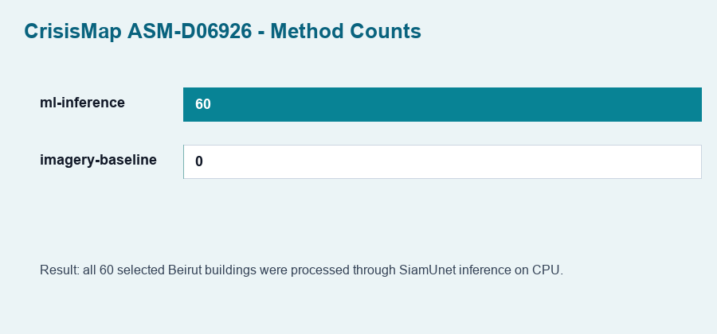
Figure 1. All 60 selected Beirut buildings were processed by ML inference.
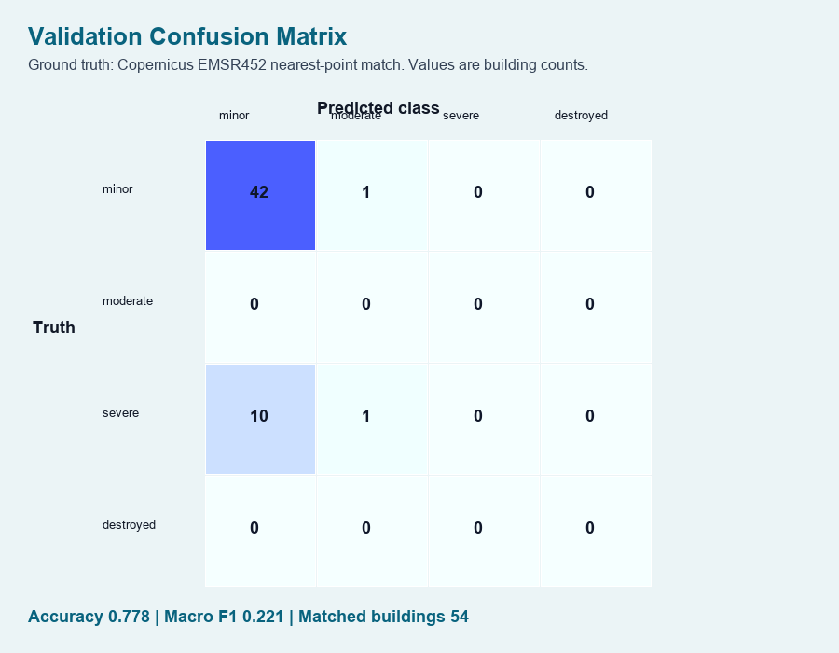
Figure 2. Confusion matrix against Copernicus EMSR452 nearest-point validation labels.
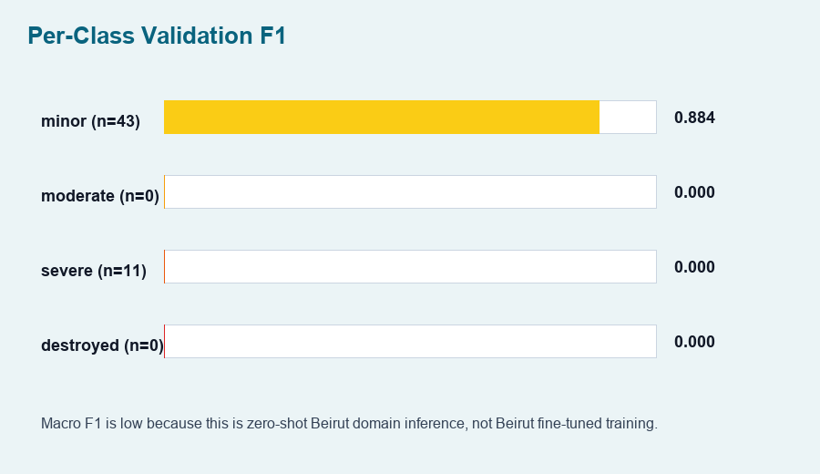
Figure 3. Per-class F1 score. Macro F1 remains low because this is zero-shot Beirut inference.
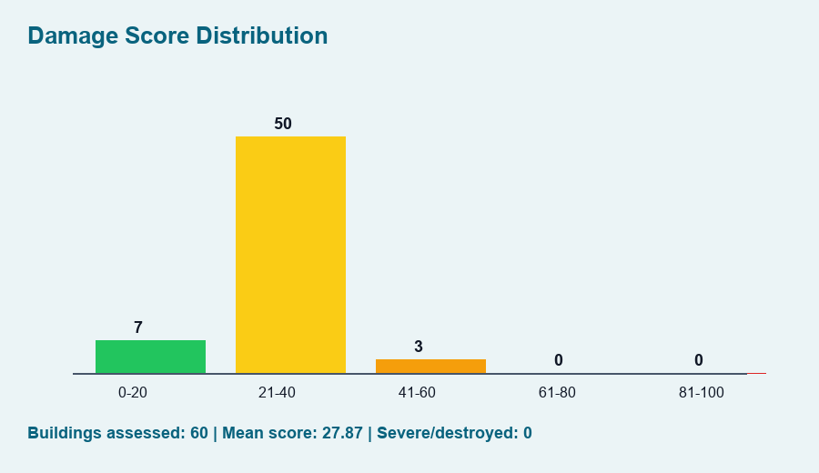
Figure 4. Distribution of final building-level damage scores.
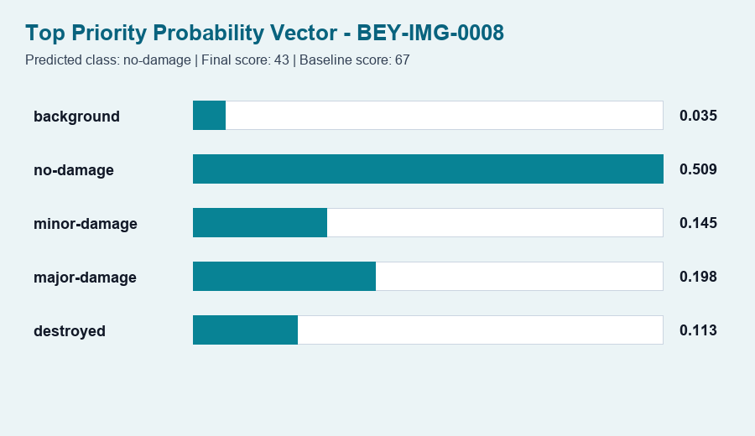
Figure 5. Probability vector for the top priority building.

8. Interpretation
The model currently detects many matched validation samples as minor/no-damage and under-detects severe damage in this Beirut sample. That is expected for zero-shot domain transfer from xBD-style disaster tiles to Beirut Maxar imagery and EMSR452 point labels.
- The pipeline is operational and can run real imagery inference locally.
- The validation score is not yet acceptable as final operational accuracy.
- Fine-tuning or threshold calibration is required before making strong claims about Beirut accuracy.

9. Recommended Next ML Step
- Create a Kaggle/Colab notebook for fine-tuning with xBD Challenge training set and Tier3 data.
- Use train/validation/test splits from xBD or a reproducible disaster-wise split to avoid leakage.
- Track loss, segmentation F1/IoU, damage macro F1, confusion matrix, and per-class recall.
- Export a new checkpoint and point ML_MODEL_CHECKPOINT_PATH to the fine-tuned model.
- Re-run Beirut validation and compare against the current baseline report.

