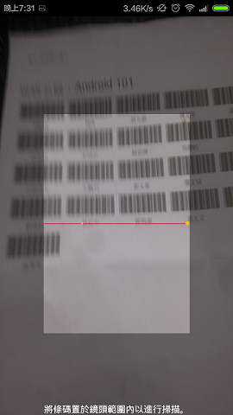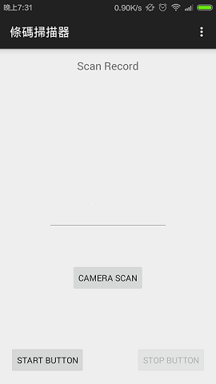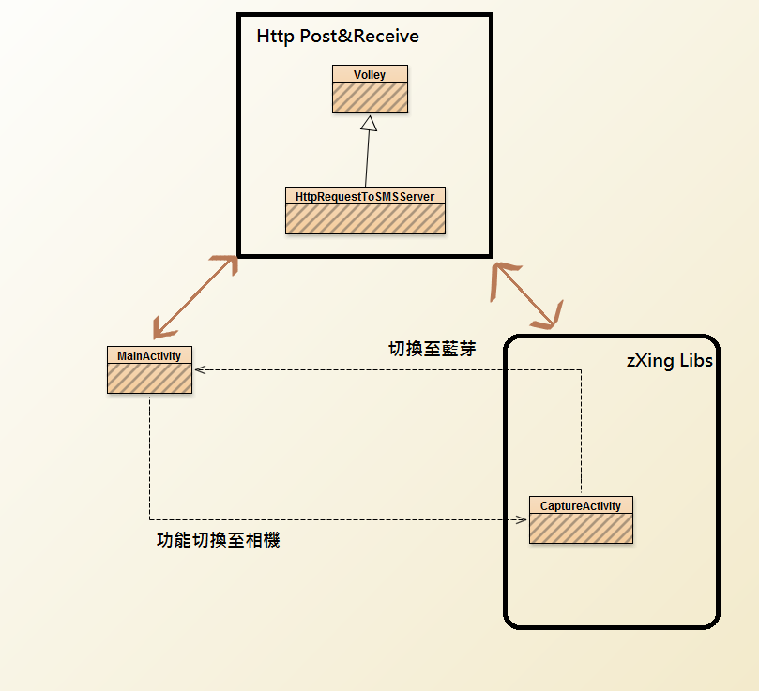

Classes 2015/04/11

Activity控制 : MainActivity、CaptureActivity(in zXingLibs)

Key Code (Internet): 兩者擁有各自handler，並各自建構handleMessage，能夠自動判別來自HTTP POST Target的回應。

Example :

1.MainActivity內宣告handler with handleMessage ，

2.宣告HttpRequestToSMSServer s=

new HttpRequestToSMSServer(context,handler,scancode)

3.使用HttpRequestToSMSServer.httpRequest()，

4.在handleMessage內執行想完成的CODE。

Libs : Volley&zXing

Volley :

HttpReuquestLibary

zXing :

ScanCodeLibary

HttpRequestToSMSServer Functions :

httpRequest(); -> Volley

String getName();

String getArrive_at();

Target :

ActionBar with NavigationDrawer 用於切換功能

pull function By using Fragment 將功能從Activity獨立出來

Clock 時鐘

pull out CaptureActivity From zXingLibs 將功能從Lib裡獨立出來

Thread and Handler 實現複數功能同時運行

防呆、防格式外條碼、防止格式正確但不在資料庫之條碼

more Function Short Code

# **Features** 2015/04/13

* Use Action Bar Activity (Support V7)
* Use Navigation Drawer (Support V4)
* Create Listview in Drawer
* Create 3 default pages in Drawer : Home ,Bluetooth ,Camera
* Use Fragment (Support V4)
* Create 3 Fragment in Project : FragmentBluetooth.java ,FragmentHome.java , FragmentCamera.java
* Pull Bluetooth function from MainActivity.java(old version) into FragmentBluetooth.java
* FragmentBluetooth.java depend to fragment_bluetooth.xml

# **Target**

* Clock 時鐘
* pull out CaptureActivity From zXingLibs 將功能從Lib裡獨立出來
* Thread and Handler 實現複數功能同時運行
* 防呆、防格式外條碼、防止格式正確但不在資料庫之條碼
* Finish the FragmentCamera.java

