

编译原理实验报告一

词法分析器的实现

姓名： 井劭杰

学号： 71116234

东南大学计算机科学与工程学院、软件学院

School of Computer Science & Engineering

College of Software Engineering

Southeast University

二0 一 九 年 一 月

# 实验目的

构造一个词法分析器，以一个C++程序为输入，以一个TOKEN序列为输出。

# 实验内容

##### 1、Input

Stream of characters

REs(The number of REs is decided by yourself)

##### 2、Output

Sequence of tokens

##### Classes of words are defined by yourself

##### Error handling may be included

# 实验方法

##### 总体思想

Programming based on FA

a)Define some REs by yourself

b)Convert REs into NFAs

c)Merge these NFAs into a single NFA

d)Convert the NFA into a DFA’ with minimum states

e)Programming based on the DFA’

##### **单词分类**

###### （1） 保留字

"include" , "iostream" , "define" , "main" , "void" , "abstract" , "static" , "const" ,

"auto" , "double" , "int" , "float" , "struct" , "long" , "unsigned" , "char" , "if" ,

"else" , "switch" , "case" , "return" , "break" , "for" , "while" , "do" , "continue" ,

"print"

###### （2） 运算符

+ | - | * | / | ++ | -- | < | > | = | >= | <= | == | ( | ) | [ | ] | { | }

###### （3） 界符

, | ; | : | # | " | <<

###### （4） 数值常数

0 | 1 | 2 | 3 | 4 | 5 | 6 | 7 | 8 | 9

###### （5） 标识符

例如： a, b1, array, num

##### **构造NFA**

###### **保留字：A..Za..z( A..Za..z )\***

图片1

###### **标识符：A..Za..z( A..Za..z | 0..9 )\***

图片2

###### **运算符：+ | - | * | / | ++ | -- | < | > | = | >= | <= | == | ( | ) | [ | ] | { | }**

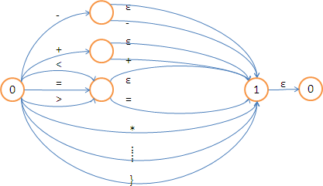

###### **界符：, | ; | : | # | " | <<**

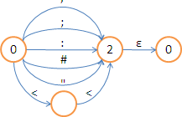

###### **常数：(0..9)(0..9)* + (Ɛ | .(0..9)*)**

图片5

##### **得到NFA’**

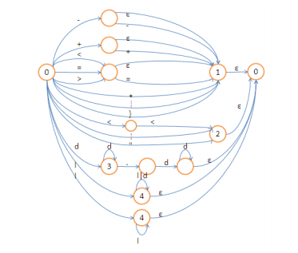

##### **构造DFA**

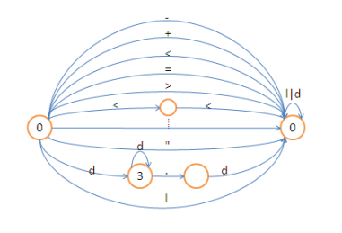

##### **得到DFA’**

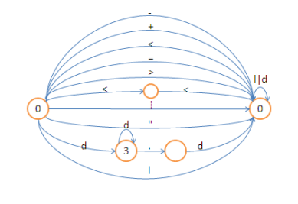

# 实验代码

#include"stdafx.h"

#include<iostream>

using namespace std;

#define MAX 26

/* Classification：

keyword----1

operator----2

delimiter----3

id----4

num----5

No-recognition----6

*/

char ch = ' ';

char token[100];//定义获取的字符

//定义keyword

const char* keyWord[] = {

"include","iostream","using","namespace","std""if","else","switch","case","break","for","while",

"do","continue","true","false","const","auto","double","int","float","struct","long","char","main",

"return","define","void","abstract","static","MAX","print","unsigned","short","class","system" };

//判断是否为关键字

bool isKey(char * token)

{

for (int i = 0; i < MAX; i++)

{

if (strcmp(token, keyWord[i]) == 0)

return true;

}

return false;

}

//判断是否是数字

bool isDigit(char digit)

{

if (digit >= '0' && digit <= '9')

return true;

else

return false;

}

//判断是否是字母

bool isLetter(char letter)

{

if ((letter >= 'a' && letter <= 'z') || (letter >= 'A' && letter <= 'Z'))

return true;

else

return false;

}

//词法分析

int Lexical_Analyze(FILE *input, FILE *output)

{

while ((ch = fgetc(input)) != EOF) {

//语句间的分隔符

if (ch == ' ' || ch == '\n' || ch == '\t' || ch == '\r') {

//ch = getc(input);

}

else if (isLetter(ch)) {

char token[100] = { '\0' };

int i = 0;

while (isLetter(ch) || isDigit(ch)) {

token[i] = ch;

i++;

ch = fgetc(input);

}

fseek(input, -1L, SEEK_CUR);

if (isKey(token)) {

fprintf(output, "%s\t\t%u\t%s\n", token, 1, "<keyword>");

}

else {

fprintf(output, "%s\t\t%u\t%s\n", token, 4, "<id>");

}

}

else if (isDigit(ch) || (ch == '.'))

{

int i = 0;

char token[100] = { '\0' };

while (isDigit(ch) || (ch == '.' && isDigit(fgetc(input)))) {

if (ch == '.')

fseek(input, -1L, SEEK_CUR);

token[i] = ch;

i++;

ch = fgetc(input);

}

fseek(input, -1L, SEEK_CUR);

//属于无符号数字

fprintf(output, "%s\t\t%u\t%s\n", token, 5, "<num>");

}

else switch (ch) {

case '+': {

ch = fgetc(input);

if (ch == '+')

fprintf(output, "%c%c\t\t%u\t%s\n", '+', ch, 2, "<operator>");

else if (ch == '=')

fprintf(output, "%c%c\t\t%u\t%s\n", '+', ch, 2, "<operator>");

else {

fprintf(output, "%c\t\t%u\t%s\n", '+', 2, "<operator>");

fseek(input, -1L, SEEK_CUR);

}

}break;

case '-': {

ch = fgetc(input);

if (ch == '-')

fprintf(output, "%c%c\t\t%u\t%s\n", '-', ch, 2, "<operator>");

else if (ch == '=')

fprintf(output, "%c%c\t\t%u\t%s\n", '-', ch, 2, "<operator>");

else {

fprintf(output, "%c\t\t%u\t%s\n", '-', 2, "<operator>");

fseek(input, -1L, SEEK_CUR);

}

}break;

case '*': {

ch = fgetc(input);

if (ch == '=')

fprintf(output, "%c%c\t\t%u\t%s\n", '*', ch, 2, "<operator>");

else {

fprintf(output, "%c\t\t%u\t%s\n", '*', 2, "<operator>");

fseek(input, -1L, SEEK_CUR);

}

}break;

case '/': {

ch = fgetc(input);

if (ch == '/') //注释符

fprintf(output, "%c%c\t\t%u\t%s\n", '/', ch, 2, "<delimiter>");

else if (ch == '=')

fprintf(output, "%c\t\t%u\t%s\n", '/', ch, 2, "<operator>");

else {

fprintf(output, "%c\t\t%u\t%s\n", '/', 2, "<operator>");

fseek(input, -1L, SEEK_CUR);

}

}break;

case '(':

fprintf(output, "%c\t\t%u\t%s\n", ch, 2, "<operator>");

break;

case ')':

fprintf(output, "%c\t\t%u\t%s\n", ch, 2, "<operator>");

break;

case '[':

fprintf(output, "%c\t\t%u\t%s\n", ch, 2, "<operator>");

break;

case ']':

fprintf(output, "%c\t\t%u\t%s\n", ch, 2, "<operator>");

break;

case '{':

fprintf(output, "%c\t\t%u\t%s\n", ch, 2, "<operator>");

break;

case '}':

fprintf(output, "%c\t\t%u\t%s\n", ch, 2, "<operator>");

break;

case '#':

fprintf(output, "%c\t\t%u\t%s\n", ch, 3, "<delimiter>");

break;

case ',':

fprintf(output, "%c\t\t%u\t%s\n", ch, 3, "<delimiter>");

break;

case '"':

fprintf(output, "%c\t\t%u\t%s\n", ch, 3, "<delimiter>");

break;

case '\'':

fprintf(output, "%c\t\t%u\t%s\n", ch, 3, "<delimiter>");

break;

case ';':

fprintf(output, "%c\t\t%u\t%s\n", ch, 3, "<delimiter>");

break;

case '=': {

ch = fgetc(input);

if (ch == '=')

fprintf(output, "%c%c\t\t%u\t%s\n", '=', ch, 2, "<operator>");

else {

fprintf(output, "%c\t\t%u\t%s\n", '=', 2, "<operator>");

fseek(input, -1L, SEEK_CUR);

}

}break;

case ':': {

ch = fgetc(input);

if (ch == '=')

fprintf(output, "%c%c\t\t%u\t%s\n", ':', ch, 2, "<operator>");

else {

fprintf(output, "%c\t\t%u\t%s\n", ':', 2, "<operator>");

fseek(input, -1L, SEEK_CUR);

}

}break;

case '>': {

ch = fgetc(input);

if (ch == '>')

fprintf(output, "%c%c\t\t%u\t%s\n", '>', ch, 3, "<delimiter>");

if (ch == '=')

fprintf(output, "%c%c\t\t%u\t%s\n", '>', ch, 2, "<operator>");

else {

fprintf(output, "%c\t\t%u\t%s\n", '>', 2, "<operator>");

fseek(input, -1L, SEEK_CUR);

}

}break;

case '<': {

ch = fgetc(input);

if (ch == '=')

fprintf(output, "%c%c\t\t%u\t%s\n", '<', ch, 2, "<operator>");

if (ch == '<')

fprintf(output, "%c%c\t\t%u\t%s\n", '<', ch, 3, "<delimiter>");

else {

fprintf(output, "%c\t\t%u\t%s\n", '<', 2, "<operator>");

fseek(input, -1L, SEEK_CUR);

}

}break;

//无识别

default:

fprintf(output, "%c\t\t%u\t%s\n", ch, 6, "<No-recognition >");

}

}

return 1;

}

int main() {

char input[30];

FILE *fin, *fout;

fin = fopen("..\\bin\\in.txt", "r");

if (fin == NULL) {

cout << "The input file is not exist!" << endl;

return 0;

}

fout = fopen("..\\bin\\out.txt", "w");

if (fout == NULL) {

cout << "The output file is not exist!" << endl;

return 0;

}

if (Lexical_Analyze(fin, fout) == 1) {

cout << "Lexical analyze succeeds!" << endl;

}

else

cout << "Lexical analyze fails..." << endl;

fclose(fin);

fclose(fout);

system("..\\bin\\out.txt");

system("pause");

return 0;

}

# 结果展示

**输入文件：**

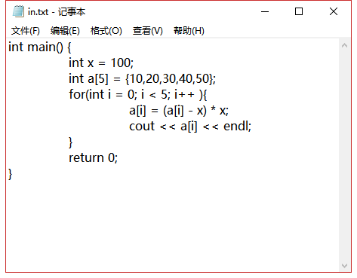

**输出文件：**

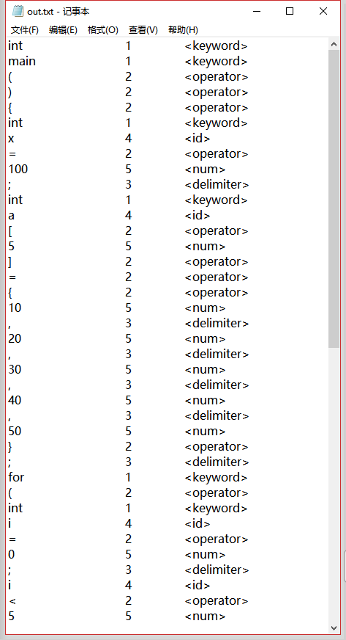

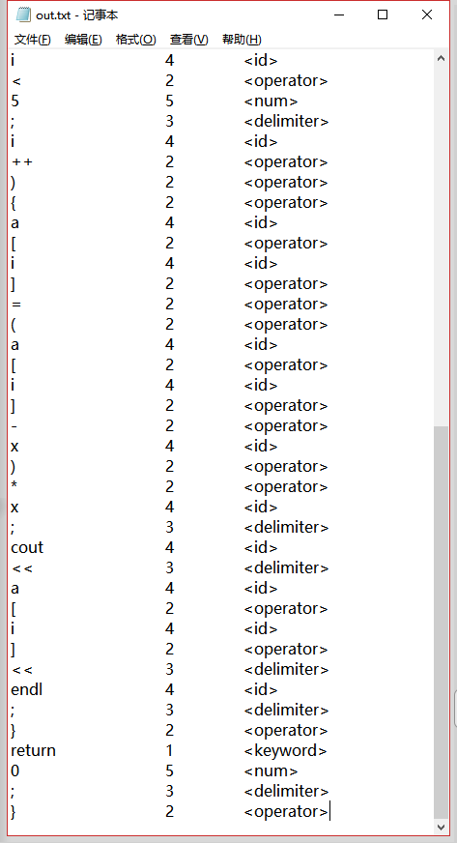

**程序运行结果：**

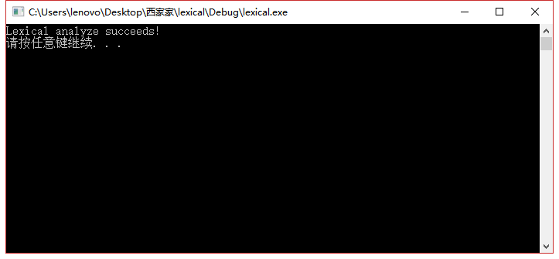

# 心得体会

本次试验的关键是根据正规表达式设计出对应的NFA，之后的化简和编码就水到渠成了。通过本次实验，我更加深刻地理解了有限自动机在编译原理中的重要地位，也学习了如何在实际操作中使用有限自动机去解决问题，把理论和实践结合了起来。