Midnight Digital Media, LLC.
By: Gina M. Levy

Business Model:

Customer Segments (CS):
Start-up business owner wanting the whole package for a site to broadcast themselves, ages 25-34. Established business owners who just need to update their sites, ages 30-50. Newbies who need a graphic design, ages 18-30.

Value Propositions (VP):
Reliable Service, Constant communication, updated techniques & Technology used, ainly for startup business people, help with updating established business people, responsive sites, innovated designs, can keep site updated

Channels (CH):
Internet, Oovoo & Skype webcaming for consulting with clients, emailing, social networking sites, face-to-face, word of mouth.

Customer Relationships (CR):
Reliable communication, Help with their needs

Revenue Streams (RS):
Ads, customer payments, Kickstarter.

Key Resources (KR):
Bank, UCF Launchpad

Key Activities (KA):
Responsive Website, Graphic Design, and Consulting with the clients

Key Partnerships (KP):
Social Media’s, Adobe Programs, Sublime text, UCF Launchpad

Cost Structure (CS):
Hosting site, Domain Name, LLC filing, Building rent, gas to meetings, Employees, Advertisement, Google Apps (with the Hosting site).

Empathy Map:

This will look like a circle when dealing with the Empathy Map. Each section of a client from beginning to end, and keeping them for a long time. A great way to continue Valued Customer Relationship which can fall in my favor.

Employees Needed:

4. Secretary-To maintain incoming and outgoing phone calls from clients to schedule a meeting. Full time position $14/hr. 40 hours a week. $560 total. $20,160 a year.

3. Social Network Manager-To upkeep the social media on Facebook, Twitter, Google+, etc. $18/hr. 40 hours a week. $720 total. $25,920 a year.

1. Web Developer-To help with the upkeep and creation of websites. $25/hr. 40 hours a week. $1000 total. $36,000 a year.

2.Graphic Designer-To help graphic designs and support the websites. $21/hr. 40 hours a week. $840 total. $30,000 a year.

5. Computer engineer-To keep systems from crashing and being able to fix and secure the sites. $28/hr. 40 hours a week. $1120 total. $40,320 a year.

Competitors:
http://purplerockscissors.com/

They are innovated creative digital agency company. They have more employees. They have lots more room for their building. They cover a lot more things in the field, while I cover only web and graphic design. They show off what they have done in the past.

Swot:

Strength: We are new and innovated group that want to help our clients. We are also affordable and will make our clients and employee feel at home.

Weakness: Our competitor Purple Rock Scissors has more employee than us and has been around longer.

Opportunities: Other places will have a lot of people to handle, so we can take up people who can’t be picked up. We also are affordable and people might like that. We will be able to

Threats: Not enough employees to take so many people. We will each have to take an even number of clients to make it through then expand.

Blue Ocean Strategy:

Eliminate: A huge building. We only need enough room at the moment for our employees. We can meet up with our clients anywhere, even on web cam to save them time and money on gas. We also take out part-timers.

Raise: The social media marketing since its going to mainly through mouth.

Reduce: The employees at the moment and make sure everyone has even number of clients. And only take a certain amount of clients until done.

Create: Not only be able to do web & graphic design for our clients but be able to put it up on a hosting site and manage it for them if they want that added to the costs and payments.

Schedule for next 6 months before opening day: Will Open Oct. 1st

April 1-8th, 2014
Draw up canvas. Choose business name.

April 8-15th, 2014
Create design for business, draw up website idea.

April 15-22nd, 2014
Look up Hosting site, Domain name, LLC, get email, and business banking.

April 22-29th, 2014
Check out buildings in Orlando. Start site. Look up workers.

April 29-May 6th, 2014
Buy domain and hosting site. Get site draft done.

May 6- 13th, 2014
Work on the site.

May 13-20th, 2014
Test the web site. Fix Problems if any.

May 20-27th, 2014
Have family and friends test the site for problems.

May 27-June 3rd, 2014
Go over the site once more.

June3-10th, 2014
Make sure LLC paper work is filed and get the company legalized.

June 10-17th, 2014
Put the Logo up on the site and make sure paperwork is good and launch the site.

June 17-24, 2014
Find a building that is affordable for right amount of people.

June 24-July 1st, 2014
Choose which one is best, then speak to people about renting.

July 1-8th, 2014
Give payment for place. Set up computers and programs, phones, and emails up.

July 8-15th, 2014
Set up Social media sites on Facebook, Twitter, and Google+.

July 15-22th, 2014
Go meet up with UCF Launchpad people to see if work is going great and on track.

July 22-29th, 2014
Meet other people who are start-up companies and network.

July 29- Aug. 5th, 2014
Market company on social media and try to get clients. Tell them opening date.

Aug. 5-12th, 2014
Keep marketing for next 2 weeks.

Aug. 12-19th, 2014
Finish up with beginning clients.

Aug. 19-26th, 2014
Make sure payments are in place for employees so I won’t worry about that.

Aug. 26- Sept. 2, 2014
Figure out how many startup people I need.

Sept. 2-9th, 2014
Figure out payment for each employee.

Sept. 9-16th, 2014
Look up people for positions.

Sept. 16-23th, 2014
Interview people for their jobs.

Sept. 23-30th, 2014
Bring in employees to go over work, and each persons job, make sure everyone has their emails set up.

Sept. 30th, 2014
Have a last minute preparation with the team about work, calls, and for opening day.

Oct.1st, 2014
Opening Day! Open doors at 8am.

Budget of $225,000

1. Hosting Site: Monthly-$15.95 x 12 year = $191.40
2. Google Domain Name: $12 Year
3. LLC filing papers- $107
4. Building office for fully furnished rent: $249 per person x 6 people (so far)= $1494 a month. A year is $17,928
5. Employee’s Total: $152,640
Total:$170, 878.

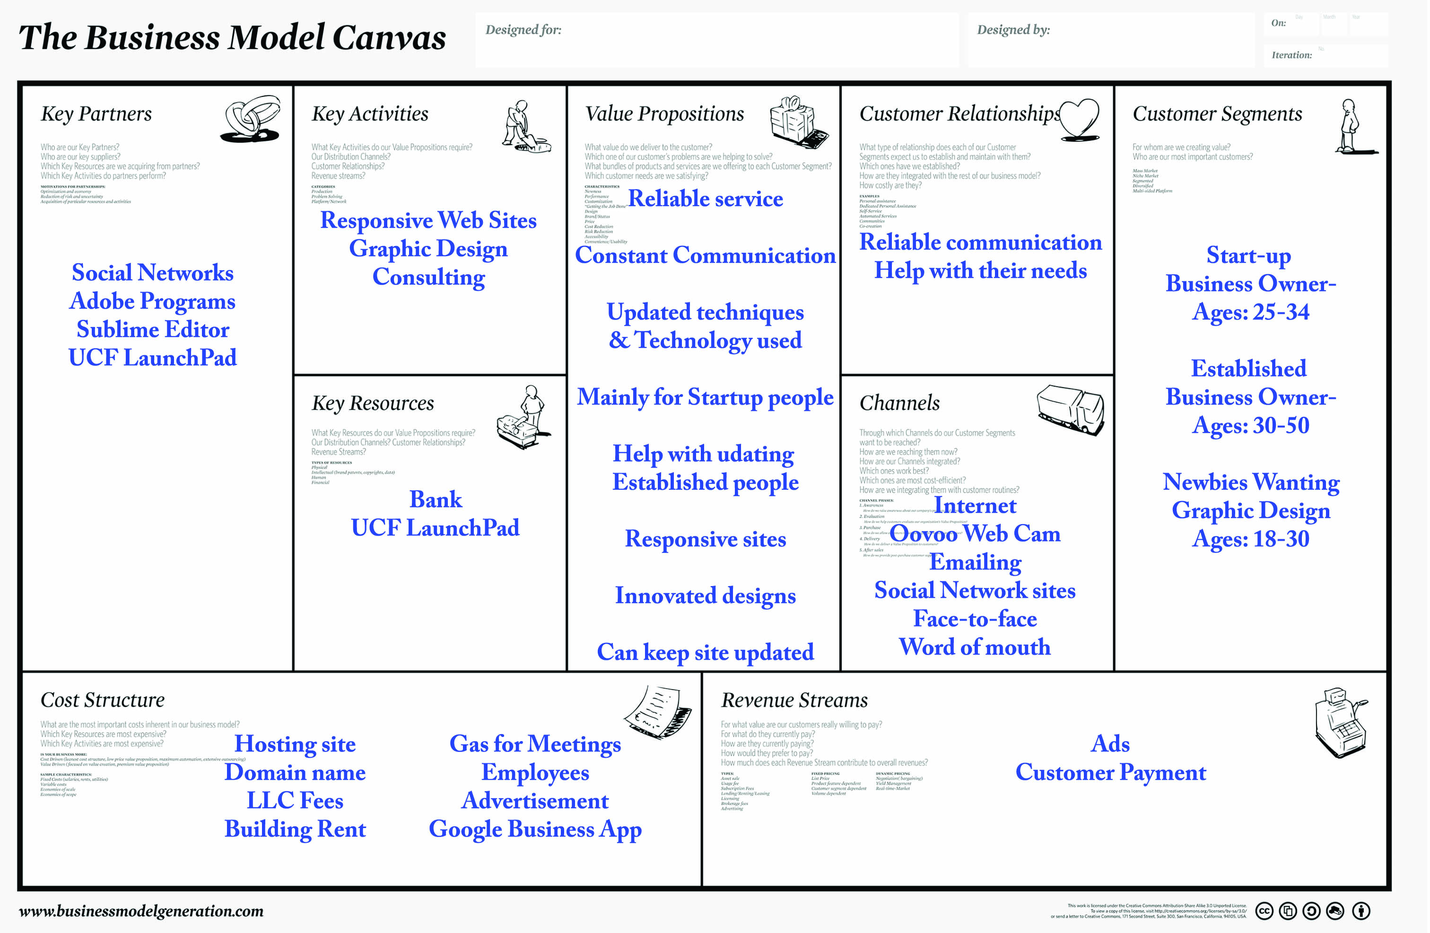

Sources:
http://www.wix.com/upgrade/website

http://www1.regus.com/zsys/ncms/en-us/landing/searchEngine/default-officeSpace8reasons.aspx?keyword=Office%20Rentals&location=in%20Orlando&pivcode=SEM-OF%20Rentals&se=Google&gclid=CPemionX3r0CFUtk7Aod8XwAzg

http://sunbiz.org/startbus.html

http://www.legalzoom.com/limited-liability-company/limited-liability-company-overview.html

http://purplerockscissors.com/

https://www.odesk.com

