Lim Jin Hui

* 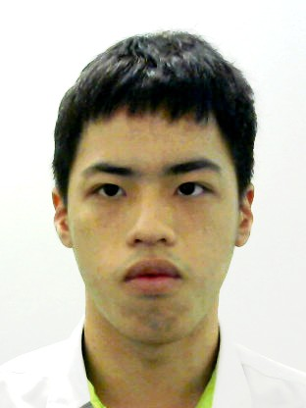Your NRIC: T0113047H
* Date of Birth: 03/05/2001
* Nationally: Singaporean
* Race: Chinese
* Gender: Male
* Your Address: BLK 517, Choa Chu Kang Street 51, #04-26, Singapore 680517
* Mobile: 93795495
* Your Email: elim53924@gmail.com

Education

* 2018 – 2019 Nitec Infocomm Technology

Institute of Technical Education

* 2014 – 2017 GCE ‘N’ Level Certification Teck Whye Secondary School

2 Distinctions for GCE ‘N’ Level

Achievement and Participation

# Year Achievement

2019 Edusave Award for Achievement, Good Leadership and Service (EAGLES)

2019 Edusave Merit Bursary (EMB)

2018 Director’s List for Academic Performance

2018 Microsoft Technology Associate Windows Server Administration Fundamentals

2017 Edusave Scholarships (ES)

Co-Curricular Activity and Certification

# Year CCA

2019 Student Volunteer Corps Community Service

2018 – 2019 Badminton

2014 – 2017 Infocomm Club

# Enrichment

* Escape Room 2018
* Class bonding BBQ 2018
* Paint ball 2018
* Amazing race 2018
* E'Space Enrichment Courses 2018
* App Inventor Workshop 2018
* Snap a Shot Photography Workshop 2018
* Dance Program – Jive 2017
* Social Etiquette, Personal Grooming and Effective Communication Skill Workshop 2017
* Community Emergency Preparedness Programme 2016
* Dance Development Programme 2015

# Service

* 2019 Chingay General Hospitality Management General Volunteer
* 2018 National Day Hospitality Management General Volunteer
* 2018 CCK Community Passion Art Festival
* 2018 Heritage Trail @ Mdm Tussards with Zhenghua CC
* 2018 Chinese New Year Celebration with Seniors at ITE College West
* 2017 W.I.S.H Project(4E1,4F,4G)
* 2016 Choa Chu Kang Bursary Award Ceremony
* 2016 Fortnightly Newspaper Recycling
* 2015 Weekly Newspaper Recycling
* 2015 Choa Chu Kang Small Action Big Impact Project
* 2015 SG50 Family Portrait Project

Skills and Competencies

# Language Proficient in 2 major languages

* English Written and Spoken
* Chinese Written and Spoken

# Leaderships

* Class Committee IT Representative 2014 - 2017
* Class Committee Environmental Representative 2016 – 2017

# Skills

* Microsoft Office – Word, Excel, PowerPoint
* Cisco Packet Tracer, NetBeans and Scratch
* Virtualization – VMWare Workstation
* Programming – Microsoft Visual Studio Community 2017

Reference

|  |  |  |
| --- | --- | --- |
| **Reference 1** | | |
| **Company** | **:** | MOE |
| **Name of Referrer** | **:** | Mr Chin |
| **Position** | **:** | Teacher |
| **Contact No.** | **:** | 9683 2157 |
| **Email** | **:** | chin_kwek_siong@moe.edu.sg |

|  |  |  |
| --- | --- | --- |
| **Reference 2** | | |
| **Company** | **:** | MOE |
| **Name of Referrer** | **:** | Mr Ben |
| **Position** | **:** | Teacher |
| **Contact No.** | **:** | 9800 4622 |
| **Email** | **:** | Ong_Kian_Beng@ite.edu.sg |